


Oxford
LINGUISTICS

■k

Meaning

in language
An Introduction to Semantics and Pragmatics

Alan Cruse

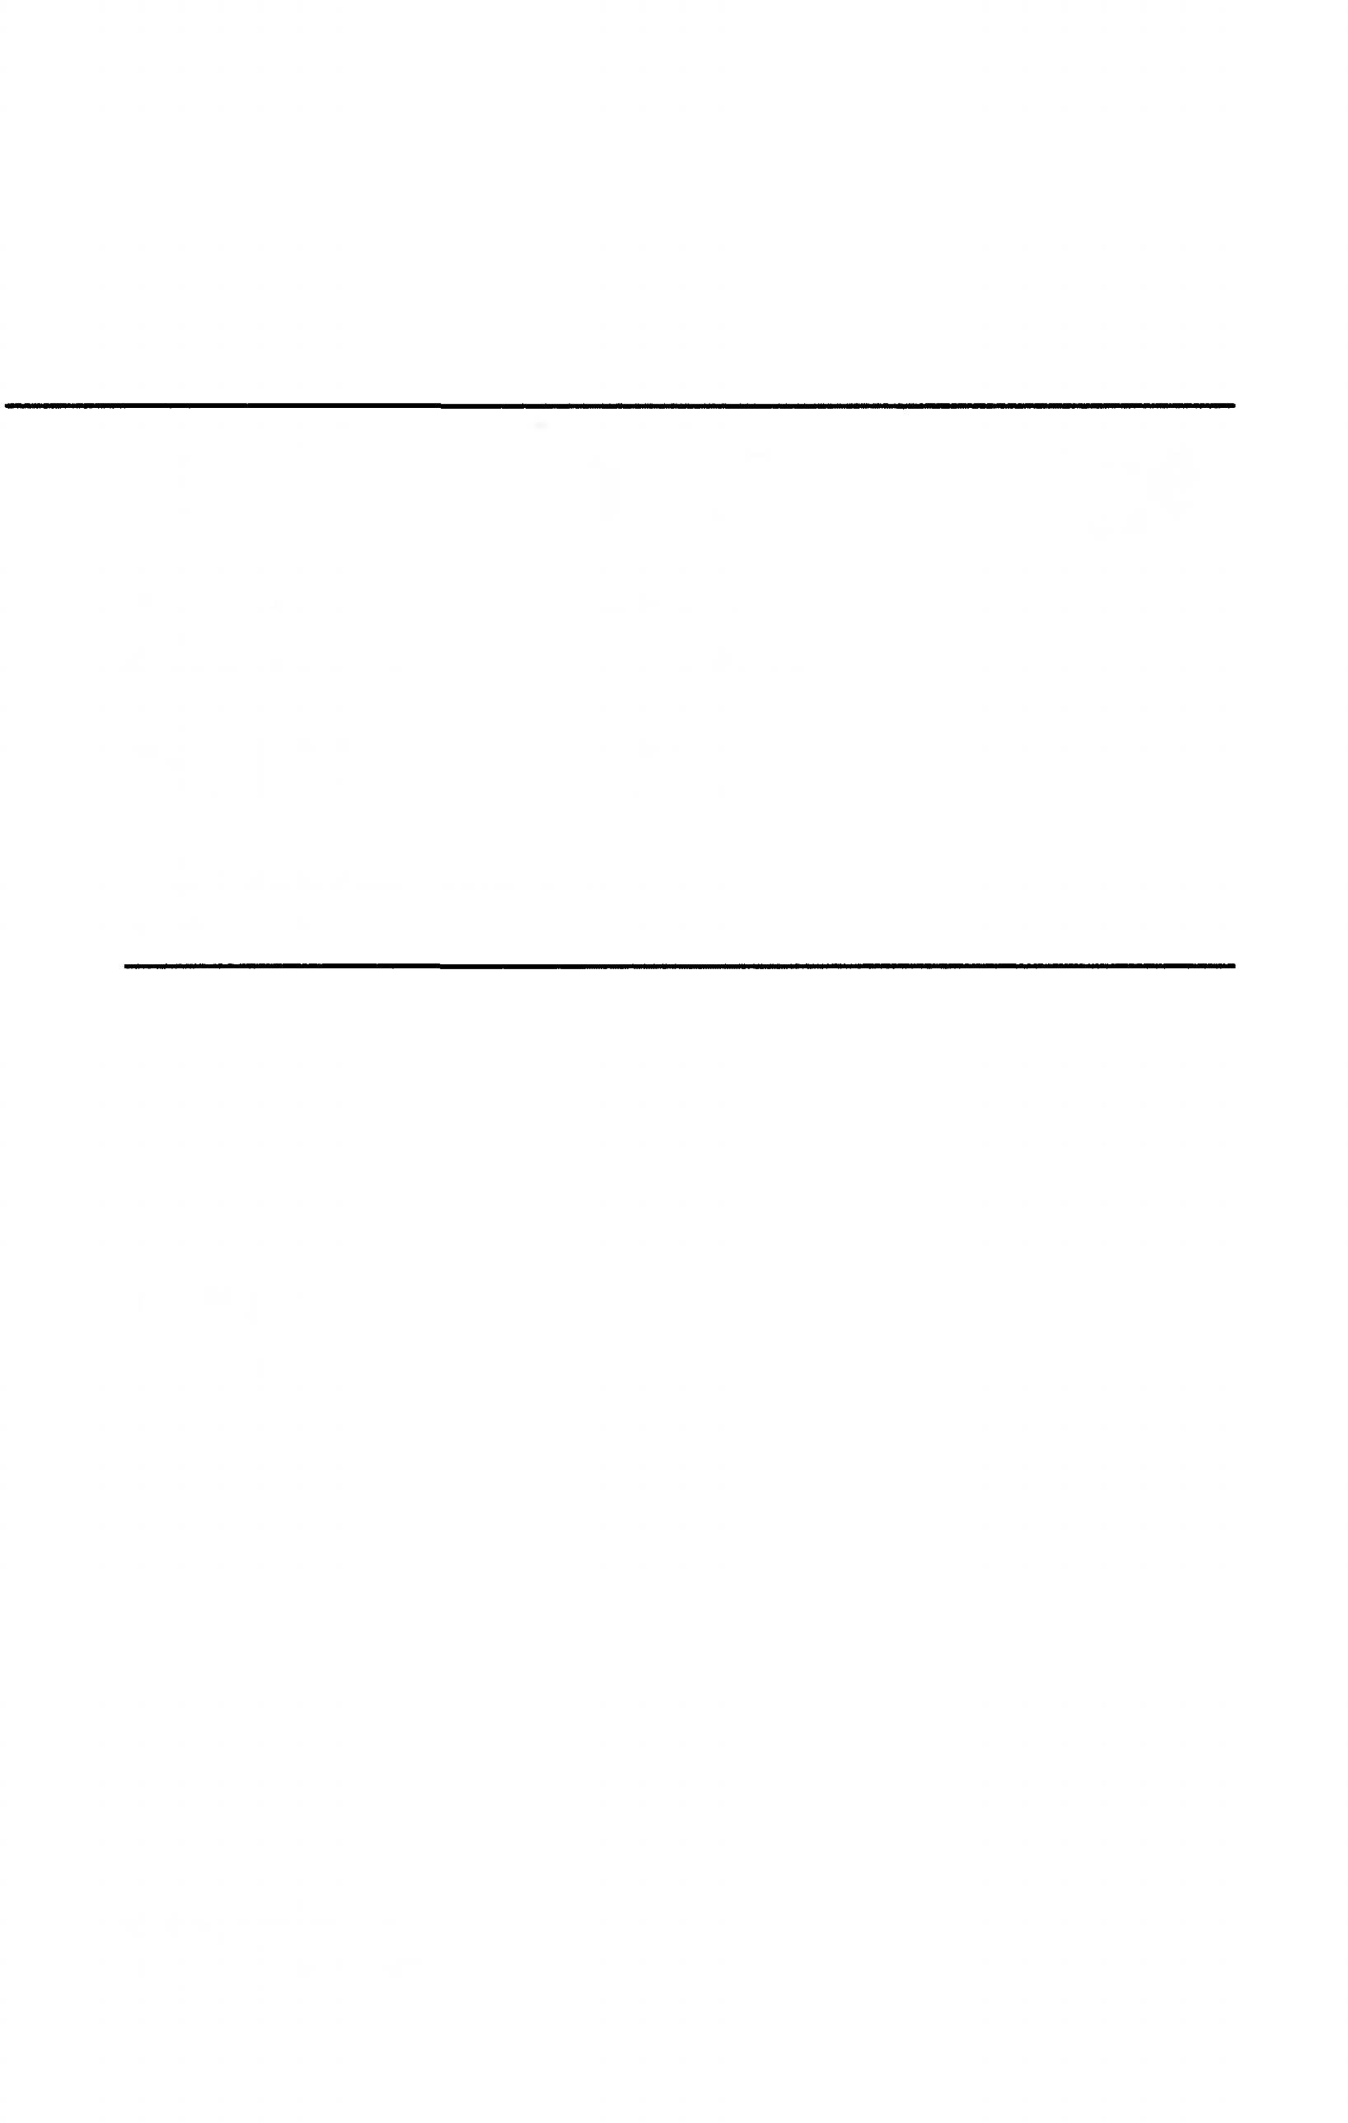

Meaning in Language An Introduction to Semantics and Pragmatics

D. Alan Cruse

University of Manchester

OXFORD
UNIVERSITY PRESS


OXFORD
UNIVERSITY PRE88
Great Clarendon Street, Oxford 0x2 6DP
Oxford University Press is a department of the University of Oxford.
It furthers the University’s objective of excellence in research, scholarship, and education by publishing worldwide in
Oxford New York
Athens Auckland Bangkok Bogota Buenos Aires Calcutta
Cape Town Chennai Dares Salaam Delhi Florence Hong Kong Istanbul Karachi Kuala Lumpur Madrid Melbourne Mexico City Mumbai Nairobi Paris Sao Paulo Singapore Taipei Tokyo Toronto Warsaw
with associated companies in Berlin Ibadan
Oxford is a trade mark of Oxford University Press in the UK and in certain other countries
Published in the United States
by Oxford University Press Inc., New York
© Oxford University Press 2000
The moral rights of the author have been asserted Database right Oxford University Press (maker)
All rights reserved. No part of this publication may be reproduced, stored in a retrieval system, or transmitted, in any form or by any means, without the prior permission in writing of Oxford University Press,
or as expressly permitted by law, or under terms agreed with the appropriate reprographics rights organizations. Enquiries concerning reproduction outside the scope of the above should be sent to the Rights Department, Oxford University Press, at the address above
You must not circulate this book in any other binding or cover and you must impose the same condition on any acquirer
British Library Cataloguing in Publication Data Data available
Library of Congress Cataloging in Publication Data (Data applied for)
ISBN 0-19-870010-5
10 98765432
Typeset by RefineCatch Limited, Bungay, Suffolk Printed in Great Britain
on acid-free paper by
Bath Press Ltd., Bath, Avon


Contents

Typographic conventions ix
Preface x
Parti Fundamental Notions 1
- Introduction 3
- Logical matters 17
- Types and dimensions of meaning 41
- Compositionality 65
Part 2 Words and their Meanings 83
- Introduction to lexical semantics 85
- Contextual variability of word meaning 103
- Word meanings and concepts 125
- Paradigmatic sense relations of inclusion and identity 143
- Paradigmatic relations of exclusionand opposition 163
- Word fields 177
- Extensions of meaning 197
- Syntagmatic relations 217
- Lexical decomposition 237
Part 3 Semantics and Grammar 263
- Grammatical semantics 265

viii Contents
Part 4: Pragmatics 301
- Reference and deixis 303
- Speech acts 329
- Implicatures 347
Conclusion 379
Answers to questions 383
References 401
Index 409

Typographic conventions

Small capitals
For concepts; occasionally for lexical roots.

Small capitals in square brackets
For semantic components.

Angled brackets
For selectional restrictions

Bold type
For technical terms when first introduced.

Italics
For citation forms when not set on a different line.

Bold italics
For emphasis.

Single quotation marks
For quotations from other authors; ‘scare quotes’.

Double quotation marks
For meanings.

Question marks
For semantic oddness.

Asterisks
For ungrammaticality or extreme semantic abnormality.

