Part 1
Fundamental Notions

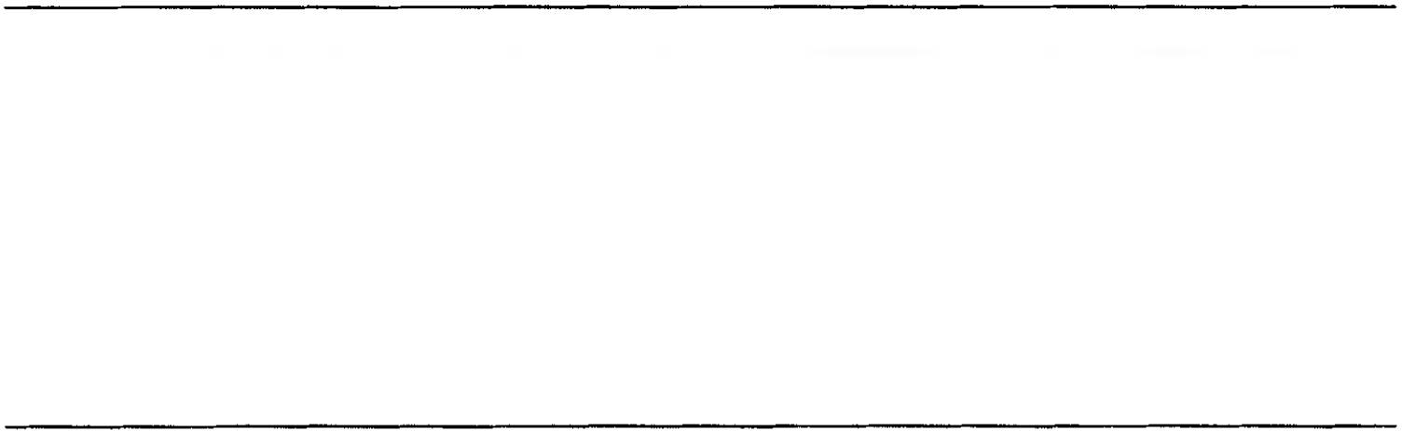

In this first part of the book, a number of fundamental, but fairly general notions are introduced, which need to be grasped before the more detailed discussions in later sections can be properly appreciated. Chapter 1 has a scene-setting function, identi­ fying the place of linguistic signs and linguistic communication in the broader domains of semiotics and communication in general. Chapter 2 introduces a num­ ber of vital conceptual tools drawn from the field of logic. Chapter 3 surveys the range of different sorts of meaning, and dimensions of variation in meaning. Chapter
4 discusses the notion of compositionality, one of the essential properties of lan­ guage, and its limits.

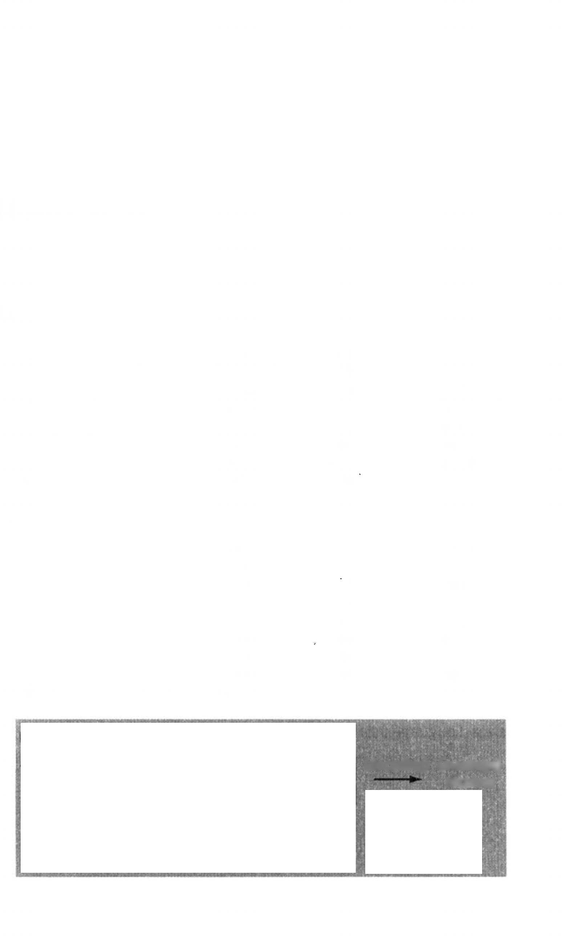
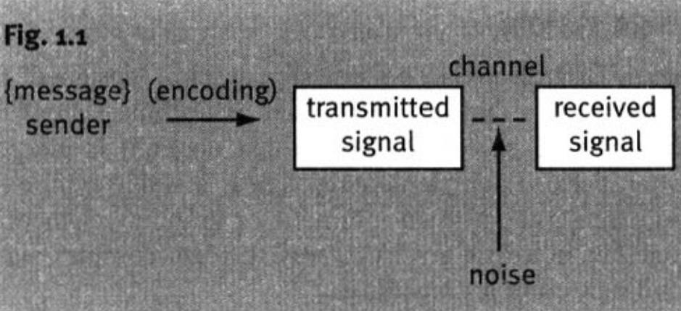


CHAPTER 1
Introduction

l.i Communication

Meaning makes little sense except in the context of communication: the notion of communication therefore provides as good a place as any to start an exploration of meaning, Communication can be conceived very broadly, including within its scope such matters as the transfer of information between biological generations via the genetic code, the interaction between a driver and his car, and indeed any sort of stimulus-response situation. Here we shall confine ourselves to what is surely the paradigm communicative scenario, namely, the transfer of information between human beings.

    - A simple model
Let us begin with a simple model, as shown in Fig. i .1 (after Lyons 1977).
In the model, the process begins with a speaker who has something to communicate, that is, the message. Since messages in their initial form cannot be transmitted directly (at least not reliably), they must be converted into a form that can be transmitted, namely, a signal. In ordinary conversation, this involves a process of linguistic encoding, that is. translating the message into a linguistic form, and translating the linguistic form into a set of instructions to the speech organs, which, when executed, result in an acoustic signal The initial form of this signal may be termed the transmitted signal.

(decoding) {message}
receiver
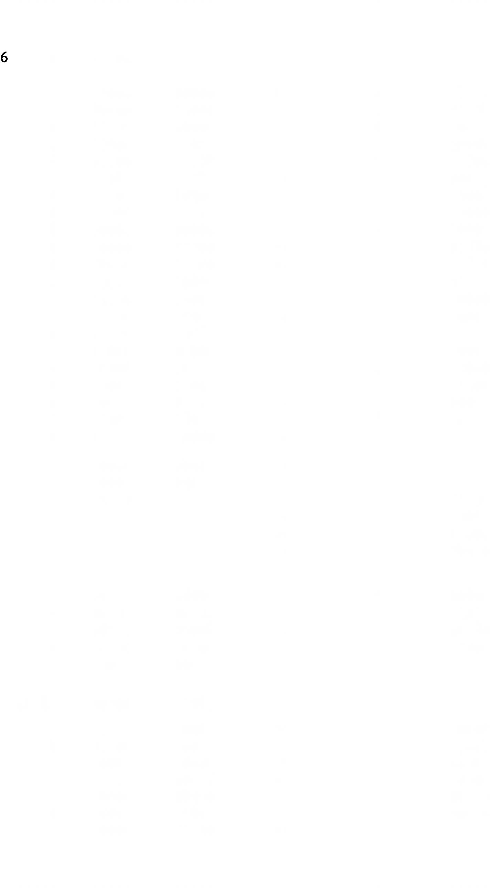

Meaning in language

Every mode of communication has a channel, through which the signal travels: for speech, we have the auditory channel, for normal writing and sign language, the visual channel, for Braille, the tactile channel, and so on. As the signal travels from sender to receiver, it alters in various ways, through distor tion, interference from irrelevant stimuli or loss through fading. These changes are referred to collectively as noise. As a result, the signal picked up by the receiver (the received signal) is never precisely the same as the transmitted signal. If every detail of the transmitted signal was crucial for the message being transmitted, communication would be a chancy business. However, effi cient communicating systems like language compensate for this loss of infor mation by building a degree of redundancy into the signal. Essentially this means that the information in a signal is given more than once, or is at least partially predictable from other parts of the signal, so that the entire message can be reconstructed even if there is significant loss. It is said that language is roughly 50 per cent redundant.
Once the signal has been received by the receiver, it has to be decoded in
order to retrieve the original message. In the ideal case, the message reconstructed by the receiver would be identical to the message that the speaker started out with. Almost certainly, this rarely, if ever, happens; how ever, we may presume that in the majority of cases it is ‘close enough’. All the same, it is worth distinguishing three aspects of meaning:
      - speaker’s meaning: speaker’s intended message
      - hearer’s meaning: hearer’s inferred message
      - sign meaning: this can be taken to be the sum of the properties
of the signal which make it (a) more apt than other signals for conveying speaker’s intended message, and (b) more apt for conveying some messages than others.
In the case of an established signalling system like language, the meanings of the signs are not under the control of the users; the signs are the property of the speech community and have fixed meanings. Of course on any particular occasion, the signs used may be ad hoc or conventional, if ad hoc, they may be prearranged or spontaneous.

Language as a sign system
Any natural human language is a complex sign system, ‘designed’ to ensure infinite expressive capacity, that is to say, there is nothing that is thinkable which cannot in principle be encoded (provided no limit is placed on the complexity of utterances). Each elementary sign is a stable symbolic associ ation between a meaning and a form (phonetic or graphic); elementary signs may combine together in a rule-governed way to form complex signs which convey correspondingly complex meanings.

Introduction 7

  - Semiotics: some basic notions

Iconicity
Signs can generally be classified as iconic or arbitrary. Iconic signs are those whose forms mirror their meanings in some respect; signs with no natural analogical correspondences between their forms and their meanings are called arbitrary. A simple example is provided by the Arabic and Roman numerals for “three”: 3 and III. The Arabic form gives no clue to its meaning; the Roman version, on the other hand, incorporates “threeness” into its shape, and is thus iconic. Iconicity is a matter of degree, and usually coexists with some degree of arbitrariness. Three horizontal lines would be just as iconic as the Roman III: the fact that in the Roman symbol the lines are vertical is arbitrary, as is the fact that its size corresponds to that of letters.
Iconicity enters language in several guises. The majority of words in a natural language are arbitrary: the form of the word dog, for instance, does not mirror its meaning in any respect. However, the so-called onomatopoeic words display a degree of iconicity, in that their sounds are suggestive (to varying degrees) of their meanings:
bang clank tinkle miaow splash cuckoo peewit curlew whoosh thud crack ring wheeze howl rumble, etc.
The predominance of arbitrariness in the vocabulary is not an accidental feature, but is a crucial ‘design feature’ of natural language. There is a limited stock of dimensions of formal variation in linguistic signs; if all signs were iconic, it is difficult to see how universal expressivity could be achieved.
Some iconicity is also apparent in grammar. For instance, words which belong together tend to occur together. In The tall boy kissed the young girl we know that tall modifies boy and not girl because tall and boy come next to each other in the sentence. In some languages this relationship might be shown by grammatical agreement, which is a kind of resemblance, and therefore also iconic. Another way in which iconicity appears in the grammar is that grammatical complexity by and large mirrors semantic complexity.

Conventionality
Many of the signs used by humans in communication are natural in the sense that they are part of genetically inherited biological make-up and do not have to be learned, although a maturational period may be necessary before they appear in an individual, and they may be moulded in various ways to fit particular cultural styles. The sort of signs which are natural in this sense will presumably include facial expressions like smiling, frowning, indications of fear and surprise, and so on, perhaps many of the postural and proxemic signs
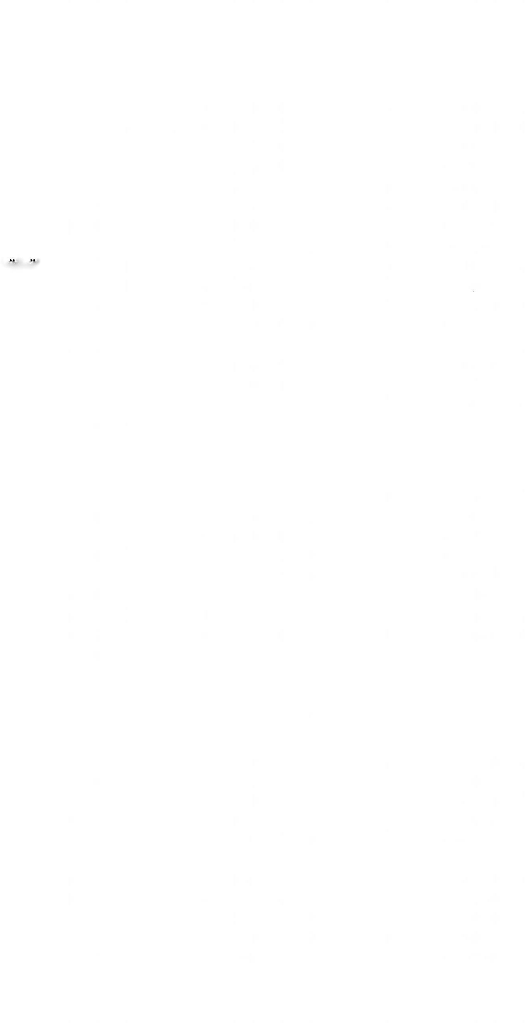

8 Meaning in language

that constitute the so-called ‘body language’, certain types of gesture, vocal indications of excitement, desire, etc. (whether or not linguistic), and many more. Natural signs are likely to be the most cross-culturally interpretable.
Other signs have conventionally assigned meanings; they have to be specif ically learned, and are likely to differ in different communities. Linguistic signs are the prototypical conventional signs. Even onomatopoeic words usually have a significant conventional element; often the iconic nature of the word can only be appreciated, as it were, with hindsight. Take the Turkish word bulbul. What does it refer to? A baby’s babbling? The noise of a mountain spring? In fact, it means “nightingale”. Looking back, one can make the connection. It is not only linguistic signs that are conventional. Obscene or offensive gestures, for instance, can vary quite remarkably cross culturally: I was once reprimanded for pointing the soles of my feet at the Prime Minister of Iraq (in Arab culture this is disrespectful: my disrespect was entirely inadvertent). Even in Europe, conventional gestures can differ: Greeks are famously—and slightly inaccurately—said to shake their heads to say “Yes”, and nod to say “No”.

1.23 Discreteness
Some signs can vary gradually in their form, and their meanings vary in paral lel with the change of form, like the fisherman’s indication of the size of ‘the one that got away’; these are called continuous signs. Other signs have fixed shapes, and must be chosen from a limited inventory: intermediate forms are not allowed, the range of possibilities is ‘chunked’; such signs are described as discrete. Linguistic signs are virtually all of the discrete variety. Again, this is not an accidental feature, but has a close connection with iconicity and arbitrariness: continuous signs are necessarily iconic; arbitrary signs are necessarily discrete.

Language and other communicative channels

The prototypical scenario for linguistic communication is two people engaged in face-to-face conversation. Of course, in such an encounter, lan guage signals are exchanged; but normally so are many other types of signal, and these modify and/or supplement the linguistically encoded message. Let us, then, briefly look at the semiotic environment of language in a typical conversation.
The signs that accompany language can be divided into two major types— paralinguistic and non-linguistic. The defining characteristic of paralinguistic signs will be taken here to be an extreme dependence on the accompanying language. Either they cannot be produced except during speech (because they are carried on the voice), or they cannot be interpreted except in conjunction

Introduction 9

with accompanying language. Examples of the first variety are abnormal volume, tempo, pitch, and voice quality; to function as signs, there must be a departure from some (personal) baseline or norm. For instance, abnormally high volume, fast tempo, or high pitch typically signal a heightened emo tional state. Examples of the second variety include pausing, emphatic ges tures, and gestures which metaphorically depict, for instance, direction of motion.
The functions of paralinguistic signs can be conveniently classified under three headings:
- Punctuation: there are signs which have functions parallel to those of punctuation in written language, mainly to segment the stream of speech so as to facilitate processing.
- Modulation: this involves the addition of an emotive or attitudinal colouring to the linguistically encoded message.
- Illustration: some signs ‘depict’ a key element in the message, such as a direction of movement, or a shape; the depiction may be relatively literal, like the hand movements of someone describing the climbing of a spiral staircase, or metaphorical, as when vertical and parallel hands accompany the setting of limits of some kind.
Not all the signs that occur alongside language are paralinguistic in the sense defined. For instance, one may smile or frown while speaking, and this may well ‘modulate’ the message. But smiles and frowns (and many other signs) are perfectly interpretable and capable of being produced in the absence of any accompanying language. These are therefore to be considered as non-linguistic.

Characteristics of linguistic signs

Paralinguistic signs are typically natural, continuous, and iconic, whereas linguistic signs are for the most part arbitrary, discrete, and conventional.

Simple and complex signs
Linguistic signs may be simple or complex. This does not just mean that they can occur singly or in groups of various sizes: the occurrence of two or more signs together does not necessarily result in a complex sign. Take the case of someone who answers a question with the word Yes, at a higher than usual pitch, and at the same time smiling. This person has not produced a complex sign with three constituents, only three simple signs simultaneously. The mean ings of the three signs are simply added together: there is no interaction between the signs other than additivity. Contrast this with a minimally com plex sign such as red wine: to obtain the meaning of this sign, we do not simply


10 Meaning in language

add the meaning of red to the meaning of wine (that would give us something like “wine plus redness”). What happens is the meaning of red interacts with the meaning of wie by restricting it.
There is no theoretical upper limit to the complexity of linguistic signs. This is rendered possible by the recursive nature of syntax, that is, the existence of rules which can be applied indefinitely many times (like the one which yields This is the dog that worried the cat that killed the rat that ate the corn that...). Such rules are an essential prerequisite for the ‘universal expressivity’ of language—the fact that anything thinkable is expressible, or at least can be approximated to any given degree of accuracy.

Signs at different linguistic levels
A linguistic sign may be no more than a phoneme (or two): this is one inter pretation of the si- of slimy, slovenly, slug, slag, slum, slink, slattern, slut, slob, etc. which seems to indicate something unpleasant, or the gl- of glare, glimmer, glitter, glisten, glow, gleam, etc. which all have something to do with light effects. These have no grammatical status, and no contrastive value, but the intuitions of native speakers leave no doubt that they should receive some recognition. Other signs occur at higher levels of linguistic organization, from morpheme level (e.g. the -5 of dogs), through word level (e.g. denationaliza tion), clause level (e.g. the formal difference between John is here and Is John here? which signals that one is a question and the other a statement), sentence level (e.g. Well do it as soon as you arrive as opposed to As soon as you arrive, well do it), up to text level (e.g. the fact that a stretch of text constitutes a sonnet is indicated by the form of the text as a whole: this form therefore constitutes a high-level sign).
The fact that a sign manifests itself at a particular level does not entail that it is to be interpreted at that level. A few examples will illustrate this point. The item the, a word, exerts its semantic effect on a whole noun phrase the little old lady who lives in the cottage on the hill; the -ed of John kissed Mary, a bound morpheme, semantically situates the time relative to the moment of utterance of the whole event symbolized by John kiss Mary; a single word like matri mony may mark a whole discourse as being in a certain register.

Approaches to the study of meaning

Meaning may be studied as a part of various academic disciplines. There is of course a significant degree of overlap between disciplines, but characteristic ally all have something idiosyncratic and unique in their approach (the following remarks are merely illustrative).


Introduction ll

Philosophy
Linguists typically take the existence of meaning for granted and accept it as an intuitively accessible ‘natural kind’. They do not ask questions like How is it possible for anything to mean something? or What sort of relation must hold between X and Y for it to be the case that X means Y? Such questions are the province of the philosopher, particularly the philosopher of language.

Psychology
Meaning is a major concern of the psychology of language and psycho linguistics. (I shall not attempt to distinguish these.) A distinctive feature here is the experimental study of how meanings are represented in the mind, and what mechanisms are involved in encoding and decoding messages. An example of a fact that could only emerge within a psycholinguistic framework is that in the lexical decision task, where experimental subjects observe strings of letters flashed on a screen and must indicate by pressing the appropriate button whether the string represents a word or not, responses are faster to words with concrete meanings than to words with abstract meanings, even when extraneous factors like length and frequency are rigorously controlled. This observation presumably provides a clue to the role of meaning in word recognition (to the best of my knowledge it is still a puzzle).

Neurology
Psychologists take a ‘macro’ view of mental states and processes. Neurologists, on the other hand, want to know how these states and processes are imple mented at the neuronal level. A psychologist might be broadly compared with a computer programmer, and a neurologist to the designer of computer chips. Meaning, like everything else in mental life (at least if one is a physicalist) must boil down ultimately to connections between neurons.

Semiotics
Semioticians view language as one sign system amongst many, and seek out those features which render it so successful. They are also likely to give emphasis to marginal aspects of linguistic signification. The recent strong interest in iconicity in language represents a significant overlap between the linguistic and semiotic approaches to meaning.

Linguistics
It is not easy to encapsulate the linguistic approach to meaning in language succinctly. There are perhaps three key aspects. The first is that native speakers’ semantic intuitions are centre-stage, in all their subtlety and nuances: they constitute the main source of primary data. The second is the

12 Meaning in language

importance of relating meaning to the manifold surface forms of language. The third is the respect paid not just to language, but to languages.

The linguistic study of meaning in language

    - What is linguistic meaning?
Here we attempt to say what is to count as meaning in language. Following an impulse towards generosity rather than austerity, we shall as a first step say that all meaning is potentially reflected in fitness for communicative intent. It will be assumed that a way of tapping into this is in terms of contextual normality: every difference of meaning between two expressions will show up as a difference of normality in some context. Thus, we know that illness and disease do not mean the same, because during his illness is normal, but during his disease is not; almost and nearly do not have precisely the same meaning because very nearly is normal but very almost is not; pass away and kick the bucket have different meanings because It is with great sadness that we report that our Beloved Ruler kicked the bucket two minutes after midnight is odd, but It is with great sadness that we report that our Beloved Ruler passed away two minutes after midnight is normal. We take normality!oddness and relative oddness!normality to be primitive intuitions.
It will be noticed that the move in the above characterization was from
meaning to contextual abnormality. Unfortunately, the move cannot without further ado be made from abnormality to meaning, because there are other factors besides meaning which affect normality.
Let us assume that we are dealing with spoken language and that the utter ance is correctly pronounced. The two sources of abnormality that we wish to eliminate if possible are grammatical deviance and 'meaning’ that is non- linguistic in origin. Let us make the simplifying assumption that if a pin pointed deviance is grammatical in nature, it will not prove possible to reduce it by contextual manipulation, for instance by interpreting it as metaphor, science fiction, or fairy-tale. Thus, They goes is irredeemably deviant in any context, whereas I shall go there yesterday might just make sense in a setting where time travel (or at least temporal scrambling) is possible. That leaves non- linguistic meaning to be taken care of. Consider the possibility that a certain type of delivery, not amounting to mispronunciation, may be a sign that the speaker is under the influence of some pharmacological substance. Let us make the further assumption that some speaker is deliberately trying to con vey this information. This might well be odd in, for instance, the context of a sermon. Is this linguistic meaning? (In the case described, it is certainly a kind of meaning, and language is used to convey it.) Presumably it is not linguistic meaning, but how do we exclude it? One way is to stipulate that linguistic meaning must either be conventionally associated with the linguistic forms used, or be inferable from the latter in conjunction with contextual knowledge.


Introduction 13

One indication that the above example is not of this type would be its insensitivity to the actual words used.

What are we trying to achieve?

      - Specifying/describing meanings
A very important task is to discover a way of specifying or describing mean ings, whether of isolated words or sentences, or of utterances in context. The position taken in this book is that in general, meanings are not finitely describ able, so this task boils down to finding the best way to approximate meanings as closely as is necessary for current purposes (lexicographers have long had to confront this problem for words).
      - How meaning varies with context
The meanings of all linguistic expressions vary with the context in which they occur. For instance, the shade of colour indicated by a redhead and red wine are markedly different; the periods of time denoted by month in (1) and (2) are quite likely to be different:
        - He’s here for a month, (could be four weeks; not dependent on time of utterance)
        - He’s here for the month, (will depend on time of utterance, but could be 31 days)
Some variations, like the sex of the doctor in Our doctor has just married a policeman and Our doctor has just married an actress can be predicted by general principles; other variants are less, or not at all predictable. Semanticians seek a revealing account of contextual variation.
      - Kinds of meaning
There are different sorts of meaning, each with different properties. For instance, whatever the difference in meaning between (3) and (4), it does not affect the truth or falsity of the statement:
- Old Joshua Hobblethwaite popped his clogs last week.
- Old Joshua Hobblethwaite passed away last week.

      - What happens when meanings combine?
Another vital aspect of semantics is how simple(r) meanings combine to form more complex meanings. To some extent this is a function of grammatical structure: for instance, the way red and hat combine in a red hat is not the same as the way turn and red combine in to turn red. But differences occur even within the same grammatical construction: the mode of combination of red and hat in a red hat is different from that of long and eyelash in long eyelashes (compare long eyelashes and a long river).

Meaning in language

1.6.2.5 Systematicity and structure; possibility of formalization
All semanticians are to some extent looking for regularities and system in the way meanings behave, as this leads to maximally economical descriptions. The most dedicated to this aspect of semantics are those who attempt to model the semantic behaviour of natural language expressions by means of a strict logical or quasi-mathematical formalism. This route will not be followed in this book.

      - New meanings from old
A striking feature of linguistic expressions is their semantic flexibility: beyond their normal contextual variability, they can be bent to semantic ends far removed from their conventional value, witness She swallowed it hook, line and sinker or You ll find her in the telephone book. The study of such extensions of meaning is an important task for semantics.

      - Role(s) of context
It is usually assumed that linguistic expressions can be assigned some sort of context-independent semantic value, although there is much disagreement regarding exactly what this is. There is also general agreement that context is of vital importance in arriving at the meaning of an utterance. The role of context ranges from disambiguating ambiguous expressions as in We just got to the bank in time, through identification of referents (who is he, where is there, in time for what, in He didn't get there in time), to working out ‘between the lines’ messages like B’s ignorance of the whereabouts of the corkscrew in:
- A: Where’s the corkscrew?
B: It’s either in the top drawer in the kitchen, or it’s fallen behind the piano.

The approach adopted in this book
We are not yet in a position to rule out any approaches which yield insights, even if some such approaches appear at first sight incompatible. This book therefore takes an ecumenical position on many issues. In so far as there is a theoretical bias, it is towards the cognitive semantic position. This means, in particular, that the meaning of a linguistic expression is taken to arise from the fact that the latter gives access to a particular conceptual content. This may be of indeterminate extent: no distinction is made between linguistic meaning and encyclopaedic knowledge.
Since this book is not intended to propound a body of theory, but to acquaint non-specialists with the range of semantic phenomena in language, there is a bias towards descriptive coverage at the expense of theoretical rigour.


Introduction 15

Branches of the study of meaning in language

The following are the main broadly distinguishable areas of interest in the study of meaning. They do not by any means form watertight compartments: there are many points of overlap.

Lexical semantics
Lexical semantics studies the meanings of words; the focus here is on ‘content’ words like tiger, daffodil, inconsiderate, and woo, rather than ‘form? ‘grammatical’ words like the, of, than, and so on. To a non-specialist, the notion of meaning probably has a stronger link with the idea of the word than with any other linguistic unit: words are, after all, what are listed in dictionar ies, and the main function of a dictionary is to tell us what the listed words mean. For this reason, lexical semantics perhaps provides the easiest access route into the mysteries of semantics in general, and this is one reason why it has been given a prominent place in this book, and why it comes early.

Grammatical semantics
Grammatical semantics studies aspects of meaning which have direct rele vance to syntax. This has many manifestations, which can only be briefly illustrated here. One problem is the meaning of syntactic categories (problem atic, because not everyone believes they can be assigned meanings). Consider, for instance, the differences in the meaning of yellow in the following:
- She wore a yellow hat. (adjective)
- They painted the room a glowing yellow, (noun)
- The leaves yellow rapidly once the frosts arrive, (verb)
Another aspect of grammatical semantics is the meaning of grammatical morphemes like the -ed of walked, the -er of longer, the re- and the -al of retrial, and so on.
Clearly this overlaps with lexical semantics, partly because some grammat ical elements are words (like the, and of), but more particularly because some aspects of the meanings of full lexical items determine to some degree their grammatical behaviour (for instance, the fact that I am studying that question is grammatical, but not lam knowing the answer to that question).

Logical semantics
Logical semantics studies the relations between natural language and formal logical systems such as the propositional and predicate calculi. Such studies usually aim at modelling natural language as closely as possible using a tightly controlled, maximally austere logical formalism. It is arguable that sometimes such studies shed more light on the formalism used than on the language being


16 Meaning in language

modelled; none the less, valuable insights have come from this approach. To date, most such studies have concentrated on the propositional/sentential level of meaning, and have rarely attempted to delve into the meanings of words.

Linguistic pragmatics
For present purposes, pragmatics can be taken to be concerned with aspects of information (in the widest sense) conveyed through language which (a) are not encoded by generally accepted convention in the linguistic forms used, but which (b) none the less arise naturally out of and depend on the meanings conventionally encoded in the linguistic forms used, taken in conjunction with the context in which the forms are used. This rather cumbersome formulation is intended to allow into pragmatics things like the identity of the individual referred to by John in I saw John today, and the assumption that the room in question had several lights in John entered the room; all the lights were on, at the same time excluding, for instance, the possibility that the person saying I saw John today had a private ad hoc arrangement with the hearer that when ever he said John, he should be taken to mean “Mary” (since it does not arise naturally out of the normal meaning of John), and excluding also the possibil ity of someone’s inferring from a speaker’s slurred speech that they were drunk (since this does not depend on the conventional meanings of the words uttered). Pragmatics is usually contrasted with semantics, which therefore deals with conventionalized meaning; obviously, the three divisions discussed above belong to semantics.

Suggestions for further reading

Much fuller accounts of the semiotic environment of spoken language can be found in Argyle (1972), Beattie (1983), Ellis and Beattie (1986) and Clark (1996).

