Part 2
Words and their Meanings

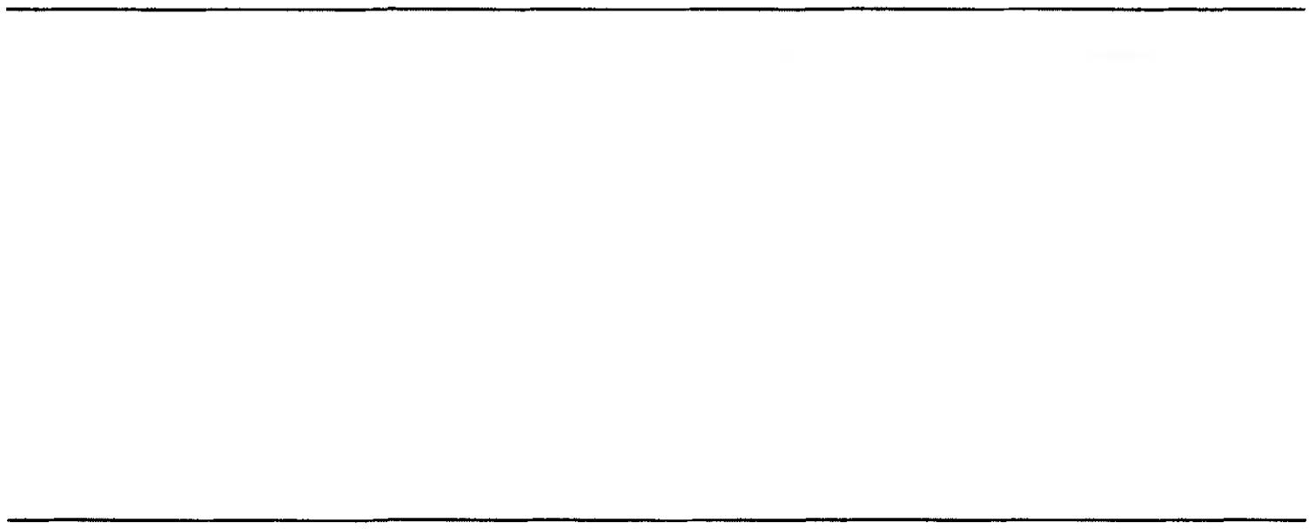
To the layman, words are par excellence the bearers of meaning in language. While it is in danger of understating the importance of other linguistic structures and phe­ nomena in the elaboration of meaning, this view is not entirely unjustified: words do have a central role to play in the coding of meaning, and are responsible for much of the richness and subtlety of messages conveyed linguistically. Hence it is no acci­ dent that this part of the book is the most substantial. Here, after the introductory Chapter 5, we discuss how word meanings vary with context (Chapter 6), the relations between word meanings and concepts (Chapter 7), paradigmatic sense relations (Chapters 8 and 9), larger vocabulary structures (Chapter 10), how new meanings grow out of old ones (Chapter 11), how words affect the meanings of their syntagmatic neighbours (Chapter 12), and finally, theories of lexical decomposition (Chapter 13).

CHAPTER 5

Introduction to lexical semantics

  - The nature of word meaning 87 5.3 Approaches to lexical semantics 96

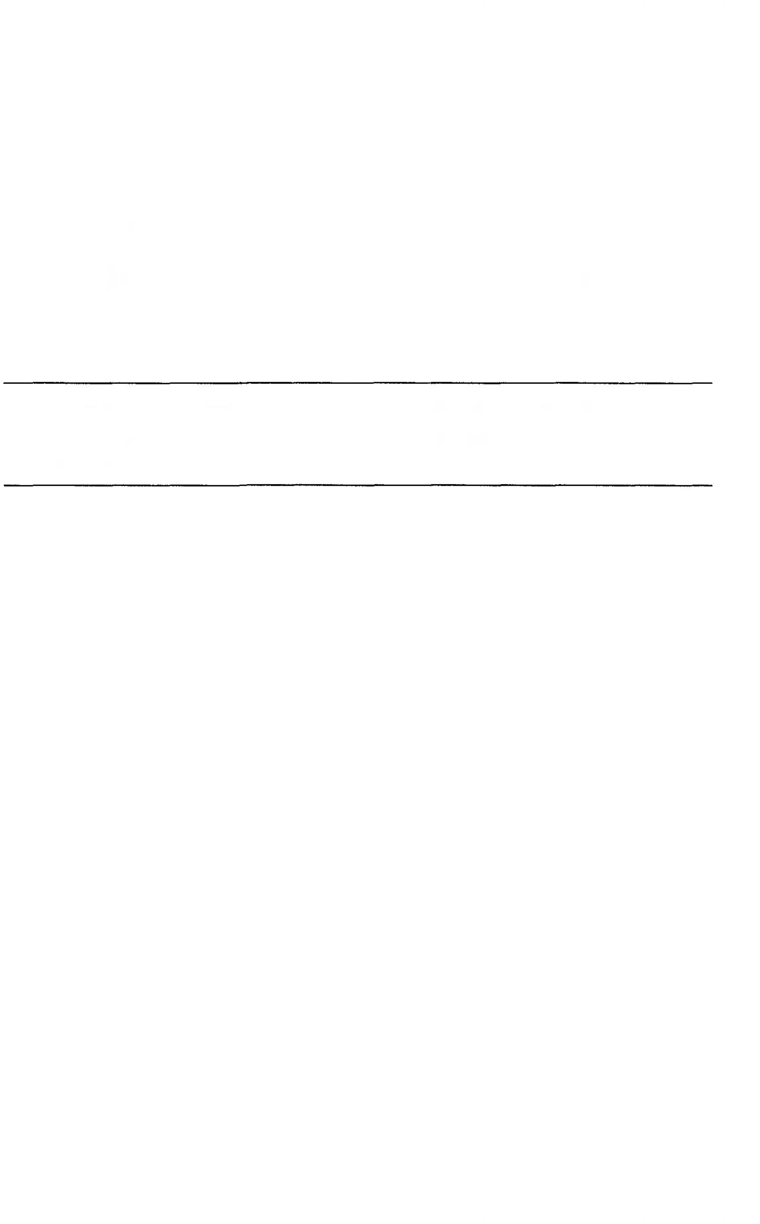
  - The major problems of lexical semantics 95
Suggestions for further reading 102



CHAPTER 5

Introduction to lexical semantics

The nature of word meaning

In a descriptive introduction to meaning such as this, it is inevitable that the meanings of words should loom large, even though in more formally oriented accounts, word meanings are left largely unanalysed, or are reduced to mere skeletons of their true selves. There are, of course, more or less reputable justifications for such neglect. However, most (linguistically innocent) people have an intuition that meaning is intimately bound up with individual words; indeed, this, par excellence, is what words are for. While such an intuition seriously underestimates other aspects of meaning, it is not, in itself, wrong, and an adequate introduction to meaning should not shrink from the slipperi ness and complexity of word meaning simply because it cannot be neatly corralled into a favoured formalization. Hence, the present and the following eight chapters will be devoted to various aspects of lexical semantics.

What is a word?
There has been a great deal of discussion of the nature of the word as a grammatical unit, too much even to summarize here. Most of it, anyway, is not relevant to our concerns. But it is as well to have some idea of what we are dealing with. The notion has notoriously resisted precise definition. Probably the best approach is a prototypic one: what is a prototypical word like? Well, for our purposes, the classical characterization as ‘a minimal permutable element’ will serve. This attributes two features to a prototypical word:

- It can be moved about in the sentence, or at least its position relative to other constituents can be altered by inserting new material.
- It cannot be interrupted or its parts reordered.

In other words, in making changes to a sentence, we are by and large obliged to treat its words as structurally inviolable wholes. Let’s see briefly how this works. Take a sentence like (1):

88 Meaning in language

- The government is strongly opposed to denationalization. Reordering appears in such examples as (2X4):
- The government is opposed to denationalization—strongly.
- What the government is strongly opposed to is denationalization.
- It is denationalization that the government is opposed to.
And the possibilities for the insertion of new material are as follows:
- The (present) government, (apparently), is (very) strongly (and implac ably) opposed (not only) to (creeping) denationalization, but... etc.
Notice that the only possible insertion points are between words. Words, of course, are separated by spaces in writing, although not usually by silences in speech. They also have a characteristic internal structure, in that they proto- typically have no more than one lexical root. (This notion will become clearer below, but, for instance, the lexical roots of the following words are shown in capitals:
GOVERNment reORDERing STRONGly deNATIONalization OPPOSed TYPically CLEARer LEXical)
Some words, such as HEDGE-HOG, BUTTER-FLY, and BLACK-BOARD seem to have more than one lexical root. These, however, are atypical, and for many of them it is possible to argue that the apparent roots are not fully autonomous, semantically, but form a fused root. Other words have no lexical roots at all: these are the so-called grammatical words like the, and, and of. There will be more on the iexical7‘non-lexical’ distinction below.
At this point it is necessary to be somewhat more precise about what we mean by a word. In one sense, obey, obeys, obeying, and obeyed are different words (e.g. for crossword purposes); in another sense, they are merely different forms of the same word (and one would not, generally speaking, expect them to have separate entries in a dictionary). On the other hand, obey and disobey are different words in both senses, whereas bank (river) and bank (money) are the same word for crossword purposes, but we would expect them to have separate dictionary entries and they are therefore different words in the second sense. Finer distinctions are possible, but for our purposes it will be sufficient to distinguish word forms and lexemes. Word forms, as the name suggests, are individuated by their form, whether phonological or graphic (most of our examples will be both); lexemes can be regarded as groupings of one or more word forms, which are individuated by their roots and/or derivational affixes. So, run, runs, running, and ran are word forms belonging to the same lexeme run, while walk, walks, walking, and walked belong to a different lexeme, walk, dis tinguished from the former by its root; likewise, obey, obeys, obeying, and obeyed belong to a single lexeme and disobey, disobeys, disobeying, and disobeyed, des pite having the same root as the first set, belong to a different lexeme, distinguished

Lexical semantics 89

this time by the possession of the derivational affix dis-. A simple test for derivational affixes (the matter is in reality, however, complex and contro versial) is that they are never grammatically obligatory. For instance, in John is disobeying me, disobey can be substituted by watch, without giving an ungram matical sentence, which shows that dis- is not essential to the grammatical struc ture of the sentence. This is true of all occurrences of dis-. On the other hand, any verb which will fit grammatically into the frame John is — me must bear the affix -ing, showing that it is not a derivational, but an inflectional affix: word forms that differ only in respect of inflectional affixes belong to the same lexeme. It is the word-as-lexeme which is the significant unit for lexical semantics.

Lexical and grammatical meaning
A distinction is often made between lexical and grammatical meaning (some times only the latter is allowed as being properly linguistic). There are dangers in all dichotomies; this one is harmless provided it is borne in mind that in reality there is a continuously varying scale, of what might be termed lexicality and grammaticality. A convenient way of presenting the distinction is in terms of the sorts of element which carry the meaning in question. We can divide grammatical units into closed-set items and open-set items (another dichotomy which disguises a graded scale). Central examples of closed-set items have the following characteristics:
- They belong to small substitution sets (perhaps as small as one).
- Their principal function is to articulate the grammatical structure of sentences.
- They change at a relatively slow rate through time, so that a single speaker is unlikely to see loss or gain of items in their lifetime. (No new tense markers or determiners have appeared in English for a long time.) In other words, the inventory of items in a particular closed-set grammatical category is effectively fixed (i.e. ‘closed’, hence the name).
These may be contrasted with open-set items, which have the following characteristics:
- They belong to relatively large substitution sets (especially if semantic plausibility is ignored).
- There is a relatively rapid turnover in membership of substitution classes, and a single speaker is likely to encounter many losses and gains in a single lifetime. (Think of the proliferation of words relating to space travel, or computing, in recent years.)
- Their principal function is to carry the meaning of a sentence.
Both closed- and open-set items carry meaning, but their different functions mean that there are differences in the characteristics of the meanings that they typically carry.
90 Meaning in language

A closed-set item, in order to be able to function properly as a grammatical element, has to be able to combine without anomaly with a wide range of roots, and for this to be possible, it must have a meaning which is flexible, or broad enough, or sufficiently ‘attenuated’ not to generate clashes too easily, and it must signal contrasts which recur frequently. Hence, meanings such as “past”, “present”, and “future”, which can co-occur with virtually any verbal notion, and “one” and “many”, which can co-occur with vast numbers of nominal notions, are prototypical grammatical meanings.
In contrast, there is no limit to the particularity or richness of the meaning an open-set element may carry, as there are no requirements for recurrent meanings or wide co-occurrence possibilities. Hence, open-set items typically carry the burden of the semantic content of utterances. Because of the rich ness of their meanings and their unrestricted numbers, they participate in complex paradigmatic and syntagmatic structures.
What are called content words (basically nouns, verbs, adjectives, and adverbs) prototypically have one open-set morpheme (usually called the root morpheme) and may also have one or more closed-set items in the form of affixes. Lexical semantics is by and large the study of the meanings of content words, and is oriented principally to the contribution that open-set items make to these. Grammatical semantics concentrates on the meanings of closed-set items. However, a strict separation between grammatical and lexical semantics is not possible because the meanings of the two kinds of element interact in complex ways.

Word meaning and sentence meaning
In general, word meanings are not the sort of semantic units that one can communicate with on an individual basis, unless other meaning compon ents are implicit. A word, on its own, does not actually say anything, does not convey ‘a whole thought’: for that purpose, more complex seman tic entities are necessary—built out of words, certainly—having at least the complexity of propositions (argument+predicate). Words (and at a more basic level, morphemes) form the building blocks for these more complex structures.

The notion “possible word meaning”
It is worth while to pose the question of whether there are any restrictions on possible meanings for words. We may approach this in two stages. We can first ask whether there are any universal restrictions; and we can then enquire as to the existence of language-specific restrictions.
Let us take the first question first. Is there anything conceivable that could never be the meaning of a word? It will be as well to restrict ourselves to notions that can be expressed by a combination of words, otherwise we shall be in really deep water. One line of thinking can, I think, be disposed of relatively

Lexical semantics 91

quickly. It may be thought that no language could possibly have a word meaning, for instance, “to face west on a sunny morning while doing something quickly”. I confess that I would be astonished to find such a word. But the reason is not that it is theoretically impossible, but that it would be of such limited utility. Languages have words, at least partly, because in the cultures they serve, the meanings such words carry need to be communicated. (Of course, cultural evolution can leave words stranded, as it were, but this does not inva-lidate the basic point that words at some stage must be motivated in terms of possible use.) This means that if some culture had a use for the notion expressed, then it would not be surprising if there were a word for it. In the case in question, for instance, maybe the word could designate a specific sort of act of disrespect towards the Sun God, which carried specific penalties. If we take into account the possibility of outlandish (to us) religious beliefs, it is clear that the scope for improbable word meanings of this sort is (almost) unlimited.
Now let us look at a different sort of case. Take the sentence (6):
- The woman drank the wine slowly.
The notion “drank slowly” could easily be lexicalized (i.e. expressed by a single word): we have in English, after all, verbs such as quaff, and sip, which com bine the meaning of “drink” with some adverbial manner component. Simi larly, a verb meaning “drink wine” is not at all implausible, as one of the senses of drink in English is specifically “drink alcoholic beverage” (as in Mary doesn't drink, she’ll just have an orange juice). In contrast to these more-or-less plausible word meanings, consider next the possibility of having a word mean ing “The woman drank” (blisk), or “the wine slowly” (blenk). On this system, Blisk wine would mean “The woman drank wine”, and The woman drank blenk would mean “The woman drank the wine slowly”. It seems clear that here we are in the realms not of implausibility, but of impossibility. As a further example, consider the phrase very sweet coffee. It is perfectly within the bounds of possibility that there should be a single word meaning “sweet coffee”, or “very sweet”, even “very sweet coffee”, but it is not conceivable that there should be a word meaning “very — coffee” (i.e. any adjective applied to coffee would be automatically intensified). What is the difference between the possible and the impossible cases? There seem to be two parts to the answer. First, a word meaning is not allowed to straddle the vital subjectpredicate divide. Second, possible word meanings are constrained in a strange way by semantic dependencies. It is first necessary to distinguish dependent and independent components of a semantic combination. The independent component is the one which determines the semantic relations of the combination as a whole with external items. So, for instance, in very large, it is large which governs the combinability of the phrase very large with other items. Thus the oddness of, say, ?a very large wind is attributable to a semantic incompatibility between large and wind—there is no inherent clash between very and wind, as the nor-
92 Meaning in language

-mality of a very hot wind demonstrates. By similar reasoning, the independent item in warm milk is milk, and in drink warm milk is drink. By following this line of reasoning, we can establish chains of semantic dependencies. For instance, the chain for very young boy is:
“very” —> “young” —>> “boy”
and that for drink warm milk is:
“warm” —> “milk” —>> “drink”
The constraint that we are looking at says that the elements that constitute the meaning of a word must form a continuous dependency chain. This means, first, that there must be a relation of dependency between elements. This rules out “wine slowly” as a possible word meaning, because there is no dependency between “wine” and “slowly” in “Drink wine slowly”. Second, there must be no gaps in the chain which need to be filled by semantic elements from outside the word. This rules out cases like “very — milk”, where the dependency chain would have to be completed by an external item such as “hot”.
Another way of approaching the question under discussion is to take an extensional viewpoint and ask what are the characteristics of a ‘possible nameable’. A full answer to this question would deal with possible nameable objects, events, states, and so on. The present discussion will deal only with the first of these, and will follow Pulman (1983). Nameables, in general, are dis tinguished linguistically by the ability to take proper names (obviously), but also by the ability to be referred to by means of singular, non-collective count nouns (at least in English). (The characterization of nameability in states, processes, events, and so on, would require reference to adjectives and verbs, as well as nouns.)
We shall illustrate the sort of argument involved in saying what is nameable by reference to a particular sort of nameable, namely, physical objects. The concept of physical object seems to involve at least the notions of perceiv ability, relative continuity in space and time, and potential detachability from surroundings. However, not all physical objects, by these criteria, are naturally nameable. A couple of quotations from Chomsky are relevant here:
- the most elementary notion we have, the notion ‘physical object’, seems to be quite complex. One wing of an aeroplane is an object, but its left half, though equally continuous, is not. (1976:203.)
(Since, in an obvious sense, the left half of an aeroplane wing is a physical thing, we may interpret Chomsky as talking about nameability.)
- there are no logical grounds for the apparent non-existence of words such as LIMB, similar to limb except that it designates the single object consisting of a dog’s four legs so that its LIMB is brown … would mean that the object consist ing of its four legs is brown. Similarly, there is no a priori reason why a natural language could not contain a word HERD, like the collective herd except that it
Lexical semantics 93
denotes a single scattered object with cows as parts, so that a cow lost a leg
implies the HERD lost a leg, etc. (1965: 201.)
The existence of physical things which intuitively do not seem to be name able implies the existence of principles of nameability, which may not be rigid, but which will at least render some ‘things’ more readily nameable than others. (The notion of ‘prototypical’, to be discussed in Chapter 7, is relevant here: what we are looking for are the prototypic features of nameability.) A fairly basic suggestion is that to be nameable, a physical thing must be bounded, that is, it must have boundaries set on the basis of either physical detachability, or characteristic function, appearance, or behaviour. This is, of course, pretty vague, and a full treatment would critically examine all these terms, but take, for instance, Chomsky’s left half of an aeroplane wing. This is physical, but while the whole wing is bounded by distinctive function and appearance, the left half is not separated from the rest of the wing by any salient function or visual discontinuity, nor does it behave in a characteristic way. In this way, the left part of an aeroplane wing differs from an earlobe, which is visually separ ated from the rest of the ear, and the tip of the tongue, which has no visual separateness, but has its own characteristic functions and a special place in our experience of our bodies. (Notice that some nameables, by the definition given above, will count as whole things and others as parts of those wholes; that is a separate question.)
Chomsky’s examples of limb and herd are more difficult and controver-sial. First it must be recognized that some ‘scattered’ individuals are nameable, such as fences, constellations, villages, forests, and so on. To adapt Pulman slightly, we can say that nameable collections of otherwise independently name-able entities generally show one (or more) of the following features:
  - The collection is relatively spatio-temporally contiguous (fence, forest, village).
  - It is the product of human agency (fence, village, artistic installation)
  - The members of the collection jointly fulfil a function not fulfilled by any of them separately (fence, bikini).
Notice that both Chomsky and Pulman insist on a distinction between singular scattered objects and collectives. But the criteria are not clear. Pulman refers to “things which are designated by singular count nouns or proper names but nevertheless regarded as plural: collective words like herd, pile and flock, and proper names like the United States or the Commonwealth”. (Notice that the possession of one of the features mentioned above seems to be neces sary for these collective words.) But what is meant by “are regarded as plural”? A word like committee can take plural concord with a verb: The committee have decided, but this is not the case with, for instance, pile. *The pile of stones are black.
Chomsky is not much more explicit for limb, although he is for herd. But


94 Meaning in language

in the case of limb, he gives as the sort of sentence which would prove that there was a genuine word limb, something like The limb of the dog is brown. Actually, such cases are not rare: The foliage of this tree is light green means simply that the leaves of the tree are light green. Chomsky’s requirements for for herd are perhaps more strict. It seems that for herd to be a bona fide example, a part of a cow must count as a part of aherd (which it clearly does not for the ‘normal’ word herd). Notice that this criterion would rule out foliage, one would not say The foliage of this tree has prominent veins, but The leaves of this tree have prominent veins. (Similarly: *John’s priceless library of first editions has lost several pages.) But it is not clear that it holds for fence, either (and others discussed by Pulman as bona fide singular non-collectives). If the separate (and separated) posts which constituted a fence each had a hole in it, would one say The fence has holes in it or The fence poles have holes in them! I would be happier with the latter. On the other hand, I would be happy with You can’t wear this bikini because it has holes in it (cf. also This bikini has a reinforced gusset).
I suspect that there is, in fact, no sharp distinction between the for herd type of example and the herd type. I am inclined to agree with Chomsky, however, to the extent that the for herd type are somewhat rare. (It may be that more relevant factors remain to be discovered.) Obviously a similar investigation needs to be carried out on states, actions, processes and events, and so on, to see what factors determine nameability by a single lexical item (notice that proper names are largely (?totally) confined to nouns).
Of a more controversial status are cases like the putative ‘impossible’ words benter and succeive (Jackendoff 1990:261). Let us consider benter first. This is proposed as a logically coherent converse of enter which cannot be lexically realized. Sentences such as (7) are fully normal:
- Mary entered the room.
The proposed converse of this would be (8):
- The room bentered Mary.
(On the pattern of: Mary followed John and its converse John preceded Mary.)
The other example sometimes cited is succeive, which is intended to denote the true converse of receive:
- John received the parcel.
- The parcel succeived John.
The explanation given for these constraints is expressed in terms of semantic roles such as agent, patient, etc. There is a certain plausibility about the claims. However, although there may be some resistance to words having such mean ings, and in the cases cited there are no obvious candidates, the prohibition is perhaps not absolute, as the following observations suggest. First, the meaning of benter is not all that far removed from one reading of receive. We also have

Lexical semantics 95
words such as envelop, incorporate, which seem to have the right sort of mean ing. In the case of succeive, the word reach appears to encode approximately the right sort of meaning:
(n) I sent John a parcel; he received it yesterday.
- I sent John a parcel; it reached him yesterday.
The constraints on word meaning discussed above would seem to be universal in nature. However, there also exist constraints of a more language-specific type. Some languages seem to proscribe the packaging together of certain sorts of meaning in a single word. A single example will suffice. Consider sentence (13):
- John ran up the stairs.
Here, the word ran encapsulates two notions, that of movement, and that of manner. This is a common pattern in English:
- John crawled across the road.
staggered into the room. waltzed through the office. etc.
However, this pattern is not possible in many languages, including French. In French, such sentences must be rendered as in (15):
- Jean monta l’escalier en courant.
Here, the notions of motion and direction are jointly packaged into monta, but manner has to be expressed separately. (Notice that the French pattern is not pro hibited in English: John mounted the stairs running, but is markedly less natural.)

The major problems of lexical semantics

Linguists with different theoretical commitments will give different accounts of what the core tasks of lexical semantics are; the following is an attempt at a relatively theoretically neutral summary.

Description of content
Describing content is in a sense the most obvious task: how do we say what a word means? Unfortunately, even at this level of generality it is impossible to escape the tentacles of theory, because there are scholars who maintain that the notion ‘the meaning of a word’ is not a coherent one; and for those who believe there is such a thing, the nature of the description of it will hang crucially on what sort of thing it is believed to be. We shall look briefly below at some of the options.


96 Meaning in language

Contextual variation
However one characterizes the notion of the meaning of a word, one is forced to confront the fact that the semantic import of a single word form can vary greatly from one context to another. There are various theory-dependent strategies for attacking this problem, but the facts will not go away: the vari ation must be accounted for. Variation is not random: part of a satisfactory account will identify and explain patterns of variation.

Sense relations and structures in the lexicon
Regular patterns appear not only in the nature and distribution of the meanings of a single word in different contexts, but also between different words in the same context. 0

Word meaning and syntactic properties
An important question is whether and to what extent the syntactic properties of words are independent of, or are controlled by, their meanings. There are still many different views on this topic.

Approaches to lexical semantics

    - One-level vs. two-level approaches
A major dividing line which separates semanticists is the question of whether a distinction can be made between semantics and encyclopaedic knowledge. Those who believe such a division can be made often draw an analogy with phonetics and phonology. Human beings can make and learn to recognize an almost infinite variety of speech sounds, but in any particular language, only a handful of these function distinctively to convey meanings, or enter into sys tematic relations of any complexity. These are the true linguistic elements on the ‘sound’ side of language (Saussure’s expression plane). In a similar way, the variety of ‘raw’ meanings is virtually infinite, but only a limited number of these are truly linguistic and interact systematically with other aspects of the linguistic system. The vast detailed knowledge of the world, which speakers undoubtedly possess, is, according to the dual-level view, a property, not of language elements, but of concepts, which are strictly extralinguistic. Truly linguistic meaning elements are of a much ‘leaner’ sort, and are (typically) thought of as (more) amenable to formalization. One criterion suggested for recognizing ‘linguistic’ meaning is involvement with syntax, whether by virtue of being the meaning carried by some grammatical element, or because it

Lexical semantics 97
correlates with such factors as agreement patterns or sub-categorization of major syntactic categories.
Partisans of the single-level view claim that no non-arbitrary basis for assigning aspects of meaning (or knowledge) to the ‘semantic’ or ‘encyclo paedic’ side of a purported dichotomy has been put forward which survives even a cursory scrutiny. Most cognitive linguists would take the view that all meaning is conceptual, and that the ‘extra’ level of structure proposed by the two-level camp does not actually do any theoretical work. The distinction between grammatical and lexical/encyclopaedic meaning is not necessarily denied, but it is likely to be seen as a continuum, rather than a dichotomy, and entirely conceptual in nature.

Monosemic vs. polysemic approaches
The point at issue in relation to the distinction between the monosemic and the polysemic approach is how many meanings ought to be attributed to a word. There is no dispute about clear-cut cases of homonymy, like that of bank, where there is no conceivable way of deriving one meaning from the other. The dispute centres on clusters of related senses characteristic of polysemy. (For greater detail, see Chapter 6.) The monosemic view is that as few senses as possible should be given separate recognition in the (ideal) lexicon of a language, and as many as possible derived from these. The argument usually goes like this: if one reading of a word is in any way a motivated extension of another one, then only one should be recorded, and the other should be left to the operation of lexical rules, which in general apply to more than one instance and hence represent systematicity in the lexicon.
The polysemic approach rejects the assumption that a motivated extension of a word sense does not need to be recorded in the lexicon. The basic reason for this is that lexical rules only specify potential extensions of meaning, only some of which become conventionalized and incorporated in the lexicon: others are possible, and may appear as nonce forms, but there is none the less a clear distinction between these and those which are established (in principle, anyway: actually there is a continuous scale of establishment). Take the case of drink. In many contexts, it is clear what is being drunk, but obviously one would not wish to create a different lexical entry for drink corresponding to every possible drinkable liquid. To this extent, the monosemists and the polysemists would agree. However, it is possible for some particular drink able items to be incorporated into a specific reading for drink. In principle, any class of beverage could be incorporated in this way, but in fact, in English, only “alcoholic beverages” can be encoded thus: I'm afraid John has started drinking again. Now in principle, this could have happened with fruit juice instead of alcohol, but it is a fact about the English lexicon that drink has one of these possibilities, but not the other. The majority view
98 Meaning in language

nowadays is probably monosemic, but the position adopted in this book is polysemic.

The componential approach
One of the earliest and still most persistent and widespread ways of approach ing word meaning is to think of the meaning of a word as being constructed out of smaller, more elementary, invariant units of meaning, somewhat on the analogy of the atomic structure of matter (although the immediate inspiration for the first proposals on these lines was not physics, but phonology). These ‘semantic atoms’ are variously known as seines, semantic features, semantic components, semantic markers, semantic primes (to cite a few of the terms). Here, the merest outline of the approach is presented; componential semantics is treated in greater detail in Chapter 13.
Probably the first statement of a componential programme for semantics within modem linguistics was due to Hjelmslev (1961). He believed as a matter of principle that the meaning side of the linguistic sign should show the same structuring principles as the sound side. For him the notion of reduction was of major importance. The phonological structure of hundreds of thousands of different signs in a language can be analysed as combinations of syllables drawn from a list of a few hundred, and these, in turn, can be shown to be built out of phonemes belonging to an inventory of fifty or so, thus arriving at the ultimate phonological building blocks, the distinctive features, whose number is of the order of a dozen. In the same way, the meaning side of signs should be reducible to combinations drawn from an inventory significantly less numerous than the stock of signs being analysed. Hjelmslev did not have any universalist pretensions, each language being unique and needing an analysis in its own terms, nor were his ‘figurae’ (his term for the basic elements) in any way abstract: they were the meanings of words in the language. What he seemed to have in mind, therefore, was the discovery of a set of basic words, out of whose meanings all other word meanings could be constructed. Hjelmslev was the first structural semanticist: the approach was developed considerably by European linguists, with a German variety and a French variety.
A componential approach developed in America, seemingly independently (and largely in ignorance) of the movement in Europe. It first appeared amongst anthropological linguists, and scored a significant success in reducing the apparent impenetrable complexity of kinship systems to combinations from a limited set of features. A new version, proposed by Katz and Fodor (1963), appeared in the context of early Chomskyan generative grammar. This was much more ambitious than anything which had appeared previously: first, it formed an integral part of a complete theory of language; second, it made claims of universality and psychological reality; and third, the features were not confined to the meanings of existing words, but were of an abstract nature.


Lexical semantics 99
This approach did not take hold in mainstream generative linguistics, and among current generativists a thoroughgoing componential approach is found only in the work of Jackendoff (1983,1990,1996).
An extreme version of componential semantics is found in the work of Wierzbicka (1996). This is a highly original approach, which is not an offshoot of any of the approaches described above, but takes its inspiration from much earlier philosophical work, notably by Leibniz (1903). Wierzbicka’s view is that there exists a very restricted set of universal semantic atoms in terms of which all conceivable meanings can be expressed. Her inventory of primes is astonishingly small (she started out with eleven, but the list has now grown to fifty or so), and they are not abstract, and hence unverifiable by direct intu ition, like those of Katz and Fodor, but are concrete, and any analysis should satisfy the intuitions of native speakers.

‘Holist’ approaches
It is a belief of all componentialists that the meaning of a word can, in some useful sense, be finitely specified, in isolation from the meanings of other words in the language. Among philosophers of language, this is known as the localist view. For a localist, contextual variation can be accounted for by rules of interaction with contexts. The contrary position is the holistic view, accord ing to which the meaning of a word cannot be known without taking into account the meanings of all the other words in a language. There are various versions of holism: two will be outlined here.

      - Haas
I first learnt semantics from W. Haas (1962, 1964), whose highly idiosyncratic view of meaning derives from an aspect of Wittgenstein’s work, namely, his ‘use’ theory of meaning, which is encapsulated in the dictum: “Don’t look for the meaning—look for the use.” In other words, the meaning of an expression is the use to which it is put. As it stands, this is not very helpful, merely suggestive. Haas gave it a personal twist, inspired by J. R. Firth’s dictum: “Words shall be known by the company they keep.” This interprets ‘use’ as the contexts, actual and potential, in which the expression occurs normally (i.e. without anomaly). Haas went further than this. He said that the meaning of a word was a semantic field (not the usual semantic field) which had two dimen sions: a syntagmatic dimension, in which all possible (grammatically well- formed) contexts of the word were arranged in order of normality; and a paradigmatic dimension, in which for each context, the possible paradigmatic substitutes for the word were arranged in order of normality. Relative normal ity was for Haas a primitive. In principle, ‘context’ includes extralinguistic context; but Haas argued that since every relevant aspect of extralinguistic context can be coded linguistically, nothing is lost by restricting attention to linguistic contexts. The word’s semantic field, as understood by Haas,
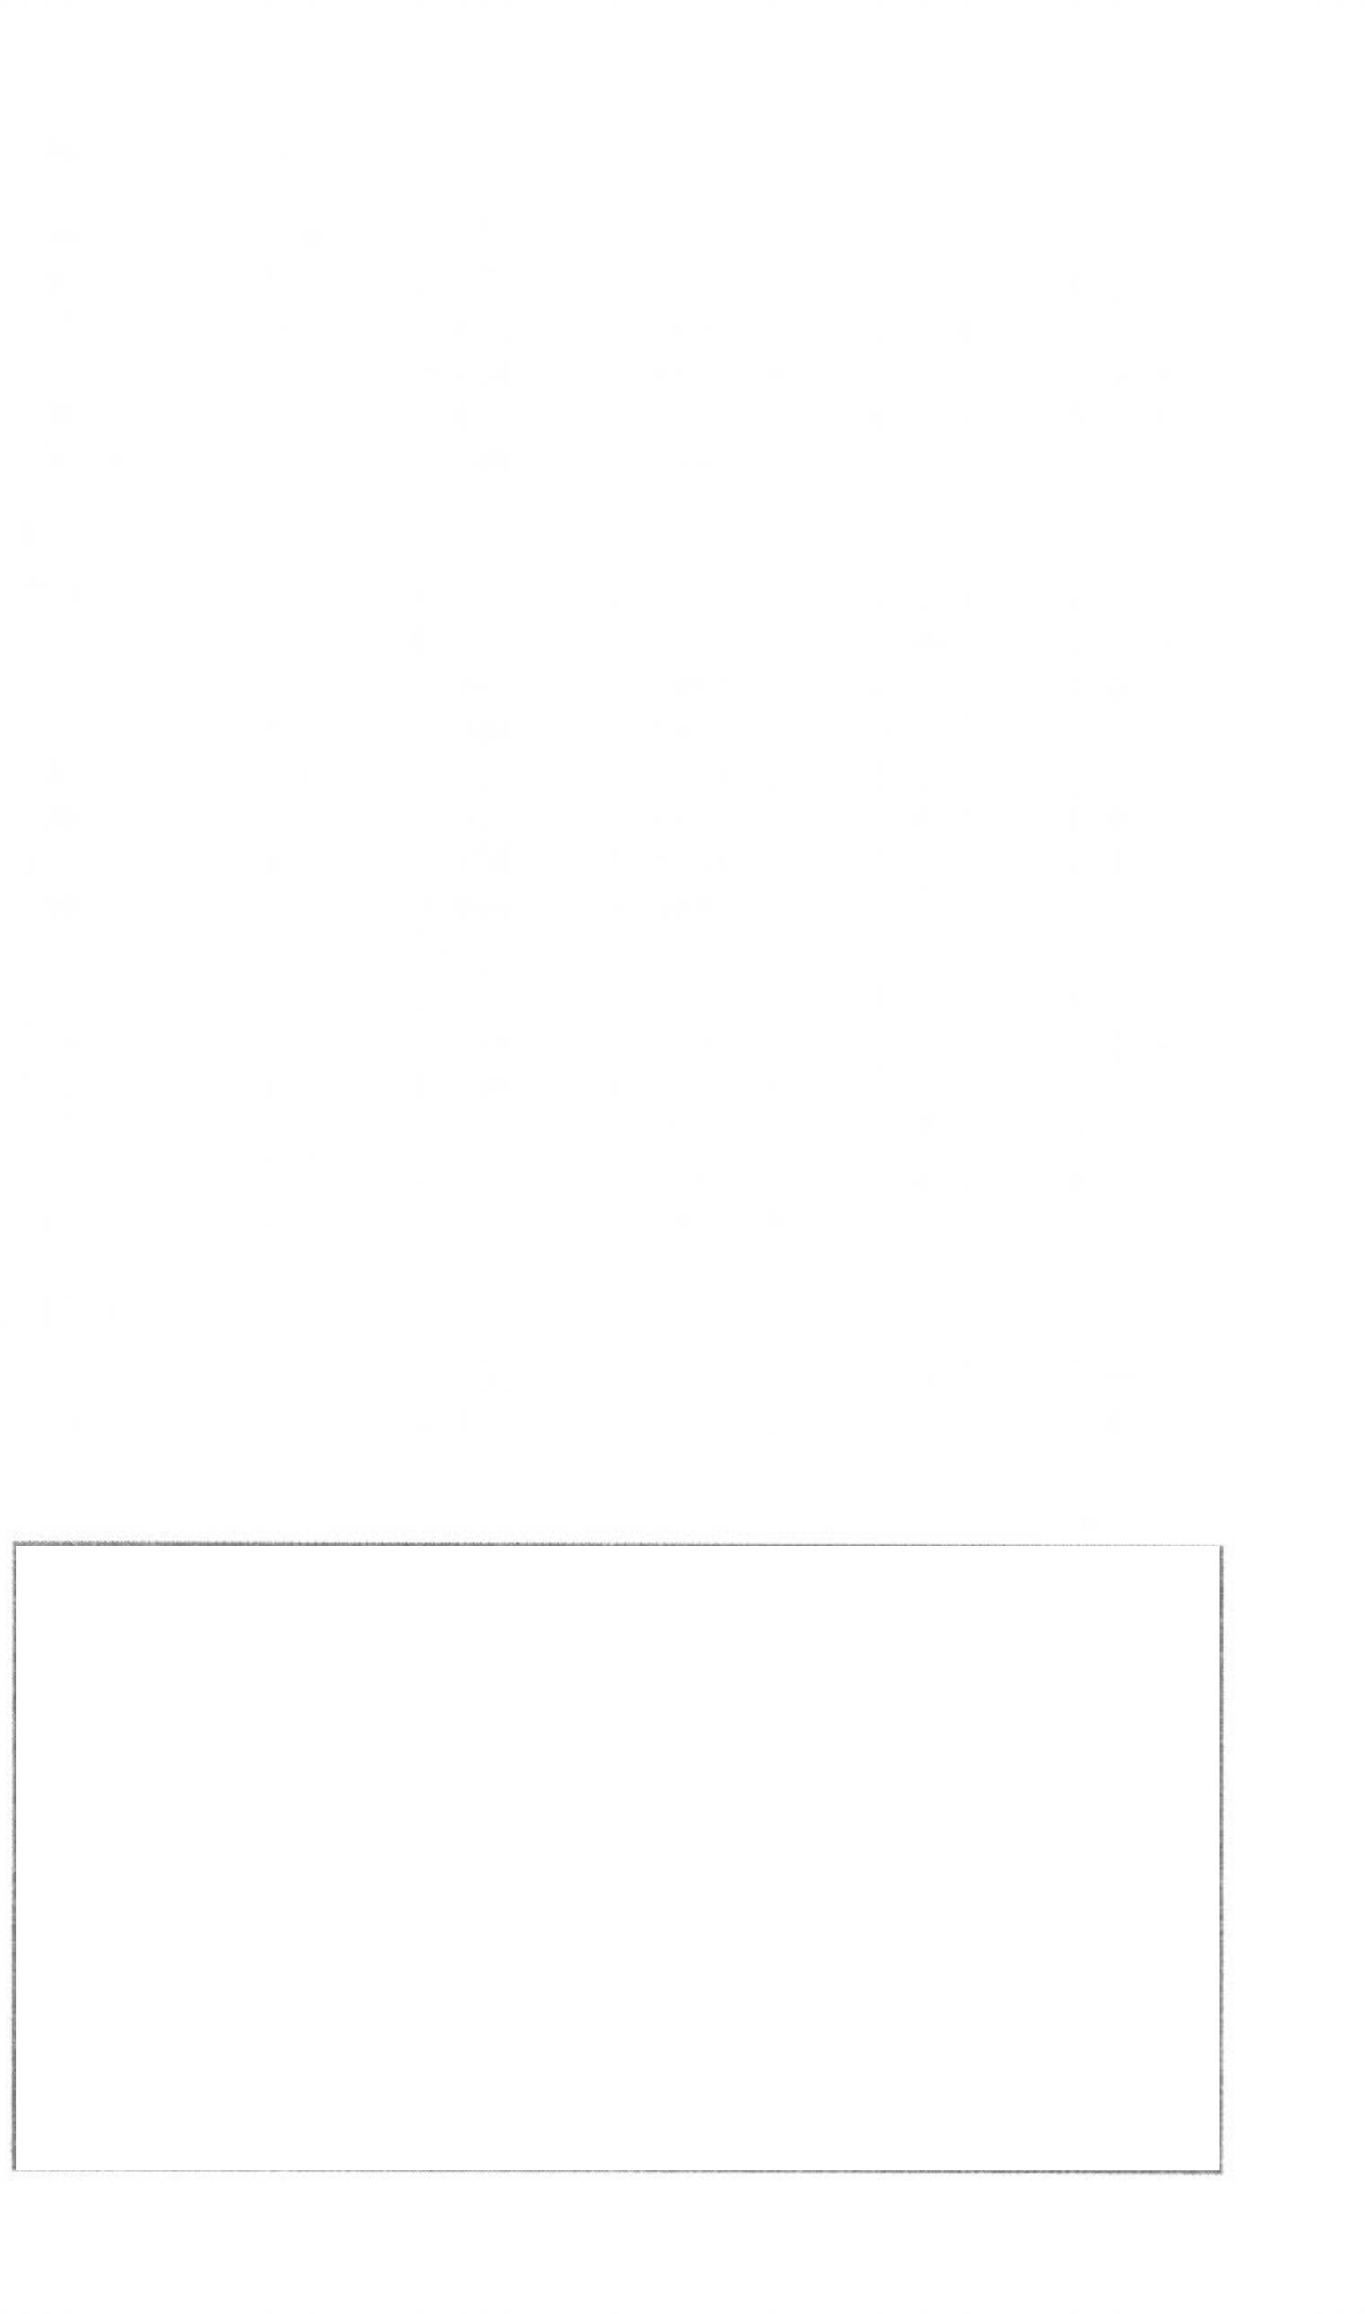
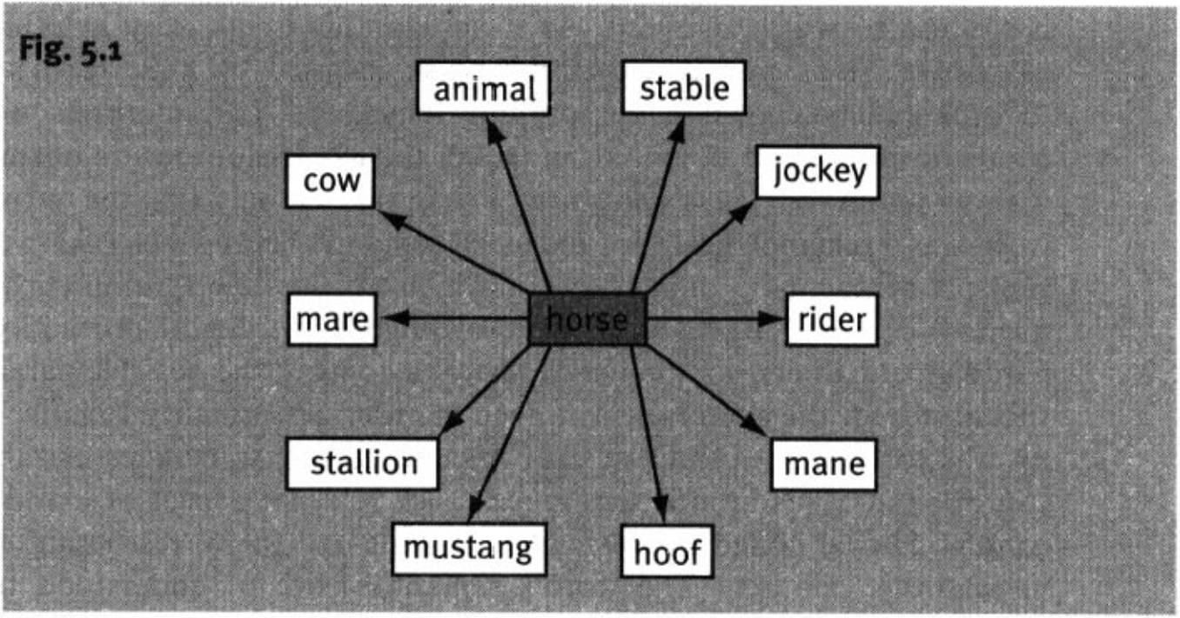
100 Meaning in language

constitutes its meaning, Notice that every word therefore participates in the meaning of every other word (he was inspired here by Leibniz’s monads); there is therefore no distinction between word meaning and encyclopaedic knowledge. Haas's view was that the semantic field of a word (as he defined it) actually constituted the meaning of the word; here, the view will be taken that the semantic field of a word reflects its meaning.
53.4.2 Lyons
A second variety of holism is represented by Lyons (1977). The essence of this approach is the quintessentially Saussurean belief that meanings are not sub stantive, but relational, and are constituted by contrasts within the same sys tem. Lyons states that the sense of a lexical item consists of the set of sense relations which the item contracts with other items which participate in the same field. Sense relations, he insists, are not relations between independently established senses; one should rather say that senses are constituted out of sense relations. So, for instance, the meaning of horse should be portrayed along the lines shown in Fig. 5.1.
In this system, the links are of specific sorts, such as “is a kind of” (e.g.
horse: animal), “is not a kind of’ (e.g. horse: cow), “is a part of’ (e.g, mane-
: horse), “is characteristic noise produced by” (e.g. neigh: horse), “is a dwelling place for” (e.g. stable: horse), and so on. Since the words illustrated also enter into relations with other words than horse, the full meaning of horse is a complex network of relations potentially encompassing the whole lexicon.

53.5 Conceptual approaches
Conceptual approaches (at least as the term is used here) are single-level approaches and identify the meaning of a word (or at least a major part of it)
Lexical semantics 101

with the concept or concepts it gives access to in the cognitive system. Among cognitive linguists, the prototype model of concept structure holds sway.
The origins of the prototype approach can be traced to Wittgenstein (1972) (who initiated more than one line of thinking that was to influence linguistics). He is usually credited with being the first to challenge the classical Aristotelian notion of natural categories as being definable in terms of necessary and sufficient criteria. He put forward the well-known example of game, chal lenging his readers to come up with the necessary and sufficient criteria for something being a game. None of the obvious suggestions is criterial:
involves physical activity has winners and losers
is played for amusement has rules, etc.
None of these is either exclusive to games or necessary for something to be a game. Wittgenstein proposed the notion of family resemblance: the members of a large family typically resemble one another in a variety of ways, but there are no features which they all have, and there may be members who share no features, but these will none the less be linked to the others by a chain of resemblance. Although important in breaking the stranglehold of the Aristotelian theory, this notion is not very helpful for semantic analysis. Witt genstein did not say what family resemblance consisted of, in particular, how in-family resemblances differ from out-family resemblances. In other words, there was nothing other than arbitrary stipulation to stop everyone in the world from belonging to the same family. (However, a similar problem still bedevils modem descendants of Wittgenstein’s family resemblance.)
The notion of non-Aristotelian categories was taken up and further refined
by cognitive psychologists, especially Rosch (1973, 1978) and her co-workers, who established what is now known as prototype theory as an account of natural categories. On this account, members of a category are not equal— they vary in how good they are, or how representative, of the category. The very best are the prototypical members, and the category is essentially built round these: other examples are assimilated to the category or not, according to how closely they resemble the prototype. A fuller account of prototype theory will be found in Chapter 7.
Jackendoff (1983, 1990, 1996) is another linguist who locates word meaning in conceptual structure (his picture of conceptual structure bears strong resemblances to that of the cognitive linguists). Like the cognitive linguists, he sees no need for an intermediate ‘linguistic semantics’. Unlike many cognitive linguists, however, he is strongly componentialist, and believes that intuitively perceived relationships should (must) be accounted for in terms of shared semantic building blocks. He also has a strong predilection for precisely for malized representations. Perhaps the most important characteristic separating Jackendoff from the cognitive linguists is his continued espousal of the


102 Meaning in language

Chomskyan precepts of strong innateness, the insufficiency of general cogni tive abilities to explain all linguistic behaviour, and the autonomy of syntax.

5.3.6 Formal approaches
Formal approaches to semantics attempt to express the facts of meaning through a strict formalism, preferably closely related to one of the standard logics. The hoped-for pay-off from adopting this sort of approach includes greater explicitness, testability of hypotheses, easier link-up with syntax, and machine implementability. Those who are less sympathetic to this kind of approach point to the existence of significant aspects of semantics which are continuously variable, and to the somewhat meagre descriptive results so far achieved. Formalist approaches will not be given any prominence in the present work, which aims rather at a certain descriptive richness.

Suggestions for further reading

This chapter mostly serves as an introduction to topics which are treated in greater detail in later chapters, so most of the relevant reading is given later. For the same reason, no discussion questions are included.
On word and lexeme, see Lyons (1977: ch. 13). Pulman (1983) has been cited in the furead as a major reference for nameability; see also Jackendoff (1990), for benter and succeive. For the different ways of ‘packaging’ meaning in lexical items, seeTalmy (1985).
For Lyons’s notion of sense, see Lyons (1977: ch. 7.3); for Haas’s contextual approach, see Haas (1962,1964).

