

CHAPTER 7

Word meanings and concepts

7.1 Introduction | 127 | Discussion questions and exercises | 141
7.2 The nature of concepts | 130 | Suggestions for further reading | 142
7.3 Domains | 140



CHAPTER 7

Word meanings and concepts

Introduction

As has already been stated, the view taken in this book is that the approach to meaning which promises to be most fruitful is to regard it as conceptual in nature. This is not to deny that there are (presumably important) relations between linguistic forms and extralinguistic reality. Our approach is, however, based on the assumption that the most direct connections of linguistic forms (phonological and syntactic) are with conceptual structures, and until these are sorted out, there is little hope of making progress with the more indirect links with the outside world. The consequences of this view for lexical semantics are spelled out in more detail in this chapter.

    - The importance of concepts
Concepts are absolutely vital to the efficient functioning of complex organ isms like human beings. They are organized bundles of stored knowledge representing an articulation of events, entities, situations, and so on in our experience. If we were not able to assign aspects of our experience to stable categories, it would remain disorganized chaos. We would not be able to learn from it because each experience would be unique, and would not happen to us again. It is only because we can put elements of experience into categories, that we can recognize them as having happened before, and we can remember our previous reactions to their occurrence, and whether they were successful or not. Furthermore, shared categories are a prerequisite to communication.

    - Word-concept mapping
We shall assume a fairly simplistic model both of conceptual structure and of the relations between linguistic forms and concepts. In this model, concepts are linked together in a complex multi-dimensional network (see Fig. 7.1).
The links are of specific types (e.g. is a kind of, is a part of is used for, etc.) and are of variable strength. These links correspond to concepts of a more
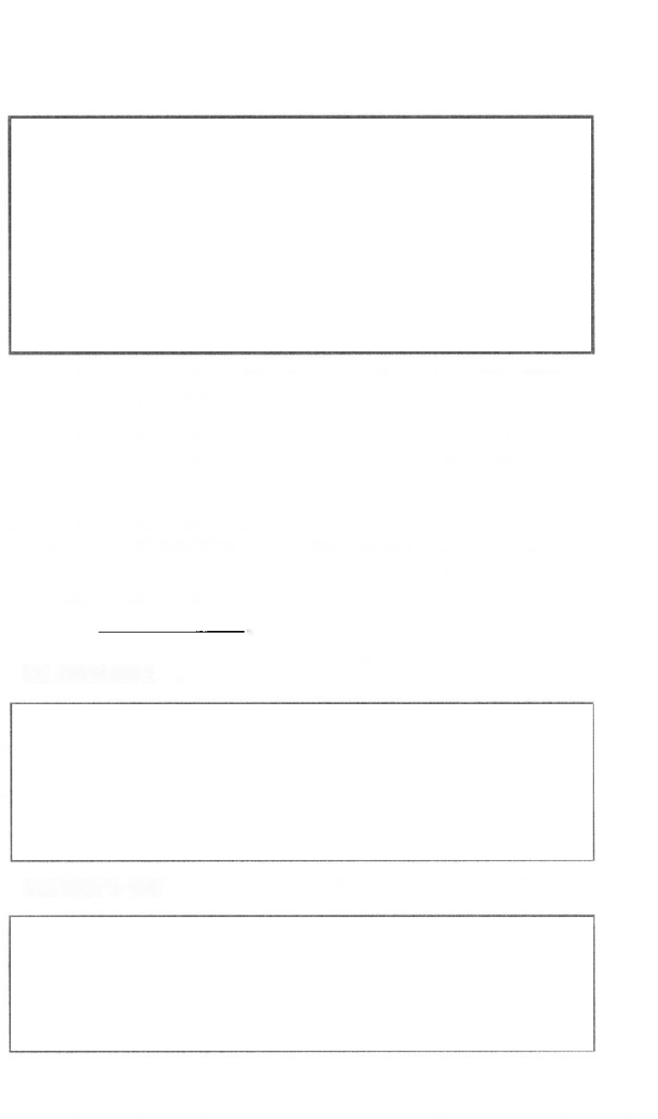
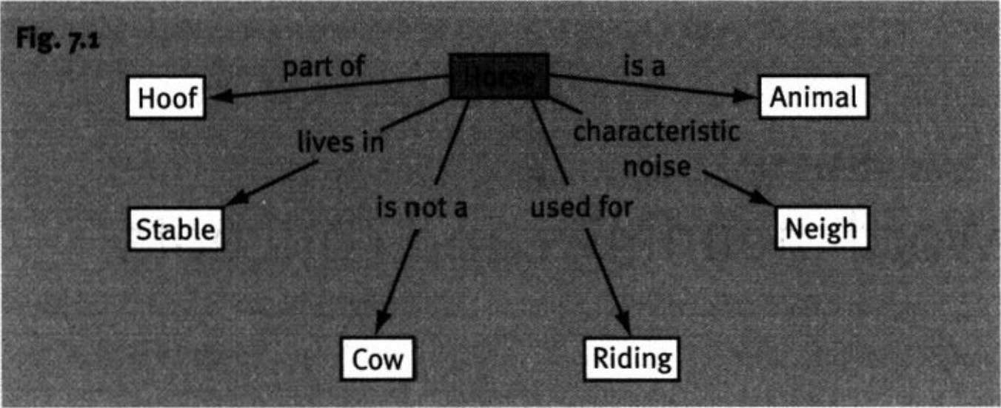
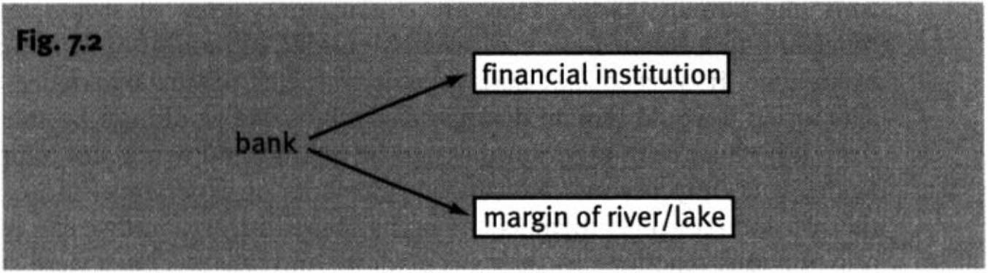
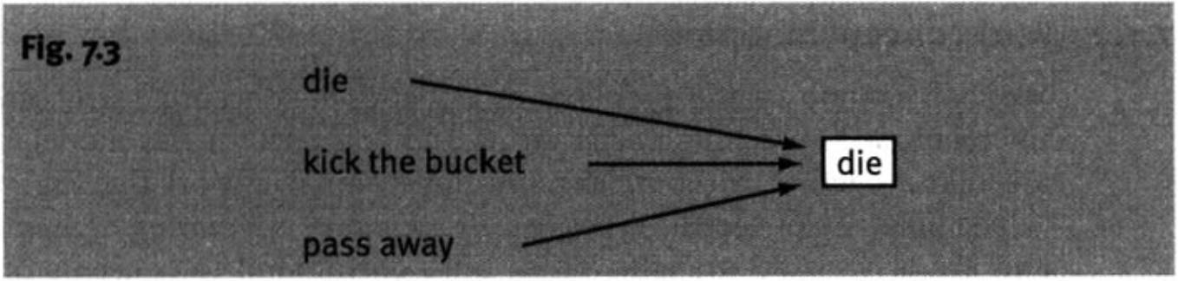
128 Meaning in language

schematic kind than the concepts which they serve to connect, which are typically richer and more complex.
Linguistic forms map on to conceptual structures of comparable complex ity. Here we shall confine our attention to individual words. Each full lexical item directly activates a concept and indirectly activates linked concepts according to the strength of the link. There is no direct link between, for instance, the word horse and the concept AnimAL: the word horse has a direct link only with the concept HORSE.
The mapping between words and concepts may be any of the following:
- one-to-one: in this arrangement, a word gives access to a single con cept; an example might be:
syzygy SYZYGY

- one to many:

- many-to-one:


Word meanings and concepts 129

(It is assumed here that words which make the same contribution to the truth conditions of sentences map on to the same concept.)
- a many-to-many mapping is also possible, but it arises from a combin ation of (ii) and (iii) above.
The three words/expressions which map on to Die in (iii) above are not identical in meaning, therefore since they all map on to the same concept, the differences between them must be a property of the words themselves, not of the concepts; these may be termed word-specific properties. Among words mapping on to a single concept, we can distinguish words like die, horse, and cry, which activate their associated concepts (Die, Horse, and CrY) in a neutral way, from those like kick the bucket, pass away, nag, steed, blubber, which modulate the concept by adding emotive or other features. From this it follows that the meaning of a word consists of word-specific properties plus the properties of the associated concept.

    - Conceptual structure
Before we go on to a detailed look at the nature of concepts, it will be useful to stand back and take a look at conceptual structure in a wider perspective. The view outlined here is quite close to what Jackendoff has developed over the last decade or so.
It is usually taken for granted that the expressive possibilities of language are infinite: not only is there an infinite number of possible grammatical con structions in a language, there is no area of semantic space that cannot be designated linguistically, and semantic space is considered also to be in prin ciple infinite. Since the brain is a finite physical object, it cannot store an infinite number of linguistic forms mapped on to an infinite number of con cepts. Hence, just as the formal side of language solves the problem of infinity by providing a set of units with recursive rules for combination, in a similar way there must be primitives and formation rules, which specify well-formed complex conceptual structures.
Three independent levels of structure are proposed by Jackendoff: phono logical, syntactic, and conceptual, the latter constituting the level of mean ing. A complete description of a language must incorporate a specification of primitives and formation rules for each level, together with correspond ence rules, which indicate the relationships between structures on the three levels.
It is a general requirement of any account of conceptual structure that it be rich enough to account for every last nuance expressible in language. Con ceptual structure could in principle be richer than expressible linguistic mean ings, but it cannot be less rich. Jackendoff calls this the expressive constraint. (He also has a grammatical constraint, which amounts to a bias in favour of conceptual structures that can be put into transparent correspondence with

130 Meaning in language

surface syntactic structures, and against ‘deep structures’ of a radically differ ent form to the corresponding surface forms.)
In many linguistic theories, a level of semantic structure is postulated, in addition to conceptual structure. Only the former is ‘truly linguistic’, the latter being part of general cognition. The arguments on this topic are complex and controversial. However, the view taken in this book is that there is only one level; that is to say, syntactic structures map directly on to conceptual struc tures. The basis for this view is that there is no work for a distinct semantic level to do: everything needed to motivate grammatical structure is present in conceptual structure. The simplest arrangement should be adopted until there is overwhelming evidence that only a more complex system can handle the facts: such evidence, in our view, is at present lacking.

The nature of concepts

Concepts have the status of categories: they classify experience and give access to knowledge concerning entities which fall into them. In this section we shall consider how conceptual categories can best be characterized.

    - The classical approach
The classical approach to categorization, which goes back at least to Aristotle, but is still often taken for granted, defines a category in terms of a set of necessary and sufficient criteria (or conditions, or features) for membership. So, for instance, the criteria for some X to qualify for inclusion in the category GirL are:
X is human X is female X is young
If any of these criteria are not satisfied, then X is not a girl (i.e. the criteria are individually necessary); if all the criteria are satisfied, then X is a girl (i.e. the criteria are jointly sufficient). (The above set of criteria can be taken as a definition of the meaning of gzrZ.)

    - Some problems of the classical approach
There is a certain undeniable obviousness about this way of defining categor ies. However, it has a number of shortcomings.

      - Lack of plausible analyses
The superficial plausibility of the Aristotelian analysis of girl (and similar words) is misleading. The words like girl, which apparently can be satisfactor-

Word meanings and concepts 131

ily defined by means of a set of necessary and sufficient features constitute a relatively small proportion of the vocabulary at large, and are confined to certain semantic areas, such as kinship, and specialized terms for animals specifying age and sex, and so on. There are many everyday words whose meanings cannot be captured by means of a set of necessary and sufficient features. Wittgenstein’s famous example is game. He argued that it was impos sible to draw up a list of features possessed by all games which jointly dis tinguish games from non-games. One might suggest the following as possible criteria:
        - involves winning and losing: there are many games which do not involve winning and losing: party games, such as charades, Matthew, Mark, Luke, and John, kissing games; children’s games such as leapfrog, hallalevo, and hopscotch, etc.
        - involves more than one person: solitaire is a game for one person.
        - has arbitrary rules: again, children’s games, such as dressing-up games, and ducks and drakes, have no statable rules.
        - done purely for enjoyment: many games are played professionally.
In spite of the lack of compliance with these criteria, we communicate using the word game perfectly successfully, and without any sense of linguistic imperfection. Such examples can be multiplied almost indefinitely: apple, dog, table, water, house, flower, dance, violin, etc., etc.

      - Fuzzy boundaries
An Aristotelian definition of a category implies a sharp, fixed boundary. How ever, much empirical research on category structure has shown that the boundaries of natural categories are fuzzy and contextually flexible. For instance, Berlin and Kay (1969), who studied colour categories, found that while judgements of central examples of colours were relatively constant across subjects and reliable within subjects on different occasions, judgements of borderline instances, for instance between red and orange, or between blue and purple, showed neither agreement amongst subjects nor reliability with a single subject on different occasions. Labov (1973) studied subjects’ naming of line drawings illustrating cups, mugs, vases, bowls, and the like which system atically varied parameters such as ratio of height to width, curved or straight sides, presence or absence of a handle. Again, the finding was that certain items received reliable assignation to a particular category, while others were uncertain. He also found that contextual conditions could alter subjects’ responses, so that, for instance, an instruction to imagine all the items as containing rice extended the boundaries of the BowL category, while a similar instruction to imagine coffee as contents extended the cup category. Such results receive no natural explanation within the classical (Aristotelian) picture.

132 Meaning in language

7-2.2.3 Internal structure of categories
As far as the classical conception of categories goes, everything that satisfies the criteria has the same status, that is to say, something is either in the cat egory, or not in it, and that is all there is to say about the matter. However, language users have clear intuitions about differences of status of items within a category: some members are felt to be ‘better’ examples of the category than others. For instance, an apple is a better example of a fruit than is a date, or an olive. In other words, categories have internal structure: there are central members, less central members, and borderline cases. No account of these facts can be given using the classical approach.

    - The standard prototype approach
We shall first of all describe what might be called the ‘standard’ approach to prototype theory, deriving from the work of Eleanor Rosch (1973, 1978) and her co-workers (Rosch and Mervis 1975). The main thrust of Rosch’s work has been to argue that natural conceptual categories are structured around the ‘best’ examples, or prototypes of the categories, and that other items are assimilated to a category according to whether they sufficiently resemble the prototype or not.

      - GOE and family resemblance
Rosch’s most basic experimental technique is the elicitation of subjects’ Goodness-of-Exemplar (GOE) ratings. Subjects are asked to give a numerical value to their estimate of how good an example something is of a given category. The rating scale typically goes something like this:
1: very good example 2: good example
3: fairly good example
4: moderately good example 5: fairly poor example
6: bad example
7: very bad example/not an example at all
So, for instance, if the category was veGeTABLe, the ratings of various items might be as follows:

POTATO, CARROT I
TURNIP, CABBAGE 2
CELERY, BEETROOT 3
AUBERGINE, COURGETTE 4
PARSLEY, BASIL 5
RHUBARB 6
LEMON 7


Word meanings and concepts 133

Significantly, subjects do not find this to be a totally meaningless task. While there is of course a great deal of variation between subjects, statistically, the results within a culturally and linguistically homogeneous population cluster strongly round particular values. The prototypes of categories are determined by selecting the item with the lowest average numerical score.
Ratings of GOE may be strongly culture dependent. (Familiarity is undoubtedly a factor influencing GOE scores, but the scores cannot be reduced to familiarity.) For instance, in a British context (say, a typical class of undergraduates), DATe typically receives a GOE score of 3-5 relative to the category of frUiT, but an audience of Jordanians accorded it an almost unanimous 1.
Wittgenstein described the instances of the category GAme as manifesting a relationship of family resemblance: the members of a human family typically resemble one another, but there may well not be any set of features that they all possess, and it may be possible to find two members who have no features in common. However, they will be linked by a chain of intermediate members with whom they do share features. So, for example, A may have no features in common with C, but has the same nose as B, who in turn has the same eyes as
C. Prototype theory embraces Wittgenstein’s notion that family resemblance unites the members of a category, but adds to it the vital idea of central and peripheral members.
7.2.3.x Prototype effects
Taken in isolation, the existence of stable GOE scores might be thought to be of minor cognitive significance. However, there is abundant evidence that pro totypicality, as measured by GOE scores, correlates strongly with important aspects of cognitive behaviour. Such correlations are usually referred to as prototype effects. The principal prototype effects are as follows:

Order of mention
When subjects are asked to list the members of a category, and especially if they are put under time pressure, the order of listing correlates with GOE ratings, with the prototypical member showing a strong tendency to appear early in the list.

Overallfrequency
The overall frequency of mention in such lists also correlates with GOE score.

Order of acquisition
Prototypical members of categories tend to be acquired first, and order of acquisition correlates with GOE rating.

Vocabulary learning
Children at later stages of language acquisition, when vocabulary enlargement


134 Meaning in language

can be greatly influenced by explicit teaching, learn new words more readily if they are provided with definitions that focus on prototypical instantiations than if they are given an abstract definition that more accurately reflects the total range of the word’s meaning.

Speed of verification
In psycholinguistic experiments in which subjects are required to respond as quickly as they can to a categorization task, subjects produce faster responses if the tasks involve a prototypical member. In a typical set-up, subjects see a pair of words, say frUiTiBAnAnA, flashed up on a screen, and they are to respond as quickly as possible by pressing one of two buttons, the one labelled Yes if the second named item belongs to the category indicated by the first item and No otherwise. Results show that responses to, for instance, frUiT:AppLe, where the second item is a prototypical member of the class denoted by the first, are faster than, say, frUiT:DATe (for average British subjects).

Priming
Another psycholinguistic technique involves the phenomenon of priming. In a typical set-up, subjects see strings of letters flashed on to a screen and their task is to respond Yes (by pressing the appropriate button) if the string of letters makes a word of (say) English, and No if it does not. Responses are timed electronically. It is a well-established experimental fact that if a word is preceded by a semantically related word, response to it will be speeded up. So, for instance, a Yes response to DOCTOR will be faster if NURSE has been just previously presented. It is found that the presentation of a category name has the greatest speeding-up effect on the prototype of a category, and the effect is proportionately less as we move away from the centre of the category to the periphery (as measured by GOE scores).

7.1-3-3 Intuitive unity, definitional polyvalence
Most of the work on prototypes has been carried out by psychologists, and the nature of the experiments reflects this. A purely linguistic characterization of categories with a prototypic organization (it is not necessary to assume that ALL categories have this sort of structure) is that they show intuitive unity, but are definitionally polyvalent. That is to say, they cannot be captured by means of a single definition, but require a set of definitions. For instance, the seman tic field covered by the term game can be quite well described by means of a restricted set of definitions, but no satisfactory unitary definition exists.
7.2.3.4 Fuzzy boundaries
A common position is to maintain that only the prototype has ioo per cent membership of a category, the degree of membership of other items being dependent on their degree of resemblance to the prototype, this, in turn, being reflected by their GOE score. (It has sometimes been claimed—wrongly, in my


Word meanings and concepts 135

opinion—that when subjects give GOE ratings, they are actually judging degree of membership.) From this one would have to conclude that a natural category has no real boundaries, and indeed this has been explicitly claimed by, for instance, Langacker:
There is no fixed limit on how far something can depart from the prototype and still be assimilated to the class, if the categorizer is perceptive or clever enough to find some point of resemblance to typical instances. (Langacker 1991 b: 266.)
Not all scholars belonging to the cognitive linguistics fraternity agree that GOE and DOM (degree of membership) should be equated. However, there is general agreement that category boundaries are typically fuzzy. (Arguments against the GOE=DOM claim will be detailed below.)

7.2*3.5 The mental representation of categories
The earliest hypotheses regarding the mental representation of categories sug gested that there was some sort of portrait of the prototypical member, against which the similarity of other items could be computed and their status in the category determined. This idea fell out of favour when it was realized that many ‘portraits’ would have to be three-dimensional and would have to incorporate characteristic behaviour (although Jackendoff still envisages all these possibilities for his 3-D representation of conceptual categories). Many prototype theorists (e.g. Lakoff) speak only of ‘prototype effects’, and remain uncommitted on the subject of the form of mental representations.
More recently, feature-based treatments of prototype structure have appeared. With these, categories with a prototype structure are represented by a set of features. However, unlike the classical features, these do not constitute a set of necessary and sufficient criteria, except perhaps for the prototype itself. Rather, the features are such that the more of them that are manifested in some particular instantiation, the higher the GOE score the item in ques tion will obtain (note that in GOE terms, a score of 1 is high and 7 low). In such systems, features may be differentially weighted, that is to say, some features will have a greater effect on determining centrality in the category than others (there is nothing in principle to prevent some features being neces sary). The general idea can be illustrated using the category veHiCLe. The features listed in (1) would seem to be plausible (note that these have not been subjected to empirical testing, they are based on my intuitions: the list is illustrative, not necessarily exhaustive):
- (a) Designed to go on roads.
  - Has its own propulsive power.
  - Can go faster than an unaided human.
  - Can carry persons/goods in addition to driver.
  - Has four wheels.
  - Metallic construction.


136 Meaning in language

  - Persons/goods enclosed.
  - Manoeuvrable.
Clearly a central example of the category of vehicle, such as CAr, will have all these features. If they are correct, it ought to be possible, for items judged not to be central, to pinpoint features they do not possess. For instance, a typical class of students will mark the following items as non-prototypical in the class of veHiCLe. For each of them, there are features from the above list which are missing:
TrAin: Not designed to go on roads.
Not manoeuvrable.
TrACTor: Not designed to go on roads.
Driver not always covered.
BiCYCLe Doesn’t have own propulsive power.
Does not carry persons/goods in addition to driver.
(The category veHiCLe, like GAme, is one for which it is not possible to draw up an adequate set of necessary and sufficient features; notice, however, that there may be features—[ConCreTe] is a possible example—which are necessary.)

7.2.3.6 Basic-level categories
Categories occur at different levels of inclusiveness, as shown in (2):
- (a) vehicle—car—hatchback.
  - fruit—apple—Granny Smith.
  - living thing—creature—animal—cat—Manx cat.
  - object—implement—cutlery—spoon—teaspoon.
One level of specificity in each set has a special status (shown in bold in (2)), called basic or generic level of specificity. Characteristics of basic-level items are as follows.
- The most inclusive level at which there are characteristic patterns of behavioural interaction: imagine being asked to mime how one would behave with an animal. This is rather difficult without knowing whether the animal in question is a crocodile or a hamster. Likewise with, say, an item of furniture. However, the assignment is relatively easy if it involves a cat, horse, mouse, or chair.
- The most inclusive level for which a clear visual image can be formed: this is similar in principle to the previous characteristic: try to visualize an item of cutlery or a vehicle, without its being any specific type. A fork or a lorry, however, are easy to visualize.
- Used for neutral, everyday reference. Often felt by speakers to be the ‘real’ name of the referent: suppose A and B are sitting at home; A hears a noise outside and says What’s that? B looks out of the window

Word meanings and concepts 137

and sees an alsatian in the garden. How does B reply? Out of the following choices, normally (b) will be chosen:
- (a) It’s an animal.
  - It’s a dog.
  - It’s an alsatian.
The other two responses would require special contextual conditions.
- The basic level is the level at which the best categories can be created. Good categories are those which maximize the following characteristics:
  - distinctness from neighbouring categories;
  - internal homogeneity;
  - differential informativeness.
Generally speaking, categories which are more inclusive than the basic level (e.g. AnimAL) have less internal homogeneity, while narrower categories (e.g. ALsATiAn) show less distinctness from neighbouring categories. The above characteristics are to be understood encyclopaedically. For instance, a div ision of animals into male and female would yield two clear categories which might have utility in certain circumstances. But they would not be good categories by the above criteria because (a) distinctness from neigh bouring categories is restricted to one feature, (b) internal homogeneity is likewise restricted: as a result, a female mouse resembles a male mouse far more than it resembles a female elephant (and the same is true for all animals), even though it falls into a different category.
- Names of basic level categories tend to be morphologically simple, and ‘original’, in the sense of not being metaphorical extensions from other categories: take the case of spoon, which is a basic-level term; all the more specific categories have more complex names: teaspoon, table spoon, soup spoon, coffee spoon, etc.

    - Problematic aspects of prototype model
While the standard prototype-theoretical approach undoubtedly sheds light on the nature of natural conceptual categories, it is not without its problematic aspects.
      - The bases of GOE ratings
The first point is that although subjects readily enough make GOE judge ments on the basis of two words (category name and item name), this is surely rather unnatural: it would presumably be more revealing to produce GOE ratings for actual objects or events, etc. Furthermore, this would be likely to highlight the fact that the GOE scale is a conflation of several more basic scales. One of these is undoubtedly familiarity, although it can be shown that


138 Meaning in language

GOE ratings cannot be reduced to familiarity ratings. Another is well- formedness: AppLe may well receive a high rating in the category frUiT if only the words are presented, but what if an actual apple were presented, and it happened to be rotten? Well-formedness does not necessarily correlate with familiarity. Most mushrooms are at least slightly deformed in one way or another. Yet there seems little doubt that a perfectly formed specimen would receive the highest GOE rating (other things being equal). Another factor is important, which in Cruse (1990) is called ‘quality’. Think of an emerald. Most emeralds are pale in colour and have faults in the form of tiny cracks, etc. The best emeralds are deep in colour, but these are rare, and are even more susceptible to faults. An emerald with a deep glowing green colour would be voted the prototype on the basis of its ‘quality’, which is distinct from fre quency and well-formedness. Here, then, we have at least three independent strands potentially making up a GOE score, and there may be more.

      - Category boundaries and boundary effects
One of the most serious shortcomings of the ‘standard’ prototype view is that no category boundary is recognized (see the quotation from Langacker at section 7.23.4). The few scholars who do admit that a boundary exists, evince little interest in it (e.g. Lakoff). Yet a category without a boundary is virtually useless: a primary function of a category is to discriminate between things which are in it and things which are not in it. The classical view of categories, with necessary and sufficient features, set a boundary (albeit an unnaturally sharp one) but allowed no internal structure. In throwing this out, prototype theory has thrown out one of the baby twins with the proverbial bath water. The view taken here is that a fully satisfactory description of a category must specify both internal structure and location of boundary area. It is accepted that category boundaries are to a greater or lesser extent fuzzy (so classical definitions are not adequate); but even fuzzy boundaries have locations, which are in principle specifiable. Both category centres and category boundaries have both linguistic and behavioural correlates, and should be given equal status in accounts of category structure.

7.2.43 Degrees of membership
As we have seen, the standard prototype view is that only the prototype of a category has 100 per cent membership of the category, other items having a degree of membership dependent on their resemblance to the prototype. Such a view is possible only if categories are not assigned boundaries. Once bound aries are assigned, then an item must be a full member of the category, not a member at all, or a borderline example. Even a non-central member of a category, like osTriCH in the category of BirD, is a full member. On this view, the notion of degree of membership of a category applies only to borderline cases. For instance, most people would probably judge BiCYCLe and skATe BoArD to be borderline instances of the category veHiCLe. Here, the notion of


Word meanings and concepts 139

degree of membership becomes operational, and I myself, for instance, would judge BiCYCLe to have a higher degree of membership than skATeBoArD.

7.2.4«4 Compound categories
The categories which result from the combination of two (or more) basic categories are often regarded as presenting particular problems for prototype theory. The most famous example is peT fisH, which was discussed in Chapter
4.4.3. To recapitulate briefly, the item emerges as prototypical in studies of this category (at least in an American setting) is GUppY. This is held to be a prob lem because a guppy is not judged, in separate tests, either to be a prototypical fish (e.g. TroUT is rated more highly), or a prototypical pet (e.g. CAT and DoG are rated more highly). As we argued earlier, it is probably unreasonable to expect that the prototype of a compound category XxY should be prototypical in X and Y separately. However, it might be reasonably demanded of a prototype approach that the prototype of a compound category should be predictable from the representations of the component categories. Some attempts have been made to do this, but they are inconclusive (for a worthy try, see Hampton (1992)).

7.2.4.5 Context sensitivity
From our point of view, the GUppY problem is one aspect of a much wider problem in prototype theory, namely, the contextual sensitivity of ‘centrality’. Typically, GOE ratings are assigned to putative members of named categories out of context. But it is intuitively obvious that judgements of the ‘best’ examples of, say, the category [CAr] are going to depend on whether one has in mind a racing context, a context of town use, or long-distance travel. It seems likely that if none of these is made explicit, then the word car evokes some sort of ‘default’ context; it is unlikely that we make our judgements in a genuine zero context. How to achieve a way of specifying categories so that contextual effects can be predicted is a difficult problem, but it must be envisaged as a long-term aim, because human users of natural conceptual categories have no difficulty in adjusting to context.

7.2.5 Types of conceptual category
It is worth while considering briefly the characteristics of the category nAT UrAL ConCepTUAL CATeGorY. In particular, we might speculate on what the features of a good example of such a category might be. First, it seems clear that a good category will distinguish clearly between things that are in it and things that are not in it; in other words, it will have a relatively well-defined boundary. Second, bearing in mind that a major function of conceptual cat egories is to provide headings under which information/knowledge can be economically stored, it is reasonable to expect a good category to be richly informative, in the sense that knowing that some entity belongs to a particular
140 Meaning in language

category gives access to a substantial body of knowledge about the entity. This, in turn, would seem to correlate with a well-developed and richly articu lated internal structure.
It is almost certainly a mistake to imagine that all categories are built to the same pattern. There is, for instance, variation in the relative importance of the internal structure and the boundary. An extreme case would be a category with boundaries but no internal structure at all. This would be the case for a category defined purely by means of a list of members (it is not clear that any natural categories are so constituted, or at least not any of the more perman ent type that get associated with lexical items: nonce categories can be like this,
e.g. dividing people into groups on the basis of the alphabetical position of their names). The balance of salience between boundary and internal structure can vary. For instance, GAme has very fuzzy boundaries, but a rich internal struc ture, whereas oDD nUmBer has clear boundaries, but a relatively weak internal structure (people do make differential GOE judgements on odd numbers: 3, 5, and 7 are judged to be the ‘best’, and such numbers as 319,947 come low down on the list, but the basis for such judgements seems to be relatively ‘thin’).

Domains

An important aspect of conceptual structure is emphasized by Langacker and his followers, and that is that concepts only make sense when viewed against the background of certain domains, which are usually themselves concepts of a more general or inclusive nature. To take an obvious example, an autono mous, free-standing specification of the concept finGer is well-nigh unthink able; it is an essential feature of this notion that it is a spotlighted portion of a HAnD. Separated from a hand, a finger is a sausage-shaped piece of bone and flesh. Notice that HAnD and finGer are dependent on one another: HAnD can not be properly characterized without making any reference to finGer. As another example, consider the wheel of a bicycle. In isolation from a bicycle (or other wheeled device), a wheel is just a circular structure; but the concept wHeeL is more than this, and can only be characterized by reference to a more inclusive domain of some kind such as BiCYCLe, or wHeeLBArrow, etc. Lan gacker refers to the region or aspect of a domain highlighted by a concept as the profile, and the domain part of which is rendered salient in this way is called the base; thus, wHeeL profiles a region of the base BiCYCLe. According to Langacker, the profile cannot be apprehended on its own.
It is important to note that profile and base are relational terms, not abso lute ones. Take the case of wHeeL. This profiles a region of its base BiCYCLe. But it in turn functions as the base domain for more specific profilings, such as HUB and rim and spoke. And finGer functions as a base for more specific profilings such as (finGer)nAiL and knUCkLe. In other words, the base-profile

Word meanings and concepts 141

relation forms chains of elements (the term domain is usually reserved for concepts which function as a base for at least one profile). However, the chains are not endless: in the direction of specificity, NAIL, for instance, is probably the end of the chain involving HAND for most of us. There is also a limit to the degree of inclusiveness, in that there are some domains which are not profiles of anything more inclusive; these are called basic domains and include such elementary notions as SPACE, TIME, MATTER, QUANTITY, CHANGE, and so forth (these bear some resemblance to JackendofiTs basic ontological categories, but they are not identical).
To complete this elementary sketch of the relation between concepts and domains, one further elaboration is necessary. This is that a concept is typic- ally profiled, not against a single base domain, but against several, the whole complex going under the name of domain matrix. As a relatively simple example, take the notion of TENNIS BALL. This is obviously profiled against BALL, along with sister categories such as CRICKET BALL, FOOTBALL, etc. BALL in turn is profiled against SPHERE (then SHAPE and ultimately SPACE, as well as (at least) THING, SIZE, WEIGHT, and ELASTICITY). At some stage, TENNIS BALL pre- supposes TENNIS, but the relationship is perhaps not immediate: we perhaps have TENNIS EQUIPMENT as an intermediate domain, which will also include RACKET, COURT, and NET, and TENNIS ACTIONS (for want of a better name) such as SERVICE, RETURN, LOB, and so on which will be immediate base domains for BALL, and probably also TENNIS JUDGEMENTS such as IN, OUT, FAULT, LET, and SCORING, all of which crucially involve BALL, and must be considered add- itional base domains. A lot of this is speculative and arguable, but it is clear that from the cognitive linguistic perspective, a full comprehension of the meaning of tennis ball is going to involve all these things.

Discussion questions and exercises

- Which of the following are ‘plain’ words (i.e. words which map onto a concept without ‘modulating’ it)?
guffaw money inebriated tickle slim funny uxorious crestfallen surprised stroll pedagogue doctor vandal infant fiddle (n.)

- Suggest a set of prototype features for one or more of the following conceptual categories (or select your own example(s)):
CLOTHES FRUIT MUSICAL INSTRUMENT HOBBY BUILDING HOUSEHOLD APPLIANCE

For each category, draw up a list of possible members, including some marginal cases, and ask another person to assign GOE ratings. Consider to what extent the ratings can be accounted for in terms of your suggested features.

142 Meaning in language

- Which of the following would you consider to be basic-level categories?
BIRO TEASPOON SANDAL UNDERWEAR SEAGULL DAISY GRASS BULLDOZER BUS MOUNTAIN BIKE SELF-RAISING FLOUR WALNUT SUGAR ARMCHAIR DELICATESSEN SUPERMARKET PETROL STATION TOWN HALL PARK MOTORWAY ROAD CANAL POLICE STATION BUILDING GROCERIES WINE CHAMPAGNE BEVERAGE MILK

Suggestions for further reading

That meaning is essentially conceptual in nature is one of the central tenets of cognitive linguistics. The best introduction to cognitive linguistics currently available is Ungerer and Schmid (1996). Ultimately, a reader interested in this approach will eventually want to tackle the foundational text. The ‘bible’ of the cognitive approach is Langacker’s two-volume Foundations of Cognitive Grammar (1987 and 1991a). However, this is not an easy read; fortunately, many of the basic topics are expounded in a much more accessible form in Langacker (19916). The interested reader will also find articles on a wide range of cognitive linguistic topics in the journal Cognitive Linguistics.
An alternative ‘conceptual’ approach to meaning can be found in the works of Jackendoff; Jackendoff (1983) provides a good introduction. An interesting comparison between Jackendoffs approach and the cognitive linguistic approach (including a contribution from Jackendoff himself) can be found in Volume 7 (1) of Cognitive Linguistics, which also gives a fairly full bibli ography of Jackendoff’s later work.
Cruse (1990) provides an introduction to prototype theory as applied to lexical semantics. (The volume which includes this article also contains many other articles on the topic.) A fuller account is to be found in Taylor (1989); Cruse (1992c) is a critical review of this. Ungerer and Schmid (1996) has an interesting chapter on categorization. For a more psychological view of the prototype approach to meaning, see the articles in Schwanenflugel (1991), especially those by Hampton and Murphy. Cruse (1995) attempts to apply prototype theory to lexical relations.

