

CHAPTER 10

Word fields
io.i Introduction 179 10.6 Miscellaneous types 194
  - Hierarchies V9 Discussion questions and
  - Linear structures 189 exercises 195
  - Grids 191 Suggestions for further reading 196
  - Clusters 193



CHAPTER 10

Word fields

Introduction

The vocabulary of a language is not just a collection of words scattered at random throughout the mental landscape. It is at least partly structured, and at various levels. In this chapter we look at some of those structures. There are various modes of structuring. It is useful, at the outset, to distinguish two major types of structure, the linguistic and the psycholinguistic. No one with a cognitive linguistic bias would be willing to concede that these might be independent; however, the connection might well be indirect. Linguistic structures in the lexicon are defined linguistically—those which we shall be concerned with here are defined semantically, in terms of meaning relations; psycholinguistic structures are defined in terms of such properties as associa tive links, priming characteristics, and patterns of speech error. Obviously a semantic structure will be reflected in some way in patterns of language use, and in that sense is necessarily ‘psychologically real’. But the specific and characteristic psycholinguistic techniques of investigation may not reveal it as a coherent structure. The position taken here is that the two approaches are complementary; the rest of this chapter will concentrate on aspects of lin guistic structuring in the lexicon.
Linguistic structures in the lexicon may have a phonological, grammatical, or semantic basis. Obvious examples of grammatical structuring are word classes (grouping of words according to their syntactic properties) and word families (sets of words derived from a common root). Here we shall be con cerned with semantically defined structures, particularly those generated by sense relations, or sets of sense relations. We begin with those based on para digmatic sense relations.

Hierarchies

One of the most important types of paradigmatic structure in the lexicon is the branching hierarchy, which prototypically has the form shown in Fig. io. i.

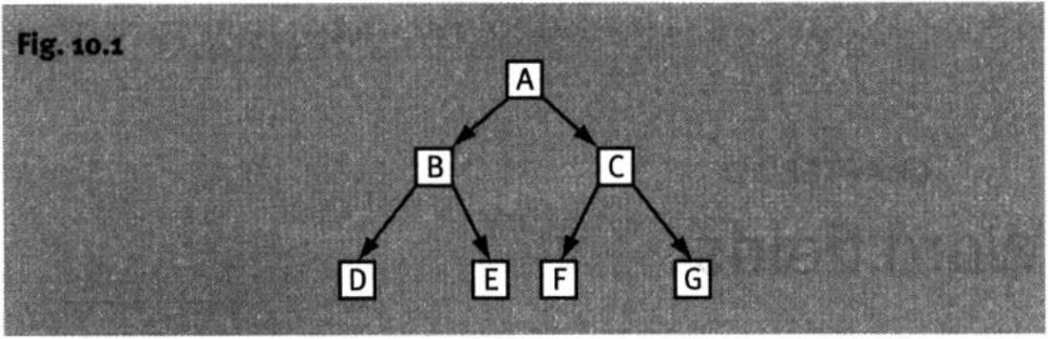

l8o Meaning in language

A given type of hierarchy can be characterized in terms of two relations, a relation of dominance and a relation of differentiation. The relation of domin ance is the one which holds between A and B, A and C, B and D, B and E, C and F, and C and G in Fig. 10.1, and is symbolized by the lines joining the nodes (branching points). The relation of difference is the one which holds between B and C, D and E, and F and G. In a well-formed hierarchy, the relations of dominance and differentiation are constant throughout the structure.
A further characteristic of a well-formed hierarchy is that the branches never come together again as one descends the hierarchy; to put it in another way (the so-called unique mother constraint), for any element m the hierarchy except the highest (A in Fig. io.i, sometimes called the beginner), there is one and only one element which immediately dominates it. Only certain types of relation guarantee this state of affairs.
In a lexical hierarchy, which is the sort that concerns us here, A, B, . . . G correspond to lexical items (or more accurately, units of sense). There are two main sorts of lexical hierarchy, (i) taxonomic (or classificatory) hierarchies, in which the relation of dominance is taxonymy (or, more accurately, its con verse, for wrhich there is no special name) and the relation of differentiation is co-taxonymy, and (ii) mcronomic (or part-whole) hierarchies, in which the relation of dominance is meronymy (or more accurately, holonymy) and the relation of differentiation is co-meronymy. We shall consider each of these in turn.

    - Taxonomic hierarchies
Taxonomic hierarchies are essentially classificatorv systems, and they reflect the way speakers of a language categorize the world of experience, A well- formed taxonomy offers an orderly and efficient set of categories at different levels of specificity An example of (part of) a taxonymy is given in Fig. 10.2.

10.2, r, 1 Levels
A characteristic of taxonomic hierarchies is that they have well-developed levels. These can be clearly seen in Fig. 10.2. As illustrated, tableware is at level

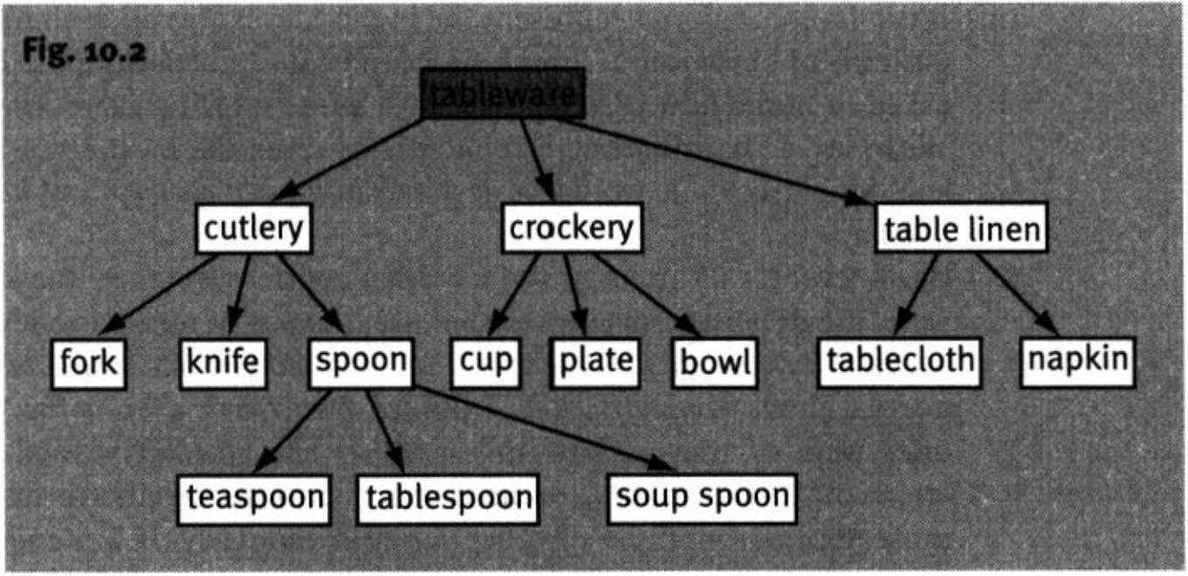
Word fields 181

L cutlery, etc. at level 2, fork . . . tablecloth at level 3, and so on. Only four levels have been shown, but it is arguable that this is only a fragment of a larger hierarchy of something like household goods, in which the sister nodes to tableware would be occupied by such items as appliances, furniture, soft furnish ings, and so on. Levels can be established in two ways, which in a prototypical hierarchy give the same answer, but in real-life hierarchies sometimes diverge. To determine the level of an element by the first method one simply counts the nodes to the top of the hierarchy (the unique item which dominates all the others in the hierarchy, the beginner) including the element in question. By this method, one can easily determine that tablespoon is at level 4. Levels estab lished by counting nodes are called technical levels in Cruse (1986). The other approach to levels consists in looking for distinctive characteristics of the items at different levels. This approach yields substantive levels. The substantive level displaying the richest set of characteristic properties is undoubtedly what psychologists call the basic level, and anthropological linguists, the generic level. The basic level in the hierarchy illustrated in Fig. 10.2 is level 3.

      - The basic level
The main characteristics of the basic level and the items which occur there are as follows:
        - Basic-level categories maximize two properties of ‘good’ categories: resemblance between members, and distinctiveness of members from those in sister categories. In categories at higher levels, internal resem blance diminishes; at lower levels, external distinctiveness diminishes. Basic-level categories are thus the most efficient in the whole hierarchy.
        - Basic-level categories represent the highest level for which a clear visual image can be formed. It is easy to visualize a spoon, but less easy to visualize an item of cutlery (without selecting one representative example). Likewise, a dog is easy to visualize, but an animal is not.


182 Meaning in language

        - Basic-level categories represent the highest level for which characteristic patterns of behavioural interaction can be described. Suppose one were asked to mime how one behaved with an item of furniture. Impossible. With, say, a chair (a basic-level item), however, there would be no prob lem. Similarly, knife would be easier than item of cutlery, and horse than animal.
        - Basic-level terms are used for everyday neutral reference; they are, as it were, the default terms for normal use: the use of non-basic-level terms needs to be specially motivated. Thus, Would you like an apple? is more normal than Would you like a Golden Delicious?, even if the fruits on offer were of that variety, unless either the speaker wished to draw attention to the variety, or needed to be more specific to distinguish those apples from those of other varieties. Similarly, jgm’wg to feed the dog today? is generally more appropriate as a neutral question than Who's going to feed the animal today?, even in a situation where the less specific designation would be referentially successful, unless, of course, the additional emotive overtones observable with the more general term are intended.
        - Anthropological linguists point out that basic-level items tend to be morphologically simple (this applies to all the items in our example except tablecloth) and not borrowed by metaphorical extension from other areas of the vocabulary.

      - Other levels
Vocabulary items at levels below the basic level are more likely to be com pound words than those at the basic level (think of teaspoon, tablespoon, soup spoon, coffee spoon, butter-knife, steak knife, cake fork, etc.). In hierarchies where the basic-level items are count nouns, the items at higher levels are frequently mass nouns. This is particularly the case for artefacts (or more generally, words in whose meaning functional rather than perceptual features are dominant), that is, not for biological species: cutlery, crockery, furniture, stationery, underwear, hosiery, poultry.

      - Number of levels
Research by anthropological linguists has shown that taxonomic hierarchies which appear in everyday language rarely have more than five or six levels, and even this number is uncommon: they mostly occur in small fragments. Our example has four levels, five if we include household goods. The number limita tion does not apply to expert, technical vocabularies.

      - Gaps and autotaxonymy
Lexical gaps are not infrequent in taxonomic hierarchies, especially in levels above the basic level. We speak of a lexical gap when there is intuitive or other

Word fields 183

evidence of the existence of a well-established concept corresponding to the point in the structure where the gap occurs. For instance, there is no super ordinate (in English) for the set of verbs of “going under one’s own steam on land” (for an animal or human), whose hyponyms would be crawl, walk, run, hop, etc. Nor is there a word for the general notion of “going under one’s own steam”, whose hyponyms would include the (missing) word just mentioned, together with swim and fly, and so on. There is no everyday term for devices for telling the time (timepiece belongs to a different register from clock and watch). There is no everyday term in English for members of the animal king dom (equivalent to in French, or beastie in Scottish): creature is from a more formal register, and animal in this sense (as in the animal kingdom) only occurs in technical registers.
Sometimes (what would otherwise be) a gap in a hierarchy is filled by an extended sense of an item immediately above or below it, thus creating an example of autotaxonymy: one reading of a lexical item functioning as a taxonym/superordinate of another (it is not always easy to tell which is the original sense and which the extended sense). The following are examples of this:
(ia) A: Haven’t you got any trousers1 to wear?
B: Yes, I’ve got my new jeans.

(ib) A: Are you going to wear your jeans?
B: No, I think I’ll wear my trousers2

(2a) Potatoes1 are one of the most nutritious of all vegetables.
(2b) Do you want any vegetables, or just potatoes2?

(3a) A: I hear they’ve bought a house1?
B: Yes, a lovely cottage near Netherfield.

(3b) A: Do they live in a cottage?
B: No, in a house2.
In all the above, the readings marked with a superscript 1 are superordinates of those marked 2.
      - Real-life taxonomies
We have so far been discussing what in some ways are ideal taxonomies. How ever, real-life taxonomies are often not so straightforward: branches seem to converge and the position in the hierarchy of common lexical items may seem obscure. One of the complicating factors is the existence of terms with a restricted perspective alongside the purely or predominantly speciating (‘kind forming’, i.e. taxonymic) terms. The field of clothing will be used to illustrate these points. We shall take clothing as the beginner of the clothing taxonomy (notice that there is arguably a more inclusive taxonomy of “things you can wear”, which would include, for instance, watches and perfume). The first true


184 Meaning in language

taxonyms we encounter as we go down the hierarchy are those at the basic level: trousers, jacket, dress, skirt, shoe, bra, knickers. There seems to be no intermediate level corresponding to cutlery and crockery in the tableware hier archy. However, the picture is complicated by the existence of various sorts of restricted perspective-terms, which look at first as though they were the counterparts of cutlery and so on. Some of the perspectives are:
where worn relative to body: underwear, footwear
when worn: evening wear, nightwear
who wears it+only visible to intimates: lingerie
worn while doing what: sportswear, slumberwear
There is no term for everyday, publicly observable, not-for-special-purpose clothing; this type functions as a kind of unnamed default category, only deviations from which are lexically distinguished. Notice the following points. A further specification of ‘lingerie’ would need to mention vest, knickers, nightie, pyjamas. But the first two are underwear, and the latter are night/ slumberwear. However, men’s vests and men’s pyjamas are not lingerie. If we call the default clothing neutralwear, then a reading of dress, let’s call it dress1, will appear amongst its taxonyms/hyponyms. But this is a hyponym of a more general reading of dress, dress2, which includes both dress1 and evening dress. Tennis shoe is a hyponym of sportswear, but shoe is also hyponymic to evening wear and footwear. All this makes it virtually impossible to construct a well- formed hierarchy from clothing terms. The appearance of chaos can be miti gated if we bear in mind the following points:
- Neat hierarchies appear only if the perspective is kept constant; if this is not the case, cross-classification can occur.
- Each perspective potentially yields a separate hierarchy.
- Different hierarchies can intersect in various ways
- With the possible exception of hierarchies with unmarked perspective, the elements in taxonomic hierarchies are not full lexical senses, but contextually circumscribed subsenses.
We might thus expect to be able to establish well-formed, but partial, hierarchies under specific perspectives. An example might be the wHere worn perspec tive, whose beginner would not be lexicalized, but which would have as hyponyms:
underwear, footwear, headwear
These all seem to be mutually exclusive, with no common descendants/ con vergent branches. Another perspective might be oCCAsion/fUnCTion, again with a non-lexicalized beginner, whose hyponyms would include:
evening wear, sportswear, leisurewear, slumberwear, outdoor wear
These are less obviously distinct, in that some items could arguably fall under

Word fields 185

more than one heading (e.g. anorak). But if we say that the nodes of the hierarchy are occupied by subsenses (that is to say, for example, that a leisure wear anorak is different from a sportswear anorak), then the well-formedness of the hierarchy can be preserved.
10,2.1.7 Contrastive aspects
The taxonomies of different languages can differ not only in the names of the categories, but also in which categories are recognized. A few examples of this will suffice. Take first the term animal in English, in its everyday sense which contrasts with bird, fish, and so on. Strange as it may seem to English speakers, there is no such category in French, and it is difficult to explain to speakers of French exactly what the category comprises. The French word animal desig nates all members of the ‘animal kingdom’, including birds, fish, insects, etc. The nearest equivalent to this in English, although it does not belong to the same register as the French word, is creature. There is thus no single word translation of animal in, for instance, The Observer’s Book of British Wild Animals', it has to be rendered as something like Les Mammiferes, Reptiles et Amphibiens Sauvages de la Grande Bretagne. Another similar case is nut in English, which again has no equivalent in French (nor in German). For Eng lish speakers, walnuts, hazelnuts, and almonds belong to a single category, namely that of nuta; there is no such category for a French speaker (or thinker!). (There is a botanical category of ‘dry fruit’, but most French speakers do not know it.) Other examples: in French, une tarte auxpommes is a kind of gateau, but an apple tart is not a kind of cake', in French, la marme- lade belongs firmly in the category of confiture, but marmalade is felt by English speakers not to be a kind of jam', in German, an Obstgarten is a kind of Garten, but an orchard is not a kind of garden for an English speaker. These sorts of examples could be multiplied indefinitely.

    - Meronymic hierarchies
The second major type of lexical hierarchy is the meronomy, in which the relation of dominance is (the converse of) meronymy, and the relation of differentiation is co-meronymy. Probably the most familiar of the extensive meronomies is the segmental version of the human body as seen from the outside, as shown in Fig. 10.3.
Some of the details of this hierarchy are disputable; for instance, whether shoulders are parts of arms, as shown, or parts of the trunk. Commonly encountered machines also have well-developed meronomies associated with them, but few people who are not experts could give a full account of the parts of a car, washing machine, or computer. Most of our knowledge is in the form of fragments of meronomies.

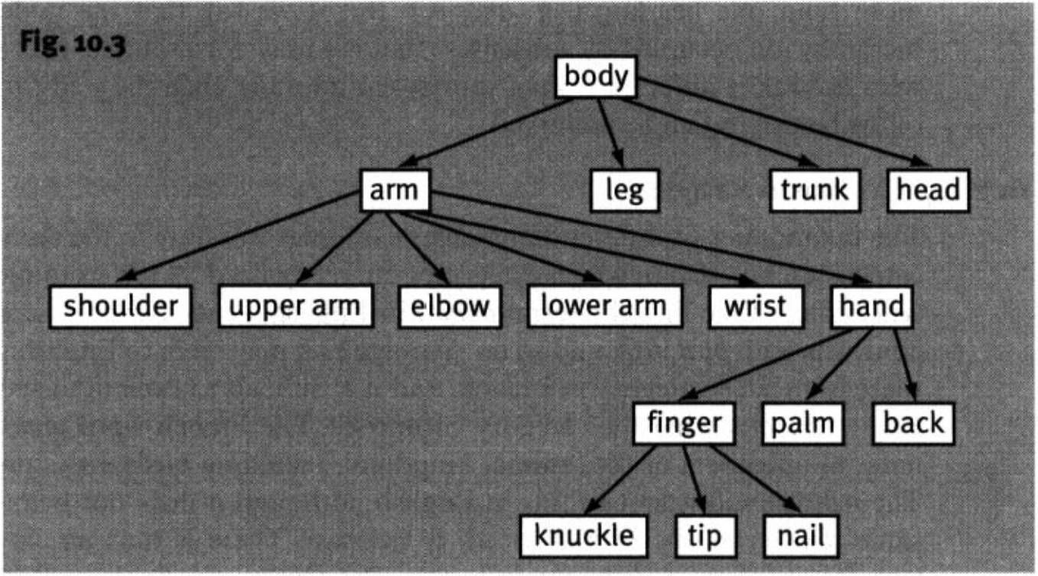
186 Meaning in language

10,2.2a Levels
The major forma) difference between a taxonomy and a meronomy is the lack of clear generalized levels in the latter. In a sense the body meronomy illus trated is uncharacteristic because of the homologies between the arm and the leg: knee corresponds to elbow, sole offoot to palm of hand, toes to fingers, etc. But this does not extend to other parts of the body Speakers have no intu itions as to whether, for instance, ths fingernail is or is not at the same level as the anus, or, in a different domain, the hub-cap to the seat cushions or the carburettor jets. For this reason, there seems to be no equivalent to the basic level of a taxonomy, no unmarked level of specificity independent of context. Of course there are unmarked levels of specificity in particular contexts, but these appear to be governed by something like Gricean principles (see Chapter 17). For instance, one would be more likely to say Mary felt someone touching her arm than Mary felt someone touching her upper arm: the latter would require special contextual conditions. (Even though the arm is part of the body, Mary felt someone touching her body would be interpreted differently.) On the other hand, Ahmad came into view, the falcon chained to his wrist would be more likely than Ahmad came into view, the falcon chained to his arm (it is not immediately clear why this is so).

10.2.2.2 Lexical gaps
Tn a taxonomic hierarchy, the beginner is frequently not lexicalized. This is never the case in a meronomy Gaps do occur, however, and most often in a characteristic position: not infrequently, the main functional part has no name, and speakers are embarrassed if they are asked to supply it. For instance, what do we call the part of a teapot to which the spout, handle, and


Word fields 187

lid are attached? Some people reply: But that is the teapot other responses are ZmwZ and body. But there seems to be no fully established term. Another example: a spoon has two main parts, the handle and the ?????. Again the response is usually hesitation and embarrassment, with some again suggest ing bowl and body. Yet another example concerns the part of a pair of spectacles to which the arms are attached.
Some apparently ‘accidental’ gaps are found, such as the part of a fork to which the prongs are attached (or, indeed, the part of the hand to which the fingers are attached, and of which the palm and the back are parts). These are, however, relatively rare. In some cases we find automeronymy, that is, when part and immediate whole have the same name (but distinct senses, cf. autohy ponymy). A good example of this is to be found in the human body merono- my. The term body is used both (i) for the whole ensemble and (ii) as a close equivalent to trunk (it is, in fact, perhaps the more usual term). It is body in sense (ii) which is the metaphorical source of the suggestions of body for the main parts of teapot and spoon. Other possible examples of this are arm, in two senses, one which includes hand and one which excludes hand, and wheel, which has two senses, one including and the other excluding tyre.

10.2.2.3 Contrastive aspects
Languages typically show differences in respect of the way wholes are divided into lexically distinguished parts, although there are reasons to believe that the underlying principles are more or less universal. This means that differences are mostly confined to (i) different groupings of the same smaller units, and (ii) differences in how far subdivision is carried. Radically non-congruent divi sions are rare. An example of (i) is provided by English and Modern Greek in respect of divisions of the arm. In English, hand extends to the wrist and no further; in Modem Greek (which is not unique in this respect), xeri goes up to the elbow. There is a parallel relation between foot and podi'. the latter extends to the knee. Notice that both systems respect the joints as natural boundaries for parts. Which part of xeri is being referred to in a particular instance is left to context to determine (there is rarely any ambiguity). But since the part of xeri which corresponds to hand is the most salient part, and overwhelmingly the most frequently involved in activities and so on, in the vast majority of contexts, little is lost by translating, or otherwise equating hand and xeri.
The other type of difference appears when one language provides finer divisions than another. One might say, for instance, that pommette in French is a subdivision of the part denoted in English by cheek (and French joue). The pommette is the rounded part of the cheek over the cheekbone; cheekbone will not do as an equivalent, because one cannot say She has red cheekbones, whereas in French one can say Elie a les pommettes rouges (this would go into English as red cheeks). Another example is the Turkish word ense, which means “back of the neck”. It is worth asking whether the absence of an English equivalent for pommette or ense represents a lexical gap or a

188 Meaning in language

conceptual gap. This distinction is by no means always easy to make, although there are clear cases. For instance, for French speakers, there is no natural category to which peanuts, almonds, and walnuts belong (English “nuts”), nor one which includes rabbits and frogs and crocodiles, but excludes birds and fish (English “animals”). Here we have a conceptual gap. On the other hand, English speakers would probably agree that there was a useful concept of “animal locomotion”, but since we have no verb denoting just that, we can speak of a lexical gap. In the case of pommette, there is probably a conceptual gap: English speakers feel no need to single out this area of the cheek. The case of ense (cf. French nuque) is less clear. The concept is easy enough to grasp for English speakers, but then so are concepts like “the right side of the head” and “the underside of the tongue”, which English speakers can con strue when necessary, but which would not be felt to be salient enough to merit lexical recognition. It might also be relevant to ask whether there is any sign of (incipient) lexification of back of the neck, such as non-compositional speci ficity of meaning (as in the case of blackbird), or morphological evidence such as the existence of fingertip, but not *nosetip alongside tip of the finger and tip of the nose: these would point to the emergence of a lexifiable concept. All things considered, my intuition is that ense, like pommette, does not designate a viable concept for an English speaker.
Meronomic systems of different languages also differ in the way analogous parts of different wholes are grouped for naming purposes. For instance, in French, the handle of a door, the handle of a suitcase, and the handle of a pump would be given different names (for a door, bouton (if round, otherwise poignee)', for a suitcase, poignee', for a pump, manivelle). They may also differ in the way similar parts of the same whole are grouped for naming purposes. For instance, in English, we distinguish one of the digits of the hand from all the others by means of the term thumb-, there is a sense of finger which excludes thumb: The hand has four fingers and a thumb (as well as one which includes thumb: five-finger exercises). In Turkish, no such distinction is made among the digits of the hand, although the thumb, like the other digits, can be distinguished by the expression buytik parmagi (“big finger”—cf. English big toe).
One further point deserves mention. Many languages designate the digits of the hand and those of the foot by unrelated terms {finger, toe)', many others, however, call the digits of the foot by a name equivalent to foot-fingers (e.g. doigts de pied in French). It is claimed that the reverse process, naming the fingers hand-toes, never occurs, and that this is motivated by the cognitive salience of the hand as opposed to the foot. This may well be the case, but perhaps the claim should not be made too strongly. I would not find it unnatural to refer to the heel of the hand.

Word fields 189

Linear structures

  - Bi poles
The simplest kind of linear structure is a pair of opposites. But there is per haps not a great deal to say about these as structures, other than what has been said under the heading of opposites in Chapter 9.
  - Bipolar chains
However, the scale on which a pair of opposites operates is often host to a number of terms which denote different degrees of the property. The most frequent pattern is for implicit superlative terms of opposite polarity at each end of the scale (there is a polarity switch between the basic antonym pair):
minuscule tiny small large huge gigantic
Implicit superlatives in English can be recognized by a number of features:
    - They are resistant to verbal grading compared with normal antonyms: very huge, huger, extremely tiny, very minuscule, etc. are all to some degree (some more than others) odd (although comparatives are usu ally happier with even: The first one was huge, the second one was even huger).
    - They can be prosodically graded, by varying the pitch range of an intonational fall carried by the adjective—the greater the fall, the high er the degree of the underlying property; normal antonyms sound odd with this intonation.
    - They can be modified by a low-pitch unstressed absolutely:
absolutely huge! absolutely tiny! ?absolutely large!
    - They resist affixation of -ish:
largish, smallish, *hugish, *minusculish

Further examples of such chains are: spotless clean dirty filthy
fantastic excellent good bad awful abysmal beautiful pretty plain ugly
adore love like dislike hate abominate
The temperature terms in English illustrate two much less frequent phenom ena in bipolar scales: attenuative terms as well as implicit superlatives (i.e. warm and cool), which occupy a position on the scale between the basic ant onyms, and a term which covers the mid-point between the basic pair of

190 Meaning in language

opposites (lukewarm), which has no polarity (does more lukewarm indicate a higher or lower temperature than /utoiwm?):
freezing cold cool lukewarm warm hot scorching

    - Monopolar chains
In monopolar chains, there is no sense that terms at the ends of the chains are oriented in opposite directions. There are various different types of monopo lar linear lexical structures. There are also various possible ways of describing and classifying them. The following system largely follows Cruse (1986).
      - Degrees
Degrees incorporate as part of their meaning different degrees of some con tinuously scaled property such as size or intensity, but there is no relation of inclusion. Their boundaries are typically vague, and they have intuitively not lost all their gradability. We can distinguish cases where the terms actually designate values of the underlying property from those which do not, but encapsulate values of a gradable property. Examples of the former type are:
fail pass distinction
An example of the second type is:
mound hillock hill mountain
Notice that these encapsulate some notion of size, but do not actually refer to sizes, but to types of earth protuberance. Other examples are:

haze | mist | fog | pea-souper
chuckle  glance | laugh  look | guffaw  stare
puddle | pond | lake | sea ocean
breeze | wind | gale | hurricane

      - Stages
Stages are points in a lifecycle (taken in a broad sense) of something and normally involve the notion of progression:
primary secondary undergraduate postgraduate infancy childhood adulthood old age
egg larva pupa butterfly

      - Measures
Measures are based on a part-whole relationship, with each whole divided into a number of identical parts; there is typically a geometrical relationship between values of the scaled property designated by adjacent terms:
second minute hour day week month (etc.)
Word fields 191

inch ounce
foot yard (etc.) mile pound stone (etc.) ton

      - Ranks
In ranks the underlying property does not vary continuously, but in discrete jumps; there is none the less something that a term has more or less of than its neighbours:
lecturer senior lecturer reader professor private corporal sergeant
In the above cases, the underlying property can be considered to be something like “seniority”. But notice that this does not vary gradually: one sergeant cannot outrank another.
The cardinal integers can be considered to fall under this heading, the vari able property being “numerosity” (which again, does not vary continuously: no group of twelve items can outnumber another group of twelve items). The levels of a taxonomic hierarchy are also ranks:
variety species genus family

      - Sequences
In all the above cases, there is some property which an item has more of than items which precede it in the sequence, and less of than items which follow it. However, there are also ordered terms for which this does not seem to be the case; these are called sequences. There is nothing that Tuesday has more of than Monday:

Monday January Spring morning
Tuesday February Summer afternoon
Wednesday March Autumn evening
Thursday April Winter night


These categories should not be taken too seriously: it will be noticed that several sets could be considered under more than one heading. There may be a satisfactory taxonomy, but it has not been found yet: it may be better to think in terms of features which cross-classify.

Grids

Grids are generated by recurrent concrete sense relations, or, which comes to much the same thing, by recurrent (and therefore independent) semantic com ponents. The unit of a grid is the cell, which consists of four lexical items, any one of which must be uniquely predictable from the remaining three. The following are examples of cells:

192 Meaning in language

(i) man | woman | (ii) hand | finger
ram | ewe | foot | toe
(iii) dog | puppy | (iv) take | steal
cat | kitten | kill | murder
These can be given componential analyses as follows:

- [X] [mALe]
[Y] [mALe]
- [X]
m
- [X]
[Y]
- [V.(i)]
[V.(2)]
- [femALe]
- [femALe]
- [DiGiT]
- [DiGiT]
- [YoUnG]
- [YoUnG]
[V.(i)] [iLLeGALLY]
[V.(2)] [iLLeGALLY]

Notice that the following is not a well-formed cell:
flower tulip animal cat
In a sense, the relation of taxonymy recurs, here. But the criterion of full predictability of any item from the other three is not met. Prediction is pos sible in one direction:
flower tulip
? cat
But in the other direction prediction is not possible:
flower tulip animal ?
A word needs to be said about the relations involved in these structures. In many cases, these are simply concrete versions of already familiar relations. Consider (ii). The relation between hand and finger is (a concretely specified version of) the familiar one of meronymy, and that between hand and foot is (a concretely specified version of) co-meronymy. But what of the relation between finger and toel They are not co-meronyms, because they are not parts of the same (immediate) whole. This is a new relation, which appears only in connection with recurrent concrete relations: in Cruse (1986) terms related as finger and toe are, are termed analogues (the relation may be called analogic- ity). Another example of analogicity is:


captain headmaster vice-chancellor boss
governor
team school university business prison



Word fields 193

The terms on the right are analogues (of one another).
It is clear that the introduction of concrete relations has brought with it whole new dimensions of structuring in the lexicon. An important and inter esting question is whether there is a finite number of such structures, or whether the number is indefinitely large. Even if the number turns out to be indefinitely large, there is still a question of whether the number of distinct relations is finite (indefinitely large structures could in principle be generated from a finite number of relations). No firm position will be taken on this point here; but it bears mention that some linguists believe the number to be limited (one suggestion is 53!).
All the grids illustrated above have been paradigmatically consistent. But there is nothing in the notion of a grid which imposes paradigmatic con straints. The following are well-formed grid cells:
pen write bird fly dog bark spade dig fish swim cat miaow
However, there must be a paradigmatic relation between analogues; for instance, anything which bears the same relation to something else as pen does to write, or spade to dig, must be a noun.

Clusters

Clusters are essentially groups of synonyms. The name is intended to indicate that the sharpness and complexity of structuring is much less than in other types of field: they are somewhat informal groups. There are two main types of cluster, the centred cluster and the non-centred cluster.

    - Centred clusters
A centred cluster has a more-or-less clear core of one or two items, and a penumbra of more peripheral items. Among the characteristics of the core items are:
      - They are expressively neutral.
      - They are stylistically unmarked, that is, they occur in a wider range of registers than any of the other terms.
      - They are propositionally superordinate.
In the set: die, pass away, pop off, decease, breathe one s last, kick the bucket, die is clearly the core member: it is expressively neutral, and stylistically unmarked. Feature (iii) is not applicable, since the members of the set are all propositional synonyms.
In the set: walk, amble, stroll, stride, saunter, walk is the core item: there is no marked expressive variation in this set, but walk is stylistically unmarked, and

194 Meaning in language

is a superordinate of all the others. Although amble, stroll, and so on are hyponyms of walk, they do not form a satisfactory hierarchy, because the relation of difference is too weak: there is considerable overlap between, say, amble and stroll, which can be differentiated only by examining their proto type centres.
In the set: brave, courageous, intrepid, gallant, fearless, valorous, heroic, plucky, there are two candidates for the core, brave and courageous. The cri teria do not favour either one of these, they are both relatively unrestricted contextually compared with their fellows, so we must recognize a two-member core.

    - Non-centred clusters
In non-centred clusters, the items spread over a spectrum of sense, but there is no superordinate item. Typically they display very slight propositional differ ences, which do not destroy synonymy as long as the items are reasonably close together on the spectrum, but may not be felt to be synonyms if they are widely separated. Typical examples are (taken as referring to sounds):
rap, tap, knock, slap, thwack, crack, bang, thump, bump, pop, tick, click, ring, tinkle, clink, clank, jingle, jangle, ping,. . .
Clusters may overlap: this is unusual and non-canonical in taxonomic and meronomic hierarchies. For instance, the following two clusters overlap:
      - unusual, rare, uncommon, infrequent, etc.
      - odd, queer, strange, weird, peculiar, extraordinary, alien, etc.
Group (i) consists of words denoting low frequency of occurrence, whereas the words in group (ii) denote unfamiliarity (of course, these notions are not unconnected). Although the groups are in a sense distinct, intuitively, unusual, odd, and strange (at least) are felt to be synonyms.

Miscellaneous types

We have now dealt, albeit briefly, with the major types of word field that can be treated in terms of characteristic structures. There are other important groupings of words, for which the notion of structure seems less appropriate. Two examples will be mentioned. First, there are the so-called word families. These are words derived from a common root, like cook (v.), cook (n.), cook ery, cooker, cooking (n.), etc. Of course there are semantic processes at work here which recur with other roots, but there does not seem much to say about this group of words (or other similar ones) as a group. Second, there are groupings of words by, for instance, register, as in colloquial or formal use, or by field of discourse, such as the vocabulary appropriate for (and possibly
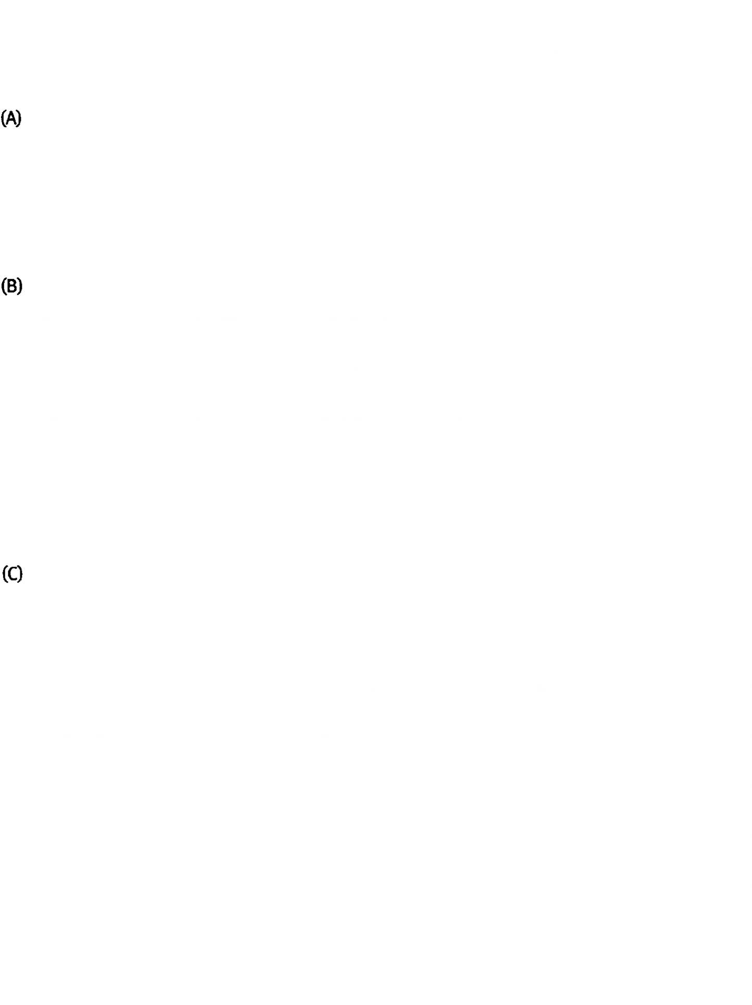
Word fields 195

restricted to) a religious sermon, a legal document, or a medical textbook. Again, as structures these have no particularly striking properties.

Discussion questions and exercises

1. Construct the best lexical hierarchies you can from the following sets of words, noting any difficulties. For Set A you will need to supply a number of superordinates.

tablecloth | wine gloss | table mat | salt
napkin | teaspoon | breadknife | coaster
tumbler | vinegar | water jug | fork
cake dish | saucer | napkin ring | knife
butter-knife | corkscrew | cake-slice | pepper
breadboard | butter dish | soup spoon | teaspoon
serving spoon | soup bowl | dessertspoon | mug
jacket | knickers | sportswear | T-shirt
shirt | blouse | underpants | trousers
jeans | cardigan | coat | pyjamas
sweater | suit | evening wear | vest
overcoat | waistcoat | clothes | underwear
skirt | anorak | nightwear | tracksuit
shoes | slippers | sandals | boots
socks | stockings | tights | top
bodysuit | kilt | dress | knitwear
dressing gown | nightdress | jeanswear | leggings
blouson | blazer | trenchcoat | briefs
bra | stole | gloves | sporran
book | novel | headline | section
booklet | paperback | textbook | review
programme | volume | thesis | title
preface | catalogue | hardback | periodical
pamphlet | footnote | encyclopaedia | biography
index | brochure | questionnaire | memorandum
journal | circular | manifesto | magazine
handbook | article | tract | page
newspaper | dictionary | thesaurus | editorial
leader | paragraph | leaflet | letter
note | chapter | leader | monograph
paper | sentence | advertisement | glossary


196 Meaning in language

Suggestions for further reading

The topics covered in this chapter are covered in greater detail in Cruse (1986), chs 5-8.
For discussion of Tolk taxonomies’ by anthropological linguists see Berlin et al. (1973), Brown et al. (1976), Berlin (1978), Hunn (1983), Brown (1995) and Brown (forthcoming a). Lehrer (1974) contains a detailed study of the field of cooking terms in English.
Meronomies are discussed in Brown (1976) and Brown (forthcoming b). Brown (forthcoming a) and (forthcoming b) are especially interesting on the general principles of naming.

