

CHAPTER 13

Lexical decomposition

  - Introduction 239 13.5 What are the alternatives to
  - The prima-facie motivation for lexical decomposition? 260
lexical decomposition 239 Discussion questions and
  - The aims of lexical decomposition 242 exercises 261
  - Problematic aspects of lexical Suggestions for further reading 261
decomposition 254



CHAPTER 13

Lexical decomposition

Introduction

The search for semantic atoms, or ‘the alphabet of thought’—the smallest units of meaning out of which all other meanings are built—has a long his tory, and is very much alive today still. It has survived intense opposition, even ridicule. In fact, it is probably true to say that virtually every attempt to expli cate a rich word meaning ends up by giving some sort of breakdown into simpler semantic components. There seems no other way to do it, or at least nothing that is not merely a ‘notational variant’. Some prototype theorists (see Chapter 7) valiantly stand out against the general trend, hoping to develop a more ‘analogical’ way of approaching meaning (as opposed to the ‘digital’ nature of componential theory). But it is none the less striking how easily even prototype theorists can slip into using feature representations. However, even within a broad acceptance of the validity of the feature approach, there is scope for quite radical disagreements on such topics as the nature of semantic features, how they are to be discovered and verified, how they combine, whether all aspects of word meaning are susceptible to a feature analysis, and so on.

The prima-facie motivation for lexical decomposition

It is sometimes proposed that the semantic atoms of a natural language are the meanings of its lexical items. On this view, complex meanings are certainly built up out of combinations of simpler ones, but there is no need to break up the meanings of individual words (or at least, morphemes): they are seen as unanalysable monads. It would therefore be useful for us to look first of all at the sort of reasons that have been put forward for lexical decomposition, that give the componential enterprise a prima-facie plausibility.
240 Meaning in language

Partial similarities

One such reason is the intuition that a pair of words may be partially similar in meaning and partially different. There is a certain plausibility in construing this situation in terms of components of meaning some of which are common to the two words in question, and some of which are not shared. As an obvious example of such a case, take mare and stallion. The similarity between these can be expressed by saying that they are both horses, that is, they share the component [Horse], and that they differ in that mare has a component [femALe] not shared by stallion, and stallion has [mALe], which is not present in the meaning of mare. Or take the case of heavy and light', these share the component of [weiGHT], and differ in that heavy has a component [more THAn AverAGe], where light has [Less THAn AverAGe]. A concrete analogy for this might be a mixture of sand and salt, on the one hand, and a mixture of sand and sugar on the other. Both preparations share a property of grittiness, which can be attributed to the presence of sand in each; but they differ in taste, which can be attributed to the fact that one contains sugar and the other, salt. The concrete analogy of a mixture was chosen deliberately, because in a mixture, the properties of the individual constituents are still in evidence in the mixture. Many systems of lexical decomposition seem to aim at something of this sort. It is worth noticing, however, that if chemical compounding were thought to be a more appropriate analogy, the nature of semantic composition would change radically, and we would be looking for quite different sorts of com ponents. Take the case of salt, which is a compound of sodium and chlorine: very few, if any, of the properties of either sodium or chlorine are observable in salt.

Correlations
The examples of partial similarity which provide the most convincing evidence for lexical decomposition are correlations, where the proposed components can be seen to be distributed independently of one another. The following are examples:

(1)

[sHeep] [Horse]
[mALe] [femALe] ram ewe
stallion mare

The components [mALe] and [femALe] are widely distributed in the language; [femALe], for instance, occurs in: mother, daughter, wife, girl, woman, aunt, sow, cow, doe, filly, vixen, hen, and many others; [Horse] occurs in horse, mustang, foal, gelding, and probably also forms part of the definition of stable, jockey, neigh, fetlock, etc.
Further illustrative examples are given in (2) and (3):

Lexical decomposition 241

      - [ADULT]
[HUmAn] adult [sHeep] sheep
[YoUnG]
child ewe

Notice that when a polysemous word appears in a correlation, only one of its senses (see Chapter 6) is intended to be operative. For example, there is a sense in which a lamb is a sheep, but there is nothing odd about saying Make sure that the lambs do not get separatedfrom the sheep. It is the latter sense which is intended in (2). {Adult is likewise polysemous.)

      - [ADULT]
[mALe] man [femALe] woman
[YoUnG]
boy girl


A two-dimensional correlation does not necessarily give a full analysis of the meaning of a word. In (2), [YoUnG] [sHeep] seems a satisfactory analysis of lamb, but [YoUnG] [femALe] is not a satisfactory analysis of girl', the [HUmAn] factor is missing.

13,2.3 Discontinuities
In some cases there is more direct evidence of the functional discreteness of a portion of meaning, in the form of a discontinuity of some sort in the seman tic structure of a sense. Some examples will make this point clearer.

        - The ambiguity of I almost killed her (“I was on the point of carrying out an action (e.g. pulling the trigger of a gun) which would have caused her to die”/“I acted in such a way as to cause her to be almost dead” (e.g. by squeezing her windpipe)) suggests a functional autonomy for components [CAUse] and [Die] within the meaning of fc/ZZ.
        - The fact that The astronaut re-entered the atmosphere is appropriate even on the astronaut’s first trip into space, indicates that we must analyse “re-enter” into (at least) move and in, since in the case men tioned, the recurrence signalled by re- applies only to in, that is, the astronaut must on some previous occasion have been located inside the earth’s atmosphere. (According to my intuitions—but this is a matter for argument—the sentence is not ambiguous: it does not matter whether the astronaut has had a previous experience of entering the atmosphere or not.)
        - The fact that the default reading of That's not a stallion is that the animal indicated is a mare, that is to say, the negative applies only to the [mALe] component, leaving the Horse component untouched (although complete negation is of course also possible in appropriate contexts) is evidence of the separability of [mALe]. (Notice also the potential ambi guity of an overworked stallion (“too much pulling of heavy carts”/


242 Meaning in language

“required to perform stud duties with too many mares”), which testifies further to the functional independence of [mALe].)

13.2.4 Simplex: complex parallels
In many cases, grammatically simple forms have semantic properties either very similar to, or closely parallel to, complex forms. Consider the case of false and untrue. In the case of untrue, the notions [noT] and [verACioUs] (let’s say) are expressed by different morphemes, so the meaning of untrue must be ana lysed as complex. But what about false? There is no morphological evidence for complexity, but in view of the close meaning relationship to untrue, it would seem almost perverse not to give false the same semantic analysis. There are countless similar cases. Synonymy is not necessary. Compare riselfall with lengthen!shorten (in their intransitive senses). Lengthen and shorten are clearly related morphologically to long and short, and can be analysed semantically as [BeCome] [more] [LonG] and [BeCome] [more] [sHorT]. Now, given that the con trast between lengthen and shorten is the same as that between rise and fall, and given that the semantic relation between lengthen and long is the same as that between rise and high (and fall and low), surely this justifies a componen- tial analysis of rise and fall as [BeCome] [more] [HiGH] and [BeCome] [more] [Low], respectively?

The aims of lexical decomposition

In this section we look in greater detail at the sorts of ideal end-results that various semanticists have aspired to in embarking on a componential analysis of general vocabulary. It is worth pointing out that most have been content to work on small groups of words that were hopefully representative of the lexi con as a whole.

Reduction (cf. dictionaries)
An important aim of many componentialists (although not necessarily all) has been to achieve a genuinely reductive analysis of the realm of meaning. As an illustration of this ‘mindset’, we may take the example of the Danish linguist Louis Hjelmslev.
Hjelmslev was a representative of early European structuralism in lin guistics; his was the first definite proposal for a componential semantics, fol lowing up a suggestion of Saussure’s. He started from Saussure’s well-known conception of the linguistic sign, illustrated in Fig. 13.1.
Saussure imagined a realm of all possible meanings, which he called the ‘content plane’ of language (originally, ‘le plan du contenu’) and a realm of all possible human linguistic sounds, which he called the ‘expression plane’ (le
Lexical decomposition 243

- _<■*•••• ■/• ■/• '.■ •/■ ’A "A tN ■
•".’*.•*.• "/•'. • ’/• 'A ••••-' *
*’/• lS '/• "A ¥5 •> ’> I
•fg+gfsfg+g+gfgf
*a%aS<%%%<VaSaSa

t*tV<V•MMz?t<a?V HMM

V* V* ■.
expression plane

content plane

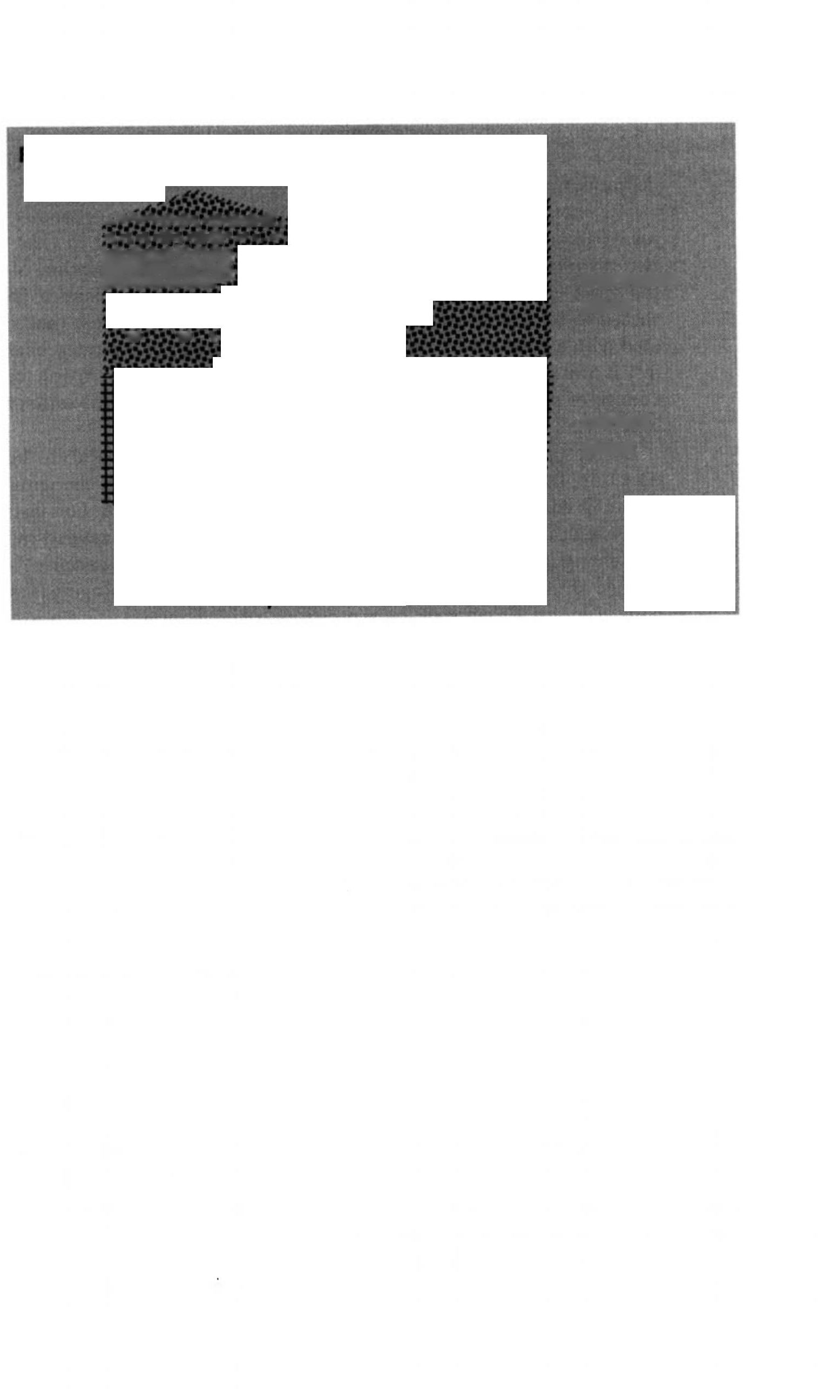
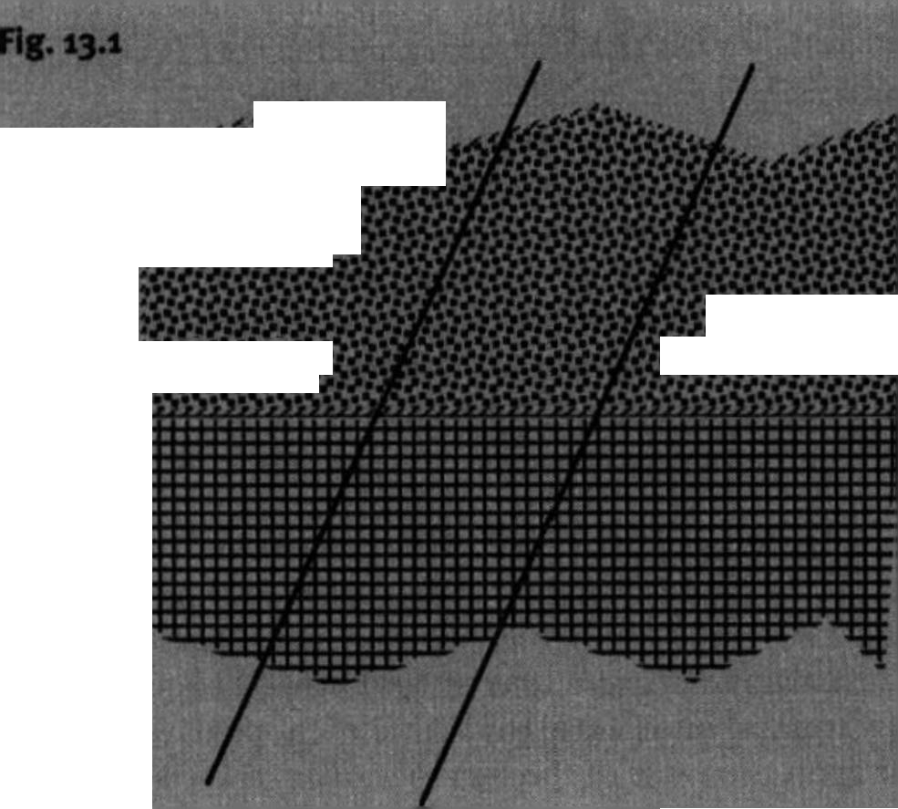


plan de Fexpression’). He then characterized the linguistic sign as a slice through the two planes, which created an arbitrary (in the semiotic sense) association between a specific sound and a specific meaning.
Now, a study of the sound aspect of the signs in any natural language shows that they lend themselves to a genuine reductive analysis, that is, they can be progressively analysed into combinations of ever simpler units belonging to smaller and smaller inventories. Take the case of English. We may take it that the vocabulary of English comprises several hundreds of thousands of items. However, the sound structures of these items are not like the pebbles on a beach, each one idiosyncratically individual and not systematically related to any others: all the words of English (in their sound aspect) can be shown to be built up out of combinations of smaller units drawn from a much more restricted list of 200 300 syllables; these in turn can be shown to be made up of phonemes drawn from an even smaller list (20-80), themselves analysable as combinations of distinctive features numbering no more than a dozen or so. In this way, the initial bewildering variety is reduced to systematic order. Hjclmslev believed in the symmetry of the two planes of language, and con cluded that it ought to be possible to perform a parallel analysis of the content plane of signs which would achieve a similar reduction of bewildering variety to system and order.
For Hjclmslev, the simpler meaning units in question were essentially the
meanings of other words. Hjelmslev thus hoped to arrive at a restricted basic vocabulary in terms of which all other meanings could be expressed. It is worth noting that this aspiration is still very much alive in the world of



244 Meaning in language

lexicography: many modem dictionaries, especially those targeted at foreign learners, such as the COBUILD dictionary and the OALD, deliberately aim to define all words using a restricted defining vocabulary.
The method of analysis was based on commutation, originally used to justify phonemic analysis. A phonemic difference was said to exist between two distinct elements of the expression plane when substitution of one for the other entails a change in the content plane. So, for instance, [p] can be shown to be a different phoneme from [b] in English, because [pin] is associ ated with a different meaning from [bin]. However, the aspirated bilabial stop [ph] is not a different phoneme from the unaspirated form [p], because a change of meaning is never associated with the choice of one rather than the other.
By the principle of symmetry, the same procedure is valid in the reverse direction, that is, we have isolated a semantic element when changing a bit of meaning entails a parallel change in the expression plane. For instance, an analysis of the meaning of mare into [Horse] [femALe] is justified by the fact that changing [femALe] into [mALe] (by a kind of thought experiment) entails a change of the expression side of the sign to stallion, and changing [Horse] into [sHeep] entails a change of the expression to ram. However, if we postulate that the meaning of horse includes the semantic component [BLACk], then this is not supported, because changing it to [Brown] entails no change in the associ ated phonetic form.
A distinction was made between components belonging to restricted inven tories and those belonging to unrestricted inventories. Take the case of stallion analysed as [Horse] [mALe], once again; the substitution possibilities of [mALe] are very restricted indeed, the only possibility being [femALe]; the possibilities for [Horse], however, are much wider. Components belonging to restricted inventories are the more significant for reductive purposes, since they have the widest distribution, in the sense of occurring with the greatest variety of other components.
Mention has been made above of the importance to Hjelmslev of a reduc tive analysis. Let us see how this works out in practice. Take a set of words such as the following:
rise raise high
fall lower low
lengthen (1) lengthen (2) long
shorten (1) shorten (2) short
(Lengthen (i) and shorten (i) are intransitive, like rise and fall; lengthen (2) and shorten (2) are transitive/causative like raise and lower)
This is a highly structured set, with many sets of correlated contrasts. If we take the lexical items to be the minimal semantic atoms, then this set needs twelve semantic units for its description. Such a description will not give an
Lexical decomposition 245


account of the parallelisms: these would have to be stated separately. Now suppose we perform the following analysis:
rise = [BECOME] [MORE] [HIGH]
fall = [BECOME] [MORE] [LOW]
raise = [CAUSE] [BECOME] [MORE] [HIGH] lower = [CAUSE] [BECOME] [MORE] [LOW]
lengthen (1) = [BECOME] [MORE] [LONG] shorten (1) = [BECOME] [MORE] [SHORT]
lengthen (2) = [CAUSE] [BECOME] [MORE] [LONG] shorten (2) = [CAUSE] [BECOME] [MORE] [SHORT]
This new analysis shows that the contrast between, for instance, rise and fall is the same as that between rawe and lower, since both are attributable to the contrast between [HIGH] and [LOW]. Also, the contrast between high and raise is the same as that between long and lengthen (2), and so on. Notice that this is achieved with the use of only seven components, as opposed to twelve without lexical decomposition. The economy becomes more striking if other items are added to the set:

wide widen (1)
narrow narrow (1)
widen (2)
narrow (2)

thick thicken (1) thicken (2)
thin thin (2)

strong strengthen (1)
weak weaken (1)
strengthen (2)
weaken (2)

Without lexical decomposition, these would add eighteen more semantic atoms, giving thirty in total; with decomposition along the above lines, only six new semantic elements are necessary, giving a total of thirteen for the set.
However, there are correlations in our set of words that cannot be expressed by our analysis as it stands, for instance:
rise:fall: lengthen (i):shorten (1)
Accounting for this should lead to even greater economy in the inventory of components. Consider the following:

raise =
lower =
lengthen (2) =
shorten (2) =
[CAUSE] [BECOME] [MORE] [HIGH] [CAUSE] [BECOME] [MORE] [LOW]
[CAUSE] [BECOME] [MORE] [LONG] [CAUSE] [BECOME] [MORE] [SHORT]

The parallelism here can be captured if we analyse as follows:



246 Meaning in language

raise = [CAUse] [BeCome] [more] [HiGH] lower = [CAUse] [BeCome] [Less] [HiGH]
lengthen (2) = [CAUse] [BeCome] [more] [LonG] shorten (2) = [CAUse] [BeCome] [Less] [LonG]
This seems on the right lines, but, as it stands, it loses the parallelism
raise: lower:: high: low. It appears that a more radical analysis is required:
raise = [CAUse] [BeCome] [more] [HeiGHT] [ref: X] lower = [CAUse] [BeCome] [Less] [HeiGHT] [ref: X]
Here we introduce the notion of a reference point: to raise something is to cause it to be at a greater height than some reference point, normally the height it was before the act of raising took place. This notion of reference point can be used also in the analysis of high and low (and mutatis mutandis, long and short) since something which is high is at a greater height (and some thing low is at a lesser height) than some reference point, often an average of some sort (see discussion of antonyms in Chapter 9):
high = [more] [HeiGHT] [ref: Average] low = [Less] [HeiGHT] [ref: Average]
long = [more] [LenGTH] [ref: Average] short = [Less] [LenGTH] [ref: Average]
At first sight this does not seem to reduce the number of components. However, the pay-off comes when we extend the analysis to larger sets, because the addition merely of a single new dimension, for example, [speeD], [weiGHT], [HArDness], or whatever, allows us to account for the meanings and relationships of six new words.
The discussion so far has sought to illustrate the effects of allowing com- ponential analysis to be motivated by the existence of correlations and the need to be reductive. It is as well, however, to bear in mind the limitations of such an analysis. Two are worth emphasizing at this point. The first is that the proportion of the vocabulary which lends itself to this sort of analysis is relatively restricted: the majority of words remain unanalysed. Areas which have proved amenable to componential analysis are, for example, kinship terms, terms referring to male/female/young/adult animals and humans, and binary oppositions like those discussed above. The second point is that even when a word can be analysed, like stallion, the analysis leaves much semantic knowledge unaccounted for.
A radical, relatively recent proposal for reductive analysis of word meaning is that of Anna Wierzbicka (1996), who is probably the most original of contemporary componentialists, and is certainly the most thoroughgoing. She takes her inspiration not from the structuralists, but from much further back in the past: her source is Leibniz, who was the first to attempt to discover an

Lexical decomposition 247

‘alphabet of thought’ by reducing complex meanings to combinations of sim pler ones. Leibniz followed a Hjelmslev-like procedure of beginning with complex meanings (like “stallion”) and reducing them to simpler ones, guided by the meanings of other words. When reduction could go no further, Leibniz thought, one will have arrived at the fundamental units of thought. Wierz- bicka does things the other way round: she starts with a small list of what appear to be indispensable notions (her original list had exactly eleven mem bers), and tries to express as many meanings as possible with these, only adding items to the list of primitives when forced to do so. Her current list (not held to be definitive) runs as follows:

“substantives”

“determiners” “augmentor” “quantifiers” “mental predicates”

“non-mental predicates” “speech”
“actions and events” “evaluators” “descriptors”
“time” “space”
“partonomy” “taxonomy” “metapredicates” “interclausal linkers”
“imagination and possibility” “words”
[1], [YoU], [someone], [someTHinG], [peopLe]
[THis], [THe sAme], [oTHer], [some] [more]
[one], [Two], [mAnY/mUCH], [ALL]
[THink], [know], [wAnT], [feeL], [see], [HeAr]
[move], [THere is], [(Be) ALive]
[SAY]
[Do], [HAppen]
[GooD], [BAD]
[BiG], [smALL]
[wHen], [Before], [AfTer], [A LonG Time], [A sHorT Time], [now]
[wHere], [UnDer], [ABove], [fAr], [neAr], [siDe], [insiDe], [Here]
[pArT (of)] [kinD]
[no], [CAn], [verY]
[if], [BeCAUse], [Like]
[if ... woULD], [mAYBe] [worD]


To qualify as a member of this list, a suggested primitive must be universal (this is of course hard to check, but it must be expressible in all known lan guages). Wierzbicka argues that since all humans are bom with the same innate capacities, if the primitives are a reflection of innate semantic capaci ties, then an apparent primitive that appears in some languages but not others must be expressible in terms of primitives that appear in all languages. Primi tives must also not be abstract, they must be accessible to direct intuition, and any proposed analyses should pass the test of native speaker judgements of plausibility. She dismisses analyses of the Katz and Fodor variety as not so much genuine analyses of meaning as translations into an artificial language (sometimes referred to in derogatory fashion as “markerese”) for which no one


248 Meaning in language

has any intuitions. The following will give the flavour of a typical Wierzbickan analysis:
X punished Y for Z:
- YdidZ.
- X thought something like this:
- Y did something bad (Z).
- I want Y to feel something bad because of this.
- It will be good if Y feels something bad because of this.
- It will be good if I do something to Y because of this.
- X did something to Y because of this.
This analysis is intended to capture in maximally simple terms the fact that punishment is objectively justifiable causation of suffering for an offence. Notice that ‘it will be good’ must be taken to indicate an objective evaluation; substitution of a subjective evaluation such as I will feel good in (e) and (f) would yield a definition of take revenge on.
The analyses are couched in the form of sentences. This means that there must also be a set of semantically interpretable syntactic primitives. This aspect of the system is under investigation, but is currently less well developed.

Lexical contrasts and similarities
A somewhat different approach to componential analysis takes as its primary aim the explication of lexical contrasts and similarities within the lexicon of a language. On this view, a minimal semantic component is the smallest possible difference between the meanings of two words; all components have to be justified by actual lexical contrasts; furthermore, the closer two word mean ings are, the more components they should have in common. Let us see how this works out in practice, using in the first place a familiar example (in the literature). We shall attempt a componential analysis of the word chair. Bear in mind that the aim is to distinguish chair from every other word in English, and also to indicate its semantic distance from other items. We shall begin with the most distant words and move steadily closer; this is not theoretically neces sary, but it is convenient and makes it easier to be systematic. From each of the following contrasts, we can extract a feature, and the full set adds up to a specification of the meaning of chair '.
chair vs. thought [ConCreTe] vs. cat [inAnimATe]
vs. trumpet [fUrniTUre] vs. table [for siTTinG] vs. sofa [for one]
vs. stool [wiTH BACk]
Ideally, the components should be necessary, and should therefore be justifi-


Lexical decomposition 249

able by entailment (for instance, It’s a chair entails It 5 inanimate, It’s an item of furniture, etc.). According to the above analysis, chair and thought repre sents the most distant pair, whereas chairs nearest neighbours are stool and sofa, with each of which it shares five out of six components. If the above analysis is correct and complete, then there is nothing designated by a term in English which is not a chair and which shares all six features. (This does not mean that chair cannot be further subdivided: for instance, armchair would possess all the features of chair, plus [wiTH Arms]. But this is not a true contrast, since an armchair is a kind of chair.)
An analysis of this type clearly covers the whole vocabulary, and provides a great deal more information than the previous type. All the same, it is worth noting that there are things we know about chairs which are not represented, for instance, that a chair 3 inches wide would be no use, or one whose ‘flat’ portion was tilted at an angle of 60 degrees, or one made of cardboard. (Information of this type would typically be found in a prototype representa tion; for more details of this, see Chapter 7.)
As a second example, let us see if we can analyse the verb walk-.
walk vs. sleep [ACTion]
vs. bite [LoComoTion]
vs. drive [UsinG BoDY onLY] vs. fly [on GroUnD]
vs. crawl [BipeDAL]
vs. hop (like frog) [UsinG LimBs ALTernATeLY] vs. run [one fooT ALwAYs on GroUnD]
In this case, it is not quite so clear what should be in the analysis. Should we, for instance, make a distinction between mental acts like thinking and physical acts like walking? Should we distinguish locomotion using mechanical energy from an external source, like driving a car, from, for instance skiing, where only one’s own energy is used? Have we adequately distinguished walk from, say, dancel However, the broad lines of the analysis are clear enough.
Notice that this approach does not guarantee a reductive analysis: we shall almost inevitably end up with as many components as words we are analysing. This is because so many features appear in the analysis of a single word: they are not independently distributed. The names of the animals provide a clear illustration of this. In order to distinguish cats, dogs, sheep, cows, wolves, seals, elephants, and so on from one another, each one must be allotted a dis tinguishing feature such as [CAnine], [feLine], [Bovine], [ovine], [vULpine], [pHoCine], [eLepHAnTine]. Hence, an analysis of the set of animal terms requires more features than there are animals, since each one will contain, in addition to the unique distinguishing feature, others such as [ConCreTe], [Ani mATe], [mAmmAL] and so on.

250 Meaning in language

Lexical relations and entailments
A componential analysis can formalize, at least to some extent, certain recur rent meaning relations between lexical items. Sense relations are treated in greater detail in Chapters 8-10; here we shall concentrate on just two, for the purposes of illustration, namely, the relation of inclusion which holds between dog and animal, tulip and flower, and so on (known as hyponymy), and the relation of exclusion that holds between dog and cat, and between tulip and rose (incompatibility). The first relation is the easier: we can say that word W(i) is a hyponym of word W(2) iff all the components of W(2) are included in the componential specification of W(i). By this definition (which is too simple, but we shall ignore the complications here) the following hyponymous relationships can be explicated:
stallion [AnimAL] [eQUine] [mALe] is a hyponym of
horse [AnimAL] [eQUine]
kitten [AnimAL] [feLine] [YoUnG] is a hyponym of
cat [AnimAL] [feLine]
chair [ConCreTe] [inAnimATe] [fUrniTUre]
[for siTTinG] [for one] [wiTH BACk] is a hyponym of
furniture [ConCreTe] [inAnimATe] [fUrniTUre] and so on.
The examples considered so far are very straightforward, but there are some complications. For instance, we need some way of filtering out cases like kill ([CAUse] [BeCome] [noT] [ALive]) and die ([BeCome] [noT] [ALive]), because although the specification of kill includes that of die, kill is not a hyponym of die, and John killed does not entail John died. (We also need to ensure that dead ([noT] [ALive]) does not come out as a hyponym of alive ([ALive].) The moral is that a satisfactory system of lexical decomposition must take account of the different ways in which semantic components combine together (see section 4.5 below).
Explaining incompatibility is a little more complicated. This is because there is nothing in the specification of, say, horse ([AnimAL] [eQUine]) and cat ([AnimAL] [feLine]) which enables us to conclude that it is not possible for something to be both at the same time. Since we can conclude this, if our descriptive apparatus does not allow us to represent it, then it can be said to be to that extent deficient. The usual way round this is to include as part of the semantic theory within which the proposed features operate, a specification of those sets of features whose members are mutually exclusive (sometimes called antonymous n-tuples). The following are examples:
[mALe]/[femALe] [reD]/[Green]/[BLUe] etc.

Lexical decomposition 251

[CAnine]/[feLine]/[ovine]/[Bovine] etc. [CirCULAr]/[sQUAre]/[TriAnGULAr] etc.
Notice that grouping the features in this way means that we do not have to make special statements for every pair of lexical items. For instance, it is not only dog and cat that are incompatibles, but also any pair of words such that one contains one feature belonging to an antonymous n-tuple and the other contains another feature from the same antonymous n-tuple. Thus puppy, bitch, spaniel, alsatian, etc., all of which contain [CAnine], are each incompat ible with words such as kitten, tom, moggy (which contain [feLine]), cow, calf, bull, heifer, (which contain [Bovine]), horse, colt, filly, mare, mustang (which contain [eQUine] ), and so on.
This approach can be extended (with some reservations) to cover certain entailments and the distinction between analytic and synthetic propositions. For instance, it was pointed out that hyponymy between two lexical items in parallel positions in two propositions may be reflected in a relation of entail ment from the proposition containing the hyponym to that containing the superordinate, as in the case of It's a dog and It's an animal, and A dog passed by and An animal passed by. To the extent that this is valid for hyponyms, it can easily be expressed in componential terms. But equally, the same reservations apply, namely, that propositions differing only in the specificity of lexical items in a particular position do not invariably show entailment. Sometimes the entailment is in the wrong direction, as in All animals need food and All dogs need food, or That's not an animal and That's not a dog. Sometimes there is no entailment at all, as in John began to sprint and John began to run (even though John sprinted across the quad entails John ran across the quad). Some times there is entailment without hyponymy, as in Mary's birthmark is on her thigh and Mary's birthmark is on her leg. The fact that native speakers can easily assess the presence or absence of entailment presumably means that there is some systematic relationship between hyponymy and entailment, which then can be translated into componential terms, but this will be possible only when the factors governing the different entailment-related effects are fully understood. To the best of my knowledge, this is not currently the case.

Anomaly
The task of predicting whether a combination of words is anomalous or normal is usually handled within componential systems by specifying selec- tional restrictions, that is, features which accompanying words must possess for a normal sentence to result. These also help to account for contextual disambiguation. So, for example, we can explain why in John expired, expired means “died”, while in My driving licence has expired, it means “has become invalid”. The solution is to specify the relevant selectional restrictions (adopt ing the convention that these appear in angled brackets):

252 Meaning in language

expire = [BECOME] [NOT] [ALIVE] < [HUMAN] >
= [BECOME] [NOT] [VALID] < [DOCUMENT] )
Of course, some way is needed of showing that the restrictions apply to the subject of the verb; we could, for instance, put the restrictions in initial position:
expire = { [HUMAN] > [BECOME] [NOT] [ALIVE]
= { [DOCUMENT] ) [BECOME] [NOT] [VALID]
This formulation predicts that if the subject of expire is the man, then the reading “become invalid” will be anomalous, since the specification of the meaning of the man will not contain the feature [DOCUMENT], but the reading “die” will be normal, since the specification of the man will contain the feature [HUMAN]; hence the sentence The man expired will be normal, and because only one reading is normal, it will be unambiguous; similarly, mutatis mutandis, for TAe driving licence expired. It also predicts that if the subject of expire con tains neither [HUMAN] nor [DOCUMENT] in its specification, then the sentence will be anomalous, as in ?The cup expired.
As a second example, consider the word pregnant. At first sight, this seems straightforward:
pregnant = [WITH CHILD IN WOMB] ( [ANIMAL] [FEMALE] )
This would correctly predict that My sister is pregnant is normal, and The chair is pregnant anomalous. However, it would also predict that My neighbour is pregnant would be anomalous, since although a full specification of the meaning of neighbour would presumably include [ANIMAL] and [HUMAN], it would not contain [FEMALE]. How, then, do we account for the difference between The chair is pregnant and My neighbour is pregnant9. Notice that in the latter sentence, pregnant projects the feature [FEMALE] on to neighbour, what we need, therefore, is something in the specification of neighbour which licenses this projection, but blocks it in the case of chair. Basically, we need to indicate that although neighbour is unspecified for sex, it is none the less specifiable. For instance, something like the following would do the job:
neighbour [ANIMAL] [HUMAN] [MALE/FEMALE] [LIVING IN ADJACENT DWELLING]
The case of pregnant illustrates another problematic point, which is that expressing a co-occurrence restriction, in the form adopted here, seems to make the restrictions relatively extrinsic to the meaning of the item, where as in some cases, they may intuitively be felt to be more essential. In the case of pregnant, is it not the case that [FEMALE] is central to the meaning? Take another example, the verb drink. Obviously, this requires its direct object to have the feature [LIQUID]; but should the analysis be as in (a) or as in (b)?


Lexical decomposition 253

- dr ink [inCorporATe] [BY moUTH], < [LiQUiD] )
- drink [inCorporATe LiQUiD] [BY moUTH]
There are good reasons for distinguishing relatively extrinsic co-occurrence restrictions like [HUmAn] for pass away and expire, and the more inherent restrictions like those for drink and pregnant (see discussion in Chapter 12, section 8).

133-5 Discontinuities
It was suggested in section 2 above that a componential analysis provided a natural explanation for the apparent discrete nature of the variable scope of operators such as again, almost, and not within the meanings of lexical items, as in John opened the door and immediately closed it again vs. John opened the door and immediately closed it AGAIN, and the ambiguity of When I saw who it was, I almost closed the door. Two points are worth making in this connec tion. The first is that some examples of the phenomenon are more convincing than others. The case of again is convincing, because the possibilities are strictly limited. For instance, although eat and drink both (presumably) involve some such feature as [inCorporATe], the repetition of this feature in I drank, then ate again does not license a ‘first-time’ interpretation of ate’, that is, again cannot take [inCorporATe] as its scope. The case is much less convincing with negation, however. It is true that That's not a stallion normally carries some sort of presumption that a horse is being referred to, and therefore that the referent is a mare. However, the next step in the argument, that this is because only [mALe] is within the scope of the negative, is more shaky. The reason is that negatives typically have the pragmatic function of correcting some previous or imagined incorrect statement; hence, one says That's not a stallion when someone has suggested, or seems to think, that it is a stallion. But this means that what features are denied, and what are left intact depends on plausible confusions or errors on someone’s part. For instance, (a) and (b) are both plausible, but (c) is not:
- That’s not a horse, it’s a deer.
- That’s not a mouse, it’s a shrew.
- ?That’s not a horse, it’s a mouse.
To explain this, we would need to say that both horse and deer contained a feature [LArGe], which was missing from mouse and shrew, which, in turn, have [smALL], and that these features were outside the scope of the negative in (a) and (b), respectively. The problem here is that this seems to open the door to an unlimited number of features, based on the parameters of possible resemblance/confusion. For instance, the most natural interpretation of (d) is that there was a confusion in the identification of a sound:
- That wasn’t a horse, it was a car.

254 Meaning in language

Presumably there is some property of the sound which the speaker is not denying, and which led to the wrong identification. Does this justify yet another feature?
It will be recalled from Chapter 6 that the facets [TexT] and [Tome] formed discrete entities within the meaning of book. The question then arises of whether we need to make a distinction between [TexT] and [Tome] within the meaning of book and, for instance, [mALe] and [eQUine] within the meaning of stallion', and if so, what is the difference? Intuitively, there does seem to be a difference. Both types would seem to be necessary; in fact, we would expect both [TexT] and [Tome] to receive an analysis in terms of the other type of component. This is a difficult question, but perhaps the notion of autonomy is relevant: both [TexT] and [Tome] can function as readings of book', on the other hand, neither [mALe] nor [eQUine] can function as autonomous readings of stallion. Another way of looking at the difference is to say that [TexT] and [Tome] retain their individual properties within the meaning of book, relatively unaffected by the presence of the other, somewhat like the components of a chemical mixture; [mALe] and [eQUine], on the other hand, interact strongly, in that the way maleness manifests itself perceptually in the context of [eQUine] is different from the way it manifests itself in the context of, say, [CAnine] (for instance, a horse’s penis is not the same as a dog’s penis).

Problematic aspects of lexical decomposition

Too hasty analyses: the abstractness of features
Some superficially plausible componential analyses have been attacked on the grounds that they are too crude and ignore nuances of meaning. For instance, Lyons questions the legitimacy of the following:
boy = [HUmAn] [mALe] [YoUnG]
girl = [HUmAn] [femALe] [YoUnG]
on the grounds that the parallelism man:boy:: woman:girl, which is presup posed by the analysis, is only an approximate one. He points out that the transition from boyhood to manhood in ordinary everyday reference occurs at an earlier age than the corresponding transition from girlhood to womanhood (things are perhaps changing, but it is still the case that the girls in the Lower Sixth slides down more easily than the boys in the Lower Sixth, although lads seems unobjectionable).
Another well-known example is the analysis of kill as [CAUSE] [DIE], which has been criticized on the grounds that cause to die is not synonymous with AiZZ. There are events which count as instantiations of cause to die but not of kill. For instance:
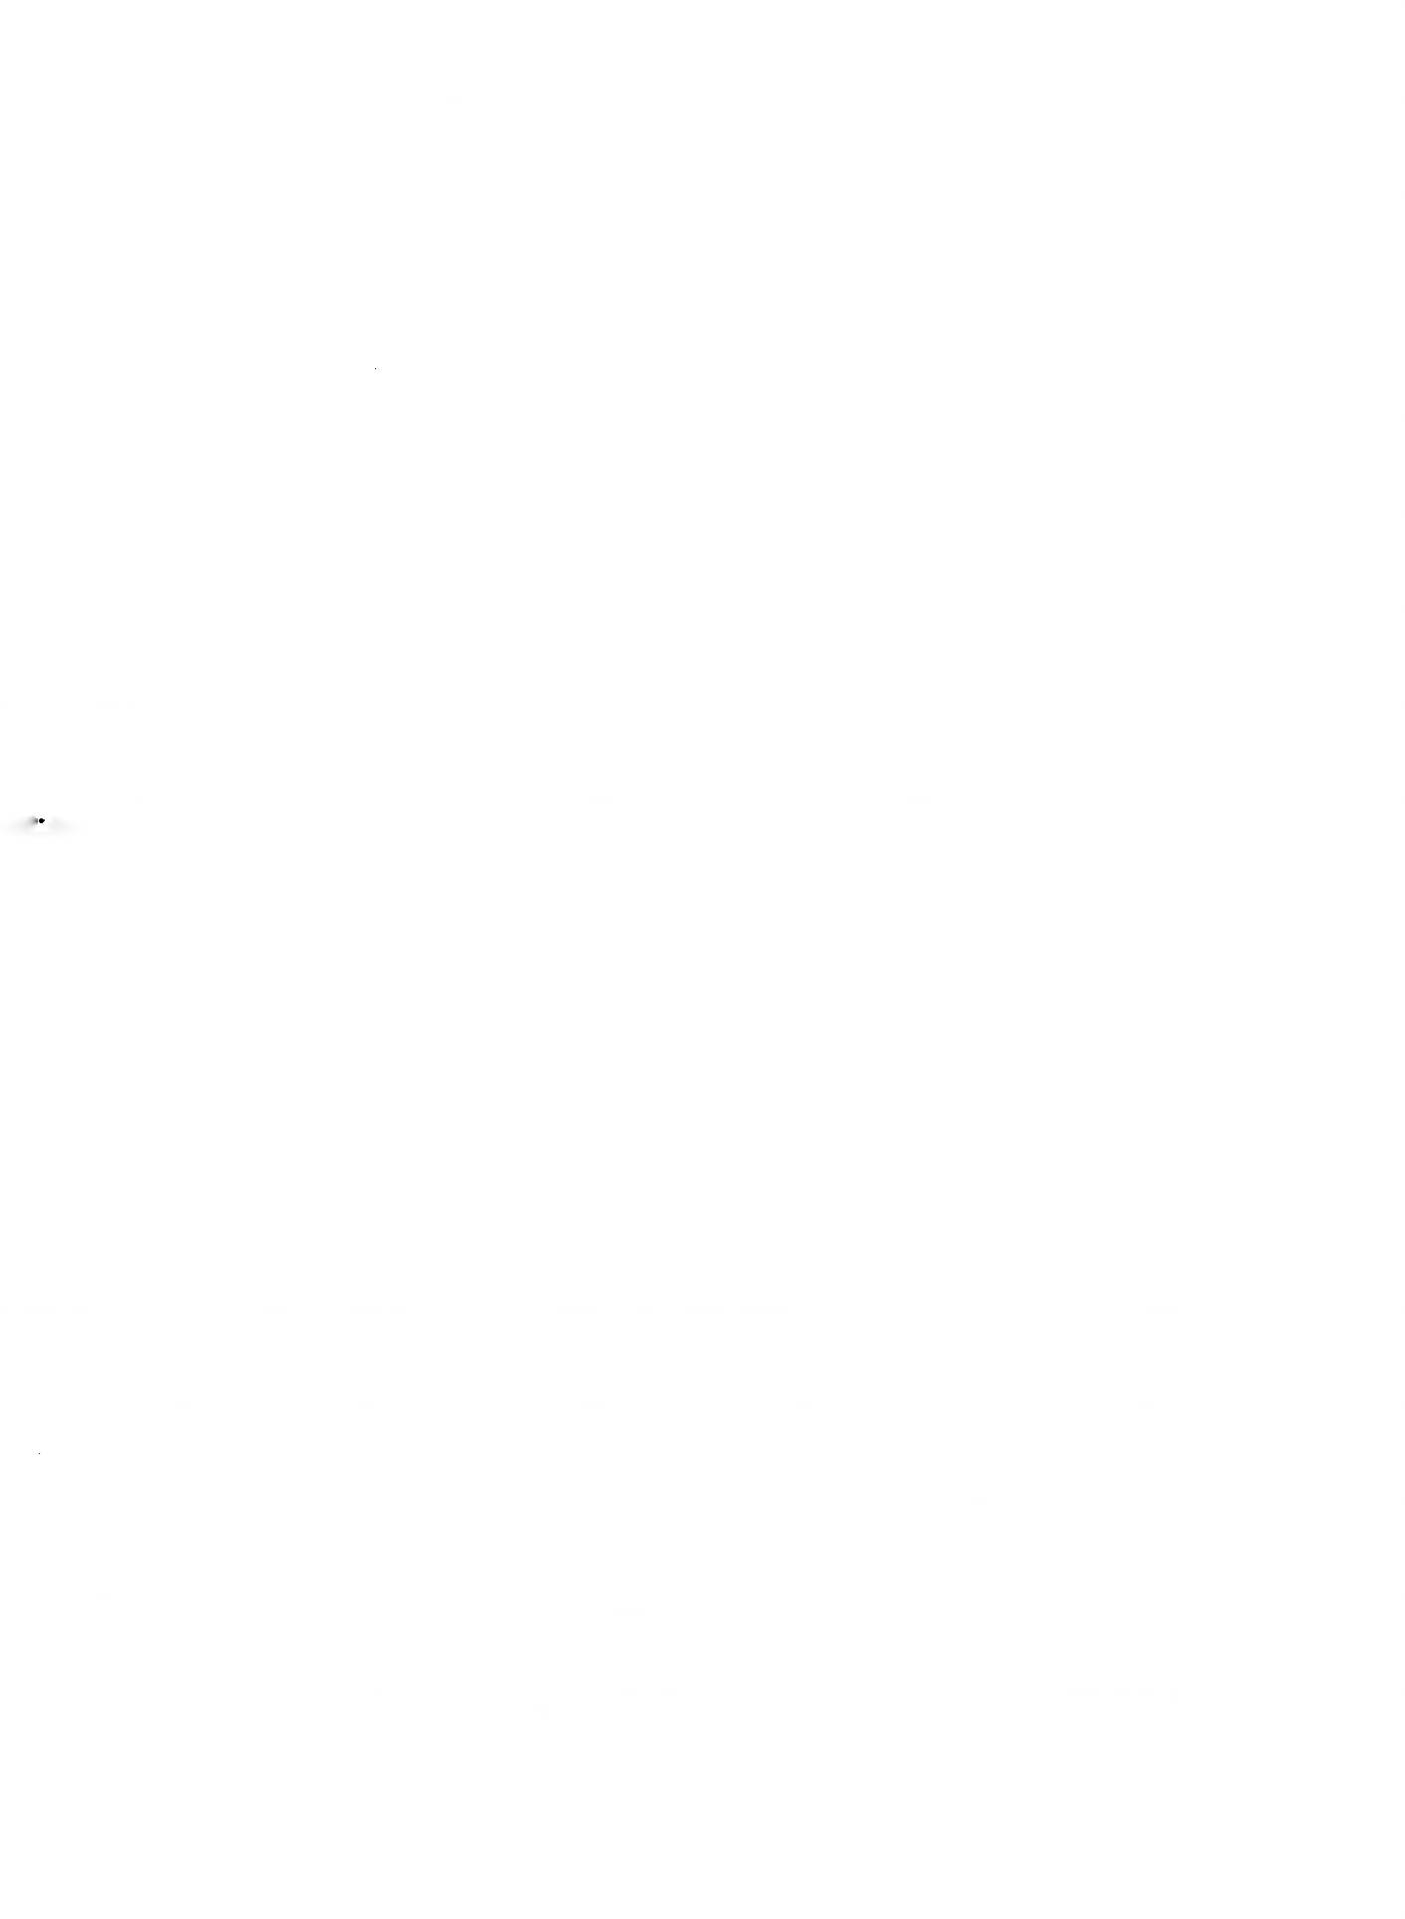
Lexical decomposition 255

- John caused Bill to die on Saturday by poisoning his cornflakes on Friday.
- ?John killed Bill on Saturday by poisoning his cornflakes on Friday.
- The lightning caused John to die when it struck the power cable supply ing his life-support machine.
- ?The lightning killed John when it struck the power cable supplying his
life-support machine.
One response to this sort of criticism is to say that semantic components are abstract elements in a semantic theory, with specific roles to play in modelling certain semantic phenomena. They are therefore not to be equated with the meanings of particular words, or indeed with any ‘surface’ meanings. A con sequence of this is that their presence or absence cannot be directly intuited: the correctness of an analysis can only be verified by its success in modelling the relevant phenomena. Wierzbicka strongly criticizes this approach and insists that semantic primitives must not be abstract, they must be accessible to direct intuition, and any proposed analyses should pass the test of native speaker judgements of plausibility. She dismisses analyses of the abstract var iety as not so much genuine analyses of meaning as translations into an arti ficial language (sometimes referred to in derogatory fashion as “markerese”) for which no one has any intuitions.

Bogus analyses
It has already been mentioned (in Chapter 8) that some pairs of words, like stallion.horse, wear, as it were, their hyponymous relationship on their sleeve, since one is readily definable in terms of the other (A stallion is a male horse), whereas for other hyponymous pairs, like horse'.animal (true taxonyms), no such definition is available. This fact casts some doubt on analyses such as:
horse = [AnimAL] [eQUine] and merits a closer look.
One objection to an analysis of this kind runs as follows. Consider, first, a specification of stallion as [Horse] [mALe] (leaving horse unanalysed for the moment). Suppose we remove the feature [mALe], what are we left with? Well, this is an intelligible question, and obviously we are left with [Horse]. Likewise, if we remove the feature [Horse], we are left with the feature [mALe]. In each case what remains is an intelligible portion of meaning. But look now at horse
= [AnimAL] [eQUine]. Removing [eQUine] is no problem: we are left with [Ani mAL]. But what happens if we remove [AnimAL]? What is left? In what sense does [eQUine] represent an intelligible portion of meaning in the absence of [AnimAL]? In fact, the only way of explaining what [eQUine] means is to relate it to horse\ [eQUine] = “pertaining to horses”. Hence, saying that horse = [AnimAL] [eQUine] is equivalent to saying “a horse is a horsey animal”. If this is an analysis at all, it clearly is of a different type from “a stallion is a male horse”.
256 Meaning in language

Universal vs. language-specific components

Many systems of componential analysis aim at universality (for instance, Wierzbicka’s), that is, the set of semantic components in terms of which meanings are to be expressed are part of our innate cognitive/linguistic cap acity, and should therefore be adequate for the description of any natural human language. It is worth pointing out, however, that the analytical methods of such as Hjelmslev and Pottier do not guarantee universality, since they are based on reduction and/or contrasts within a single language. Univer sality would have to be checked out separately, and that is no simple matter. (Wierzbicka always checks her components against as many languages as possible, but they are always, in principle, provisional.)

Finiteness and exhaustiveness
There is a basic incompatibility between the aims of finiteness and exhaustive ness in a componential analysis, and different theorists attempt to resolve the conflict in different ways.
A favourite strategy is to have limited aims. For instance, one could say that the function of semantic components is not to account for lexical meaning in all its richness, but only to explicate the syntactic properties of words.
The system devised by Katz and Fodor (1963) illustrates this sort of approach. First, what they set out to account for is limited to ambiguity, anomaly, and logical properties such as entailment and analyticity. Second, a distinction was proposed between those aspects of a word’s meaning which participated in systematic relations with other words, and an idiosyncratic, unanalysable, unsystematic residue which fell outside the scope of the analysis (some scholars consign this to a ‘pragmatic’ component of word meaning). The systematic aspects were to be exhaustively accounted for by a finite set of semantic markers drawn from a finite pool. For instance, one of the readings of the word bachelor had the following analysis:
bachelor = (AnimAL) (mALe) [young seal without a mate during the breed ing season]
(In Katz and Fodor’s system, semantic markers were indicated by round brackets, and semantic distinguishes by square brackets.) The distinction between markers and distinguishers was severely criticized because of unclear criteria, but one of the motives was to preserve finiteness. However, the aim of finiteness is compromised even with the specified limitations. Take the case of the colour terms. According to Katz and Fodor, these all possessed the marker (colour) and were distinguished from one another by distinguishers:
red = (colour) [red]
green - (colour) [green] and so on.


Lexical decomposition 257

It was pointed out, however, that this failed to predict anomalies such as This red paint is green. This could be averted by promoting the features distinguish ing different colours to marker status:
red - (colour) (red)
green = (colour) (green) and so on.
However, this would have the unfortunate consequence that every perceptually discriminable shade of colour would have to be assigned a marker, since they are all incompatible with one another, and all are potentially designated by lexical items. Extending this to all areas of the vocabulary would surely multi ply unacceptably the number of markers.
Limiting the role of components to the formalization of lexical contrasts, as in Pottier’s or Nida’s systems, would seem to guarantee a finite inventory. However, if we think that the lexemes of a language at any particular moment are just a selection from a vastly greater pool of potential words (is this finite?), any of which might enter the language at some point, then the notion of finiteness becomes less secure.
It is as well, too, to bear in mind an important distinction between a set of features which are sufficient to identify a lexeme (i.e. to distinguish it from all others), and a set of features which provide an exhaustive description of the meaning of a lexeme. An illuminating analogy is with identification keys for, say, wild flowers. Typically one is asked a series of questions, each one of which narrows down the choice until only one possibility remains. Let us suppose that questions asked establish that the plant has a prostrate habit, the leaves are grouped in threes on the stem, the flowers are red, and the petals have a triple notch at the end. Let us further suppose that only one species shows this particular set of characteristics. It is clear that this set of features, although adequate to identify our plant, do not in any way amount to a full description of the plant. The same is true of features of meaning: what is good enough for distinguishing from all other meanings does not ipso facto provide a specification of the meaning. Once the notion of ‘full description’ is raised, the notion of finiteness again begins to look shaky.
It is possible that some aspects of meaning are inherently not amenable to specification by means of a finite set of components. Plausible candidates for this status are properties which are continuously graded. Take the property of anomaly. It varies continuously from very slight, as in The baby is sad (N.B. The baby looks sad is normal) to extreme, as in Zebra-green gravity evaporates against tunnels of truth; it does not vary in discrete jumps. Katz and Fodor’s system gives us a simple dichotomous characterization of sentences as anom alous or not, but this is not how things are in reality. There is no way a finite set of components can model a continuously varying property. Similarly, the Katz and Fodor system gives a yes/no answer to the question of whether one sen tence entails another, rather than a point on a continuous scale of degree of
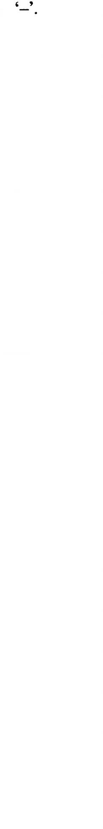
258 Meaning in language

necessity (see Chapter 3). Another important graded property is prototypical ity, or centrality in a category (see Chapter 7).

Binarism
Some systems of componential analysis insist on the binary nature of seman tic components, that is to say, components have one of two values, ‘+’ or
On this system, features are associated together in pairs. Take the case of “stallion” and “mare”, which we analysed earlier as [Horse] [mALe], and [Horse] [femALe], respectively. The features [mALe] and [femALe] form an obvi ous binary pair, and in the binary system we would need only one component which could have one of two values. However, we must decide whether it should be [+/-mALe] or [+/- femALe]. One most commonly sees [+/-mALe] in such circumstances. However, the convention in phonology is for the marked term of a binary contrast to carry the positive sign and the unmarked term to bear the negative sign. There are various reasons for claiming that the meaning “female” is the marked term of the “male”/“female” opposition. One is the fact that in a great many cases, the word from a related pair referring to a female is formed from the word referring to the corresponding male by the addition of a morphological mark in the form of an affix: prince!princess} lion! lioness} poetlpoetess} usher!usherette} waiter! waitress} conductor!conductress} etc. Cases where the word referring to a male is derived from the word refer ring to a female are extremely rare in English: widow!widower. A further indi cation of the marked nature of [femALe] is the fact that in general only the term referring to males can also have a generic use. So, for instance, actors can designate a group of males and females; actresses has no such use. This also applies where the terms are morphologically unrelated: dogs can be a mixed set, but not bitches} the man- of mankind embraces males and females. {Ducks and cows go against this tendency, but such cases are in the minority.) If, therefore, we follow the phonological convention, then stallion should be ana lysed as [Horse] [-femALe].
A strict adherence to binarist principles leads to a number of problems. Two will be mentioned here. First, how do we distinguish between for example horse, which is neither male nor female (it is commonly said in such cases that the contrast is neutralized), and for example table, which is also neither male nor female, but differs from horse in that the contrast is not even applicable? One solution is to allow something like a ‘zero’ value of the feature, which indicates a neutralization of the contrast. Adopting this possibility, we would simply not specify the feature at all for table—the feature is absent—whereas for horse we would include the feature in our analysis, but give the zero value (0), as in [Horse] [^femALe]. Notice, however, that in pure binarist terms this is cheating, as it involves a third value of the component.
A second problem arises when features apparently form a set consisting of more than two. Take the example of chair, where one of the features was [for

Lexical decomposition 259

siTTinG]. What are the implicit contrasts here? Well, we need at least [for sLeepinG] (to account for beds), [for sTorinG] (to account for cupboard), and [for eATinG AT] (not really satisfactory, but let it pass), for table. A binarist solution would be to divide these into two groups of two each, then further divide into two. But there does not appear to be a non-arbitrary way of doing this. A (not very plausible) suggestion might be to divide furniture into “human supporters” (chairs and beds) and “thing-supporters” (cupboards and tables). An even more difficult case would be to give a binary analysis of colour terms. It seems altogether more plausible to recognise that there are binary features and non-binary features, without trying to force everything into the same mould.
Even if a binarist system is not adopted, antonymous n-tuples containing only two members, like [mALe]/[femALe], need to be specially signalled, since words differentiated by only these features have special properties. For instance, they are likely to be not only incompatibles, but also complementa- ries, like man and woman. (It is worth pointing out that defining lexical complementaries on the basis of differentiation by features drawn from a two-member set of antonymous n-tuples results in a much larger class of complementaries than that defined in Chapter 9. For instance, brother and sister would be complementaries by the feature definition, but That's not my sister does not entail That's my brother, so they would not qualify as comple mentaries by the earlier definition. Generally speaking, the detailed properties of the different sorts of opposite are very hard to model adequately in terms of features.)

*6 How do components combine?
Most systems of lexical decomposition are very inexplicit about how the com ponents combine to form larger units of meaning. Weinreich advanced think ing somewhat by suggesting that the modes of composition for features were identical to those for words in sentences, and he introduced two basic modes of composition, according to whether the features in a compound formed clusters or configurations. In clusters, features combined in a Boolean fashion. This is, for instance, the way in which [Horse] and [mALe] combine in “stal lion”: anything which is both male and a horse is a stallion. Some features, however, combine more in the way in which a verb and its direct object com bine: the meaning of drink wine, for instance, is not formed in this way. Weinre ich suggested that the features [fUrniTUre] and [for siTTinG] combine in this way in the meaning of chair. Wierzbicka also has recognized this problem and, adopting a broadly similar approach, has begun to elaborate a basic universal semantic grammar which governs the processes of composition. It must be said, though, that, while equating the composition of components to that of words in sentences may well be a step forward, the latter remain deeply mys terious, and are still mostly taken for granted.
260 Meaning in language

What are the alternatives to lexical decomposition?


The question must be asked at some point whether there are any alternatives to semantic components: can we do without them in semantic analysis? There is no simple answer to this question. For some phenomena, there does seem to be an alternative. Take the case of entailment. Instead of saying that Ifs a dog entails Ifs an animal because all the components defining the meaning of dog are included in the set defining animal, why do we not simply state that the entailment holds? The description of the meaning of a word would then con sist (at least partly) of a statement of the entailments it gave rise to in various sentential contexts. Not all entailments would have to be explicitly stated: for instance, the fact that Ifs an alsatian entails Ifs an animal would follow auto matically from the fact that Ifs an alsatian entails It’s a dog, and the latter entails Ifs an animal', also, there could presumably be some schematization of sentential contexts, so that the entailments below would not have to be stated separately:

I saw a dog
I bought a dog I heard a dog
etc.
I saw an animal
I bought an animal I heard an animal

(I do not wish to minimize the difficulties of this, but it ought to be possible in principle.) One advantage of this approach would be that the description of word meaning could easily be opened up to include relationships with a lower degree of necessity than full logical entailment (componential analyses nor mally require full logical necessity). The result would then be little different from one type of prototype representation of word meaning (see Chapter 7). This is, essentially, the method of meaning postulates. Notice that meaning postulates presuppose nothing about atomicity, or the distinctness of bits of meaning, or, indeed, finiteness. Most things that can be said about word mean ing in componential terms (in addition to entailment) can also be said using meaning postulates. For instance, instead of saying that drink requires its direct object to possess the component [LiQUiD], we simply say that it must entail liquid (in suitable contexts). Antonymous n-tuples are automatically covered in the statements of entailments (e.g. Ifs red entails Ifs not green), instead of requiring a ‘special’ statement, as with a componential analysis.
Does this mean that componential analysis is completely dispensable? Well, not exactly. The prima-facie reasons for believing in semantic components given at the beginning of this chapter still stand, and a meaning postulate analysis gives no account of them. A meaning postulate analysis gives the same description of [mALe] as a component of stallion as of [eQUine] as a component of horse', the fact that the former is intuitively satisfying and well


lexical decomposition 261

supported, whereas the latter is ‘bogus’ receives no recognition. A possible conclusion from this line of argument is that ‘componentiality’ is a property of some, but not all, aspects of the meaning of some, but not all, words, and should be recognized in semantic descriptions. Of course, if this were accepted, there would be no place for a ‘componential theory of meaning’.

Discussion questions and exercises

Suggest a componential analysis of the following words along the lines of Pottier’s analysis of chair (remember that each feature should be motivated by a possible contrast within the field):
skirt book cottage teaspoon violin dream (v.) kiss(v.)

Suggestions for further reading

The earliest proposals for a componential approach to semantics can be found in Hjelmslev (1961). European structuralism subsequently developed a French version and a German variety. The main French exponent was Pottier (see Pottier 1974, and Tutescu 1975; Baldinger 1980 has a summary in English). For an account of the German variety of structuralism, see Coseriu (1975) and Geckeler (1971). Nida (1975), although purportedly a contribution to generative grammar, is very much in the spirit of European structuralism.
The earliest proposals for a componential semantics within the generative school were from Katz and Fodor (1963), which were further developed in Weinreich (1966) and Katz (1972). Current exponents are Jackendoff (e.g. 1983) and Pustejovsky (1995) (both of these are fairly technical, especially the latter).
The most recent account of Wierzbicka’s views on semantic primes is Wierzbicka(i996).
For sceptical views of the componential approach, see Bolinger (1965) and Sampson (1979); see also Taylor (1996) and Deane (1996) (whose target is JackendofFs system).

