I

Chapter 9

Meaning Components

9.1 Introduction

In chapter 3 we reviewed a range of lexical relations, including the MALE-
FEMALE and ADULT-YOUNG relations in sets of words like those below:

  - man-woman-child
dog-bitch-pup stallion-mare-foal
ram-ewe-lamb bull-cow-calf hog-sow-piglet

As we saw, these and other relations are characteristic of the lexicon. To ex plain this networking, some semanticists have hypothesized that words are not the smallest semantic units but are built up of smaller components of meaning which are combined differently (or lexicalized) to form different words.
Thus, to take perhaps the commonest examples in the literature, words like woman, bachelor, spinster and wife have been viewed as being composed of elements such as [ADULT], [HUMAN] etc.:

oman bachelor spinster wife
[FEMALE] [MALE] [FEMALE] [FEMALE]
[ADULT] [ADULT] [ADULT] [ADULT]
[HUMAN] [HUMAN] [HUMAN] [HUMAN]

[UNMARRIED] [UNMARRIED] [MARRIED]

260 Theoretical Approaches

The elements in square brackets in 9.2 above are called semantic compon ents, or semantic primitives and this kind of analysis is often called com- ponential analysis (CA for short). As we shall see in this chapter, there are three related reasons for identifying such components. The first is that they may allow an economic characterization of the lexical relations that we
Meaning Components 261
Similarly we might be able to deal with some kinds of antonymy, or more generally incompatibility, as in 9.7 below. The words spinster, bachelor, wife are incompatible and from a comparison of their components we might suggest a definition like 9.8:

looked at in chapter 3, and the sentence relations we discussed in chapter 4, like the contradiction between 9.3a and b below, or the entailment be tween 9.4a and b:
  - bachelor
spinster wife
[mALe]
[femALe] [femALe]
[ADULT] [HUmAn]
[ADULT] [HUmAn] [ADULT] [HUmAn]
[UnmArrieD]
[UnmArrieD] [mArrieD]

  - a. Ferdinand is dead.
b. Ferdinand is alive.

  - a. Henrietta cooked some lamb chops.
b. Henrietta cooked some meat.

In the next section, 9.2, we discuss how semantic components might be used to capture lexical relations, and in 9.3 we look briefly at Jerrold Katz’s semantic theory, a componential theory designed to capture such semantic phenomena.
A second, related, justification for semantic components is that they have
linguistic import outside semantics: that only by recognizing them can we accurately describe a range of syntactic and morphological processes. We look at this claim in section 9.4.The third and most ambitious claim is that in addition to these two important uses, such semantic primitives form part of our psychological, architecture: that they provide us with a unique view
  - Lexical items P, Q, R . . . are incompatible if they share a set of fea tures but differ from each other by one or more contrasting features.

Thus spinster is incompatible with bachelor by contrast of gender specifica tion; and with wife by the marital specification. Note that these definitions are not exact but are meant to give a general idea of how this approach might proceed. Componential analysts also often make use of binary fea tures and redundancy rules, which we can briefly describe.

    - Binary features

Many linguists use a binary feature format for these components, similar to that used in phonology and syntax. Our original examples will in this format be as below:

of conceptual structure. We look at two versions of this approach when we examine the work of Ray Jackendoff in section 9.6 and James Pustejovsky in 9.7.
woman
bachelor spinster wife
[+FEMALE] [-FEMALE] [+FEMALE] [+FEMALE]
[+ADULT] [+ADULT] [+ADULT] [+ADULT]
[+HUMAN] [+HUMAN] [+HUMAN] [+HUMAN]

[-MARRIED]
[-mArrieD]
[+MARRIED]

Lexical Relations in CA

One use for semantic components is that they might allow us to define the lexical relations we looked at earlier. Take, for example, hyponymy (inclu sion). Below we can see that spinster is a hyponym of woman, and their components might be given as shown:
Note that this allows a characterization of antonyms by a difference of the value plus or minus a feature, and so is considered a more economical for mat by many writers.

    - Redundancy rules

The statement of semantic components is also more economical if we include

  - woman spinster
[femALe] [femALe]
[ADULT] [HUmAn]
[ADULT] [HUmAn] [UnmArrieD]
some redundancy rules which predict the automatic relationships between components. An example of such a rule is:

We can see that by comparing the sets of components we could define hyponymy as:
  - A lexical item P can be defined as a hyponym of Q if all the features of Q are contained in the feature specification of P.
HUMAN ADULT ANIMATE MARRIED MARRIED
ANIMATE
—> ANIMATE
—> CONCRETE
—> ADULT
HUMAN etc.

262 Theoretical Approaches

If we state these rules once for the whole dictionary, we can avoid repeating the component on the right of a rule in each of the entries containing the component on the left: so every time we enter [HUmAn], for example, we don’t have to enter [AnimATe] . With redundancy rules like 9.10, an entry like 9.11a below for wife might be stated more economically as in 9.11b:
Meaning Components 263
The first two aims are met by having two components: firstly, a dictionary which pairs lexical items with a semantic representation; and secondly, a set of projection rules, which show how the meanings of sentences are built up from the meanings of lexical items. The third aim is partially met by the use of semantic components. We can look at the dictionary and the projec tion rules in turn.

  - a. wife
b. wife
[+FEMALE] [+HUMAN] [+ADULT] [+MARRIED] [+ANIMATE] [+CONCRETE], etc.
[+FEMALE] [+MARRIED]
9.3.2 The Katzian dictionary

To sum up: in this approach each lexical item will be entered in the diction ary with a complex of semantic components. There will be in addition a set of redundancy rules for these components which apply automatically to reduce the number of components stated for each item. Lexical relations can then be stated in terms of the components.

Katz’s Semantic Theory

    - Introduction

One of the earliest approaches to semantics within generative grammar was componential: it appeared in Katz and Fodor (1963), and was later refined, notably in Katz and Postal (1964) and Katz (1972):1 for simplicity we will refer to it as Katz’s theory. Two central ideas of this theory are:

      - Semantic rules have to be recursive for the same reasons as syn tactic rules: that the number of possible sentences in a language is very large, possibly infinite.
      - The relationship between a sentence and its meaning is not arbitrary and unitary, i.e. syntactic structure and lexical content interact so that John killed Fred and Fred killed John do not have the same meaning despite containing the same lexical elements; nor do The snake frightened Mary and The movie delighted Horace despite having the same syntactic structure. In other words, meaning is com positional. The way words are combined into phrases and phrases into sentences determines the meaning of the sentences.
i
Katz’s theory reflects this by having rules which take input from both the syn tactic component of the grammar, and from the dictionary. For these linguists the aims of the semantic component, paralleling the aims of syntax, are:

- to give specifications of the meanings of lexical items;
- to give rules showing how the meanings of lexical items build up into the meanings of phrases and so on up to sentences;
- to do this in a universally applicable metalanguage.
The details of the form of dictionary entries changed considerably during the development of this theory; we can risk abstracting a kind of typical entry for the most famous example: the word bachelor (adapted from Katz and Fodor 1963, Katz and Postal 1964):2 3

  - bachelor {N}
    - (human) (male) [one who has never been married]
    - (human) (male) [young knight serving under the standard of another knight]
    - (human) [one who has the first or lowest academic degree]
    - (animal) (male) [young fur seal without a mate in the breeding season]

The conventions for this entry are as follows. Information within curly brackets {>} is grammatical information; here simply that the four readings are all nouns. Our entry in 9.12 contains two types of semantic component: the first, the elements within parentheses (i), arc semantic markers. These are the links which bind the vocabulary together, and are responsible for the lexical relations we looked at earlier. The second type, shown within square brackets [t], are distinguishes. This is idiosyncratic semantic information that identifies the lexical item. So Katz and his colleagues built into their theory the common-sense idea that part of a word’s meaning is shared with other words, but part is unique to that word.

9.3.3 Projection rules

These rules are responsible for showing how the meaning of words combines into larger structures. Since this theory was designed to be part of a Chomskyan generative grammar, the rules interfaced with a generative syn tactic component. So typically the projection rules operated on syntactic phrase markers, or ‘trees’, as in figure 9.1. The projection rules used these trees to structure the amalgamation of word meanings into phrase meanings, and then phrase meanings into the sentence’s meaning. Again we can select a standard example from Katz and Fodor (1963) in figure 9.1. In this figure the subscripts (1-4) on the syntactic labels show the order of amalgamation of semantic readings, once the individual words had been attached to the


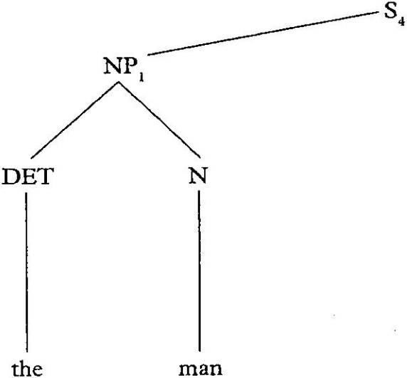
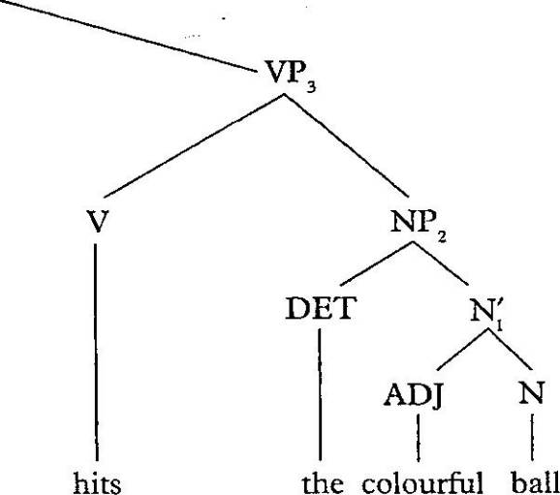
264 Theoretical Approaches

Figure 9.1 Projection rules

Source-. Katz and Fodor (1963)

bottom of the tree. To keep the figure readable, we just include the words, not their associated dictionary entries, which are of course what is actually being amalgamated; we’ll look at this fuller version a little later. Thus the projection rules begin at the bottom of the syntactic tree by amalgamating the semantic readings of the and man to give the semantics of the NP the man. Similarly, the rules combine the semantics of colourful and ball) then adds the semantics of the^ to form the NP the colourful ball. Thereafter the rules move up the tree combining elements until a semantic representation for the whole sentence The man hits the colourful ball is reached. We can see that these projection rules are clearly designed to reflect the compositionality of meaning.
The main constraint on the amalgamation processes involved in these rules is provided by selection restrictions. These are designed to reflect some of the contextual effects on word meaning. We can stay with the . same example and look at the dictionary entries for colourful and ball in 9.13 and
9.14 below, with the selectional restrictions shown on the adjective in angle
brackets < >:
  - colourful {ADJ}
    - (colour) [abounding in contrast or variety of bright colours]
<(physical object) or (social activity)>
    - (evaluative) [having distinctive character, vividness, or pictur esqueness] <(aesthetic object) or (social activity)>

  - ball {N}
    - (social activity) (large) (assembly) [for the purpose of social dancing]
    - (physical object) [having globular shape]
    - (physical object) [solid missile for projection by engine of war]
Meaning Components 265

Thus the dictionary provides two readings for colourful and three for ball; and as we noted, the selection restrictions which restrict co-occurrence are attached to the adjective. To see how this works we can observe that by simple arithmetic the two readings for colourful and the three for ball should produce six combinations for colourful ball. However some combinations are blocked by the selection restrictions: the second reading of colourful) being restricted to (aesthetic object) or (social activity) will not match the second or third readings for ball.
As the projection rules successively amalgamate readings, the selection restrictions will limit the final output. We will not spell out the process in any great detail here except to show one legal output of the amalgamation rules for figure 9.1:
  - The man hits the colourful ball.
[Some contextually definite] - (physical object) - (human) - (adult)
- (male) - (action) - (instancy) - (intensity) [strikes with a blow or missile] - [some contextually definite] - (physical object) - (colour) - [[abounding in contrast or variety of bright colours] [having globular shape]]
From this brief outline of the Katzian approach to meaning, we can see that an essential part of the theory is the attempt to establish a semantic metalanguage through the identification of semantic components: in simple terms, the theory is decompositional. It is these components that Katz (1972) uses to try to characterize the semantic relations of hyponymy, antonymy, synonymy, contradiction, entailment, etc. We can take just one example of this: Katz (1972: 40) provides the simplified dictionary entry for chair in 9.16:
  - chair
(Object), (Physical), (Non-living), (Artefact), (Furniture), (Portable), (Something with legs), (Something with a back), (Something with a seat), (Seat for one)
Katz argues that the internal structure of components in 9.16 can explain the entailment relation between 9.17 below and each of 9.18a-h:
  - There is a chair in the room.
  - a. There is a physical object in the room.
- There is something non-living in the room.
- There is an artefact in the room.
- There is a piece of furniture in the room.
- There is something portable in the room.
- There is something having legs in the room.
- There is something with a back in the room.
- There is a seat for one in the room.

266 Theoretical Approaches

This then is a semantic justification for meaning components: in the next section we review arguments that semantic components are necessary for the correct description of syntactic processes too.
Meaning Components 267

  - a. They shot the bandits.
b. They shot at the bandits.
Body part ascension construction:

Grammatical Rules and Semantic Components

As mentioned earlier, some linguists claim that we need semantic compon ents to describe grammatical processes correctly, i.e. that it is grammatically
  - a.
b.
  - a.
b.
Mary slapped Fred’s face. Mary slapped Fred in the face.
Igor tapped Lavinia’s shoulder.
Igor tapped Lavinia on the shoulder.

necessary to recognize that certain units of meaning are shared by different lexical items. Thus two verbs might share a semantic concept, e.g. moTion, or CAUse. We could reflect this in two complementary ways: one is by setting up verb classes, e.g. of motion verbs or causative verbs; the other is to factor out the shared element of meaning and view it as a semantic com ponent. In this section we review some components that have been proposed in the analysis of grammatical processes and we begin by looking at the basic methodology of this approach.

    - The methodology
To see the effect of these assumptions on methodology, we can look at an example from Beth Levin’s study of the semantics of English verbs (Levin 1993). As part of this study, she investigates the semantic features of four English verbs by examining their grammatical behaviour. The verbs are cut, break, touch, hit (Levin 1993: 5ff.). All four are transitive verbs as shown in:
  - a. Margaret cut the bread.
- Janet broke the vase.
- Terry touched the cat.
- Carla hit the door.
Levin looks at how these four verbs interact with three different construc tions which are usually seen as involving alternations of argument structure: middle constructions as in 9.20;3 conative constructions involving at, as in the b sentences in 9.21 and 9.22; and what she terms body part ascen sion constructions, as in the b sentences in 9.23 and 9.24:
Middle construction:
  - a. These shirts wash well.
b. This car drives very smoothly.
Conative construction:
  - a. He chopped the meat,
b. He chopped at the meat.
As Levin’s examples in 9.25-7 below show, not all of these four verbs occur in each of these constructions:
  - Middle
    - The bread cuts easily.
    - Crystal vases break easily.
    - *Cats touch easily.
    - *Door frames hit easily.
  - Conative
    - Margaret cut at the bread.
    - *Janet broke at the vase.
    - *Terry touched at the cat.
    - Carla hit at the door.
  - Body part ascension
    - Margaret cut Bill’s arm.
    - Margaret cut Bill on the arm.
    - Janet broke Bill’s finger.
    - *Janet broke Bill on the finger.
    - Terry touched Bill’s shoulder.
    - Terry touched Bill on the shoulder.
    - Carla hit Bill’s back.
    - Carla hit Bill on the back.
In fact the four verbs have distinct patterns of occurrence with the three grammatical processes, as shown in 9.28 (Levin 1993: 6-7).

 | touch | hit | cut | break
Conative | No | Yes | Yes | No
Body-part ascension | Yes | Yes | Yes | No
Middle | No | No | Yes | Yes

On the basis of this grammatical behaviour, the semanticist can hypothesize that each of these verbs belongs to a different set, and indeed further

268 Theoretical Approaches
investigations of this sort would confirm this. Other verbs which belong to these sets are shown in 9.29:

  - a. Break verbs: break, crack, rip, shatter, snap . . .
- Cut verbs: cut, hack, saw, scratch, slash. . .
- Touch verbs: pat, stroke, tickle, touch. . .
- Hit verbs: bash, hit, kick, pound, tap, whack. . .

We have dealt with this example at length because it provides an example of how verb classes can be set up within this type of approach. The next move in a decompositional approach, as we described earlier, would be to try to establish what meaning components might be responsible for this bunching of verbs into classes. Levin’s conclusion, based on further analysis, is as in 9.30 (1993: 9-10):

  - touch is a pure verb of contact, hit is a verb of contact by motion, cut is a verb of causing a change of state by moving something into contact with the entity that changes state, and break is a pure verb of change of state.

This might provide us with the semantic components in 9.31 below; and suggests that whatever other elements of meaning they might contain, we might analyse these four verbs as in 9.32:

  - CHANGE, MOTION, CONTACT, CAUSE

cut CAUSE, CHANGE,CONTACT, . MOTION
break CAUse, CHAnGe
touch CONTACT
hit CONTACT, MOTION

So from a componential point of view, the presence of these different semantic components in these verbs causes them to participate in different grammat ical rules. It follows then that correctly identifying the semantic components of a verb will help predict the grammatical processes it undergoes.
Of course the semantic components identified in 9.32 are only part of the meaning of these verbs. For a discussion of the relationship between these components and other elements of a verb’s meaning, see Pinker (1989: 165ff.) and his ‘Grammatically Relevant Subsystem’ hypothesis. This hypo thesis is that only some components of a word’s meaning, such as those in 9.32, which are shared by a number of words, are relevant to grammatical processes; other item-specific elements are not. Pinker gives the example of the English verb to butter (Pinker 1989: 166):

  - Thus a verb like to butter would specify information about butter and information about causation, but only the causation part
Meaning Components 269

could trigger or block the application of lexical rules or other lin guistic processes.

We can perhaps liken this distinction among semantic information to Katz’s distinction, discussed earlier, between semantic markers and distinguishers. Components like those in 9.32 which form part of Pinker’s grammatically relevant subset would correspond to Katz’s markers, though Pinker’s focus is on lexical rules rather than lexical relations. It is clear that Pinker, along with other writers, considers the grammatically relevant subset to be the main focus of research into language universals and language acquisition. The aim is to establish:

  - a set of elements that is at once conceptually interpretable, much smaller than the set of possible verbs, used across all languages, used by children to formulate and generalize verb meanings, used in specifically grammatical ways (for example, being lexicalized into closed-class morphemes), and used to differentiate the narrow classes that are subject to different sets of lexical rules. (Pinker 1989: 169)

A number of different terms have been used to make this binary distinction in the meaning of lexical items, including the following:

  - Grammatically relevant subsytem versus unrestricted conceptual representation (Pinker 1989)
Semantic structure versus semantic content (Grimshaw 1994) Semantic form versus conceptual structure (Wunderlich 1997) Semantic structure versus conceptual structure (Mohanan and Mohanan 1999)

    - Thematic roles and linking rules

Semantic components have been used to investigate several areas of the syntax-semantics interface. It has been claimed for example that they might allow a more satisfactory account of the interaction of verbal argument structure with the thematic roles discussed in chapter 6. There we dis cussed the mapping between a verb’s syntactic arguments, like subject and object, and its thematic roles like AGenT and pATienT. One problematic area much discussed in the literature is the mapping of thematic roles in various types of what have been called locative alternation verbs (Rappaport and Levin 1988, Pinker 1989, Levin and Rappaport Hovav 1991, Gropen et al. 1991). In chapter 6 we discussed a subset of these, the spray!load verbs which allow the alternation shown below:

  - a. He loaded newspapers onto the van.
b. He loaded the van with newspapers.

270 Theoretical Approaches
  - a. She sprayed pesticide onto the roses.
b. She sprayed the roses with pesticide.

The description we proposed there is that the speaker can choose between alternate mappings, or linkings, between grammatical and theta-roles: in
9.36a and 9.37a the direct object represents the THEME, while in 9.36b and
9.37b it is the GoAL. As has been pointed out in the literature (e.g. Anderson 1971), however, this analysis overlooks a semantic difference between a and b sentences, namely that in the b versions there is an interpretation of completeness: the van is completely loaded with newspapers and the roses are all sprayed with pesticide. This is not true of the a sentences. The difference is not explicable in our description of alternate mappings to theta-roles.
Other problems arise when we try to characterize similar variations in
other movement-to-location verbs. Rappaport and Levin (1985), Pinker (1989) and Gropen et al. (1991) discuss locative verbs like/war, which des cribe an agent moving something into or onto a place, for example:

  - Adele poured oil into the pan.

In a theta-role analysis we would describe a linking pattern of AGenT, THeme and GoAL mapping into subject, direct object, and prepositional phrase, respectively. Some verbs, like pour, show this linking and do not allow the GoAL to be direct object, as we can see in 9.39:
"S.,
  - *Adele poured the pan with oil.

Other verbs, however, like fill, reverse this pattern:

  - a. Adele filled the pan with oil.
b. *Adele filled the oil into the pan.

Here the GoAL is direct object and the THeme must be in a prepositional phrase. Still other verbs, like brush, allow both mappings as alternatives:

  - a. Adele brushed oil onto the pan.
    - Adele brushed the pan with oil.

It is not clear that a simple listing of mappings to theta-roles sheds any light on these differences. We might have to simply list for each verb an idiosyn cratic theta-grid. Levin, Rappaport Hovav, Pinker and other writers have argued that this approach would ignore the fact that verbs form natural classes and that we can make general statements about how these classes link to certain argument structure patterns. It is proposed that a more
Meaning Components 271

satisfactory account of the semantic-syntax interface requires a finer-grained analysis of verbal semantics and that a decomposition of the verb’s meaning is the answer.4
Rappaport and Levin (1985), for example, and Pinker (1989), propose that the variation in argument structures in 9.38-41 reflects different semantic classes of verb, as in 9.42 and 9.43:

  - Verbs of movement with the semantic structure ‘X causes Y to move into/onto Z’:
- Simple motion verbs, e.g. put, push.
- Motion verbs which specify the motion (especially manner),
e.g. pour, drip, slosh.

  - Verbs of change of state with the semantic structure ‘X causes Z to change state by means of moving Y into/onto it’, e.g. fill, coat, cover.

The verb class in 9.42 typically has an argument structure where the THeme argument occurs as object and the GoAL argument occurs in an into! owro-prepositional phrase as in 9.44:

  - a. Ailbhe pushed the bicycle into the shed.
    - Harvey pulled me onto the stage.
    - Joan poured the whiskey into the glass.

The verb class in 9.43 typically has an argument structure where the pATienT occurs as the object and what we might call the insTrUmenT5 occurs in a wzrA-prepositional phrase as in 9.45:

  - a. Joan filled the glass with whiskey.
    - Libby coated the chicken with oil.
    - Mike covered the ceiling with paint.

A third semantic class has the characteristics in 9.46:

  - Verbs of movement which share the semantic structure ‘X causes Y to move into/onto Z’ with the verbs in 9.41 and thus can have the same argument structure, but which also describe a kind of motion which causes an effect on the entity Z, e.g. spray, paint, brush.

This third class allows the speaker a choice: either to emphasize the move ment, thus giving the argument structure in 9.47a below, shared with verbs in 9.42, or to focus on the change of Z’s state, giving the argument structure

272 Theoretical Approaches

in 9.47b below, shared with 9.43. This choice is what has been termed
locative alternation.

  - a. Vera sprayed paint onto the wall.
b. Vera sprayed the wall with paint.
The authors whose work we have cited here would argue that the mapping between individual verbs and particular argument structures, and phenomena like locative alternation, can only be described by investigating the internal semantic structure of the verbs.
A similar pattern occurs with locative verbs describing removal (Levin
and Rappaport Hovav 1991), where we find related verbs like clear, wipe and
remove-.
  - Robert cleared ashtrays from the bar.
  - Christy wiped the lipstick from the glasses.
  - Olivia removed the empties from the crate.
Once again an assumption of a canonical mapping between AGenT—subject, THEME-direct object and souRCE-prepositional phrase will not adequately characterize the behaviour of these verbs. See 9.51-3 below, for example:
  - Robert cleared the bar.
  - Christy wiped the glasses.
  - ?Olivia removed the crate.
In 9.51 and 9.52 clear and wipe allow the soUrCe as direct object, and the THeme to be missing; but remove does not allow this pattern: 9.53 is semant ically different and cannot mean that Olivia took something from the crate. Another pattern allowed by clear also has the soUrCe as direct object but retains the THeme in an o/-phrase:
  - Robert cleared the bar of dishes.
  - ?Christy wiped the glasses of lipstick.
  - ?Olivia removed the crate of empties.

As we can see from 9.55, wipe is less acceptable with this pattern and again remove does not permit it: sentence 9.56 cannot mean that Olivia took empties out of the crate. Again, the proposal is that these differences in syntactic argument structure reflect three semantic classes of removal verb (Levin and Rappaport Hovav 1991: 129):
Meaning Components 273
  - Clear verbs: clear, clean, empty.
Wipe verbs: buff, brush, erase, file, mop, pluck, prune, rake, rinse, rub, scour, scrape, scratch, scrub, shear, shovel, sponge, sweep, trim, vacuum, wipe, etc.
Remove verbs: dislodge, draw, evict, extract, pry, remove, steal, uproot, withdraw, wrench, etc.

Here again it seems that we might be missing something if we describe the differences between these verbs simply by listing alternate mappings be tween syntactic functions and theta-roles. Levin and Rappaport Hovav sug gest setting up semantic verb classes, which we can represent as in 9.58-60 below:

  - Verbs of removal with the semantic structure ‘X causes Y to go away from Z’, e.g. remove, take.

  - Verbs which share the same semantic structure ‘X causes Y to go away from Z’ but include specification of the means of removal, either:
- the manner of removal, e.g. wipe, rub, scrub', or
- the instrument of removal, e.g. brush, hose, mop.

  - Verbs which have the semantic structure ‘X causes Z to change by removing Y’, i.e. change of state verbs which focus on the resultant state, e.g. clear, empty, drain.

As we saw in our examples 9.48-56 above, each semantic class has a different pattern of syntactic argument structure. The remove verbs in 9.58 have the THEME as direct object and the soUrCe in a /row-prepositional phrase, and no other pattern. The wipe verbs in 9.59 occur with the same pattern but can also occur with the soUrCe as direct object and no overt THeme. Finally the clear verbs in 9.60 allow an alternation between two patterns: the first is the argument structure shared with the other two classes, where the THeme is direct object and the soUrCe is in a /row-prepositional phrase, and the second is where the soUrCe occurs as direct object and the THeme in an (/-prepositional phrase. The reader can check these patterns against the sentences in 9.48-56.
Clearly there are generalizations to be made about the way that change
of state verbs in both the spray-type class earlier and the clear-type class here allow a locative alternation; see Pinker (1989) and Levin and Rappaport Hovav (1991, 2005) for discussion. For now we can see the force of the claim that only an examination of the verb-internal semantic structure allows the analyst to correctly characterize these variations in verbal argument structure. Semantic components, it is argued, allow us to give a motivated explanation of the links between individual verbs, their argument structures, and the alternations they undergo.

274 Theoretical Approaches

Components and Conflation Patterns

A similar research programme of using semantic components to charac terize the syntax-semantics interface has been followed by Leonard Talmy (1975, 1983, 1985), who has studied how elements of meaning are com bined not only in single words but across phrases. Talmy has for example identified semantic components associated with verbs of motion. These include the following (Talmy 1985: 60-1):
  - the Figure: an object moving or located with respect to an
other object (the Ground);
the Motion: the presence per se of motion or location in the event;
the Path: the course followed or the site occupied by the Figure object with respect to the Ground object;
the Manner: the type of motion.

Thus in 9.62:
  - Charlotte swam away from the crocodile.

Charlotte is the Figure; the Ground is the crocodile', the Path is away from’, and the verb encodes the Manner of motion: swam. In 9.63 below:
’x.
  - The banana hung from the tree.

the banana is the Figure; the tree is the Ground; from is the Path; and Manner is again expressed in the verb hung.
Talmy has pointed out differences between languages in how these sem antic components are typically combined or conflated in verbs and yerb phrases, comparing for example how Path and Manner information is con flated in English, as in 9.64 below, and Spanish, as in 9.65:
Meaning Components 275
phrase. This strategy for the verb is schematically represented as in 9.66 below:

  - Conflation of Motion with Manner (Talmy 1985: 62) Figure Motion Path Ground Manner/Cause

I
<surface verbs>

Other examples of this pattern from English are in 9.67:

  - a. The flag drooped on the mast.
    - The ball spun across the line.
    - She pirouetted out of the lecture hall.
    - They rolled the beer keg into the seminar.

In the Spanish sentences in 9.65 the information is differently packaged: the Path is encoded in the verb and the Manner is encoded in external phrases. The conflation in the verb can be represented as in 9.68:

  - Conflation of Motion with Path (Talmy 1985: 69)
Figure Motion Path Ground Manner/Cause

[move
[be located

<surface verbs >

  - a.
b.

  - a.

b.

He ran out of the house. He ran up the stairs.

Salio de la casa corriendo. left from the house running ‘He ran out of the house.’ Subio las ecaleras corriendo. went-up the stairs running ‘He ran up the stairs.’
Some further examples of this from Spanish are in 9.69 (Talmy 1975, 1985):

  - a. La botella entro a la cueva (flotando). the bottle moved-in to the cave (floating) ‘The bottle floated into the cave.’
    - La botella saZto de la cueva (flotando). the bottle moved-out from the cave (floating) ‘The bottle floated out of the cave.’
    - El globo subio por la chimenea (flotando).

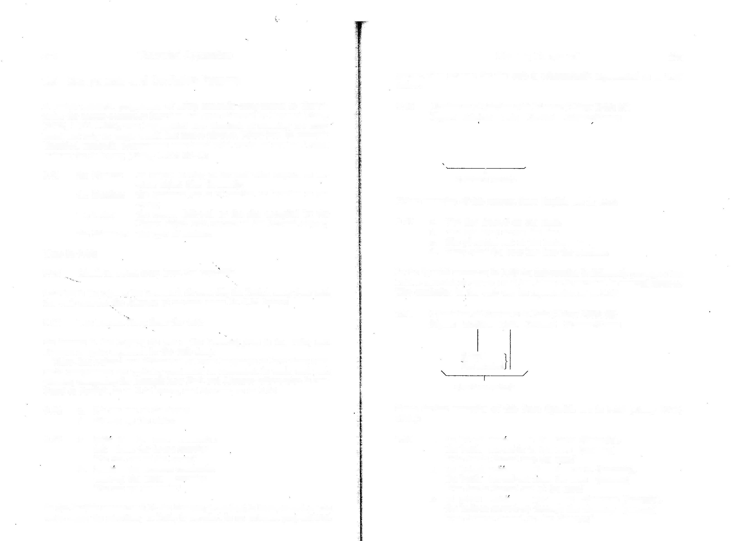
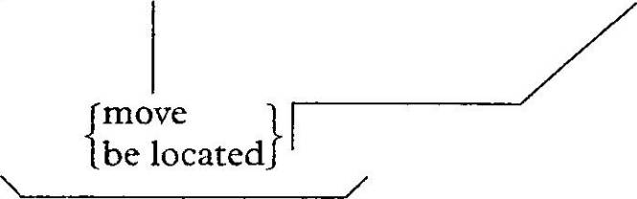
In the English sentences 9.64 the Manner, ‘running’, is incorporated in the verbs while the direction, or Path, is encoded in an external prepositional
the balloon moved-up through the chimney (floating) ‘The balloon floated up the chimney.’

27S Theoretical Approaches

    - Meti el barril a la bodega rodandolo. I moved in the keg to the storeroom rolling it ‘I rolled the keg into the storeroom.’
    - Quite el papel del paquete cortandolo.
I moved off the paper from the package cutting it ‘I cut the wrapper off the package.’

A third possible pattern of conflation combines the Figure with the Motion: that is, instead of information about Manner - about how something is moving - being incorporated into the motion verb, as in English running! swimming/hopping!cartwheeling etc. into the cave, such a pattern would include information about what is moving. Talmy (1985) identifies the Californian
Hokan language, Atsugewi as a clear instance of this pattern, and he in cludes the following examples (p. 73):
Meaning Components 277

Literal meaning: ‘Runny icky material is located on the
ground from its own weight acting on it’ Instantiated: ‘Guts are lying on the ground’
This pattern is represented schematically as in 9.72 (Talmy 1985: 73):

  - Conflation of Motion with Figure
Figure Motion Path Ground Manner/Cause

f move 1
\
[be located J
\
I, /
<surface verbs>

  - Atsugewi verb roots of Motion with conflated Figure
-lup- ‘for a small shiny spherical object (e.g. a round candy, an eyeball, a hailstone) to move/be-located’
-t1- ‘for a smallish planar object that can be functionally af fixed (e.g. a stamp, a clothing patch, a button, a shingle, a cradle’s sunshade) to move/be-located’
'-caq- ‘for a slimy lumpish object (e.g. a toad, a cow dropping) to move/be-located’
-swal- ‘for a limp linear object suspended by one end (e.g. a shirt on a clothesline, a hanging dead rabbit, a flaccid penis) to move/be-located’
-qput- ‘for loose dry dirt to move/be-located’
-st'aq1- ‘for runny icky material (e.g. mud, manure, rotten toma toes, guts, chewed gum) to move/be-located’

In Atsugewi, then, semantic features of the Figure are encoded in the verbs

Talmy (1985) suggests that languages can be classified into different types, depending upon how their semantic components characteristically map into grammatical categories such as verbs. The word characteristically is used here to identify a normal or unmarked6 pattern in the language:
  - Any language uses only one of these types for the verb in its most characteristic expression of Motion. Here, ‘characteristic’ means that: (i) It is colloquial in style, rather than literary, stilted, etc. (ii) It is frequent in occurrence in speech, rather than only occasional,
(iii) It is pervasive, rather than limited, that is, a wide range of semantic notions are expressed in this type. (Talmy 1985: 62)
The idea is that languages fall into different types on the basis of their pat terns of conflation, and thus a classification or typology can be set up, as in 9.74 (based on Talmy 1985: 75):

of motion. Spherical Figures, for example, occur with a different verb than small flat Figures, and so on. We can select just one of Talmy’s examples of how these verb roots and other elements build into an Atsugewi verb (1985: 74):
  - Language/Language Family
    - Romance, Semitic, Polynesian,
Nez Perce,
Verb conflation pattern
Path + fact-of-Motion

- Morphological elements: locative suffix: -ik- instrumental prefix: uh-

inflectional affix-set: '-w- -a

‘on the ground’
‘from “gravity” (an object’s own weight) acting on it’
‘3rd person subject (factual mood)’
Caddo
- Indo-European except Romance,* Chinese
- Atsugewi and all of North Hokan,* Navajo
* as far as has been investigated
Manner/Cause 4- fact-of-Motion Figure + fact-of-Motion

    - Combined underlying form
/'-w-uh-st'aq'-ik--31/
    - Pronounced as [w'ost'aq'ik-a]
On the basis of this research Talmy (1991, 2000) has proposed an influential typological distinction between verb-framed and satellite-framed lan guages, where the distinguishing feature is how the surface elements signify the Path element of motion events. In a satellite-framed language like English

278 Theoretical Approaches

the typical verb of motion incorporates Motion with Manner (or Cause), but not Path. Such a language may have a large number of Path satellites. In a verb-framed language like Spanish the typical verb of motion incorpor ates Motion with Path. See Talmy (2000), Berman and Slobin (1994) and Slobin (2004) for discussion.
Talmy’s work has led to a number of cross-linguistic studies of how seman
tic components are conflated into lexical and grammatical structures, for example Choi and Bowerman’s (1992) comparison of how Korean and English-speaking children learn verbs and Ozyurek and Oz$ah§kan’s (2000) study of Turkish and English-speaking children.
In the last two sections we have looked at investigations into how semantic components influence grammatical processes and grammatical structures. Next we look at work which builds on this to propose that such semantic components are part of our conceptual structure.

Jackendoff's Conceptual Structure

    - Introduction

The semanticist Ray Jackendoff has, in a series of works (e.g. 1972, 1983, 1987, 1990, 1992), developed a decompositional theory of meaning which he calls conceptual semantics. The central principle of this approach is that describing meaning involves describing mental representations; in Jackendoff (1987: 122) this is called the Mentalist Postulate:

  - Meaning in natural language is an information structure that is mentally encoded by human beings.

So the meaning of a sentence is a conceptual structure. Since Jackendoff also believes that sentence meaning is constructed from word meaning,7 a good deal of attention is paid to lexical semantics in this approach.
Jackendoff endorses the justifications for semantic components discussed in the previous sections. These components are seen as having an important role in describing rules of semantic inference. He argues, for example (1990: 39ff.), that a major argument for identifying a semantic component CAUse is economy. One of the aims of a semanticist is to explain the relationship between the sentences below:

  - George killed the dragon.

  - The dragon died.

As we saw in earlier chapters, the label entailment is used for this relation: to recognize a speaker’s intuitions that if 9.76 is true then so 9.77 must be;
Meaning Components 279

or to put it another way, just from hearing 9.76, we know 9.77.8 Jackendoff’s argument is that if our analysis remains above the level of the word, all we can do for 9.76 and 9.77 above is recognize the relationship between the two words kill and die, as in 9.78:

  - x killed y entails y died

However we then have to have similar but distinct rules for lots of other pairs, including:

  - a. x lifted y entails y rose
- x gave z to y entails y received z
- x persuaded y that P entails y came to believe that P

Jackendoff claims that to do this is to miss a generalization: namely that all such cases share the schema:

  - x cause E to occur entails E occur

In other words, there is a semantic element CAUse which occurs in many lexical items and which, as a result, produces many entailment relations.
Jackendoff’s work also shares the aims of Levin and others, as described in section 9.4, that semantic decomposition can be used to investigate the mapping between semantics and grammatical processes. We shall see later in this section examples of conceptual structure being used to describe grammatical rules and structures.

    - The semantic components

Jackendoff’s work identifies an inventory of universal semantic categories, or concepts, which include: Event, State, Material Thing (or Object), Path, Place, and Property.9 At the level of conceptual structure a sentence is built up of these semantic categories. The two basic conceptual situations are Event and State, and if we look at examples of these, we can see some thing of the role of the other semantic components. We can show an exam ple of an Event by looking at a sentence describing motion: 9.81 below gives first the syntactic structure, 9.81a, then the conceptual structure, 9.81b, of the same sentence Bill went into the house (Jackendoff 1992: 13):

  - a. [s [np Bill] [vp [v went] [PP [P into] [NP the house]]]]
b. [Event GO ([TOing BILL], [path TO ([place IN ([^ HOUSE])])])]

The structure in 9.81b concentrates on the semantics of motion and thus the entity (or ‘Thing’) the house is given as an unanalysed atom of meaning. Jackendoff is claiming here that the motion event in 9.81 has three main

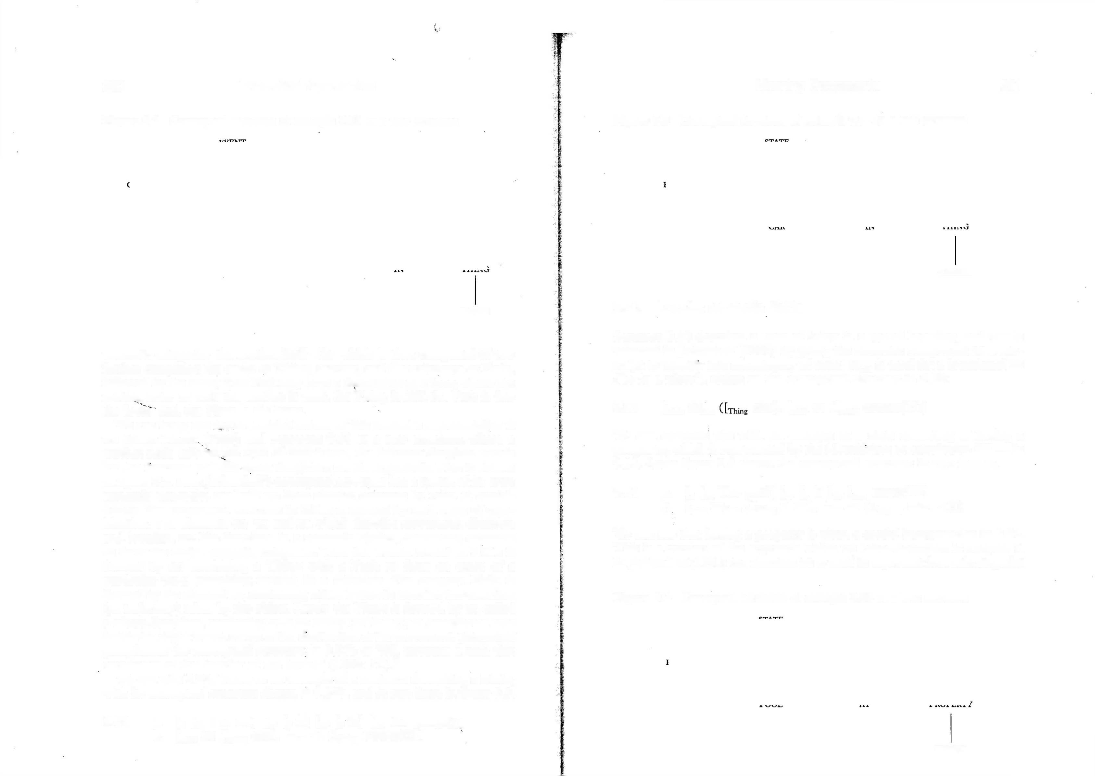
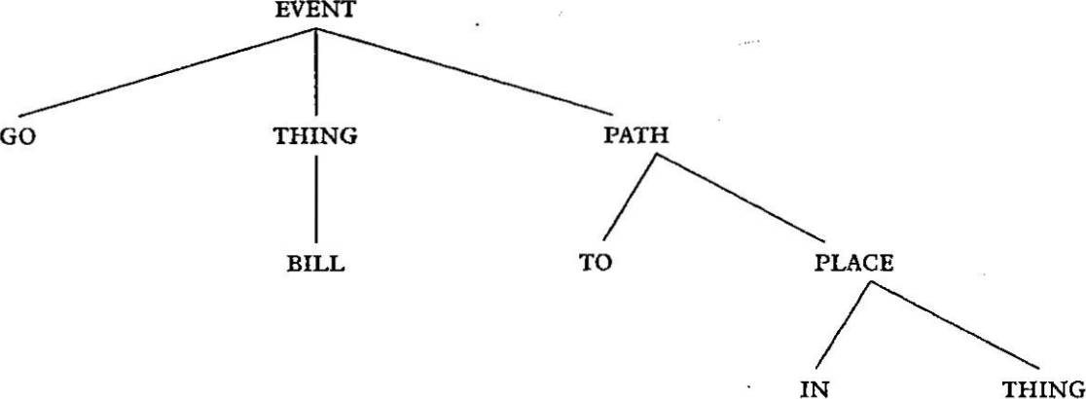
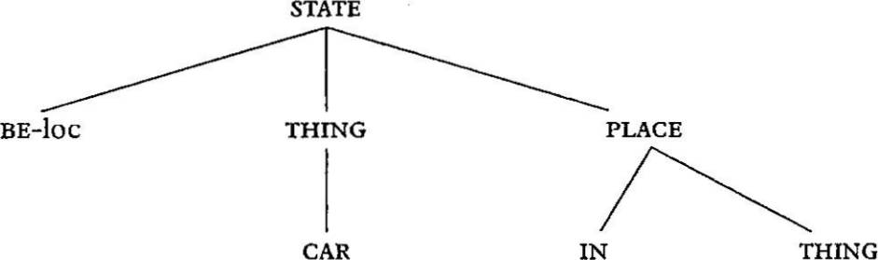
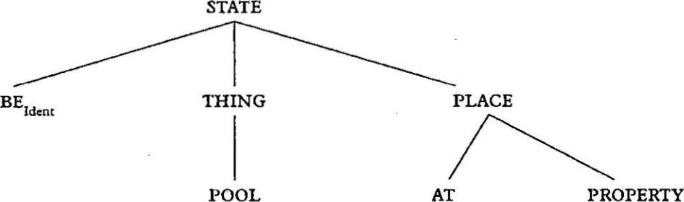
280 Theoretical Approaches

Figure 9.2 Conceptual structure of example 9.81 as a tree structure

HOUSE

semantic categories: the motion itself^ Go, which is then composed of two further categories: the entity or Thing, moving, and the trajectory, or Path, followed by the entity. This Path may have a destination or Place, where the motion ends. In 9.81 the motion is went, the Thing is Bill, the Path is into the house, and the Place is the house.
We can bring out the articulated nature of this semantic representation if we follow Pinker (1989) and represent 9.81 as a tree structure, where a mother node tells us. the type of constituent, the leftmost daughter stands for the function and tfie other daughters are its arguments. This is shown in figure 9.2. Thus Jackendoff’s conceptual structure has a syntax of its own: semantic categories are built up from simpler elements by rules of combi nation. The conceptual structure in 9.81b is formed by such rules of com bination. The elements Go, To and IN, which describe movement, direction and location, act like functions in a semantic algebra, combining elements to form the major semantic categories. Thus the overall Event in 9.81b is formed by GO combining a Thing with a Path to form an event of a particular type: something moving in a direction. The category Path is formed by the element TO, combining with a Place to describe the direction (or trajectory) taken by the object. Lastly, the Place is formed by in, called a place-function, combining with an entity (or ‘thing’) to describe an area inside the object which serves as the destination of the movement. Jackendoff paraphrases the conceptual structure in 9.81b as ‘Bill traverses a path that terminates at the interior of the house.’ (1992: 13).10
We can take 9.82a below as an example of a sentence describing a State,
with its conceptual structure shown in 9.82b, and in tree form in figure 9.3.

  - a. [s [np The car] [VP [v is] [PP [P in] [^ the garage]]]]
b. [state BE ([^ CAR], [Place IN ([^g GARAGE])])]
Meaning Components 281

Figure 9.3 Conceptual structure of example 9.82 as a tree structure

GARAGE

    - Localist semantic fields

Sentence 9.82 describes a state of being in a spatial location, and this is reflected in Jackendoff (1990) by giving the semantic component BE a sub script to identify this subcategory of state: BE^ is used for a locational Be (‘be in a place’), giving us the conceptual structure in 9.83:

9-83 [Sta„ BEj^ CAR], [Place IN ([rang GARAGE])])]
We can compare this with an example of a state consisting of having a
property, which is represented by the identifying or copulative BEIden[ in
9.84. Again figure 9.4 shows the conceptual structure in tree format.

  - a. [s [NP The pool] [w [v is [AP [ADJ empty]]]]]
b« [state BEWent ([Thing POOL], [place AT ([property EMPTY])])]

We can see that having a property is given a spatial interpretation in 9.84. This is a version of the approach which we called localism in chapter 7. In Jackendoff (1990) the function Be is used to represent four subcategories

Figure 9.4 Conceptual structure of example 9.84 as a‘tree structure

EMPTY

282 Theoretical Approaches

of sTATe, which Jackendoff calls semantic fields. These extend spatial con ceptualizations into non-spatial domains, as shown in the example sentences below:
Meaning Components 283
9.90 a. [s [np John] [yp [v emptied] the pool]]]
b. [Eveot CAUSE ([-n^g JOHN], [Event INCH ([StaK BEIdent ([^ POOL], [Place AT ([PrnperIy EMPTY])])])])]

  - a.
b.
Carl is in the pub.
[state BELoC ([^ CARL], [PIa„ IN ([Thing PUB])])]
We might paraphrase 9.90 by saying that the complex event is that John caused the event of the pool changing to the state of being empty.
The structure of the events and states we have seen so far can be repres

  - a. The party is on Saturday.
b. [state BETemp ([^ PARTY], [Place AT ([Time SATURDAY])])]
ented in formation rules like 9.91 below, where we collapse the various subclasses of Go and Be:

IdenI
9.87 | - The theatre is  - [stat. BE ([ | full.  THEATRE], [p AT ([ | FULL])])] | 9.91 | a.  b. | [evenT] [sTATe] | —> | [Event GO ([THING], [PATH])]  [state BE ([THING], [PLACE])]
 |  |  |  |  | c. | [pATH] | —> | [To ([pLACe])]

Thing
lace
Property


  - a. This book belongs to John.
b. [state BEPoss ([.j^ BOOK], [Place AT ([lhing JOHN])])]
Example 9.85 shows the function BeLoC which represents location in space;
9.86 shows BETemp, which describes location in time; 9.87 shows BEIdent which represents the ascription of a property in locational terms; and in 9.88 we
see BePoss which represents possession as location. Thus the four kinds of state are given a localise interpretation.
The same four subcategories or semantic fields apply to Event functions like Go. Spatial Go^ would be used to describe movement in space as in
sentence 9.81, Bill went into the houses GOTemp would be used for movement in time, for example^ The party has been moved from Saturday to Sunday;
GOident might be used for movement between properties, as in Joan went from being depressed to being elated; and GOPoss would represent a movement in possession like The prize went to Kate. So in this approach these four localist
semantic fields spatial location, temporal location, property ascription
and possession cross-classify the basic ontological categories of evenT and
STATE. /

    - Complex events and states

A more complicated example of an Event would be sentence 9.89 below, where we see the semantic component CHAnGe of sTATe, or inCHoATive, abbreviated to inCH, which operates as a function mapping a state into an event.

  - a. [s [NPThe pool] [yp [v emptied]]]
b- [Event INCH ([StaK BEIdent (in^ POOL], [Place AT ([Pr<)perty EMPTY])])])]

Here the event is the pool changing to the state of being empty.
A further complex event is created by the semantic function CAUse, which maps an event into a further event, as in 9.90:
- [pLACe] [in ([THinG])]
- [pLACe] —> [AT ([Time])]
- [pLACe] -> [AT ([properTY])]
g- [pLACe] [AT ([THinG])]
- [evenT] —» [Event INCH ([STATE])]
- [evenT] —> [Event CAUSE ([THING], [EVENT])]
These rules exemplify the conceptual elements identified in Jackendoff (1990). Each type of rule in 9.91 would of course need to be extended for further English examples. For example 9.9Id expands pLACe into a complex expres sion: a place-function in which defines a region of its THinG argument, its interior. Other place-functions would include UnDer, over, AroUnD, etc. which define other regions with respect to their arguments.
Having seen something of the composition of conceptual structures, we look next at one category in more detail: the category Thing.

    - THINGS: Semantic classes of nominals

So, to repeat, in this approach semantic components break down into smaller, simpler semantic components. We can see this clearly if we look at some properties of the category Thing, that is, at the semantics of nouns. We can begin with Jackendoff’s semantic feature [±BoUnDeD]. This distinguishes, for example, between count nouns like banana^ or car, and mass nouns like water or oxygen.The idea is that count nouns are basically units: if we divide up a banana or a car, by slicing or dismantling, we don’t get further instances of the basic unit. We can’t call each of the pieces a banana or a car. Mass nouns, on the other hand are not units and can be divided into further instances of themselves: if you divide a gallon of water into eight pints, each of the eight pints can still be called water. This is reflected by describing count nouns as [+BoUnDeD], or [+b], and mass nouns as [-BoUnDeD], or [—b].
Plurals of count nouns, on the other hand, act like mass nouns in many ways. They occur with similar determiners, for example:

284 Theoretical Approaches

  - Singular count nouns
- She offered me a banana, [with a]
- I didn’t get a banana. [with a]

  - Plural count and mass nouns
    - She offered me water/bananas. [with no article]
    - I didn’t get any water/any bananas, [with any]

Count plurals can also be divided into their composite units. These plural count nouns are of course different from mass nouns in being composed of individual units and Jackendoff proposes a feature ±inTernAL sTrUCTUre to distinguish between the two types: plural count nouns are +inTernAL sTrUC TUre, or [+i], while mass nouns are -inTernAL sTrUCTUre, or [—i].
What is happening here is that nouns are being cross-classified by these two semantic features. One further type is possible: a collective noun like the Government contains individual units - its members - and therefore is like a plural and [+i]; however if we do divide it, we cannot call each of the results a government, and thus it is bounded, [+b]. The resulting typology of semantic classes of nouns is in figure 9.5 with the matching of these to noun classes being as follows:
Meaning Components 285

are not overtly limited in time, are analysed as [—b]. An example is sleep
as in 9.95:

  - John is sleeping.

Verbs which describe events with clearly defined beginnings and ends are classified as [+b], like the verb cough in 9.96, which is a very short limited event:

  - John coughed.

We discussed the way that different verbs describe different types of event in chapter 5, where we used the term situation type to describe it. Thus Jackendoff is making the interesting claim that there are common concep tual elements to both number in nouns and situation type in verbs.

9.6.7 Processes of semantic combination
We have already seen Jackendoff’s claim for the advantages of semantic components in accounting for semantic inference. Jackendoff also employs

  - individuals', groups'. substances'. aggregates? *.
count nouns collective nouns mass nouns plural nouns
his conceptual primitives to investigate the relationship between semantics and grammar, in a similar way to the work of the linguists described in section 9.4. We can briefly look at some examples.
When we discussed situation type in chapter 5 we noted the fact that in English some combinations of a semelfactive verb and a durative adverbial do not result in an anomalous sentence but are given instead an iterative

Figure 9.5 Semantic classes of nominals
[Material Entity]

individuals | groups | substances | aggregates
[+b,-i] | [+b, +i] | [-b,-i] | [-b,+i]
a banana, | a government, | water, | bananas,
a car | a committee | oxygen | cars
Source: Jackendoff (1992)

    - Cross-category generalizations

One aspect of this use of these semantic features is typical of Jackendoff’s work: a feature like [±BoUnDeD] doesn’t just cross-classify nouns: it is also used to describe verbs. Thus verbs which describe ongoing processes which
interpretation, e.g.

- The beacon flashed.
- The beacon flashed for two minutes.

Thus sentence 9.97a describes a single flash; however, adding the durative adverbial for two minutes as in 9.97b does not extend this single flash over the period but describes a series of flashes. The way Jackendoff (1992) approaches this process is to view it in terms of levels of embedding in conceptual structure. Introducing a durative adverbial is taken to have the effect of taking an unbounded event, like 9.98a below, and producing a bounded event, like 9.98b:
  - a. Ronan read.
b. Ronan read until 5 am. However in an iterative sentence like:
  - The beacon flashed until 5 am.

286 Theoretical Approaches

the adverbial until 5 am is taking an inherently bounded event and produc ing a further bounded, multiple event. Jackendoff describes this as involving a rule of construal that inserts a pLUrAL (pL) component as an intermediate level between the two events, as in 9.100.

9.100 +b

9.103 -b, +i

Pl Mat

+b, -i brick Mat
Meaning Components 287

until Event
-b
Pl Event
~+b
beacon flashed Event
, [5 am]
This diagram represents the fact that the plural function (pL) has overrid den the original [+b, -i] specification of brick.
If we move to the second including function composed of (Comp), we can take as an example the nominal a house of wood, which is given the rep resentation below:
9.104 +b, -i

This is a simplified version of the sentence’s conceptual structure; Jackendoff (1992) gives a more formal and detailed account of this and similar analyses of situation type and aspect.
This account is part of a larger enterprise to provide a semantic account of a range of morphological and syntactic processes of combination. If we look at nouns, for example, these combinatory processes include plural

Mat
house comp

-b,-i wood Mat

formation, the construction of compounds like chicken curry, and the vari ous semantic uses of (/-constructions, as in a grain of rice, a wall of the house,
a house of bricks, etc. Staying with the features [±BoUnDeD] and [ilNTERNAL sTrUCTUre], Jackendoff (1992) proposes six combinatory functions which map features of [fcj and [z] together. These are divided into two types as in
9.101 below: \
Here Comp links an individual entity house, [+b, -i], with a substance wood,
[~b, —i], and the whole unit has the semantic features of the grammatical head of the construction, house. An example of where the Comp function links an individual with a plural aggregate is in 9.105 below, where the semantic structure of a house of bricks is shown:
9.105 +b, -i

  - Including functions
plural (pL)
composed of (Comp)
containing (ConT)
Extracting functions element of (eLT) partitive (pArT) universal grinder (Gr)
house
-b, +i

comp pl

+b, -i brick Mat

The headings including and extracting in 9.101 identify two different types of part-whole relation that result from the process of combination:

Mat
Mat

the including functions map their arguments into a larger entity containing the argument as a part, while the extracting functions pull out a sub-entity of their arguments. We can see these characteristics if we look briefly at these functions in turn.
The plural function, for example, reflects the process of pluralizing nouns and changes their feature specifications for boundedness and internal
structure, for example:

  - brick [+b, -i] bricks [-b, +i]

The semantic representation for the plural noun bricks is represented as in
  - below:
Here we can see the effect of the two semantic processes pL and Comp on the features [±b] and [±i]. Once again the construction as a whole has the features of the head, house. This function is also used to reflect uses where a mass noun like coffee, tea or beer is used as a count noun as for example in 9.106 below:
  - a. I’ll have a coffee.
- Table four want three coffees and two teas.
- Me, drunk? I’ve only had three beers.
Here the interpretation of a coffee is of course ‘a unit of coffee’, where the unit is some contextually appropriate one, perhaps a cup. Calling this rule

288 Theoretical Approaches
which allows the counting of mass nouns the universal packager., Jackendoff argues for a parallel with the combination of the durative adverbial and semelfactive verb described earlier. In the case of a cup of coffee, the incom patibility of the indefinite article with a mass noun triggers a rule of construal, inserting the operator Comp, which causes the reading ‘a portion composed of coffee’. The quantifiers two and and the plural endings in 9.106b and c trigger the same process.
The third including function is containing (ConT), which is used to
describe compound nominals like chicken curry or cheese sandwich, where the first element describes an important, identifying element of the second. In examples like chicken curry, the ConT function does not change the values of the features, mapping the mass nouns, i.e. [-b, -i], chicken and curry into the [-b, -i] compound chicken curry.
If we move on to the three extracting functions: element of (eLT) de scribes the semantics of phrases like a grain of rice and a stick of spaghetti, where the first noun picks out an individual from the aggregate described by the second noun, creating overall a count noun. The second function partitive (pArT) describes the semantics of partitive constructions, N of NP, like leg of the table or top of the mountain, where the phrase identifies a bounded part (the first noun) of a larger bounded entity (the second NP). These,constructions often have semantically equivalent compound nominals like taWe leg or mountain top. The final extracting function, with the rather strange name of universal grinder, is used for instances where what are usually count nouns are used to describe substances, as in Jackendoff’s unpleasant example- 9.107 below:

  - There was dog all over the road.

Here using a count noun dog without an article triggers a rule of con strual where dog loses its boundedness and is construed as a substance. We can see this perhaps as the opposite process to Comp in I3ll have a coffee where a mass noun (i.e. a substance) is interpreted as a count noun. This GR function also allows us to use animal names for their meat as in
  - below:

  - a. Have you ever eaten crocodile?
b. Impala tastes just like mutton.

From these examples we can see that Jackendoff’s approach, like the work of Levin, Rappaport Hovav, Pinker, and the other writers cited in section 9.4, uses lexical decomposition to investigate the semantics-grammar inter face. Jackendoff’s approach in particular presents a view of semantic prim itives occurring in highly articulated semantic representations. In this theory these representations are proposed as conceptual structures underlying lin guistic behaviour.
Meaning Components 289

Pustejovsky’s Generative Lexicon

James Pustejovsky (in particular 1992, 1995) has proposed a compositional account of lexical semantics which is broadly in sympathy with the Jackendoff approach described in the last section, but which both extends the compositional representation in some areas and incorporates more general or encyclopaedic knowledge into the account. The central thrust of this approach is computational. Pustejovsky argues that lexical meaning is best accounted for by a dynamic approach including rules of combination and inference, rather than the essentially lexicographic tradition of listing senses of a lexeme, as we described in chapter 3. Pustejovsky (1995: 61) proposes four levels of semantic representations for lexical items, as shown below:

  - a. Argument structure: the semantic arguments of an item and the linking rules to syntax
    - Event structure: the situation type of an item
    - Qualia structure: a classification of the properties of an item
    - Lexical inheritance structure: how the item fits into the network of the lexicon

In our discussion we will concentrate on two of these representations and two grammatical categories: event structure and verbs, and qualia structure and nouns.

    - Event structure

Pustejovsky provides a compositional account of the situation type distinc tions we discussed in chapter 5. There we reviewed several classifications systems, including Vendler’s (1967) influential division into states, activities, accomplishments and achievements. As we saw, these distinctions are viewed as part of the lexical semantics of verbs. We saw in the last section that Jackendoff includes semantic components of event structure in his repres entations, namely evenT and sTATe, with constituent components of CHAnGe (inCHoATion) and CAUse. These categories combine in semantic representa tions with other categories like THinG and pLACe. As we shall see, Pustejovsky argues for finer distinctions among situation types and for a level of event structure distinct from other semantic information.
In this literature the term event structure is used for what we have called situation type, that is, for the lexically encoded aspectual distinctions in verbs. Since events in this use also include states, a more neutral term like Bach’s eventualities (Bach 1986) might be preferable, but we will continue to use the term event structure in the present discussion. As we saw in chapter 5, a verb’s event structure is modified as it combines with other elements, including noun phrases and adverbials, to build verb phrases and sentences.

290 Theoretical Approaches

A major feature of Pustejovsky’s approach is the claim that events are composed of smaller events (sub-events) and that this relationship needs to be represented in an articulated way, by a form of syntax. We can briefly review from Pustejovsky (1992 56ff.) how the three main event types that he identifies are represented:

  - States (S) are single events that are evaluated relative to no other event, represented as:

9.113
Meaning Components 291
- The door closed.
- ES:

S LCS':
[-.closed (the-door)] [closed(the-door)]

e
Examples are stative verbs like understand, love, be tall.

  - Processes (P) are sequences of events identifying the same sem antic expression, represented as:

P \
LCS: become ([closed (the-door)])
  - a. John closed the door.
b. ES: T

P S
1 \
1 \

LCS': / [closed(the-door)]

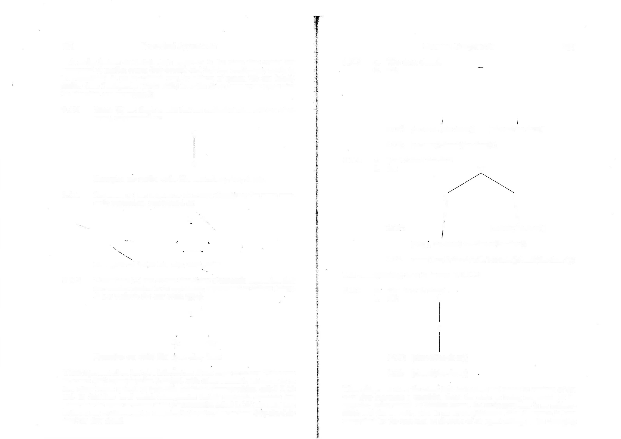
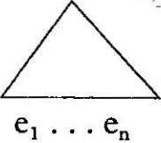
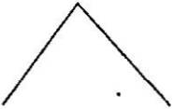
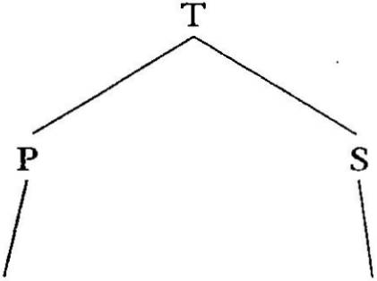

Examples are verbs like sing, walk, swim.

  - Transitions (T) are events identifying a semantic expression that is evaluated relative to its opposition, represented as follows (where E is a variable for any event type):

T

Ei —'E2
Examples are verbs like open, close, build.

These representations just give information about event structure. This event structure (ES) representation is united with other semantic information at two other levels: a level of logic-like predicate decomposition called LCS and an interface level which incorporates lexical semantic elements but maintains the event structure more transparently, called LCS'. The relations between can be shown in the causative/inchoative alternations John closed the door! The door closed'.
[act(j, the-door) A -idosed(the-door)]

LCS: cause([act(y, the-door)], become([closed(the-door)])) The corresponding state is shown in 9.115:
  - a. The door is closed.
    - ES: S

e

LCS': [closed(the-door)] LCS: [closed(the-door)]
These diagrams show the claim that inchoative and causative versions of the verb close represent a transition from the state of being not-closed to its opposite, being closed. In Vendler terms, the inchoative close is an achieve ment and the causative close is an accomplishment. The difference is here recognized by the presence or absence of an agent acting on the changing


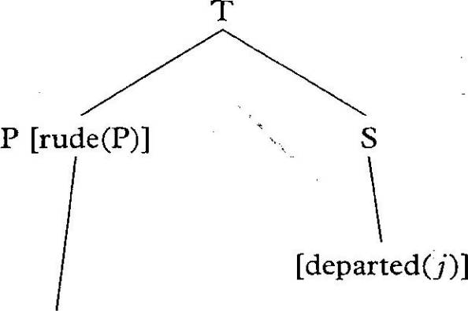
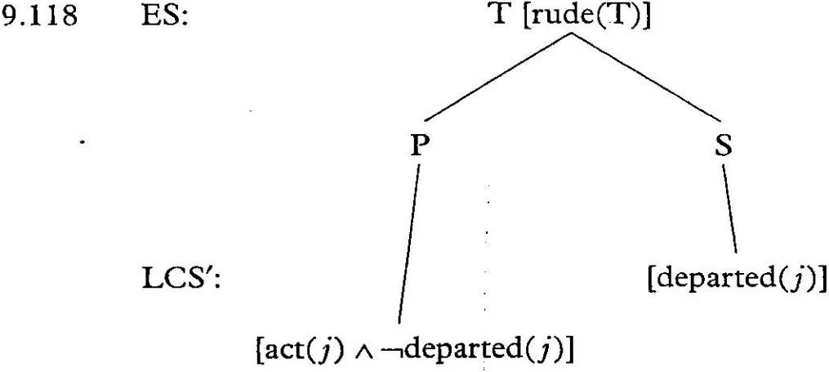
292 Theoretical Approaches

entity {John is the agent in the example above). There is no other structural distinction between these two event types.
One main justification for this type of sub-event structural description is that it allows the recognition of regular differences in adverbial interpreta tion, such as the ambiguity in 9.116a, shown by the paraphrases in b and c:

  - a. Joan rudely departed.
    - Joan departed in a rude way.
    - It was rude of Joan to depart.

The representations in 9.113-15 above allow such differences to be analysed as adverbial scope over a sub-event rather than the whole event: narrow scope versus wide scope readings. Pustejovsky (1992) proposes that the inter pretation in 9.116b is a result of the adverb having scope over the process sub-event, shown below:

  - ES:

LCS':
[act(j) A -ideparted(J)]

The interpretation in 9.116c on the other hand has the adverb taking wide scope over the whole event, shown as:

Thus the ambiguity of adverbial interpretation is given a structural account. Another related example discussed by Pustejovsky (1991) and Alsina (1999)
in this approach concerns an ambiguity of interpretation with almost that occurs in accomplishments but not in other event types.11 To use Alsina’s
Meaning Components 293

cruel example, John almost killed the cat has the two readings: John’s action resulted in the near-death of the cat and John nearly undertook an action that would have killed the cat. In the former almost has scope over the resulting State, while in the latter almost has scope over the Process.12 This account correctly predicts that an achievement verb like walk will have only one reading, the ‘nearly undertook the action’ reading, as in I almost walked, because there is only one undifferentiated event constituent in the event structure (as in diagram 9.111 earlier).
The essential claim made by this approach is that a representation which does not have access to sub-events, such as the activity and state sub-events above, will lack explanatory power.

    - Qualia structure

In his treatment of norms Pustejovsky claims that listing senses in a diction ary, making what he terms Sense Enumeration Lexicons (Pustejovsky 1995), cannot adequately account for polysemy. He discusses examples like the variation in the meaning of good in a good meal, good soccer player, good book, good husband or fast in a fast car, fast driver, fast decision, fast food etc. As we discussed in chapter 3, there are two traditional approaches to such variation: we can decide that there are a number of related senses here or alternatively that these adjectives are simply vague, so that good, for example, is simply
a general term of approbation whose meaning must be derived by contextual rules of inference. Pustejovsky argues for a variation of the multiple senses approach and against an explanation via general reasoning. His arguments are firstly that any inferences must rely on linguistic information in the accompanying nouns, and secondly that the variation is systematic, with different classes of items patterning together. However, rather than treating this by listing senses, Pustejovsky views the variants as products of specific rules of semantic composition, tied to systematic properties of the lexical item. These properties are called qualia (plural of the Latin noun qale ‘quality, nature’) in this theory.
Although all types of words have a qualia structure, we concentrate our discussion on nouns. Qualia structure has four dimensions, viewed as roles, shown below with characteristic values for nominals:
  - Qualia Structure (Pustejovsky 1995: 85)
- ConsTiTUTive: the relation between an object and its constitu ents, or proper parts.
For example: i. Material; ii. Weight; iii. Parts and component elements.
- formAL: that which distinguishes the object within a larger domain.
For example: i. Orientation; ii. Magnitude; iii. Shape; iv. Dimensionality; v. Colour; vi. Position.


294 Theoretical Approaches

- TeLiC: the purpose and function of the object
For example: i. Purpose that an agent has in performing an
act. ii. Built-in function or aim which specifies certain activities.
- AGenTive: factors involved in the origin or ‘bringing about’ of an object.
For example: i. Creator; ii. Artefact; iii. Natural kind; iv. Causal chain.

Without going into the formal detail we can sketch how the knowledge about nouns represented by qualia can be used to account for polysemy. One example is the different interpretations of bake in the following:

  - a. Joan baked the potato.
b. Joan baked the cake.

In 9.120a the verb has a change of state interpretation while in b it has an additional creation sense, i.e. the act of baking creates a cake that didn’t exist previously. For Pustejovsky this polysemy is explained by rules of combination between the verb and noun. The verb itself has only one meaning: it entails a change of state. The difference between a and b above is results from the qualia structures of the nominals.The noun cake will have as part of its agentive role that it is created by an act of baking by an agent,
i.e. that it is an artefact. The verb bake will have as part of its agentive qualia that it describes an act of baking by an agent. When the verb and noun combine to form Xverb phrase, their qualia structures merge and unite the two representation of The baking event to form the creation interpretation. In other words it is the unification of qualia structures between verb and this particular type of object that produces the creation reading. In this view an extended meaning is created by rules of composition. Hence we gain a dynamic view of polysemy which specifies the context for the extended reading. For technical details see Pustejovsky (1995: 122-5).
A further example is the variations in meanings of adjectives like fast and good mentioned earlier. Pustejovky’s approach is to treat these as modifiers of events (event predicates) and therefore applicable to events represented in the qualia structure of nominals that they combine with. The noun typist is given the qualia structure below:

  - typist
ArGsTr = [ArGI = x human]
FORMAL = X
QUALIA =
TeLiC = type(e, x)

The combination of argument and qualia structure tells us that the activity associated with this noun is an event of a human being typing. Combining
Meaning Components 295

this noun with the event modifier fast will automatically give the reading that a fast typist types fast.
Similarly the qualia structure for knife is given as:
  - knife
ARGSTR = [ARGl = XZtOOl]
FORMAL = X
QUALIA =
TeLiC = cut(e, x, y)

The telic quale tells us that a knife is used for cutting. Treating good as an event predicate means it can apply to this event of cutting incorporated in representation of this noun, ensuring that a good knife is one that cuts well. This of course generalizes across other adjectives and nouns, ensuring that a good driver drives well, a slow runner runs slowly, etc. Once again vari ation in interpretations, this time in adjectives, is triggered by specific types of knowledge represented in the nouns with which they combine.
This sketch is necessarily only suggestive but we hope that the general approach to polysemy in this theory is clear. It is accounted for by dynamic rules of combination, unifying different forms of knowledge represented in lexical entries. It is possible to discern a distant, and dynamic, family resem blance here to the use of selectional restrictions in the Katzian semantics that we described at the beginning of this chapter.

Problems with Components of Meaning

The compositional approaches we have been looking at have been criticized in two important ways. The first concerns the identification of semantic primitives. These primitives have been attacked from both philosophical and psychological perspectives. The former (e.g. J. A. Fodor 1970, Fodor et al. 1980) claims that these semantic components are simply a variation of, and equivalent to, the necessary and sufficient conditions approach to word meaning that we discussed in chapter 2. As we saw there, it proves imposs ible to agree on precise definitions of word meaning. The resulting practical problems for the decompositional semanticist include how to validate any proposed set of primitives, and when to stop identifying them, i.e. knowing what are the right features and how many is enough.
There have also been psychological criticisms, for example Fodor, Fodor and Garrett (1975), which claim that there is no experimental evidence for semantic primitives. Though there is not a large literature on the topic, some experiments have shown little or no support for varying degrees of internal complexity in words. These studies seem to show that in processing language we seem to treat words as atoms of meaning, and therefore do not divide them into subcomponents in order to understand them.13

296 Theoretical Approaches

The second focus for attack has been on the use of metalanguages. As we have seen, there have been various proposals, using a range of symbols and diagrams. The criticism has been that these devices are ad hoc and un systematic: at best another arbitrary language; at worst, a kind of garbled version of the English, French, etc. of the writer. This criticism is related to the more serious philosophical criticism that attaching a set of primitives to a word or phrase is not a semantic analysis in the deepest sense. We can recall the point discussed in chapter 2, deriving from observations by the philosopher W. V. O. Quine, that this is in effect a form of translation into another language, a language of primitive elements which is sometimes pejoratively called Markerese, after Lewis (1972), by linguists making this point. The claim is that to translate from the object language into an arbit rary invented language doesn’t advance semantic analysis very far, if you then have to translate the metalanguage. If the process doesn’t have an anchor in reality, the criticism goes, it is merely circular.14 As we said earlier, the basic idea is that since the expressions of language are symbols, they must be grounded somehow. This grounding may be of different types: in the next chapter we shall see how formal semanticists attempt to ground semantic analysis in the external world; and in chapter 11 we will see an attempt by cognitive semanticists to ground their analyses in primitive level concepts derived from bodily experience. But, the criticism goes, the type of componential analysis we have reviewed in this chapter begs the question of such grounding.
To decompositional semanticists, none of these attacks seems fatal. Re
sponses to the psychological attack, e.g. Jackendoff (1990: 37ff.), point out that we would expect words to be the relevant unit for processing, not components. After all, goes this reply, that’s why semantic features are bunched into word units: because these particular.bunchings have cognitive utility, i.e. they are useful sizes and mixtures for thinking and talking about the world. In reply to the complaint about the never-ending identification of primitives, these linguists tend to claim that this is an empirical question, not solvable in advance by stipulation, e.g.:

  - there should eventually come a point when increasing the com plexity of a semantic theory by adding new markers no longer yields enough advantage in precision and scope to warrant the increase. At that point the system of markers should reflect the systematic features of the semantic structure of the language. (Katz and Fodor 1963: 190)

Or we might note the response in Jackendoff (1990: 4) where he makes a comparison with physics, where physicists haven’t worried about identifying smaller and smaller particles, if there is sufficient justification for them.
Responses to the criticism of metalanguages have varied: some semanticists agree with it and conduct their inquiry through the medium of a natural
Meaning Components 297

language like English, see for example Wierzbicka (1980) and Allan (1986: 265-70) for discussion. This is in effect to give up the search for a neutral metalanguage. Another response is to rely more firmly on tried and tested metalanguages from other disciplines like logic, as in Dowry (1979).15 Still others, like Jackendoff, rely on empirical justification for the formalisms they use: in this view the machinery is justified to the extent it allows the analyst to capture significant generalizations.

Summary

In this chapter we have reviewed the proposal that semantic representation should involve semantic components. These components are primitive ele ments which combine to form units at the level of grammar. The nature of their combination differs from author to author: from, for example, the original Katz and Fodor listings of components at the word level to the more articulated representations used by Jackendoff, where the components are arranged as functions and arguments which can be successively embed ded within one another, and Pustejovsky, who proposes a syntax of event structure.
Linguists have argued that these components help characterize semantic relations: both lexical relations and sentential relations like entailment. As we have seen, they have also been used to investigate the semantic basis for morphological and syntactic processes. From the viewpoint of linguistic ana lysis these are claims that such components are important units at the level of semantics. From a wider perspective the question arises: are these compon ents psychologically real? Do they form part of our cognitive structures? For some linguists, like Jackendoff, the answer is yes. These elements play a role in our thinking and by identifying them correctly we are establishing meaning.

FURTHER READING

A detailed discussion of Katz’s semantic theory is in Allan (1986). Levin and Rappaport Hovav (2005) present a detailed overview of the role of decompositional semantic representations in analysing the grammar of verbs. For an introduction to Jackendoff’s work, see his Semantic Structures (1990). For Pustejovky’s notion of a generative lexicon, see his (1995) book. A collection of papers on event structure, some using approaches described in this chapter, is inTenny and Pustejovsky (2000). An example of the incorporation of a decompositional semantic representation into a grammatical theory is Role and Reference Grammar’s level of logical structure; see Van Valin (2005) for discussion. For an influential attack on componential ap proaches see J. A. Fodor (1981b).

298 Theoretical Approaches

EXERCISES

  - Use semantic components to characterize the semantic rela tions between the following words:

mother father daughter son sister brother grandmother grandfather granddaughter grandson uncle aunt cousin nephew niece
Discuss whether a binary format would be an advantage for the semantic components you decide on.

  - In section 9.7.1 we mentioned the English causative/inchoative alternation. This involves a pair of verbs where the transitive is the causative version of the intransitive. The verb might signify a change of state, as in the pair of sentences I broke the glass!The glass broke or movement as in She moved the car (The car moved. As we saw in the chapter, the inchoative is characterized by the absence of a causing agent. Below are some transitive verbs. Decide which may participate in the causative/inchoative alternation:

    - The goalkeeper bounced the ball-.
    - The ..assassin murdered the president.
    - The waiter melted the chocolate.
    - Charlie built the new swimming pool.
    - The men. lowered the boat.
    - David worried Renata;
    - The thieves destroyed the paintings.
    - Joan dried the clothes.
  - Levin and Rappaport Hovav (1995: 102-5) propose a semantic explanation for why some change of state verbs participate in this alternation and others do not. They suggest that those transitive verbs that do not participate require the direct intervention of an intentional and volitional Agent, while the opposite holds for those that do. We can test for this by substituting a non-Agent argument, for example an Instrument, as subject in the transitive sentence. The hypothesis is that if the verb allows a non-Agent subject in the transitive, if will allow the alternation. Thus:
Meaning Components 299

Try to establish if this explanation works for the verbs in the last exercise that that do not undergo the causative/inchoative alternation.

In chapter 6 we met the argument structure alternation in English called Dative Shift, where some verbs, such as give, allow both of the patterns below:

- Aideen gave the shoes to her neighbour. [NPX - V - NPZ - to NPY]
- Aideen gave her neighbour the shoes.
[NPX - V - NPy - NPZ]
This alternation seems to be restricted to certain semantic sub classes of verbs. We can adapt from Pinker (1989: 11 OU.) an ini tial hypothesis to distinguish two semantic verb classes, as follows:

- Class la: the gfve-class: verbs whose semantic structure
is ‘X causes Y to have Z’, e.g. Paul gave some ' ' money to the beggar:
Class lb: the send-class: verbs which share the basic sem antic structure of la but where the change of possession involves separation in time and/ or space, which X tries to bridge , by a means of transfer, e.g. Harry sent the check to his wife.

- Class 2: the carry-c\&ss: verbs whose semantic structure is CX moves Z to Y in a certain manner’, e.g. He carried the books to the clerk.

The difference between classes 1 and 2 can be viewed in terms of CHAnGe of possession. In Class la verbs this change is a necessary part of the meaning. In Class lb verbs the change is intended though not necessary (we can say I sent her the letter but she never got it unlike *7 gave her the money but she never, got it); while in Class 2 verbs Y’s taking possession of Z is simply not part of the verb’s meaning, although it may occur incidentally. We could then postulate a condition on Dative Alternation: Class 1 verbs allow Dative Alternation but Class 2 verbs do not.

  - John broke the window with a rock
  - The rock broke the window.

  - The window broke.
(Agent subject) (Instrument subject) (Inchoative alternation)
Thus we find Paid gave the beggar some money, Harry sent his wife the check but not ★Mary carried the clerk the books.
For the following verbs, decide which of these semantic classes they belong to and whether our prediction about Dative Alterna tion works. If not, discuss any further semantic qualification that

300 Theoretical Approaches

might be necessary, for example, are there further classes to be set up; and if so, how would you characterize them?

mail, push, kick, pass, sell, lower, hand, push, flip, throw, bring, haul, ferry, take.

  - Dative Alternation also occurs with some verbs of communi cation. Once again we can set up semantic classes to try to explain which verbs show the alternation and which do not:

Class 3: the re/Z-class: verbs whose semantic structure is ‘X causes Y to cognitively possess Z’, where ‘cognitively possess’ includes Y knowing, perceiving, learning, etc. Z. For example: Joan told the answer to Kate.
Class 4: the Jwm-class: verbs whose semantic structure is
‘X communicates Z to Y in a certain manner’, e.g.
Joan shouted the answer to Kate.

Pinker (1989) calls Class 3 ‘illocutionary verbs of communica tion’ because the verb gives information about what kind of illocutionary act the speaker intends. Thus tell in our example signals a representative act in the terminology of Searle (1976), discussed in chapter 8. Pinker (1989) and Leviw(1993) follow Zwicky (197J) in calling Class 4 verbs ‘manner of speaking’ verbs. We could claiimthat Class 3 verbs show the Dative Alternation, Joan told Kate the answer, while Class 4 verbs do not, ★Joan shouted Kate the answer.
As in the last exercise, examine the verbs below and decide which of these two semantic classes they belong to and whether our prediction about Dative Alternation works. Again, for any problematic cases, discuss whether you would add qualifications to our characterization of the classes above, or set up further semantic classes. u

teach, read, whisper, mention, quote, murmur, say, show, scream, yell, cite.

  - Dative Alternation also occurs with examples like the one below:

    - She bought a car for her daughter [NPX - V - NPZ - > NPY]
    - She bought her daughter a car.
[NPX - V - NPy - NPZ] '■
Meaning Components 301
These structures are called benefactive structures because X
performs the action of the verb for the benefit ofY, Using your own examples, discuss whether this benefactive Dative Alterna tion exhibits the same restrictions that we saw in exercises 9.4 and 9.5 i.e. is the alternation determined by a verb’s member ship of a semantic class?

  - Levin (1993), reporting on several earlier studies, notes that there seems to be a further type of lexical constraint on Dative Alternation: verbs derived from Latin roots do not undergo the alternation, even when they belong to the right semantic class.
; See for example 1 and 2 below which parallel verbs in exercises
9.2 and 9.3:

- a. He gave the books to the college.
  - He gave the college , the books.
  - He donated the books to the college.
  - *He donated the college the books.

- a. He told the news to his father.
  - He told his father the news.
  - He communicated the news to his father.
  - *He communicated his father the news.

Using your own examples, investigate the range of this constraint on the semantic verb classes allowing Dative Alternation. If you find exceptions, do they form a coherent class or classes?

  - In this chapter we reviewed Talmy’s (1985) investigations of hdw semantic components of motion events (Figure, Ground, Motion, Path, Manner) are conflated in verbs. Croft (1991a) discusses the example 1 below:

- The boat sailed into the cave.

where the verb sailed conflates both the Manner and the Motion. Croft compares this with 2;

- The boat burned into the cave.

where this cannot mean that the boat entered the cave whilst burning. Croft’s explanation is that the Manner and Motion can only be conflated in the same verb when the Manner causes the Motion. So in 1 sailing causes the motion into the cave; but in 2 burning does not.

302 Theoretical Approaches

Now.look at the following English examples, where the verb is in bold. How many of these fit in with Croft’s generalization? If any do not, try to establish what other semantic factors might be at work.

- a. They waltzed onto the balcony.
  - The wind howled through the trees.
  - The grenade bounced into the bunker.
  - The ball thudded into his chest.
  - We cycled along the canal.
  - The cart creaked along the path.
  - The jet flashed across the sky.
  - The bees swarmed into the kitchen.

  - We mentioned tests to distinguish between singular count nouns (typically representing individuals) and mass nouns (typically representing substances). One such test is divisibility: if you divide an example of the noun into, say quarters, can the same name be applied to each part? The .answer is yes for mass nouns, and no for singular count nouns. 'Another test is occurrence with determiners like a and some, for example in a frame like I brought X. Compare the singular count noun in a with the mass nouriTh b:
■ V - ' . ■ T ' ■' ' h : '
    - I brought a saucepan.
    - I brought!’rice/some rice.

.•Use these tests to classify the following nouns as singular count nouns of mass nouns:
' . ' 7. ; ' . ' ■ ... ' . .
raccoon, barley, computer, manure, waiter, chair, soil.

What problems do the following nouns cause for these tests?

Type 1: beer, coffee, tea, icecream, lemonade. Type 2: chicken, turkey, ham, potato, carrot.

Try to provide some further examples of these two types.
Meaning Components 303

    - John went out of the room.
    - The house is Helen’s.
    - The cat is on the roof.
    - The legacy went to a dog’s home.

9.11 Using the same format, provide a Jackendoff-style conceptual structure for the following sentences:

- a. The window is closed.
b. The window closed.

- a. Peg became angry.
b. Bob angered Peg.

- a. George had the money.
b. George gave the money to Cindy.

- a. The prisoners walked into the yard.
b. The guards walked the prisoners into the yard.

NOTES

- J. D. Fodor (1983) provides a good overview of Katz and Fodor’s theory. See also Katz (1987) for a more recent discussion of this approach.
- See Allan (1986, vol. 1: 274—391) for a very detailed description of the evolution of the theory and the resulting changes in dictionary entries.
- We discussed middle constructions in chapter 6. As described there, ‘argument structure alternation’ is a term used to describe processes which change the usual matching of semantic roles and grammatical positions. So in 9.20a we find shirts which would normally be the object of a verb like wash occurring as the subject.
- A view shared by other writers, like Jackendoff (1990, 1992) whose work we discuss below, and Pustejovsky (1995).
- Pinker (1989) calls this thematic role the ‘state changer’ argument, while Rappaport and Levin (1985) call it the ‘displaced theme’.These terms are used because these elements are not simple instruments but carry a role we might paraphrase as: ‘entities which by being moved cause a change of state in some

...

Using the format for Jackendoff’s conceptual structure described in section 9.6, provide a conceptual structure for each of the following sentences:

    - Maura has a car.
    - Her birthday is on Thursday. -
thing to/from which they are moved’.
- This term unmarked comes from markedness theory. This is a theory of naturalness where the more marked an element is, the less natural it is. This notion can be applied both within a language, as in this case, or cross- linguistically, as when we say, for example that back rounded vowels like French
[u] in tout [tu] ‘all’, are less marked than front rounded vowels like French
[y] in tu [ty] ‘you’. This implies that back rounded vowels are commoner in the languages of the world, will be learned earlier by children, are less likely

V

304 Theoretical Approaches

to be lost in language change or in language disorders, etc. See Jakobson (1968) for discussion.
- ‘It is widely assumed, and I will take for granted, that the basic units out of which a sentential concept is constructed are the concepts expressed by the words in the sentence, that is lexical concepts’ (Jackendoff 1990: 9).
- We discussed this notion of entailment in chapter 4.
- See Jackendoff (1990: 43, 1992: 13ff.) for further details.
- Verbs of motion have received a lot of attention in the semantics literature: see for example Miller and Johnson-Laird (1976) andTalmy (1975, 1983, 1985).
- These and similar scope ambiguities are discussed in a formal approach by Dowty (1979).
- Alsina (1999) in fact claims a third reading for this sentence: a wide scope interpretation. He distinguishes this with the explanation: for example John shoots at the cat intending to kill it, but misses.
- But see Gentner (1975, 1981) for some counter arguments and suggestions that the evidence of these earlier studies is not convincing.
- This is reminiscent of Daniel Dennett’s criticism of psychological approaches which only concern themselves with the internal state of the mind, ignoring the individual’s interaction with the environment:
The alternative of ignoring the external world and its relations to the internal machinery... is not really psychology at all, but just at best abstract neurophysiology
- pure internal syntax with no hope of a semantic interpretation. Psychology ‘reduced’ to neurophysiology in this fashion would not be psychology, for it would not be able to provide an explanation of the regularities it is psychology’s particu lar job to explain: the reliability with which ‘intelligent’ organisms can cope with their environments and thus prolong their lives. (Dennett 1987: 64)

- But see Jackendoff (1*983: 14-15) for an attack on the use of logic-based formalisms.

