Chapter 11

Cognitive Semantics

Introduction

In this chapter we look at semantics within the approach known as cognitive semantics. As is often the case with labels for theories,1 this might be objected to as being rather uninformative: in this instance because, as we have seen, in many semantic approaches it is assumed that language is a mental faculty and that linguistic abilities are supported by special forms of knowledge. Hence for many linguists semantics is necessarily a part of the inquiry into cognition. However, as we shall see, writers in the general approach called cognitive linguistics, and other scholars who are broadly in sympathy with them, share a particular view of linguistic knowledge. This view is that there is no separation of linguistic knowledge from general thinking or cognition. Contrary to the influential views of the philosopher Jerry Fodor or of Noam Chomsky,2 these scholars see linguistic behaviour as another part of the general cognitive abilities which allow learning, reasoning, etc. So perhaps we can take the label cognitive linguistics as representing the slogan ‘linguistic knowledge is part of general cognition.’ As we shall see, this slogan does fit work in semantics in this approach.
We can begin by outlining some of the main principles behind this general approach. Cognitive linguists often point to a division between formal and functional approaches to language. Formal approaches, such as generative

356 Theoretical Approaches

grammar (Chomsky 1988), are often associated with a certain view of lan guage and cognition: that knowledge of linguistic structures and rules forms an autonomous module (or faculty), independent of other mental processes of attention, memory and reasoning. This external view of an independent linguistic module is often combined with a view of internal modularity: that different levels of linguistic analysis, such as phonology, syntax and semantics, form independent modules. In this view, the difference between modules is one of kind: thus externally, it is good practice to investigate linguistic prin ciples without reference to other mental faculties; and internally, to invest igate, say, syntactic principles without reference to semantic content. This characterization of formal approaches concentrates on its epistemological implications. Formalism also implies the desirability and possibility of stating the autonomous principles in ways that are formally elegant, conceptually simple and mathematically well-formed.3
Functionalism, with which cognitive linguists identify themselves, implies a quite different view of language: that externally, principles of language use embody more general cognitive principles; and internally, that explanation must cross boundaries between levels of analysis. In this view the difference between language and other mental processes is possibly one of degree but is not one of kind. Thus it makes sense to look for principles shared across a range of cognitive domains. Similarly, it is argued that no adequate account of grammatical rules is possible without taking the meaning of elements into account.
This general difference of approach underlies specific positions taken by
cognitive linguists on .a number of issues: in each case their approach seeks to break down the abstrictions and specializations characteristic of formalism, many of which we have met in earlier chapters. Thus studies in cognitive semantics have tended to blur, if not ignore, the commonly made distinctions between linguistic knowledge and encyclopaedic, real-world knowledge - a topic we touched on earlier; and between literal and figurative language, as we shall see. Similarly cognitive linguists share the functionalist view that distinguishing linguistic levels of analysis, while a useful ploy for practical description, is potentially harmful to our conceptions of language, since syn tax, for example, can never be autonomous from semantics or pragmatics. Ultimately, this view goes, the explanation of grammatical patterns cannot be given in terms of abstract syntactic principles but only in terms of the speaker’s intended meaning in particular contexts of language use.
A further distinction that is reassessed in this framework is the traditional structuralist division between, to use Ferdinand de Saussure’s (1974) terms, diachronic (or historical) linguistics and synchronic linguistics. In his foundational lectures, Saussure, attempting to free linguistics from ety mological explanation, proposed his famous abstraction: a synchronic linguistics, where considerations of historical change might be ignored, as if in describing a language we could factor out or ‘freeze’ time.4 Such an idealization has been accepted in many linguistic theories, but is currently questioned in functional approaches. Linguistic structures, in a functionalist
Cognitive Semantics 357

perspective, have evolved through long periods of use and the processes of change are evident in and relevant to an understanding of the current use of the language. Thus processes of grammaticalization, for example, where lexical categories may over time develop into functional categories and independent words become inflections, can provide evidence of general linguistic and cognitive principles, as discussed by Heine and Kuteva (2002).5
If we turn to meaning, a defining characteristic of cognitive semantics is the rejection of what is termed objectivist semantics. George Lakoff (1988: 123-4), for example, assigns to objectivism the basic metaphysical belief that categories exist in objective reality, together with their properties and relations, independently of consciousness. Associated with this is the view that the symbols of language are meaningful because they are associated with these objective categories. This gives rise to a particular approach to semantics which Lakoff characterizes under three ‘doctrines’:

  - Objectivist semantics (adapted from Lakoff 1988: 125-6)
- The doctrine of truth-conditional meaning: Meaning is based on reference and truth.
- The ‘correspondence theory’ of truth: Truth consists in the correspondence between symbols and states of affairs in the world.
- The doctrine of objective reference: There is an ‘objectively correct’ way to associate symbols with things in the world.

In rejecting these views, cognitive semanticists place themselves in opposi tion to the formal semantics approach described in chapter 10. Cognitive semanticists take the view that we have no access to a reality independ ent of human categorization and that therefore the structure of reality as reflected in language is a product of the human mind. Consequently they reject the correspondence theory of truth, discussed in chapters 4 and
10. For these writers, linguistic truth and falsity must be relative to the way an observer construes a situation, based on his or her conceptual framework.6 The real focus of investigation should, in this view, be these conceptual frameworks and how language use reflects them. In the rest of this chapter we examine this line of inquiry; we might begin here by asking of this approach our deceptively simple question: what is meaning?
One answer in the cognitive semantics literature is that meaning is based on conventionalized conceptual structures. Thus semantic structure, along with other cognitive domains, reflects the mental categories which people have formed from their experience of growing up and acting in the world. A number of conceptual structures and processes are identified in this liter ature but special attention is often given to metaphor. Cognitive linguists agree with the proposal by Lakoff and Johnson (1980), Lakoff (1987, 1993), and Johnson (1987) that metaphor is an essential element in our categorization of the world and our thinking processes. As we shall see,

358 Theoretical Approaches
metaphor is seen as related to other fundamental structures such as image schemas, which provide a kind of basic conceptual framework derived from perception and bodily experience, and Fauconnier’s (1994) notion of mental spaces, which are mental structures which speakers set up to manipulate reference to entities. Such mental spaces underlie the process of conceptual blending (Fauconnier and Turner 2002), where speakers develop extended analogies which selectively combine existing domains of knowledge to create new scenarios. Cognitive linguists also investigate the conceptual processes which reveal the importance of the speaker’s construal of a scene: processes such as viewpoint shifting, figure-ground shifting and profiling. We look at these structures and processes in successive sections later.
A consequence of the view of language we have briefly outlined is that the study of semantics, and linguistics, must be an interdisciplinary activity. One result is that scholars working within this and related frameworks tend to stray across intra- and inter-disciplinary boundaries more easily than most. Cognitive semanticists have, for example, examined not only the rela tionship of grammar and semantics, but also historical linguistics (Sweetser 1990, Geeraerts 1997, Blank and Koch 1999), categories of thought (Lakoff 1987), literary language (Turner 2006), mathematics (Lakoff and Nunez 2000), rhetoric (Turner 1987), and ethics (Johnson 1993), amongst other areas... In our discussion, we concentrate on semantic issues and we begin with metaphor in section 11.2.

Metaphor -

    - Introduction
Metaphor has traditionally been viewed as the most important form of figurative language use, and is usually seen as reaching its most sophistic ated forms in literary or poetic language. We can, however, take a couple of examples from journalism to begin our discussion. Both are from reports on the 2002 Hollywood film awards, the ‘Oscars’:
  - Movie studios love a good fight, and a bad one too. But the Oscar battles have become trench warfare and dirty tricks.

  - ... a best actress race that has taken on heat as longtime prohibit ive favourite Sissy Spacek has suddenly caught a glimpse of Halle Berry in her rear view mirror.7

As we can see, in 11.2 the awards competition is portrayed in terms of warfare, while in 11.3 the image is of a car race. There are many explanations of how metaphors work but a common idea is that metaphor is somewhat like simile (e.g. Reading that essay was like wading through mud} in that it
Cognitive Semantics 359
involves the identification of resemblances, but that metaphor goes further by causing a transference, where properties are transferred from one con cept to another. This transference has some interesting properties, as we will see later.
Before we go on, let’s introduce some terminology. The two concepts involved in a metaphor are referred to in various ways in the literature. We can select two: the starting point or described concept (in our examples above, the Oscar awards) is often called the target domain, while the com parison concept or the analogy (in our two examples, war and car racing) is called the source domain. In I. A. Richards’s (1936) terminology the former is called the tenor and the latter, the vehicle. Both sets of terms
are commonly used in the literature; we will adopt the former: target and source.
There are two traditional positions on the role of metaphor in language. The first, often called the classical view since it can be traced back to Aristotle’s writings on metaphor, sees metaphor as a kind of decorative addition to ordinary plain language; a rhetorical device to be used at certain times to gain certain effects. This view portrays metaphor as something outside normal language and which requires special forms of interpretation from listeners or readers. A version of this approach is often adopted in the literal language theory we described in chapter 1. In this view metaphor is often seen as a departure from literal language, detected as anomalous by the hearer, who then has to employ some strategies to construct the speaker’s intended meaning. We can take as an example of this general approach Searle (1979: 114) who describes the start of the process thus (where a contextual assumption is that Sam is a person):

  - Suppose he hears the utterance, ‘Sam is a pig.’ He knows that cannot be literally true, that the utterance, if he tries to take it literally, is radically defective. And, indeed, such defectiveness is a feature of nearly all the examples that we have considered so far. The defects which cue the hearer may be obvious falsehood, semantic nonsense, violations of the rules of speech acts, or viola tions of conversational principles of communication. This suggests a strategy that underlies the first step: Where the utterance is defective
if taken literally, look for an utterance meaning that differs from sentence meaning [author’s italics].

We won’t go into details of the various proposals that have been made for the next steps that the hearer uses to repair the ‘defective’ utterance; see Ortony (1979) for some proposals.
The second traditional approach to metaphor, often called the Romantic view since it is associated with eighteenth- and nineteenth-century Roman tic views of the imagination, takes a very different view of metaphor. In this view metaphor is integral to language and thought as a way of experiencing the world. In this view metaphor is evidence of the role of the imagination

360 Theoretical Approaches

in conceptualizing and reasoning and it follows that all language is meta phorical. In particular₃ there is no distinction between literal and figurative language.8

    - Metaphor in cognitive semantics

An important characteristic of cognitive semantics is the central role in thought and language assigned to metaphor. Given the classical/Romantic opposition we have described, the cognitive semantics approach can be seen as an extension of the Romantic view.9 Cognitivists argue that metaphor is ubiquitous in ordinary language, though they pull back a little from the strong Romantic position that all language is metaphorical. While metaphor is seen as a very important mode of thinking and talking about the world, it is accepted that there are also non-metaphorical concepts:

  - Metaphors allow us to understand one domain of experience in terms of another. To serve this function, there must be some grounding, some concepts that are not completely understood via metaphor to serve as source domains. (Lakoff and Turner 1989: 135)

In emphasizing the important role of metaphor in ordinary language, Lakoff and his colleagues have identified a large number of common metaphors. One group, for example, they describe as spatial metaphors, for example the many metaphors .associated with an Up-Down orientation. These include the following, where wfe select a few of their examples (Lakoff and Johnson 1980: 14-21):

- HAppY is Up; sAD is Down
I’m feeling up. My spirits rose. You’re in high spirits. I’m feeling
down. I’m depressed. He’s really low these days. My spirits sank.
- ConsCioUs is Up; UnConsCioUs is Down
Wake up. He fell asleep. He dropped off to sleep. He’s under
hypnosis. He sank into a coma.
C. HEALTH AND LIFE ARE UP; SICKNESS AND DEATH ARE DOWN
He’s at the peak of health. He’s in top shape. He fell ill. He’s
sinking fast. He came down with the flu. His health is declining.
- HAVING CONTROL OR FORCE IS UP; BEING SUBJECT TO CONTROL OR FORCE IS DOWN
I have control over her. He’s at the height of his powers. He’s in a superior position. He ranks above me in strength. He is under my control. He fell from power. He is my social inferior.
- GooD is Up; BAD is Down
Things are looking up. We hit a peak last year, but it’s been downhill ever since. Things are at an all-time low. He does high- quality work.
Cognitive Semantics 361

- VIRTUE IS UP; DEPRAVITY IS DOWN
He is Az’g/z-minded. She has high standards. She is an upstanding citizen. That was a low trick. Don’t be underhanded. I wouldn’t stoop to that. That was a low-down thing to do.
As the authors point out, these metaphors seem to be based on our bodily experiences of lying down and getting up and their associations with con sciousness, health and power, i.e. of verticality in human experience. We will discuss this experiential basis in section 11.4 below, when we discuss image schemas. For now we can see that Lakoff and Johnson’s point is that in using language like this, speakers are not adding rhetorical or poetical flourishes to their language: this is how we conceive of happiness, health, etc. As a result metaphors are conceptual structures which pervade ordinary language. In section 11.2.3 we look at some of the features of metaphor identified in this approach.

    - Features of metaphor

Cognitive semanticists argue that, far from being idiosyncratic anomalies, metaphors exhibit characteristic and systematic features. We can look at some of these characteristics under the headings of conventionality, sys- tematicity, asymmetry and abstraction. The first, conventionality, raises the issue of the novelty of the metaphor: clearly the first of our two examples in 11.2 and 11.3 is less novel than the second. As we discussed in chapter 1, some writers would claim that some metaphors have become fossilized or dead metaphors. In the literal language theory this means that they have ceased to be metaphors and have passed into literal language, as suggested by Searle (1979: 122):
  - Dead metaphor. The original sentence meaning is bypassed and the sentence acquires a new literal meaning identical with the former metaphorical meaning. This is a shift from the metaphorical utter ance to the literal utterance.
Cognitive semanticists argue against this approach, pointing out that even familiar metaphors can be given new life, thus showing that they retain their metaphorical status. If we take, for example the Up-Down metaphor, we might consider an instance like My spirits rose to be a dead metaphor, yet this general metaphor is continually being extended: it is no accident in this view that stimulant recreational drugs were called uppers and tranquillizers, downers. The second feature, systematicity, refers to the way that a metaphor does not just set up a single point of comparison: features of the source and target domain are joined so that the metaphor may be extended, or have its own internal logic. We can take an example from a Science magazine article about the sun, where the development of suns is metaphorically viewed as
children growing up:

362 Theoretical Approaches
  - A nursery of unruly stars in the Orion Nebula has yielded the best look at our sun’s baby album . . ?°
This metaphor is part of an extended metaphorical structure which surfaces through the rest of this report; see the following extracts which extend the mapping between suns and children:
  - a. Based on data from NASA’s orbiting Chandra X-ray Observat ory, it appears that the sun threw more tantrums than expected, in the form of powerful x-ray flares . . .
b. More than 4.5 billion years of evolution have erased all traces of the sun’s youth . . .
This systematicity has been an important focus in cognitive semantic views of metaphor: Lakoff and Turner (1989) identify, for example, a metaphor Life is A joUrneY, which pervades our ordinary way of talking. Thus birth is often described as arrival as in The baby is due next week, or She has a baby on the way, and death is viewed as a departure as in She passed away this morning or He's gone. Lakoff and Turner (1989: 3-4) identify a systematicity in this mapping between the two concepts:
  - , LIFE IS A JOURNEY
-The person leading a life is a traveller.
    - His purposes are destinations.
    - The means for achieving purposes are routes.
    - Difficulties in life are impediments to travel.
    - Counsellors are guides.
    - Progress is the distance travelled.
    - Things you gauge your progress by are landmarks.
    - Material resources and talents are provisions.
Their point is that we use this mapping every day in ordinary speech as when we use expressions like: Giving the children a good start in life; He's over the hill; I was bogged down in a dead-end job; Her career is at a standstill; They're embarking on a new career; He's gone off the rails; Are you at a cross-roads in your life?; I'm past it (= I'm too old); He's getting on (= he's ageing), etc.
Another example comes from the role of metaphor in the creation of new vocabulary: the coining of the term computer virus for a specific type of harmful program; see Fauconnier (1997: 19ff.) for discussion. This coining is based on a conceptual model of biological viruses which is generalized or schematized away from the biological details:
  - Biological virus schema (Fauconnier 1997: 19)
- x is present, but unwanted; it comes in, or is put in, from the outside; it does not naturally belong;
- x is able to replicate; new tokens of x appear that have the same undesirable properties as the original x;
Cognitive Semantics 363
- x disrupts the ‘standard’ function of the system;
- the system should be protected against x; this might be achieved if the system were such that x could not come into it, or if other elements were added to the system that would counteract the effects of x, or eject x, or destroy x

This schema is transferred to the general aspects of the computer situation; it provides a way of characterizing the new domain. The schema in 11.11 is itself based on lower-level schemas like image schemas of container, path, discussed later in this chapter, and force dynamics: entry, resistance etc. (Talmy 2000, vol. 1: 409-69)
This metaphorical mapping between a health schema and a computer domain can be viewed as a form of analogical mapping (Gentner 1983, Holyoak andThagard 1995). It licenses a whole system of lexical innovations so that the anti-virus programs can be called things like ‘Dr Solomon’s’; they are said to ‘disinfect’ programs, files can be said to be ‘infected’, and the program places them in special areas of memory called ‘quarantine’.
The importance of the process of metaphorical extension of the vocabu lary can be seen from the following list of conventionalized mappings from parts of the human body:

  - Conventionalized metaphors of body parts in English (Ungerer and Schmid 2006: 117)
head of department, of state, of government, of a page, of
a queue, of a flower, of a beer, of stairs, of a bed, of a tape recorder, of a syntactic construction
face of a mountain, of a building, of a watch
eye of a potato, of a needle, of a hurricane, of a butterfly, in a flower, hooks and eyes
mouth of a hole, of a tunnel, of a cave, of a river, lip of a cup, of a jug, of a crater, of a plate nose of an aircraft, of a tool, of a gun
neck of land, of the woods, of a shirt, bottle-neck shoulder of a hill or mountain, of a bottle, of a road,of ajacket arm of a chair, of the sea, of a tree, of a coat orjacket, of
a record player
hands of a watch, of an altimeter/speedometer

Our third feature, asymmetry, refers to the way that metaphors are directional. They do not set up a symmetrical comparison between two concepts, establishing points of similarity. Instead they provoke the listener to transfer features from the source to the target. We can take the metaphor Life is A joUrneY as an example: this metaphor is asymmetrical and the mapping does not work the other way around. We do not conventionally describe journeys in terms of life, so that it sounds odd to say Our flight was born (i.e. arrived) a few minutes early or By the time we got there^ the boat had

364 Theoretical Approaches
died (i.e. gone). Even if we are able to set up such a metaphor, it is clear that the meaning would be different from that of the original structure.
Our final feature, abstraction, is related to this asymmetry. It has often been noted that a typical metaphor uses a more concrete source to describe a more abstract target. Again the Life is A joUrneY metaphor exhibits this feature: the common, everyday experience of physically moving about the earth is used to characterize the mysterious (and unreported) processes of birth and death, and the perhaps equally mysterious processes of ageing, organizing a career, etc. This is not a necessary feature of metaphors: the source and target may be equally concrete or abstract, but as we shall see, this typical viewing of the abstract through the concrete is seen in cognitive semantics as allowing metaphor its central role in the categorizing of new concepts, and in the organization of experience.

    - The influence of metaphor

Cognitivists argue that because of their presence in speakers’ minds, meta phors exert influence over a wide range of linguistic behaviours. Sweetser (1990), for example, identifies a cross-linguistic metaphor minD-As-BoDY, as when in English we speak of grasping an idea or holding a thought. She identifies this metaphorical viewing of the mental in terms of the physical as an important influence in the historical development of polysemy and of cognate words in related languages. Thus in English the verb see has two meanings: the basic physical one of ‘perceiving with the eyes’ and the metaphorically extended one of ‘understanding’ as in I see what you mean. Sweetser discusses how over time verbs of sense perception in Indo-European languages have shown a consistent and widespread tendency to shift from the physical to the mental domain. Her claim is that this basic underlying metaphor underlies the paths of semantic change in many languages so that words of seeing come to mean understanding, words of hearing to mean obeying, and words of tasting to mean choosing, deciding or expressing personal preferences. Some of her examples are given below (1990: 32ff.):

  - a. seeing —> understanding
Indo-European root *weid~ ‘see’:11
Greek eidon ‘see’, perfective oidoa ‘know’ (> English idea)
English wise, wit
Latin video ‘see’
Irish fios ‘knowledge’
- hearing -> paying attention to, obeying Indo-European root ★k’leu-s- ‘hear, listen’ English listen
Danish lystre ‘obey’
- tasting —> choosing, expressing preferences possible Indo-European root ★g’eus ‘taste’
Cognitive Semantics 365
Greek geuomai ‘taste’ Latin gustare ‘taste’ Gothic kiusan ‘try’
Old English ceosan ‘choose’ Sanskrit jus- ‘enjoy’12

Sweetser’s point is that historical semantic change is not random but is influenced by such metaphors as minD-As-BoDY. Thus metaphor, as one type of cognitive structuring, is seen to drive lexical change in a motivated way, and provides a key to understanding the creation of polysemy and the phenom enon of semantic shift. See also Heine, Claudi and Hiinnemeyer (1991) who provide a wide range of examples to support their own version of the same thesis: that metaphor underlies historical change. We will look at explanations of polysemy again in section 11.5.
In this section we have looked briefly at cognitivist investigations of the role of metaphor in language. Next we turn to a related process: metonymy.

Metonymy

We discussed metonymy in chapter 7 as a referential strategy, describing it in traditional terms as identifying a referent by something associated with it. This reflects the traditional definition in terms of contiguity. For cognit ive semanticists metonymy shows many of the same features as metaphor: they are both conceptual processes; both may be conventionalized; both are used to create new lexical resources in language and both show the same dependence on real-world knowledge or cognitive frames. The distinction between them is made in this literature (Lakoff and Johnson 1980, Lakoff 1987, Lakoff and Turner 1989) in terms of these cognitive frames. Metaphor is viewed as a mapping across conceptual domains, for example disease and computers in our example above of computer virus. Metonymy establishes a connection within a single domain.
Various taxonomies of metonymic relations have been proposed including those by Lakoff and Johnson (1980), Nunberg (1995), Fass (1997) and Kovecses and Radden (1998). We give some typical strategies below, with examples (and traditional terms in parentheses):

  - Types of metonymic relation
PART FOR WHOLE (synecdoche) All hands on deck.
wHoLe for pArT (synecdoche) Brazil won the world cup.
ConTAiner for ConTenT
I don’t drink more than two bottles.
mATeriAL for oBjeCT


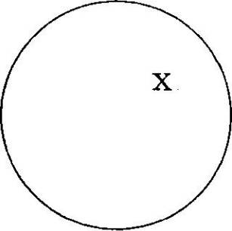
366 Theoretical Approaches

She needs a glass.
PRODUCER FOR PRODUCT
I’ll buy you that Rembrandt.
PLACE FOR INSTITUTION
Downing Street has made no comment.
INSTITUTION FOR PEOPLE
The Senate isn’t happy with this bill.
PLACE FOR EVENT
Hiroshima changed our view of war.
CONTROLLED FOR CONTROLLER
All the hospitals are on strike.
CAUSE FOR EFFECT
His native tongue is Hausa.

As with metaphor, metonymy is a productive way of creating new vocabu lary. We can give just two conventionalized examples from the proDUCer for proDUCT relation: shrapnel from the English general who invented the type of shell, and silhouette from the French finance minister who designed the technique.
There have been attempts to account for the particular choice of metonymic
reference points. Some choices seem more common and natural than oth ers, for example to use tongue for language rather than throat, or head for a person rather than, say waist. Langacker (1993: 30) suggested a general notion of salience, where items are graded for relative salience, for example (where > = more salient): human > non-human, whole > part, visible > non- visible, and concrete ^ abstract. Kovecses and Radden (1998) develop this idea further appealing to experiential and in particular perceptual motiva tion for principles governing the choice of metonymic reference point.
We have now seen something of the related processes of metaphor and metonymy. In section 11.4 we move on to consider the experientialist basis of metaphors, when we look at another, more basic cognitive structure proposed in this approach: image schemas.

Image Schemas

Image schemas are an important form of conceptual structure in the cog nitive semantics literature. The basic idea is that because of our physical experience of being and acting in the world - of perceiving the environment, moving our bodies, exerting and experiencing force, etc. - we form basic conceptual structures which we then use to organize thought across a range of more abstract domains. In Mark Johnson (1987), whose proposals we will examine in this section, these image schemas are proposed as a more primitive level of cognitive structure underlying metaphor and which pro vide a link between bodily experience and higher cognitive domains such as
Cognitive Semantics 367
language. We can look at some examples of image schemas, beginning with the Containment schema.

    - Containment schema

Mark Johnson (1987: 2Iff.) gives the example of the schema of Contain ment, which derives from our experience of the human body itself as a container; from experience of being physically located ourselves within bounded locations like rooms, beds, etc.; and also of putting objects into containers. The result is an abstract schema, of physical containment, which can be represented by a very simple image like figure 11.1, representing an entity within a bounded location.
Such a schema has certain experientially-based characteristics: it has a kind of natural logic, including for example the ‘rules’ in 11.15:
  - a. Containers are a kind of disjunction: elements are either in side or outside the container.
b. Containment is typically transitive: if the container is placed in another container the entity is within both, as Johnson says: ‘If I am in bed, and my bed is in my room, then I am in my room.’
The schema is also associated with a group of implications, which can be seen as natural inferences about containment. Johnson calls these ‘entailments’ and gives examples like the following (adapted from Johnson 1987: 22):
  - a. Experience of containment typically involves protection from outside forces.
- Containment limits forces, such as movement, within the container.
- The contained entity experiences relative fixity of location.
- The containment affects an observer’s view of the contained entity, either improving such a view or blocking it (containers may hide or display).

Figure 11.1 Containment

Source: Mark Johnson (1987: 23)


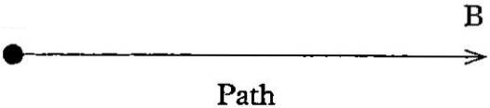
368 Theoretical Approaches

The fact that a schema has parts which ‘hang together’ in a way that is motivated by experience leads Johnson to call them gestalt structures (1987: 44):
  - I am using the term ‘gestalt structure’ to mean an organised, uni fied whole within our experience and understanding that mani fests a repeatable pattern or structure. Some people use the term ‘gestalt’ to mean a mere form or shape with no internal structure. In contrast to such a view, my entire project rests on showing that experiential gestalts have internal structure that connects up aspects of our experience and leads to inferences in our concep tual structure.

Though we have represented this schema in a static image like figure 11.1, it is important to remember that these schemas are in essence neither static nor restricted to images. The schema may be dynamic, as we shall see shortly with path and force schemas which involve movement and change.
This schema of containment can be extended by a process of metaphor
ical extension into abstract domains. Lakoff and Johnson (1980) identify ConTAiner as one of a group of ontological metaphors, where our experience of non-physical phenomena is described in terms of simple physical objects like substances and containers. For example the visual field is often con ceived as a container, as in examples like: The ship is coming into view; He’s out of sight now; There’s nothing in sight (p. 30). Similarly, activities can be viewed as containers: I put a lot of energy into washing the windows; He’s out of the race (p. 31), She’s deep in thought. States can be viewed in the same way: He’s in love; He’s coming out of the coma now (p. 32), She got into a rage, We stood in silence. For Lakoff and Johnson these examples are typical and reveal the important role of metaphor in allowing us to conceptualize experience.
Some other schemas identified by Mark Johnson (1987) include Path, Links, Forces, Balance, Up-Down, Front-Back, Part-Whole and Centre-Periphery. We might briefly look at the Path schema, and some of his examples of Force schemas, since these have been used in a number of linguistic studies.
    - Path schema
The Path schema is shown in figure 11.2. Johnson claims that this schema reflects our everyday experience of moving around the world and experien cing the movements of other entities. Our journeys typically have a beginning and an end, a sequence of places on the way and direction. Other move ments may include projected paths, like the flight of a stone thrown through the air. Based on such experiences the path schema contains a starting point (marked A in figure 11.2), an end point (marked B), and a sequence of
Cognitive Semantics 369

Figure 11.2 Path schema
A

Source: Mark Johnson (1987: 114)

contiguous locations connecting them (marked by the arrow). This schema has a number of associated implications, as listed in 11.18:
  - a. Since A and B are connected by a series of contiguous loca tions, getting from A to B implies passing through the inter mediate points.
- Paths tend to be associated with directional movement along them, say from A to B.
- There is an association with time. Since a person traversing a path takes time to do so, points on the path are readily associated with temporal sequence. Thus an implication is that the further along the path an entity is, the more time has elapsed.

These implications are evidenced in the metaphorical extension of this schema into abstract domains: we talk, for example, of achieving purposes as paths, as in 11.19 below:

  - a. He’s writing a PhD thesis and he’s nearly there.
b. I meant to finish painting it yesterday, but I got side-tracked,
and we saw examples in the last section of the related, more elaborated metaphor of Life is A joUrneY, which derives from this schema.

    - Force schemas

The Force schemas include the basic force schema of Compulsion, as shown in figure 11.3, where a force vector F acts on an entity u. In this diagram the essential element is movement along a trajectory: the dashed line represents the fact that the force may be blocked or may continue.
In figure 11.4 we see the more specific schema of Blockage, where a force meets an obstruction and acts in various ways: being diverted, or continuing on by moving the obstacle or passing through it.
Figure 11.3 Compulsion

F---------------------- >o- .. ->
u

370 Theoretical Approaches

Figure 11.4

Figure 11.5 Removal of restraint

- i
1 r
1 «
Cognitive Semantics 371

    - Prepositions

The schema of Containment has been use to investigate the semantics of spatial prepositions in a number of languages including the Cora language of Mexico (Langacker and Cassad 1985), English (Herkovits 1986), and French (Vandeloise 1991).These studies use schemas to explore the typical polysemy of prepositions: the fact that we can for example use the English preposition in in a number of related but distinct ways, as in the examples below given by Herkovits (1986):
  - a. the water in the vase
- the crack in the vase
- the crack in the surface
- the bird in the tree
- the chair in the corner
- the nail in the box
g- the muscles in his leg
h. the pear in the bowl

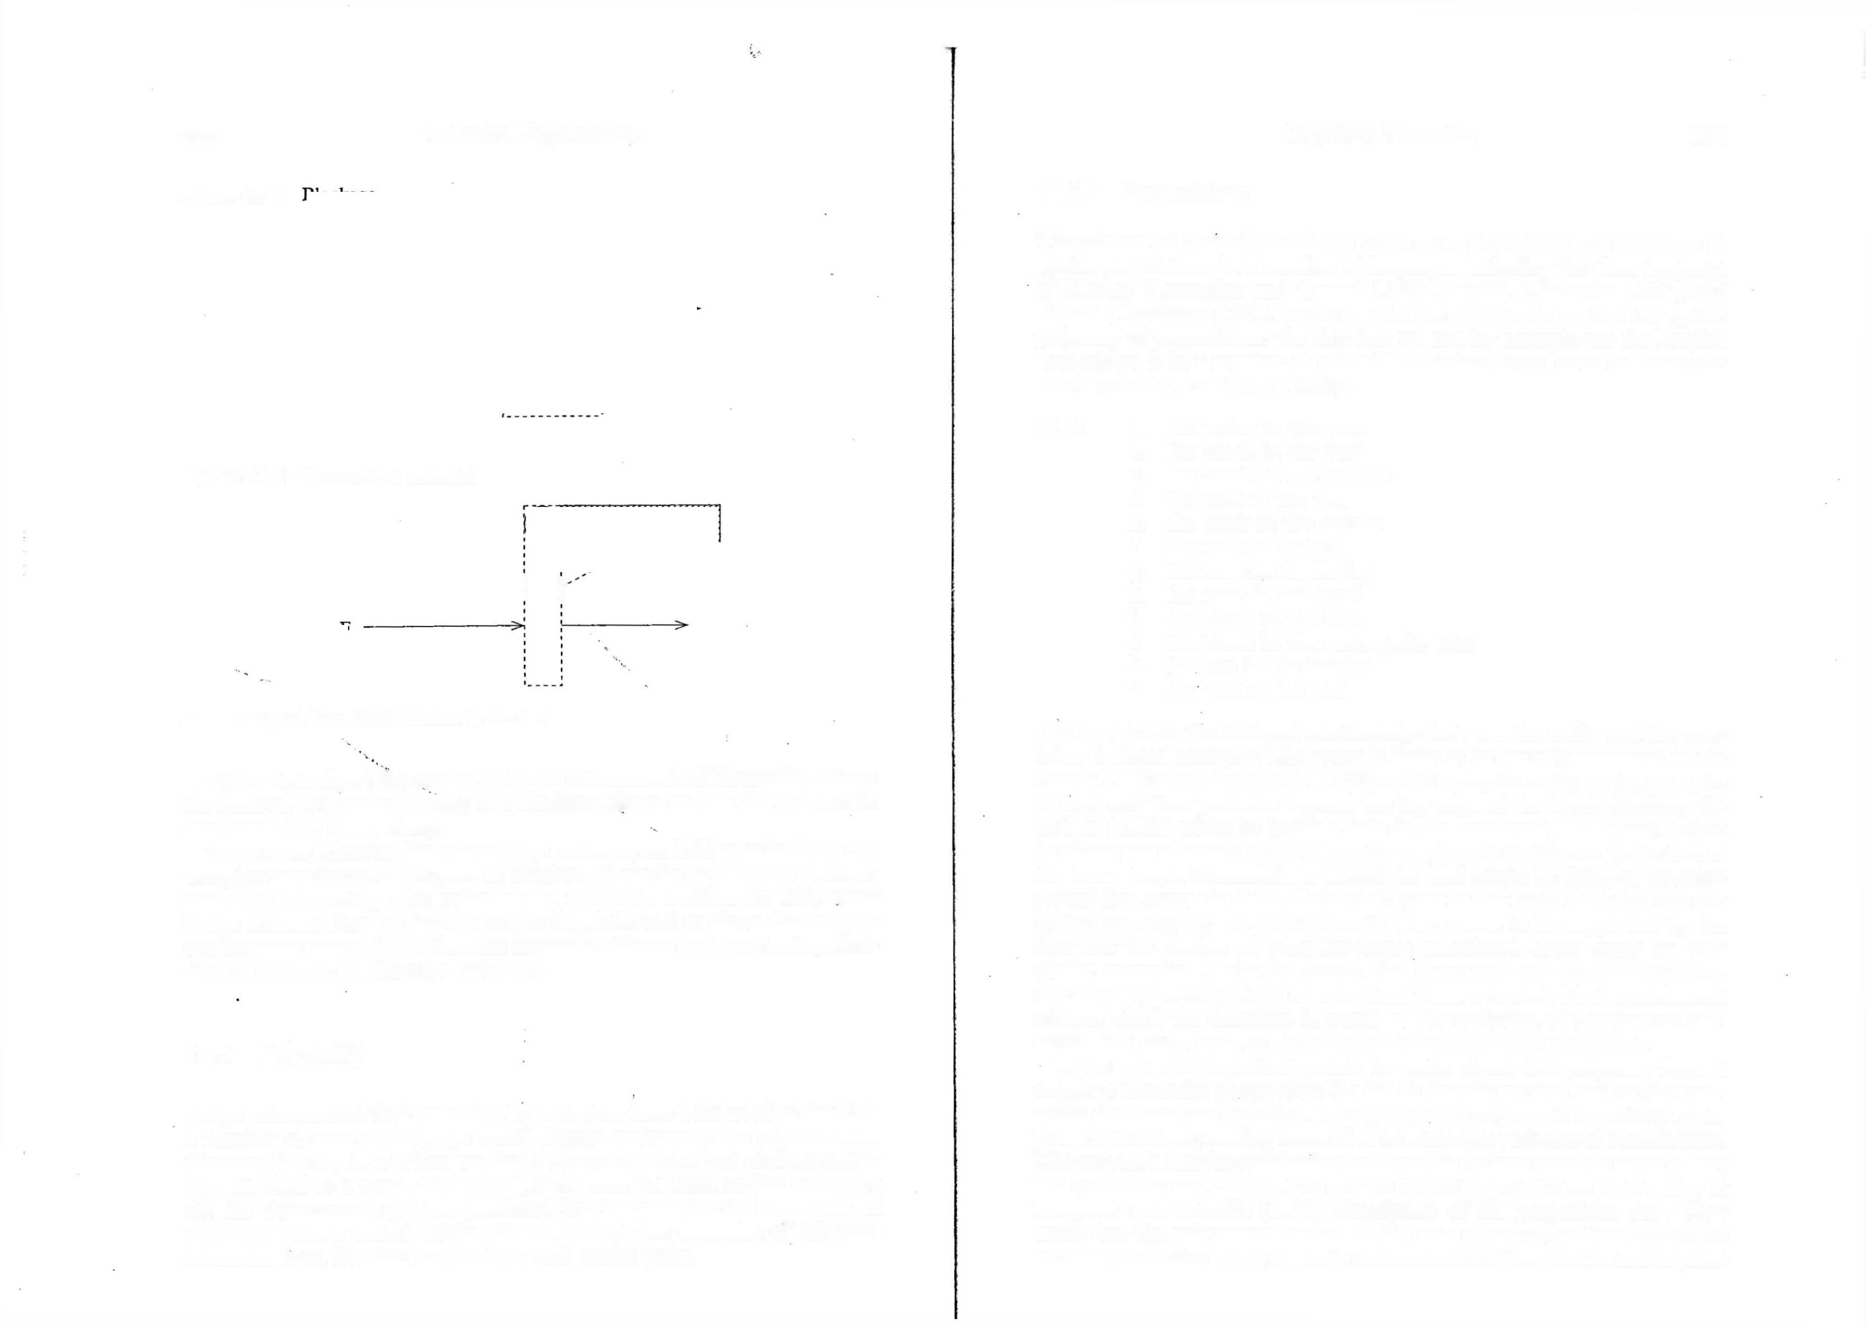
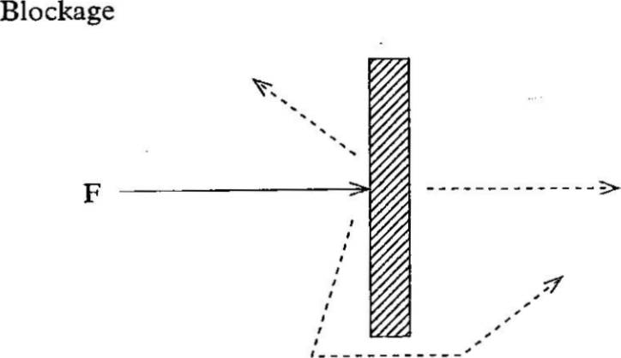
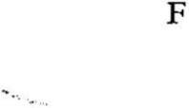
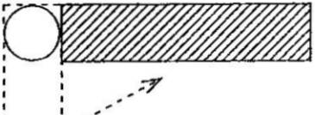

Source: Adapted from Mark Johnson (1987: 47)

Figure 11.5 shows the related schemas of Removal of Restraint, where the removal (by another cause) of a blockage allows an exertion of force to continue along a trajectory.
These force schemas, like other image schemas, are held to arise from our everyday experiences as we grew as children, of moving around our environ ment and interacting with animate and inanimate entities. As with other image schemas they are held to be pre-linguistic and to shape the form of
our linguistic categories. In the next section we discuss an important applica tion of schemas: to describe polysemy.

Polysemy

Image schemas and their extension by metaphor have been used to describe a number of areas of language which display polysemy: the phenomenon discussed in chapter 3 where we find a group of related but distinct mean ings attached to a word. G. Lakoff (1987) uses the term radial category for the characteristic pattern produced by the metaphorical extension of meanings from a central origin. We can look at two examples of this phe nomenon from English: prepositions and modal verbs.
i. the block in the box
j- the block in the rectangular area
k. the gap in the border
1. the bird in the field
It is easy to see the different relationships between the entity and the con tainer in these examples. The water is likely to be entirely contained in the vase in 11.20a but the pear in 11.20h could easily be sitting on top of a pile of fruit and thus protrude beyond the top edge of the bowl. Similarly the bird in 11.20d might be inside a hole in the tree-trunk, but equally might be sitting on a branch which if 'inside’ anything is inside our projection of the tree’s shape. Meanwhile in 11.201 the bird might be flying or hovering several feet above the field. Herkovits’s point is that such extended uses are typical and regular, i.e. not idiomatic. This seems to be supported by the fact that the studies of other languages mentioned above come up with similar examples. Herkovits claims that these uses are most satisfactorily described by viewing them as extensions from a central, ideal containment schema which she describes in words as 'the inclusion of a geometric con struct in a one-, two-, or three-dimensional geometric construct’.
There are two important points to make about this polysemy from a cognitive semantics perspective: the first is that the various and varying real- world situations are described in language in a way that is essentially meta phorical in nature, relating them all to an underlying schema of containment. The second is that the relationship between the various senses is not arbitrary but systematic and natural. We can see the latter point if we look briefly at Brugman and Lakofif’s (1988) description of the preposition over. They argue that the polysemous nature of this and other prepositions cannot be accurately described using semantic features or definitions but instead requires


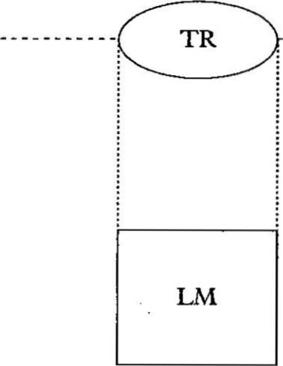
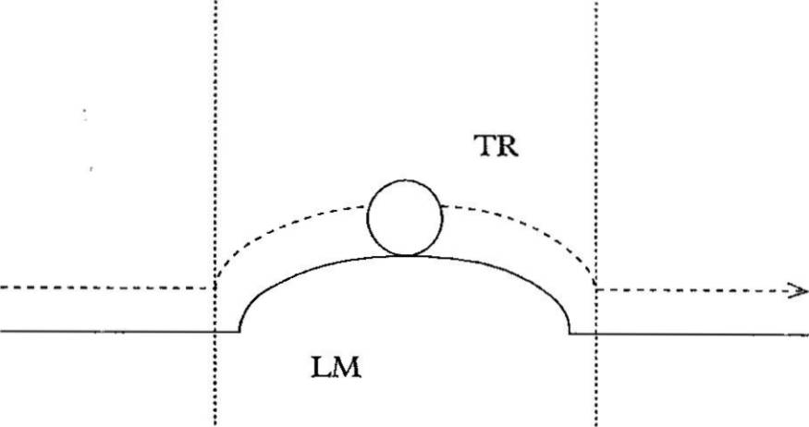
372 Theoretical Approaches

an essentially topographical approach., i.e. a description employing spatial models. They claim (1988: 479):

  - Topological concepts are needed in order to account for how prepositions can be used to characterize an infinity of visual scenes.

The polysemous nature of over can be shown, as we did for in earlier, by a set of examples (Brugman and Lakoff 1988):

  - a. The plane is flying over the hill.
- Sam walked over the hill.
- The bird flew over the yard
- The bird flew over the wall.
- Sam lives over the hill.
- The painting is over the mantel.
- The board is over the hole.
- She spread the tablecloth over the table.
- The city clouded over.
- The guards were posted all over the hill.
- Harry still hasn’t gotten over his divorce.

Brugman and Lakoff propose a complex structure for the meanings of over. the preposition has a number of related senses, of which we can select three, termed the above-across sense, the above sense, and the covering sense. Each of these senses is then structured as a radial category with extensions from a central prototype. Let us take the above-across sense first. This sense of over is described in terms of a Path image schema: using the terms trajector (TR) for a moving entity and landmark (LM) for the back ground against which movement occurs.13 Brugman and leakoff represent this in a schema like figure 11.6. This schema would fit for example 11.22a, The plane is flying over the hill. In this approach several other senses of over can be systematically related to this central schema by a number of basic processes, for example by adding information to the schema or by metaphor. In the first type of process the central schema may alter along a number of parameters: for example there may be contact between the trajector and the landmark as in 11.22b Sam walked over the hill, shown schematically in figure 11.7. Other information may be added about the landmark, which may be viewed as different geometric shapes: as an extended area as in
  - c; or as a vertical form as in 11.22d. Alternatively the focus may
be on the endpoint of the path as in 11.22e. In the second type of process the preposition can be used metaphorically, where it interacts with the metaphorical structures available to the language users. Thus in 11.22k we see a version of the Life As A joUrneY metaphor we discussed earlier, where problems are seen as obstacles.
A second major sense of over is the above sense, as in 11.22f above: The painting is over the mantel. This sense is stative and has no path element. It
Cognitive Semantics 373

Figure 11.6 Prototypical above-across sense of over

Source: Brugman and Lakoff (1988: 482)

Figure 11.7 Sam walked over the hill

Source: Brugman and Lakoff (1988: 483)

can be represented by the schema in figure 11.8. Since this schema does not include a path element it has no meaning of across. It also differs from the first sense in that there are no restrictions on the shape of the landmark, nor can there be contact between trajector and landmark. If there is contact we are more likely to use another preposition, such as on as in The painting is on the mantel.
Our third sense, or group of senses, of over is the covering sense which can be represented in figure 11.9. The schema in this figure corresponds to sentence 11.22g above: The board is over the hole. This schema may have a path element depicting the motion of the trajector into its position over the landmark as in 11.22h She spread the tablecloth over the table or 11.22i The city clouded over. In this schema the use of a quantifier like all changes the nature of the trajector, as for example in sentence 11.22j: The guards

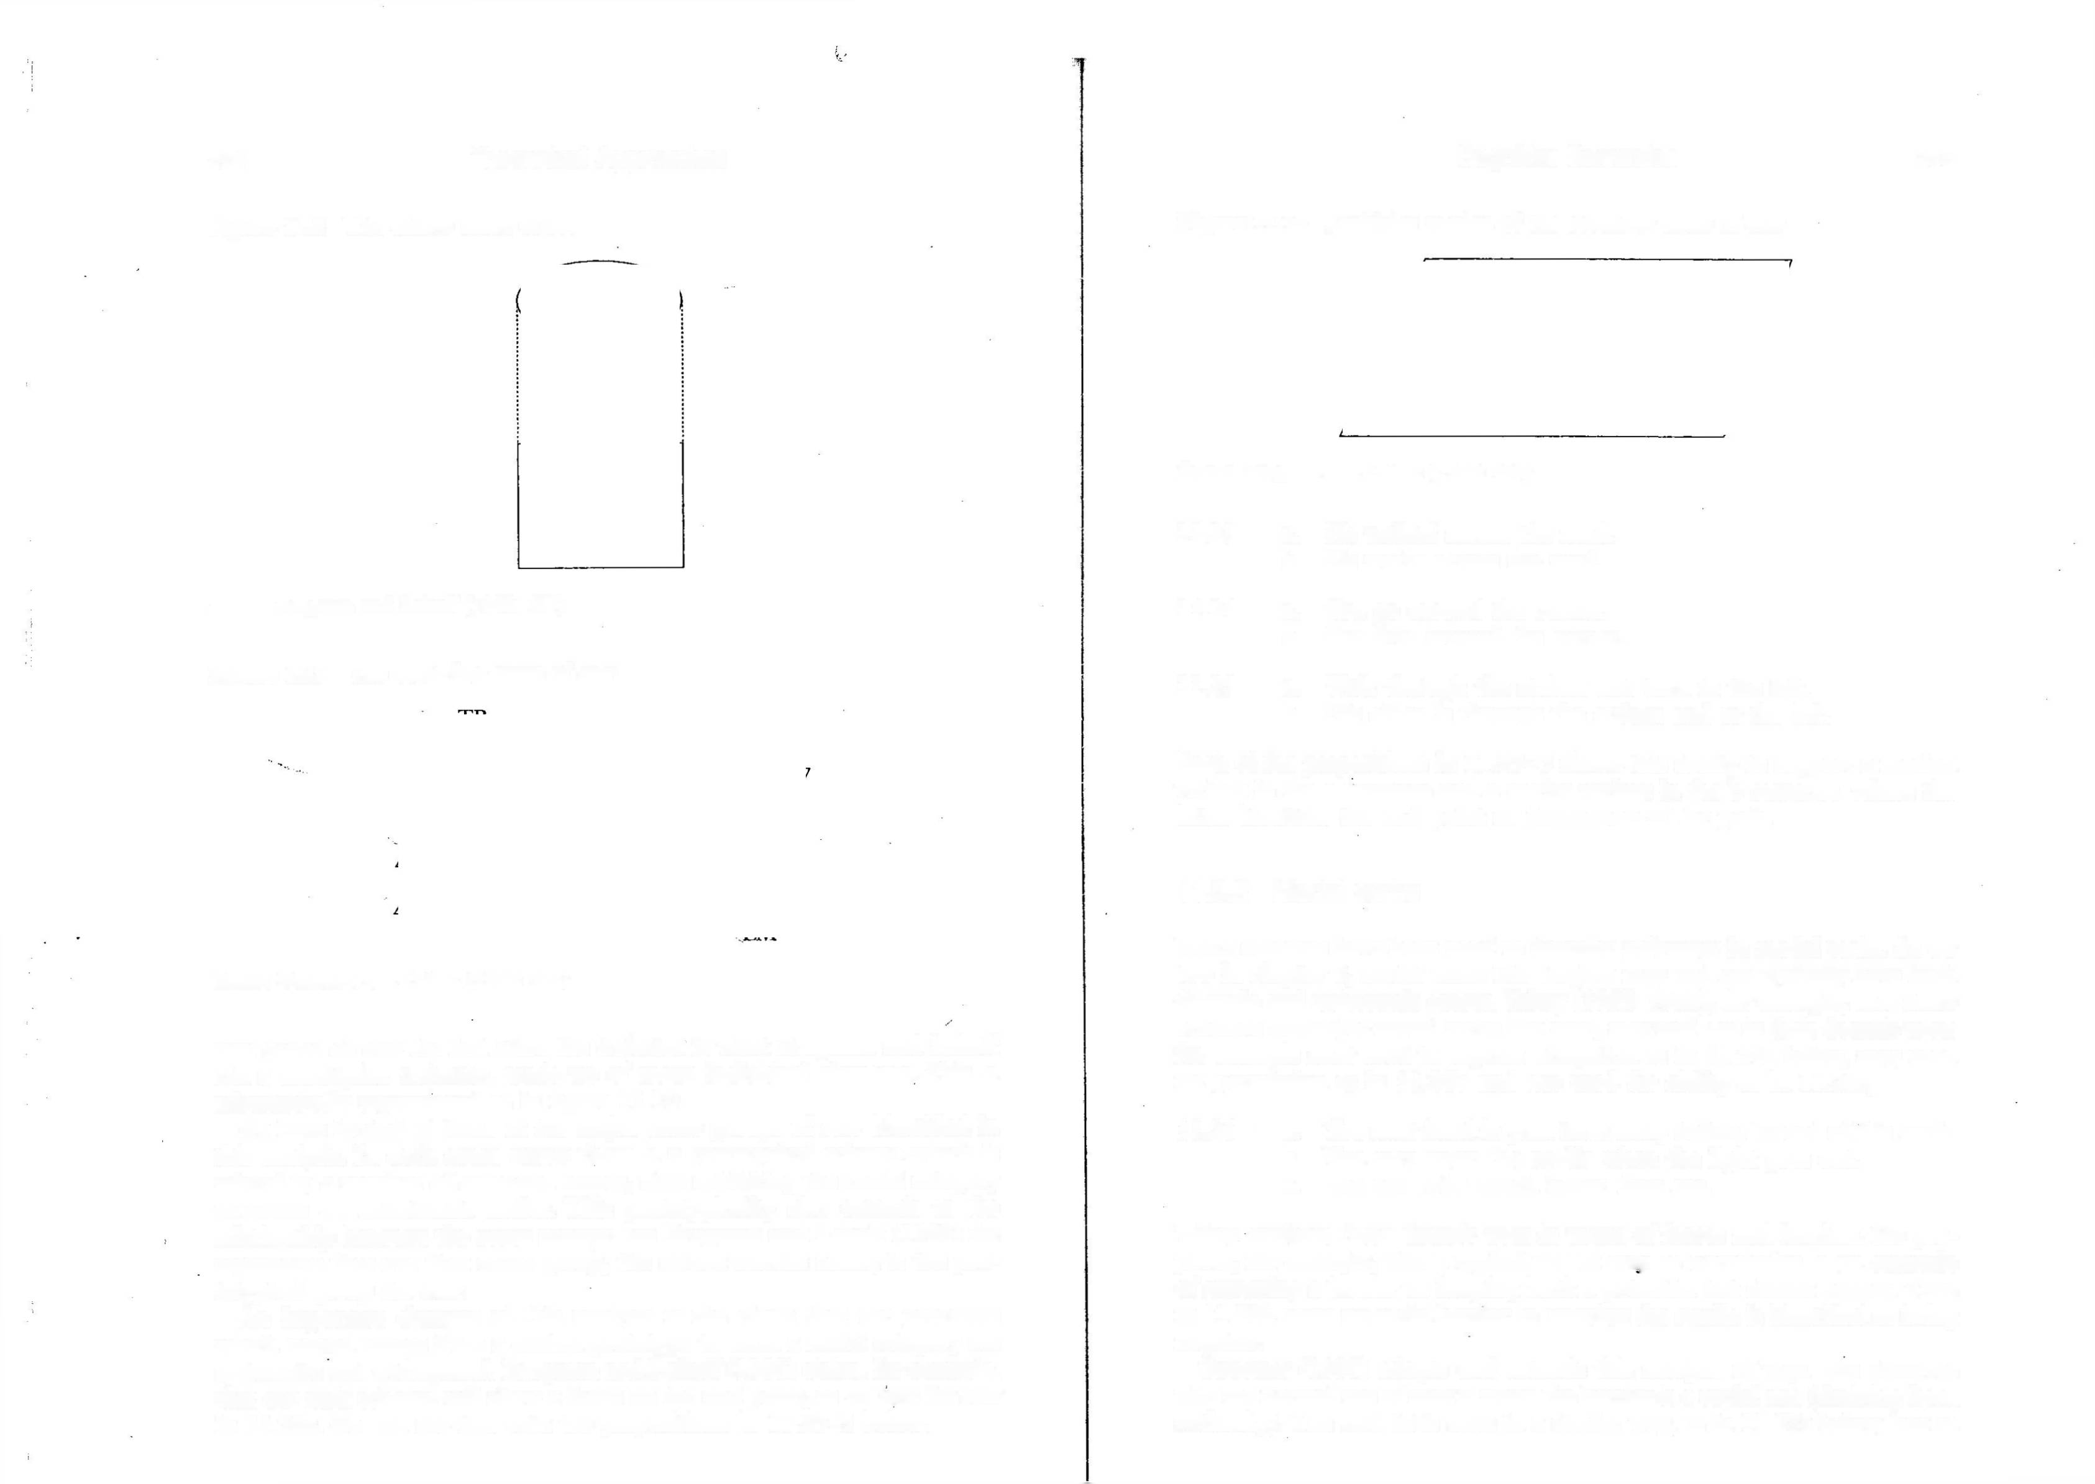
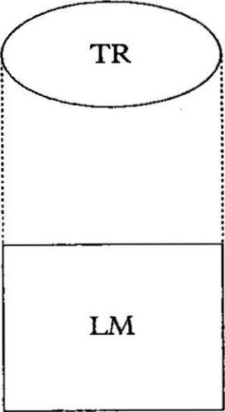
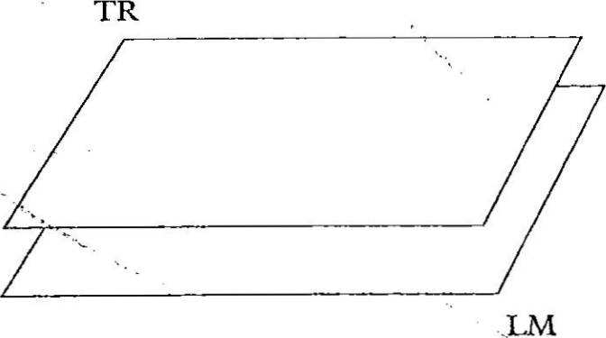
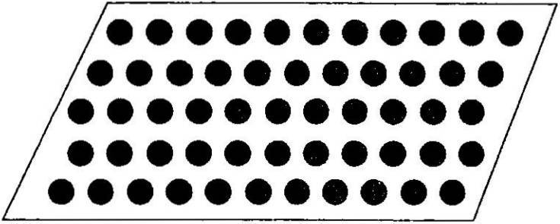
374 Theoretical Approaches

Figure 11.8 The above sense of over

Source: Brugman and Lakoff (1988: 487)

Figure 11.9 The covering sense of over

Source: Brugman and Lakoff (1988: 489)

were posted all over the hill. Here the trajector is what Brugman and Lakoff call a multiplex trajector, made up of many individual elements. This is schematically represented as in figure 11.10.
We have looked at three of the major sense groups of over identified in this analysis. In each sense group there is a prototypical schema which is related to a number of extended senses, thus exhibiting the radial category structure we mentioned earlier. This prototypicality also extends to the relationship between the sense groups: see Brugman and Lakoff (1988) for arguments that our first sense group, the above-across sense, is the pro totypical group for over.
An important element of this analysis is the claim that the processes
which extend senses from a central prototype to form a radial category are systematic and widespread. Brugman and Lakoff (1988) claim, for example, that any path schema will allow a focus on the end point, as we saw for over in 11.22e. We can see this with the prepositions in 11.23-5 below:
Cognitive Semantics 375

Figure 11.10 Multiplex version of the covering sense of over

Source: Brugman and Lakoff (1988: 490)

  - a. He walked across the road.
    - He works across the road.
  - a. You go around the corner.
    - She lives around the corner.
  - a. Walk through the atrium and turn to the left.
    - His office is through the atrium and to the left.
Each of the prepositions in 11.23-5 shows this ability to support a motion variant in the a sentence and a stative variant in the b sentence, where the latter identifies the end point or destination of the path.

    - Modal verbs

Force schemas have been used to describe polysemy in modal verbs. As we saw in chapter 5, modal verbs like English may and can typically have both deontic and epistemic senses. Talmy (1985, 1988), for example, uses force schemas to analyse modal verbs like musty may and can in their deontic uses: for example must used to express obligation as in 11.26a below, may used for permission as in 11.26b and can used for ability as in 11.26c;
  - • a. You must hand in your term essay before the end of this week.
    - You may enter the studio when the light goes out.
    - She can swim much better than me.
Talmy analyses these deontic uses in terms of forces and barriers. He pro poses, for example, that a typical use of way as permission is an example of removing a barrier or keeping back a potential but absent barrier. Thus in 11.26b some potential barrier to entering the studio is identified as being negated.
Sweetser (1990) adopts and extends this analysis of may. She observes that the normal use of may is when the barrier is a social one (deriving from authority). The verb let is used in a similar way, as in 11.27a below, but as

376 Theoretical Approaches
Sweetser notes, with this verb there are physical analogues to this removal of a potential barrier as in 11.27b:

  - a. I’ll let you smoke in the car, but just for today.
    - The hole in the roof let the rain in.

In this approach, the other deontic modals can also be given a force schema analysis: for example, the use of must for obligation is an example of the Compulsion Force schema. In 11.26a above the force is the teacher’s authority but it can also be a moral or religious force as in You must respect your parents or You must pray five times a day. The idea seems to be that there is a conceptual link between someone physically pushing you in a direction and a moral force impelling you to act in a certain way. Both are forces which can be resisted or acceded to; in this approach a common conceptual schema unites the characterization of the two situations.
Sweetser (1990) analyses the epistemic use of modals as a metaphorical
extension of these deontic uses. We can take the examples of must and may. In its epistemic use must can express a reasonable conclusion as in 11.28a and b:
  - a. It’s dead. The battery must have run down.
b. You’ve travelled all day. You must be tired.

The epistemic use of may expresses possibility as in 11.29:

  - a. You may feel a bit sick when we take off.
b. He may not last out the whole game.

Sweetser argues that such uses of modals for rational argument and judge ment are derived from their uses for the real world of social obligation and permission. This derivation follows the usual metaphorical extension from the external concrete world to the internal world of cognition and emotion. Thus to take the example of may, the epistemic use is again taken to represent a lack of barrier. Here though the barrier is to the line of reasoning leading to the conclusion expressed. Thus a sentence like 11.30a below can be paraphrased as 11.30b:

  - a. You may be right.
b. There is no evidence preventing the conclusion that you are
right.

Thus an overt parallel is drawn in this account between barriers in social action and barriers in mental reasoning.
In a similar way epistemic must is interpreted as the Compulsion Force schema extended to the domain of reasoning. So 11.31a below is para
phrased as 11.31b:
Cognitive Semantics 377
  - a. You must have driven too fast.
b. The evidence forces my conclusion that you drove too fast.

Thus Sweetser is arguing that evidence is conceptualized as a force analog ous to social pressure and laws, moving a person’s judgement in a certain direction.
This type of analysis is extended to other modals but we need not follow the analysis further: we can identify from these few examples her claim that the relationship between the deontic and epistemic use of each modal is not accidental but a further example of polysemy: i.e. the different uses are semantically related. What relates them, in this view, is the metaphorical extension of the force and barriers schemas from the social world to our inner reasoning.
So to conclude this section, we have seen that image schemas are pro posed as experientially-based conceptual constructs by which we char acterize, for example, spatial relations, and which can be metaphorically extended across a range of domains, typically shifting from the external and concrete to the internal and abstract. Such schemas are seen as the building blocks of metaphor, allowing us to conceive of emotional states as con tainers (She’s in love), evidence as compulsion (He must be guilty), or purposes as paths (A: Have you finished the book? B: I’m getting there). Polysemy is the result of this extension of schemas to form radial categories and is seen as a natural and ubiquitous phenomenon in language. In the next section we look at another form of conceptual structure identified in this approach: mental spaces.

Mental Spaces

Mental spaces are conceptual structures, originally proposed by Gilles Fauconnier (1994, 1997), to describe how language users assign and mani pulate reference, including the use of names, definite descriptions, and pronouns. Fauconnier’s structures are set up in the light of a particular view of meaning: that when we study linguistic meaning we are studying the way that language provides a patchy and partial trigger for a series of complex cognitive procedures. In this view meaning is not ‘in’ language; rather, language is like a recipe for constructing meaning, a recipe which relies on a lot of independent cognitive activity. Moreover this process of meaning construction is a discourse-based process, implying that typically a single sentence is only a step in the recipe and cannot be clearly analysed without recognizing its relationship to and dependency on earlier sentences.
So Fauconnier’s focus is on the cognitive processes triggered during dis course by linguistic structures. Within this, a particular topic of investigation has been the management of reference: the issue of how speakers and hearers keep track of the entities referred to in the language. The central

378 Theoretical Approaches
idea is that when we are involved in using language, for example in conversa tion, we are continually constructing domains, so that if we talk about,
Cognitive Semantics 379
Figure 11.11 Person-image connector

say, Shakespeare’s play Julius Caesar, we might maintain several relevant domains, or mental spaces. One domain is the world of the play, while another might be the real world, where Julius Caesar is a historical figure. Our referential practices make use of such divisions into domains so that we
Trigger a: person
girl with blue eyes
imAGe (connector) Target
- —> b: image

girl with green eyes

can use the same name Julius Caesar to talk about the historical person and the character in the play. Between our different uses of the name there are nevertheless links: we might want to say for example that Shakespeare’s character is meant to describe the historical figure. Such processes can be quite complicated: we might go to see a performance of the play and after wards say Julius Caesar was too young, referring now to the actor playing the part. Or if we saw some children running off with the foyer’s life-size figure of the actor in costume, we might say Hey, they're stealing Julius Caesar. So we can use the same name to refer to a historical person, a role in a play written about him, an actor playing that role and a figure of that actor playing the role. Fauconnier’s point is that such flexibility is inherent in our use of referring expressions: his mental spaces are an attempt to explain such behaviour.
Mental spaces can be seen as a cognitive parallel to the notion of possible worlds in formal semantics, as discussed in chapter 10, since it is assumed that speakers can partition off and hold separate domains of reference.
Some of these might be very complex: we might for example be talking of the world of Charles Dickens’s A Tale of Two Cities and refer to individuals in that novel, like Charles Dor nay and Sydney Carton. Or the domain might be very sparsely furnished, provoked just by a counterfactual as in If I were you, I'd go on a diet, where once the shift from the real to the non-real domain is made in the first clause, the I in the second clause identifies not the speaker but the addressee. Here, however, any further implications of this domain, or mental space, are not explored and it remains a local, minimal space.
    - Connections between spaces

One important issue is what links there might be between mental spaces. What, for example, allows us to use the name Julius Caesar as we did, for a historical person, a role in a play, an actor, etc.? Fauconnier (1994), building on work by Jackendoff (1975) and Nunburg (1978, 1979), dis cusses the way that speakers can make reference to entities by a number of indirect strategies. We can for example refer to a representation of someone by their name: so that looking at a photograph of a friend I might say Graham looks really young, where Graham refers to the picture of Graham (who in reality might look far from young). Fauconnier uses the terms trigger and target here: the name of the real Graham is the trigger and the target (what I want to describe) is the image. Clearly photographs and
Source: Based on Fauconnier (1994)

the people in them are related by the viewer’s recognition of resemblance, but similar strategies are widespread. We can refer, for example, to a book or books by the author’s name and say sentences like Shakespeare's on the top shelf. Similarly, a nurse might say The gall bladder in the end bed is awake’, or in a favourite type of example in this literature, a waiter might say The ham omelette zvants his bill. In chapter 7 we called this phenomenon metonymy. Fauconnier employs an identification principle which allows speakers to use such referential shifts; one version is in 11.32 below (1994: 3):

  - If two objects (in the most general sense), a and b, are linked by
a pragmatic function F (b = F(a)), a description of a, da, may be used to identify its counterpart b.

So since in our photograph example real Graham (a) and photo Graham (6) are linked by the pragmatic function imAGe, a description of real Graham (his name, df) can be used to identify his photographic image (&). It is assumed that there might be a number of such pragmatic functions, as we shall see.
We can look at some more complicated examples of this referential shift ing by looking at Fauconnier’s account of Jackendoff’s (1975) example in
  - below:

  - In Len’s painting, the girl with blue eyes has green eyes.

Let us take as an interpretation of this sentence the situation where the speaker knows the identity of the artist’s model, knows that she has blue eyes and is pointing out that the painter has decided to give her green eyes in the picture. The proposal is that here two mental spaces are set up: one is the real world (as the speaker knows it) which has in it a girl with blue eyes; the other the space of the painting which has a girl with green eyes. The sentence 11.33 explicitly connects these two girls, saying in effect they are in the image-person relationship we discussed for our hypothetical friend Graham earlier. This can be represented in figure 11.11, which shows the connection (our image relationship) as an arrow.
Fauconnier, following Jackendoff (1975), makes the point that this can be likened to the relationship between beliefs and reality: thus, paralleling 11.33 above we can say 11.34 and 11.35 below:

380 Theoretical Approaches

Figure 11.12 World-mind connector

speaker ‘real’ world

Len’s beliefs (as reported by speaker)
Cognitive Semantics 381

space is referred to as the parent space. Often of course the default (un marked) highest parent space will be reality, or more accurately the current speaker’s assessment of reality. Take for example, a speaker uttering the sen tences in 11.36 below:

  - Barry’s in the pub. His wife thinks he’s in the office.

Here the initial space is the speaker’s reality (7?) where Barry is in the pub, then the phrase his wife thinks sets up a new mental space (Al) in which his counterpart Barry₂ is in the office. The speaker can then develop either space, talking about what Barryi is doing in R or what Barry₂ is (supposedly) doing in M.


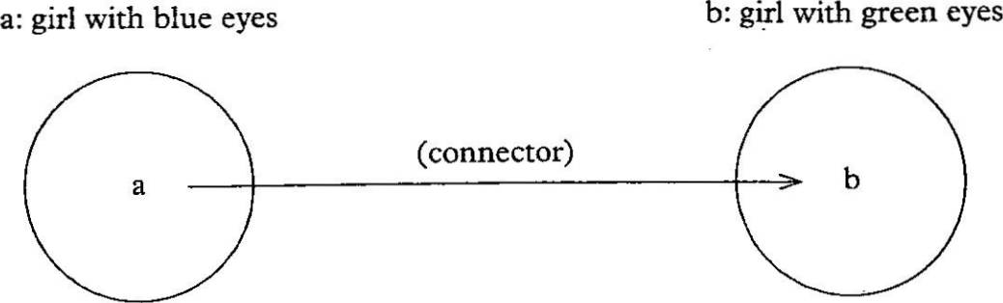
Source: Based on Fauconnier (1994)

Figure 11.13 Image-person connector
Trigger imAGe (connector) Target
a: image b: person

girl with brown eyes ’ girl with blue eyes

Source: Based on Fauconnier (1994)

  - Len believes that the girl with blue eyes has green eyes.
  - Len wants the girl with blue eyes to have green eyes.

Here Len’s belief and wish are at odds with reality as known by the speaker. In the semantics literature such examples are often described as instances of belief contexts. In this theory they are viewed as a mental parallel to the image relation, and are represented by similar diagrams, using a belief or minD connector, as in figure 11.12. As Fauconnier points out, the speaker can work such relationships in the other direction. Taking the image rela tionship as an example, a speaker might say, looking at a picture: In reality, the girl with brown eyes has blue eyes. Here the trigger is the image and the target is the real girl, as shown in figure 11.13.
These examples are of mental spaces created by talking of paintings and a person’s beliefs and wishes. There are in fact a whole range of linguistic elements which serve as triggers for setting up mental spaces, which Fauconnier calls spacebuilders. These include adverbials of location and time like in Joan's novel, in Peter's painting, when she was a child, after we find the crash site, etc. They also include adverbs like possibly and really', connect ives like if then', and certain verbs like believe, hope, and imagine. The context in which a sentence is uttered will provide the anchoring or background mental space. Where spaces are stacked inside one another, the including

    - Referential opacity

One important advantage to this idea of mental spaces and links between them is that it can be used to explain the phenomenon of referential opacity. This is the traditionally problematic area where, as we discussed in chapter 2, knowledge interacts with reference. Let’s take, for example, sen tence 11.37 below to be true of a policeman called Jones:

  - Jones believes that the leader of the Black Gulch Gang is a sociopath.

If Jones does not know that his wife is the leader of the Black Gulch Gang we can also take sentence 11.38 below to be true at the same time:

  - Jones doesn’t believe his wife is a sociopath.

Because of what Jones knows, we are not ascribing contradictory beliefs to him, even though the nominals his wife and the leader of the Black Gulch Gang denote the same individual. This is a typical effect of belief contexts and in chapter 2 we saw that such examples have been used to argue that there must be more to meaning than simply denotation.
As we discussed in chapter 10, sentences like 11.37 are described as opaque contexts. In this type of example the opacity is associated with embedded clauses under verbs of propositional attitudes like believe, want, suspect, hope, etc. To give another example, a sentence like 11.39 below can have two distinct interpretations:

  - The Captain suspects that a detective in the squad is taking bribes.

If we take 11.39 to mean that the Captain suspects a particular detective, this is called the specific or transparent reading. If on the other hand we take 11.39 to mean that the Captain suspects that one of the detectives is


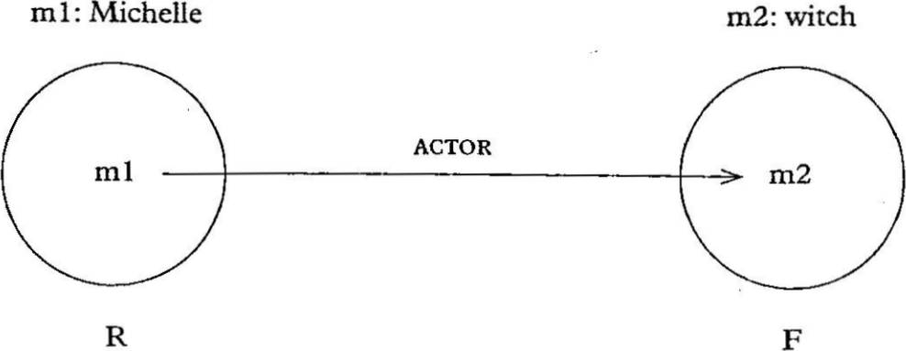
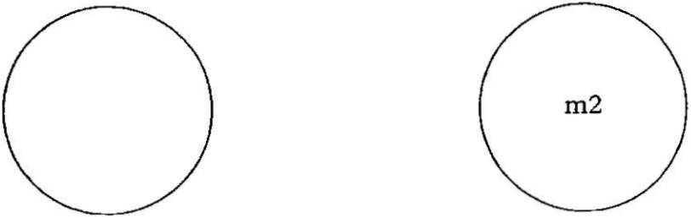
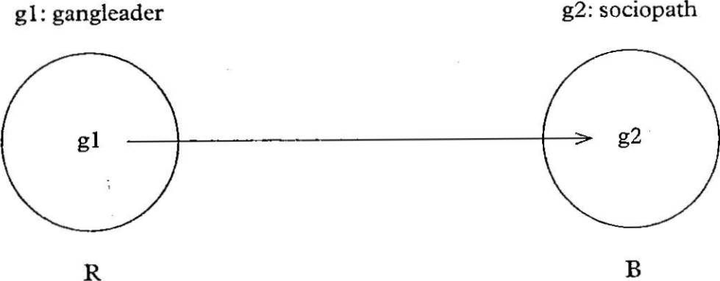
382 Theoretical Approaches

Figure 11.14 First interpretation of In the film, Michelle is a witch

involved but doesn’t know which one, this is called the non-specific or opaque reading. In another terminology used in logic, the transparent reading (the captain knows which individual) is given the Latin label the de re interpretation (meaning roughly ‘of the thing’) while the opaque reading is called the de dicto interpretation (roughly ‘of what is said’).
In the mental spaces approach these two interpretations do not arise from any ambiguity in the sentence but from two different space-connecting strat egies that hearers may use. Nor are opaque contexts restricted to verbs of propositional attitude: they are a regular cdnsequence of referential strat egies: To show this, we might go back to an example of identifying actors and parts. Suppose for example a speaker says 11.40 below:
  - In the- film, Michelle is a witch.
This sentence sets up two spaces which we. can identify as speaker’s reality
(R) and the film (F). The name Michelle can be used to refer in two ways. In the first there is the kind of referential shifting we described earlier: Michelle is the name of a person in R, but the speaker uses her name to describe the film images of her acting the role of a witch (here of course the film images may or may not resemble real-life Michelle). We could call this connector ACTor. We can represent this interpretation in figure 11.14. We can roughly describe this as: real-life Michelle plays the film part of a witch. In the second interpretation there is no referential shifting between the two mental spaces: Michelle is the name of a character in the film space and we predicate of this character that she is a witch. This interpretation can be represented in figure 11.15. We can roughly describe this as: in the film the character Michelle is a witch.
These two interpretations are predicted to be regular options whenever two spaces are set up like this and this same behaviour is used to explain the examples of referential opacity we have been looking at. If we go back to example 11.37 Jones believes that the leader of the Black Gulch Gang is a sociopath, the verb believe is a spacebuilder which adds the space of Jones’s belief (call it space B) to the parent space, which we can take to be the speaker’s reality (call this space R), although of course our sentence could
Cognitive Semantics 383

Figure 11.15 Second interpretation of In the film, Michelle is a witch
m2: Michelle m2: witch

R F

Figure 11.16 Transparent reading of example 11.37

easily be embedded in a story or someone else’s belief. The transparent reading of this sentence will be where Jones knows the identity of the gang leader in reality and sets up a belief space where he describes the gangleadcr as a sociopath. There is therefore a referential link between the gangleader in reality and the gangleader in Jones’s belief, shown by the connector arrow in figure 11.16. We can roughly describe this as: Jones know the iden tity of the gangleader in R and in his belief space B the gangleader is a sociopath.
The opaque reading of this sentence will be where Jones doesn’t know the
identity of the gangleader in R but has a belief about this person in B: here there is no referential link between the reality space and the belief space, as we show in figure 11.17. We can roughly describe this as: Jones doesn’t know the identity of the gangleader in reality but in his belief the gangleader is a sociopath.
In this approach any spacebuilder can trigger such ambiguities of inter
pretation so that a time adverbial like in 1966 can trigger two readings for the sentence 11.41 below:
  - In 1966 my wife was very young.


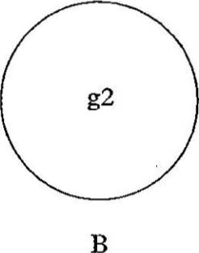
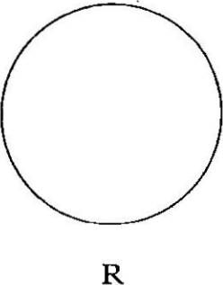
384 Theoretical Approaches

Figure 11.17 Opaque reading of example 11.37
g2: gangleader g2: sociopath

Here two time spaces are established: the ‘now’ of the speaker and the time 1966. The reference to the nominal my wife can be interpreted in two ways. The first simply identifies a wife in the 1966 time space and is consistent with the speaker either having the same wife in the ‘now’ space or not. The second interpretation is that the person who is the speaker’s wife now was not his wife in 1966, but is referred to as my wife by a shift linking the mental spaces. On this type of reading there is nothing odd about the sentence In 1966 my wife was a baby. As Fauconnier points out, this ability to connect or not connect spaces allows the transparent non-contradictory readings for his examples in 11.42 and 11.43 below:

  - In Canadian football, the 50-yard line is 55 yards away.

  - In this new Californian religion, the devil is an angel.

In this approach then the regular system of establishing mental spaces predicts these types of referential flexibility and the prediction naturally includes referential opacity. The advantage over traditional accounts, perhaps, is that this approach moves the phenomenon centre-stage, so to speak, in the study of reference and predicts that such ambiguities are very wide spread and regular.

    - Presupposition

One further advantage of the mental spaces approach is that it unifies the account of referential opacity with an analysis of presupposition. In our discussion of presupposition in chapter 4 we saw that one of the problem atic features is the defeasibility or cancellability of presuppositions. Thus, for example, sentence 11.44a below has the presupposition 11.44b, but this is cancelled in 11.44c by the added clause:
Cognitive Semantics 385
  - a. John hasn’t stopped smoking.
    - John used to smoke.
    - John hasn’t stopped smoking, because he never smoked.

We saw that presuppositions can be cancelled by various kinds of contextual information, including general background knowledge. We used examples like 11.45 and 11.46 below, where the presupposition trigger before in 11.45a produces the presupposition in 11.45b, while in 11.46 no such presupposi tion is produced because of what we know about death:

  - a. Aunt Lola drank the whole bottle of wine before she finished the meal.
    - Aunt Lola finished the meal.

  - Aunt Lola dropped dead before she finished the meal.

We won’t go into very much detail of the analysis here but the mental spaces approach explains the cancellation phenomenon by viewing presuppositions as moving (‘floating’ in Fauconnier’s term) from space to space unless blocked by contradiction with the entities and relations (essentially the facts) identified in a space.
We can take the well-worn example of the King of France as an example. Fauconnier (1994: 101) discusses the example in 11.47 below:

  - Luke believes that it is probable that the King of France is bald, even though in fact there is no King of France.

Here we have three mental spaces: we begin with the first parent space of the speaker’s reality R; then believe sets up a space of Luke’s belief B; and probable sets up another space P. The presupposition There is a King of France originates in P from the sentence The King of France is bald and is thus a presupposition of It is probable that the King of France is bald. It then ‘floats’ up to the encompassing parent space B and thus becomes a presupposition of Luke believes that it is probable that the King of France is bald. However the presupposition is blocked from floating into the space R by the explicit clause in fact there is no King of France. The advantage of this analysis is that though the presupposition is blocked in R and therefore for the sentence as
a whole, the analysis shows how it remains associated with parts of the sentence which relate to other spaces.
The floating or sharing of presuppositions between spaces is possible because of a general similarity principle, or laziness principle, of space crea tion, which Fauconnier calls optimization, as defined below:

  - Optimization (Fauconnier 1994: 91)
When a daughter space M is set up within a parent space R,
structure M implicitly so as to maximize similarity with R. In

386 Theoretical Approaches

particular, in the absence of explicit contrary stipulation, assume that
- elements in jR have counterparts in M,
- the relations holding in R hold for the counterparts in M, and
- background assumptions in R hold in M.

Though this is only an initial stab at such a principle, we can see that it must operate in all spacebuilding and thus not only explains the sharing of presuppositions across mental spaces but also explains why in counterfactuals like 11.49 below:
  - If I were rich, I’d move from Ireland to a Caribbean island.

we assume in the hypothetical space that the world is pretty much the same as in reality except for the speaker’s increased wealth. We don’t assume for example that Caribbean islands change to acquire Ireland’s climate.14
Given such a principle and the mechanism of presupposition floating, it is a straightforward prediction of this approach that all kinds of knowledge about a parent space, say reality, can cancel an incompatible presupposition.
Cognitive Semantics 387
Figure 11.18 Blend If Clinton were the Titanic

    - Conceptual blending

Conceptual blending, or conceptual integration, is a development of mental spaces theory which,. taking on board aspects of the notion of conceptual metaphor, seeks to account for speakers’ abilities to create and develop extended analogies. In cognitive semantic terms this ability involves speakers taking knowledge from different domains of experience, viewed as mental spaces, and combining them to create new relationships between the ele ments of the spaces. Fauconnier and Turner (2002) discuss one application of this, counterfactuals, with the example:

  - If Clinton had been the Titanic, the iceberg would have sunk.

This example from the time of US president Clinton’s administration is a joke that works by linking knowledge about the scandals of the Clinton years with the well-known episode of the sinking of the ship, the Titanic.

Source'. Adapted from Brenner (2005)

Blended space


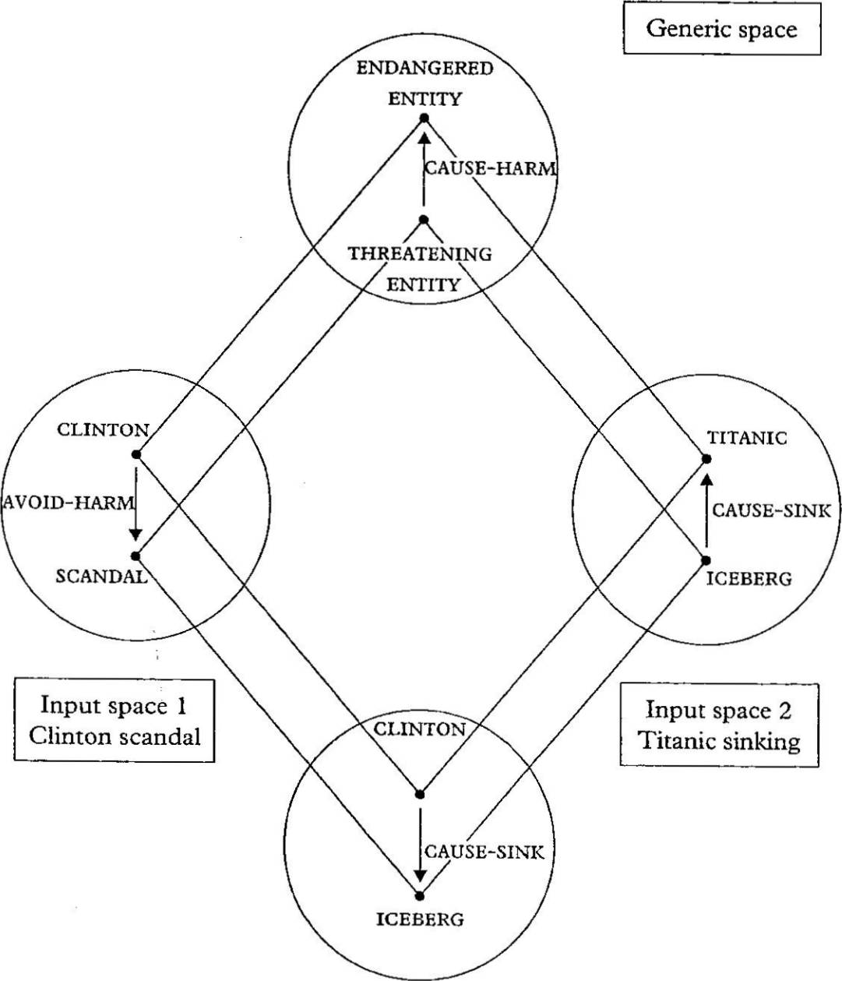
These two domains of knowledge are characterized as mental spaces that act as input to the created blend where Clinton becomes the counterpart of the Titanic and the scandals, the iceberg. This is represented as in figure 11.18, where, as before, the circles represent each mental space.
In the figure there are two input spaces, the first containing knowledge about Clinton, threatened by scandal but surviving; the second contains the sinking of the Titanic. In the generic space, the speaker identifies Clinton with the ship and the iceberg with the scandal. The blend space links ele ments from these domains to create a new scenario, where, far from being
harmed, the Clinton-Titanic sinks the scandal-iceberg, reversing the causal relationship between the ship and the iceberg (Fauconnier and Turner 2002: 222). An important feature of blends such as this is that they create material that is not in any of the input spaces; and speakers can elaborate the blend as far as they wish. This is often referred to as the blend’s emergent structure.
Example 11.50 above is taken to be merely a striking and original exam ple of a much more general process.15 Conceptual blending theory has been applied to a variety of linguistic processes from the formation of lexical blends, such as Mcjobs and infotainment, and lexical compounds, such as

388 Theoretical Approaches
desk jockey and golden parachute’, to the creation of proverbs, for example, Necessity is the mother of invention, jokes, advertisements, and literary lan guage in general (Turner 2006). There is a growing literature on blending as cognitive semanticists have sought to identify the sub-processes involved in the creation of blends. These include the process of composition, where the speaker creates links between spaces, in our example by links of identity; completion, where speakers can bring in and rely on knowledge from the relevant spaces; and elaboration, where the blend’s innovative structure is developed and new inferences formed. As with metaphor earlier, blending is proposed as a cognitive process that is more general than language: blend ing has been identified in non-linguistic areas such as rituals (Sweetser 2000).

    - Section summary

At this point we must leave our discussion of mental spaces. From our brief view of this theory, we can see that in proposing these mental structures, Fauconnier has created a procedural view of the creation of meaning, where very simple processes of space formation and linking are triggered by the linguistic input and combine to allow the participants considerable flexibility in the manipulation of reference and knowledge about domains. The circle diagrams we have seen in this section are a form of notation which helps us to view these various referential strategies as a unified phenomenon. As such, of course, these are still linguistic tools, which presumably must be translated into realistic psychological models. As we have seen, one advantage of this approach is that it firmly situates referential opacity and belief con texts in a family of regular linguistic processes. Thus they are not seen as irregular or exceptional features of languages but as part of the wonderful referential flexibility allowed to speakers by the semantic structures of their languages. The theory has been applied to variety of other areas including tense, mood and counterfactuals; see Fauconnier (1997) for details. An important development is conceptual blending theory, a dynamic model of how speakers selectively integrate elements of input spaces to create novel blended spaces; this is applied to a wide range of linguistic and cognitive processes in Fauconnier and Turner (2002). In the next section we look briefly at Ronald W. Langacker’s theory of Cognitive Grammar, which iden tifies a range of other cognitive processes important in language.

Langacker’s Cognitive Grammar

Ronald W. Langacker (especially 1987, 1991, 1999, 2002) has proposed a theory called Cognitive Grammar that has been very influential in the devel opment of the cognitive linguistics approach. As we have noted at several points, this theory makes no distinction between grammar and semantics.
Cognitive Semantics 389
The lexicon, morphology and syntax are all seen as symbolic systems. A linguistic sign is in this view a mapping or correspondence between a semantic structure and a phonological structure. This is a familiar view of lexical items but Langacker views grammar in the same light. Grammatical categories and constructions are also symbols. This may sound no differ ent than the basic assumption of all linguists who rely on the notion of compositionality: sentences are articulated groupings of words, which are sound-meaning mappings. However Langacker is quite radical, especially viewed against the structuralist and formalist grammatical traditions, in viewing larger structures as directly symbolic in the same way as words. In this view constructions have meanings in and of themselves.16 Moreover, in a departure from the traditional view of levels of analysis, items at all levels of the grammar are characterized in the same conceptual terms.
We can outline some important features of this approach, beginning by looking at how the categories of noun and verb are characterized in seman- tic/conceptual terms, and related to a cognitive account of clause structure. Thereafter we move on to look at the importance of construal in this theory.

    - Nouns, verbs and clauses

In this theory linguistic categories reflect conceptual models, such as the idealized cognitive models (ICMs) we discussed in chapter 2. Amongst such models Langacker identifies a naive world-view that he calls the billiard-ball model. This is a view or theory of reality that incorporates concepts of space, time, energy and matter. He describes it as follows:

  - These elements are conceived as constituting a world in which discrete objects move around in space, make contact with one another, and participate in energy interactions. Conceptually, ob jects and interactions present a maximal contrast, having opposite values for such properties as domain of instantiation (space vs. time), essential constituent (substance vs. energy transfer), and the possibility of conceptualizing one independently of the other (autonomous vs. dependent). Physical objects and energetic inter actions provide the respective prototypes for the noun and verb categories, which likewise represent a polar opposition among the basic grammatical classes. (Langacker 1991: 283)

Thus the linguistic categories of noun and verb are characterized in terms of a cognitive model, a conceptual partitioning of reality. Though the quota tion above identifies physical objects as the prototypical nouns, the crucial cognitive process is the bounding of a portion of experience to create a thing distinct from its surroundings. So nouns may describe time-stable states and of course may describe processes or ‘interactions’ normally identified by verbs, as in his arrival among us or dieting is bad for you. This characterization

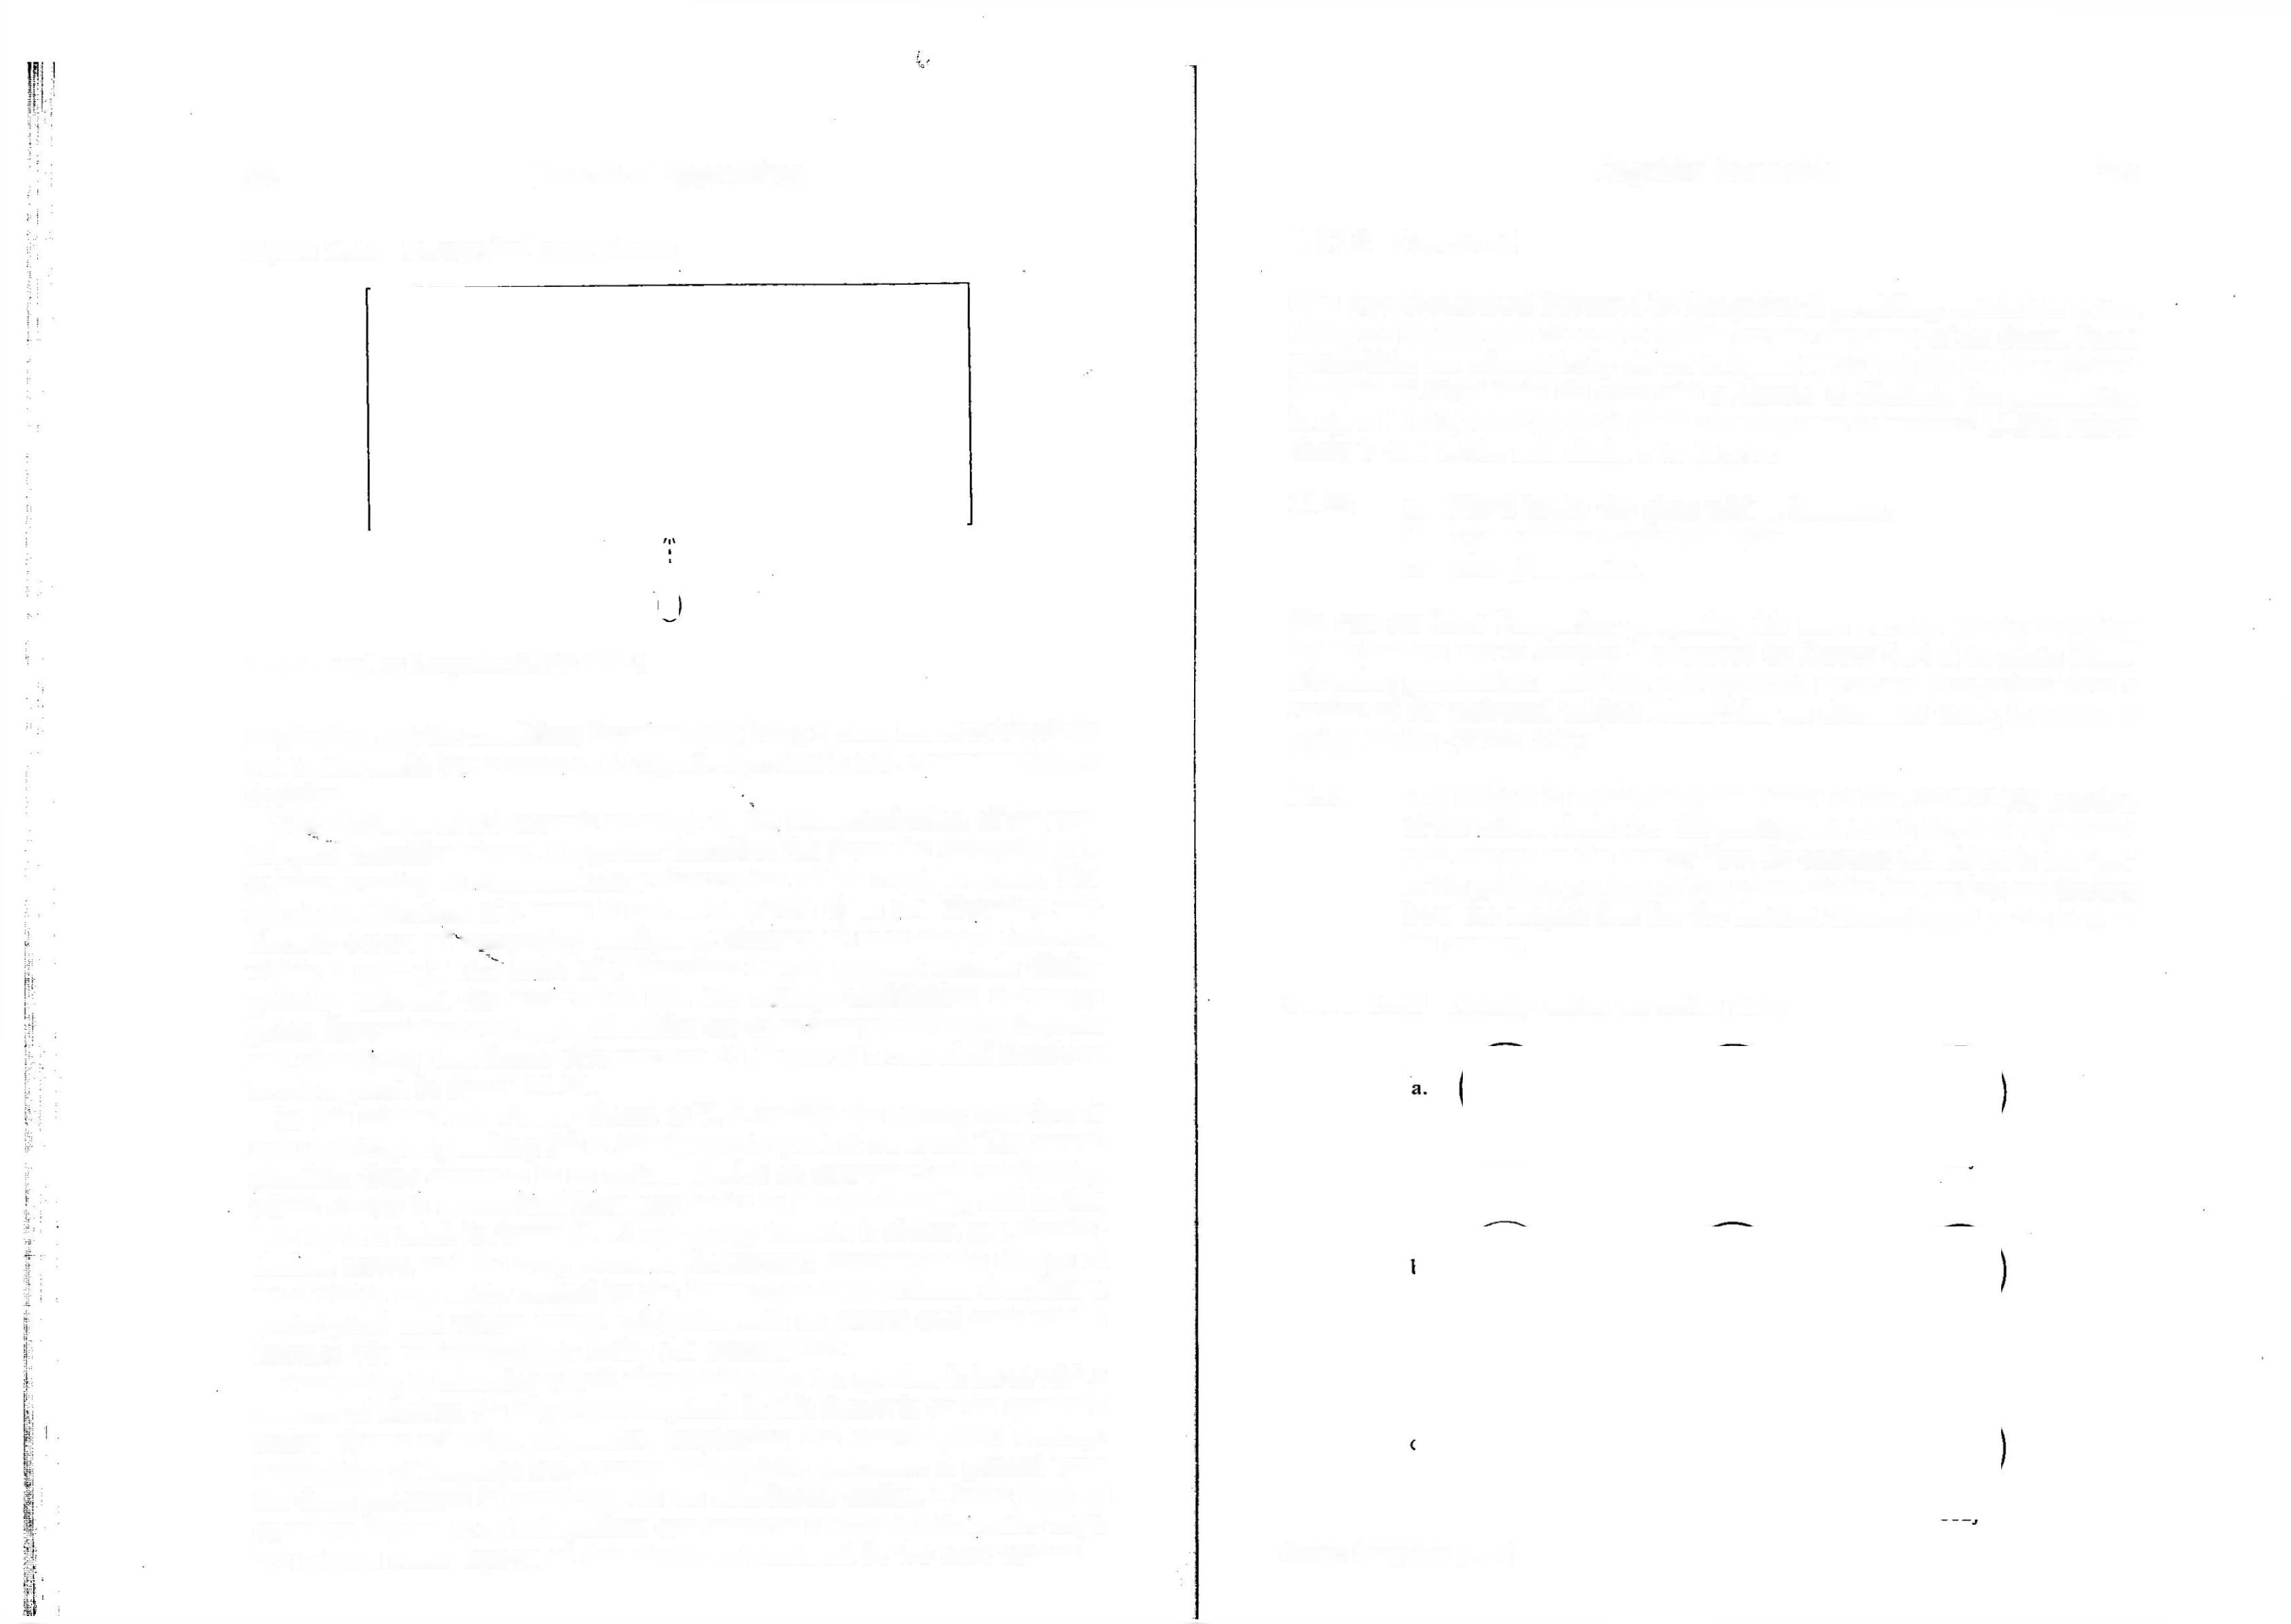
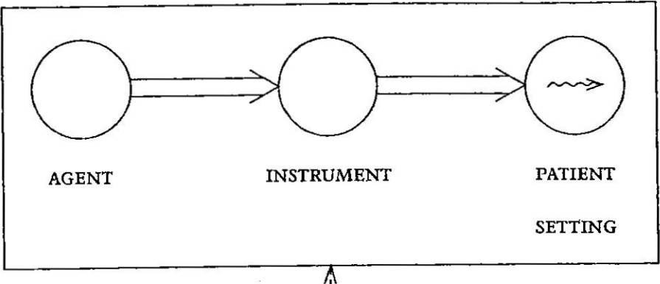
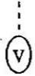
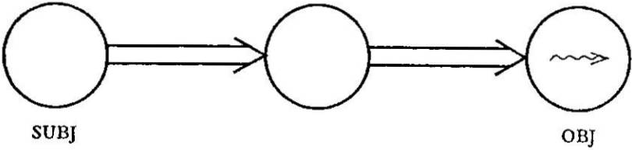
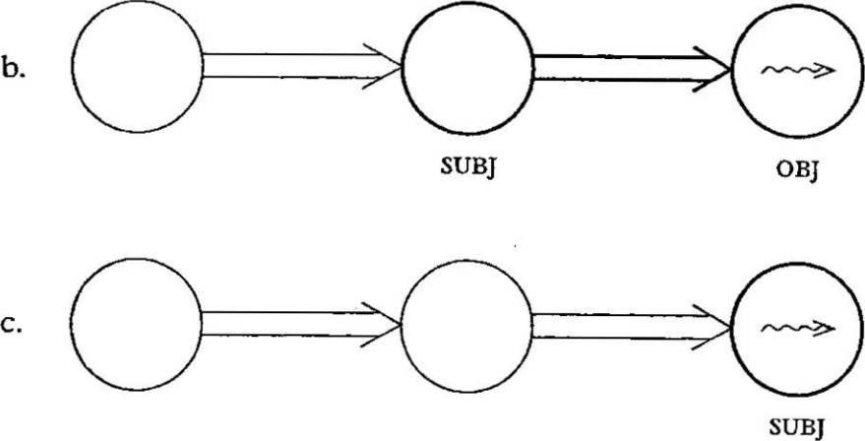
390 Theoretical Approaches

Figure 11.19 Prototypical event schema

Source: Based on Langacker (1990: 209ff.)

emphasizes that the conditions for something being a noun are not objectively out in the world but a product of cognitive processes and a communicative decision.
The model in 11.51 extends naturally to the characterization of the pro
totypical transitive clause. Langacker describes this from the viewpoint of a speaker wanting to.communicate a description of an event or scene. The initial identification of a scene is described (1987: 6) as the ‘chunking into discrete events of temporally contiguous clusters of interactions observed within a setting’. The tasks of a describer in this account include distin guishing between the occurrence and the setting, establishing a vantage point, determining what types of entities are to be interpreted as participants and identifying their forms of interaction. A schema of a canonical transitive event is given in figure 11.19.
In this schema the viewer, shown as V, is outside the setting and thus is
not a participant, making this a third person report of an event. The viewer identifies three elements in an action chain: an asymmetrical relationship where energy is transmitted from one entity to a second entity, and in this case on to a third. In figure 11.19 the energy transfer is shown as a double shafted arrow, and the wavy arrow in the pATienT represents the change of state within this entity caused by the interaction. This schema describes a prototypical case where energy originates with an AGenT and ends with a pATienT, via an intermediate entity the insTrUmenT.
Thereafter, in choosing to talk about this scene the speaker is faced with a number of choices. An important emphasis in this theory is on the speaker’s active characterization of scenes, employing the conventional concep tualizations of language and a range of cojgnitive processes. A general term for these processes is construal: as we mentioned earlier, a basic tenet of cognitive linguistics is that speakers can construe a scene in alternative ways. We discuss some aspects of this choice of construal in the next section.
Cognitive Semantics 391

    - Construal

One type of construal discussed by Langacker is profiling: within the action chain the speaker can choose to profile certain segments of the chain. Some possibilities are schematically shown in figure 11.20. We can use Langacker’s example of Floyd broke the glass with a hammer to illustrate the possibilities in figure 11.20, where profiled chain a corresponds to sentence 11.52a below; chain b to 11.52b; and chain c to 11.52c:

  - a. Floyd broke the glass with a hammer.
    - The hammer broke the glass.
    - The glass broke.

We can see here Langacker proposing his own version of the mapping hierarchies we saw in chapter 6 proposed by Dowty (1991) to relate them atic roles, grammatical relations and syntactic structure. Langacker gives a version of the universal subject hierarchies we discussed there, in terms of action chains (2002: 217):

  - The subject is consistently the ‘head’ of the PROFILED portion of the action chain, i.e. the participant that is farthest ‘upstream’ with respect to the energy flow. By contrast the object is the ‘tail’ of the profiled portion of the action chain: the participant distinct from the subject that lies the farthest ‘downstream’ in the flow of the energy.

Figure 11.20 Profiling within the action chain

Source: Langacker (1990)

392 Theoretical Approaches

For further details of this view of argument structure in terms of action chains and flows of energy, the reader is referred to Langacker (1991: 282- 377).
Another important notion is perspective, which in Langacker (1987)
is taken to include the notions of viewpoint and focus. This notion of perspective is a reflection of the importance that cognitivists attach to the role of the observer in scenes: in particular, the selection of the observer’s viewpoint and the choice of elements to focus on. We can take as a simple example of the former the choice between external and internal viewpoints of a container, as reflected in the two interpretations of the preposition around in sentence 11.54 below:

  - The children ran around the house.

If we choose an external viewpoint of the house as a container, this sentence describes a scene where the children’s motion circles the outside of the house, whereas if we choose an internal viewpoint, the children are moving around within the house’s internal space.
We saw something of the linguistic implications of focus in chapter 7 and again in chapter 9, when we discussed Leonard Talmy’s analysis of motion events into features including Figure and Ground, as in for example Talmy (1975, 1985). We saw there that the Figure (as we have seen, also called the trajector) is an entity chosen to stand out in some way from the back ground, the Ground (also called the landmark). In the case of motion events, the entity which is moving with respect to stationary surroundings tends to be chosen as the Figure. The choice to focus on either Figure or Ground in a scene can have lexical significance: Talmy (1985) describes the choice in English between the verbs emanate and emit in 11.55 and 11.56 below:
  - The light emanated from a beacon.

  - The beacon emitted light.

The verb emanate requires the Figure as subject; while emit requires the Ground as subject. Talmy argues therefore that choosing the former reflects a choice of focus on the Figure; and the latter, focus on the Ground. As we saw in earlier chapters, sometimes the choice of focus involves not separate verbs but different argument structures for the same verb, as in the pairs below:
  - a. The bees swarmed in the field.
    - The field swarmed with bees.

  - a. The ice glistened in the moonlight.
    - The moonlight glistened on the ice.
Cognitive Semantics 393

There are other related processes of construal proposed in this theory, for example scanning (Langacker 1987: 101-5), by which speakers are able to structure a scene in order to form a description. Langacker makes a distinc tion between sequential and summary scanning. These are different ways that a reporter may construe a scene. Sequential scanning is a way of view ing a process as a sequence of component sub-events. Summary scanning is a way of viewing a process as a complete unit where all its sub-events are viewed as an integrated whole. Langacker proposes that this difference is reflected in grammar in a number of ways including a speaker’s decision to use a noun or a verb to describe an event. So someone going into a room or falling off a cliff can be viewed in sequential mode and described verbally as in the a sentences in 11.59-60 below, or be viewed in summary mode and described with nominals as in the b versions:

  - a. Keegan entered the room.
    - Keegan’s entrance into the room

  - a. Wheeler fell of the cliff.
    - Wheeler’s fall from the cliff

Langacker uses an analogy to bring out the difference between these modes: sequential scanning is like viewing a motion picture sequence while sum mary scanning is like viewing a still photograph.
These examples of viewpoint, focusing, profiling and scanning reveal the importance attached in this theory, and in cognitive linguistics generally, to the role of the speaker’s construal of a situation in determining meaning.

Summary

In this chapter we have reviewed the approach known as cognitive semantics. We have seen that a distinctive feature of the approach is its attempt to form an experientialist basis for meaning. Cognitive semanticists propose that the common human experience of maturing and interacting in society motivates basic conceptual structures which make understanding and language possible. In Mark Johnson’s (1987) approach, these conceptual structures include pre-linguistic image schemas. These image schemas form more abstract cognitive models by processes of metaphor and metonymy. We saw the importance in Langacker’s Cognitive Grammar of the cognitive processes which underpin the speaker’s construal of a scene, for example by determining perspective, selecting viewpoint, Figure-Ground focus, profiling, and scanning. We also saw in Fauconnier’s theory of mental models a mech anism for explaining how participants in a discourse maintain referential links, set up referential domains and regulate knowledge sharing between them. Conceptual blending theory (Fauconnier and Turner 2002, Coulson

394 Theoretical Approaches

2000) seeks to account for a speaker’s abilities to integrate conceptual struc tures in dynamic and novel ways.
In earlier chapters we discussed the claim that semantic representations have to be grounded in some way, if semantic analysis is not just to be simply a form of translation. In chapter 10 we saw that in formal seman tics this is done by establishing denotational links with the external non- linguistic world. In this chapter we have seen that in cognitive semantics a similar grounding is sought, but not directly in reality (which in this view is not directly accessible) but in conceptual structures derived from the experience of having human bodies and of sharing in social conventions., and all that this implies.

FURTHER READING

A comprehensive introduction to cognitive semantics is George Lakoff (1987), which includes detailed discussions of the conceptual structures we have discussed. Mark Johnson (1987) investigates the experiential basis of these constructs, while Fauconnier (1994, 1997) describe his work on mental spaces. Fauconnier and Turner (2002) discusses the theory of conceptual blending. An encyclopaedic review of the rela tions between semantics and grammar in cognitive linguistics is given by Langacker’s works (1987, 1991, 2002). Taylor (2002) introduces Langacker’s theory. There are a number of good general introductions to cognitive linguistics, in particular Croft and Cruse (2004),. Ungerer and Schmid (2006), and Evans and Green (2006). Geeraerts (2006) provides an important selection of primary readings.
At a more specific level,.. Kovecses (2002) is an accessible introduction to the cognitive approach to metaphor, while Dirven and Porings (2002) and Barcelona (2003) present interesting collections of papers on the relationship between meta phor and metonymy. Tyler and Evans (2003) extend the analysis of prepositions discussed in this chapter.

EXERCISES

  - Give example sentences in English, and any .other language you know, of the metaphors Love is A joUrneY, iDeAs Are oBjeCTs and Time is MOTION.

  - For the metaphors you gave in exercise 11.1, try to establish some of the ^systematic correspondences between the two. concepts.

  - For any two languages you know, discuss similarities and differ ences in conventionalized metaphors of body parts (e.g. head of a bed, hand of a watch).
Cognitive Semantics 395

  - Discuss the, types of metonymic relationship involved in the use of the nominals in bold in the examples below:

    - The BMW is waiting for his ticket.
    - The gallery has just bought a Monet.
    - The demonstrators see Iraq as another Vietnam.
    - Brighton welcomes careful drivers.
    - The piano upstairs keeps waking the baby.
    - We do all the stuff the back office don’t do.

  - Provide your own examples of the following metonymic strategies:

CONTAINER FOR CONTENTS WHOLE FOR PART
PART FOR WHOLE
CONTROLLER FOR CONTROLLED OBJECT USED FOR USER ,

  - In this chapter we discussed the tendency for prepositions to exhibit polysemy. As we saw, within cognitive semantics this is described in terms of extension from a prototypical image schema. Below we give examples of three English prepositions: on, underhand over. For each set of examples discuss any differ ences you detect in how the preposition leads you to conceive of the spatial relations. Discuss how you could informally capture the shared meaning. Then try to use schemas like the diagrams we saw in section 11.4 to capture the distinctions you identify. (Similar examples are discussed in Lakoff 1987, Brugman 1988
and Vandeloise 1991).

    - on
The camera is on the table. The fly .is on the ceiling. The painting is on the wall. The shoe is on my foot.
The leaves are on the tree. The house is on fire.
    - under
The mechanic is under the car.
Under the wallpaper the plaster is very damp. Our next goal is to explore under the oceans. It can breathe under water.
We have the house under surveillance. Try looking under ‘Crime Novels’.

396 Theoretical Approaches

The horse jumped over the fence.
The boys walked over the hill.
The hawk hovered over the field.
The bridge stretches over the highway.
The runner looked over her shoulder at the following group.
He’s over the worst.
  - Clearly different prepositions allow different characterizations of spatial relations. However, if we compare two prepositions, say English on and in, we may find different conceptualizations cho sen between individual speakers or between dialects. For example in Irish English, some people, speaking of an item of news, might say It was on the newspaper yesterday, while others might say in the newspaper. How would you describe the two different meta phorical strategies in this example? Below are pairs of sentences differing;only in the choice of on and in. Discuss the meaning relationship between the sentences in each pair. Once again dis cuss whether diagrammatic schemas would help your analysis.

- a- I heard it on the radio..
b. I:heard it in the radio.
Cognitive Semantics 397

In the novel, Hitler wins World War II. If I were you I’d ask myself ‘Why?’ Libby wants to marry a millionaire.
On Sundays the 8 am bus leaves an hour later. In 1947 the president was a child.
In Andy Warhol’s prints Marilyn Monroe’s face keeps changing colour.

11.9 Discuss the conceptual blends in the examples below:

- Let’s respect our Mother Earth.
- They’re digging their graves with their teeth.
- Edinburgh is the Athens of the North.
- If department stores are the cathedrals of commerce, Christmas windows are the stained glass that lifts the spirits of the faithful.17

NOTES

- The label cognitive is used in this approach in a number of related ways. Ronald

- a?
b.
J heard it on the news,
{‘heard it in the news.
W. Langacker uses the term cognitive grammar to describe his own and close colleagues’ work, in for example Langacker (1987, 2002). George Lakoff (1988) uses cognitive semantics as a cover term for the work of a number of scholars

- a. He lay on his bed.
b. He lay in his bed.
- a. He lay on his deathbed.
- . b. He lay in his deathbed.

- a. I put a new engine on the car.
  - • .< . / » y . b. I put a new engine in the car.
. ■ ' 6 a. T put a new set of tyres on the car.
; ■■ ; < v - . b. I put a new set of tyres in the car.
.7 ■ a. , The children on jthe bus need to be counted,
b. The children in the bus need to be counted.

3 11.8 Using the theory of mental spaces, spacebuilders and refer ential connectors outlined in this chapter, discuss the referential interpretations of the items in bold in the sentences below:
including Langacker, Lakoff himself, Claudia Brugman, Mark Johnson, Gilles Fauconnier, Leonard Talmy, and Eve Sweetser, amongst others. References to work by these authors can be found in the Bibliography. As we note, this a very varied group of scholars, working on different topics and not always sharing the same interests. However, there are unifying factors: there is an International Cognitive Linguistics Association, which publishes a journal Cognitive Linguistics, holds an annual conference, and links researchers who share the basic outlook we describe here. In this chapter we will use the term cognitive semantics in the spirit of Lakoff (1988) as a loose, inclusive term for scholars who, while they may not form a tight, coherent school of thought, do share some basic assump tions about the direction a semantic theory must take.
- For such views see J. A. Fodor (1983) and Chomsky (1988).
- For discussion of these aims, and a rejection of them as premature for linguistics, see Fauconnier (1994: xxviii-xlvi).
- See Saussure (1974) for discussion.
- Heine, Claudi and Hiinnemeyer (1991) discuss examples of such processes of grammaticalization. These include full lexical nouns becoming pronouns, e.g. (p. 35) ‘Latin homo “person, man” to French on (impersonal subject pronoun), German Mann “man” to man (impersonal subject pronoun), and Latin persona “person” to French personne (negative pronoun, negation marker).’ Another

398 Theoretical Approaches

example (p. 131) is of nouns for parts of the body becoming spatial adverbs and prepositions, as in the example of Swahili, where what was historically a noun *mbele ‘breast’ became a noun mbele ‘front’ and then an adverb ‘in front’ as shown below:

Gari liko mbelle car is front
‘The car is in front, ahead.’

Similar processes have been identified for a number of African languages; see Heine et al. (1991) for discussion.
- This of course leaves open the question of the ‘fit’ between human categoriza tion and what is really out there in the world. The cognitivist position is consistent with a range of views. The point perhaps is that, from a linguistic perspective, it is the mapping between language and conceptual structure that is crucial. Clearly conceptual structure is intimately related to perception: for example we don’t have words in our ordinary vocabulary for the light wavelengths we cannot see as colour, or to describe the sound waves we cannot hear. The perceptual and experiential basis of conceptual categories is an important topic of inquiry in cognitive semantics. See the relations identified in Mark Johnson (1987) for example, which we discuss in section 11.3.
- Example 11.2 is from the article ‘Inside the Oscar Wars’ in Time magazine, 25 March 2002 (p. 56). Example 11.3 is from the article ‘This Glorious Mess’ in the British newspaper The Guardian, 22 March 2002 (Review section, p. 2).
- For a discussion of this distinction between classical and Romantic views of metaphor, see the accessible overview in Hawkes (1972), and the more ex tended discussions in Black (1962), Ortony (1979) and Kittay (1987).
- Given what we have already said about the cognitivist rejection of objectivist semantics, it is interesting to read the remarks of the English Romantic poet Samuel Taylor Coleridge in a letter to James Gillman, written in 1827 (cited in Hawkes 1972: 54-5):

It is the fundamental mistake of grammarians and writers on the philosophy of grammar and language to suppose that words and their syntaxis are the immediate representatives of things, or that they correspond to things. Words correspond to thoughts, and the legitimate order and connection of words to the laws of thinking and to the acts and affections of the thinker’s mind.

- From Science magazine, volume 295, no. 5561, (p. 1813), 8 March 2002.
- The symbol * is used in example 11.11, as in historical linguistics, to identify a hypothetical reconstructed form.
- We could of course add modern Indo-European examples like French gouter ‘taste’, Spanish gustar ‘please’, gustarse ‘like’, etc.
- These are equivalent to the terms Figure and Ground we met in chapter 9 in our discussion of Leonard Talmy’s description of motion events (e.g.Talmy 1985).
- This principle can be seen as a cognitive parallel to the notion in formal semantics of resemblance or similarity between possible worlds; see Stalnaker (1968) and Lewis (1973) for discussion.
- This blend was striking and memorable enough to be quoted later by Clinton’s successor, president George W. Bush at the dedication of the Clinton Presidenti-
Cognitive Semantics 399
Al Centre in Little Rock Arkansas (Press Release, 18 November 2004, Office of the Press Secretary, The White House, Washington DC).
- See Goldberg (1995) for a related view of grammatical constructions as cognit ive schemas.
- Imogen Fox, The Guardian newspaper, 9 November 2007, G2, p. 18.

