Thompson (1700-1740) is best known for his long poems “The Seasons” and “The Castle of Indolence”. He also wrote "Rule, Britannia!" which was set to music by Thomas Arne and for long served as the English national anthem. The four lines from his “Autumn” (in “Four Seasons”) are note quoted in Bewick’s Birds and must have been met with in another source such as James MacDonald’s General View […] of the Western Isles of Scotland (1811), if not in an anthology or the original collection..

“The Four Seasons: Autumn”

[…]
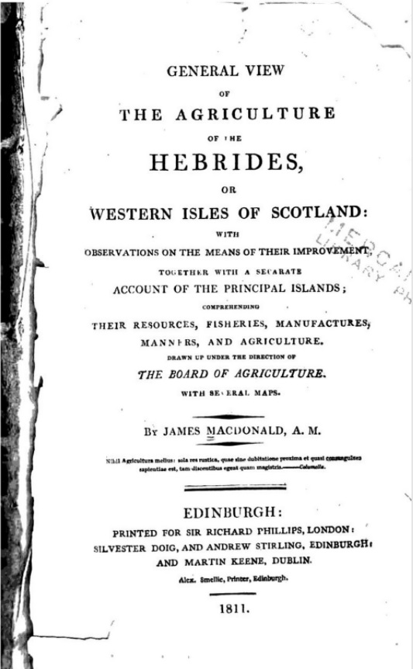
The stork-assembly meets; for many a day,
Consulting deep, and various, ere they take
Their arduous voyage through the liquid sky:
And now their route design’d, their leaders chose,
Their tribes adjusted, clean’d their vigorous wings;
And many a circle, many a short essay,
Wheel’d round and round, in congregation full
The figured flight ascends; and, riding high
The aërial billows, mixes with the clouds.
Or where the Northern ocean, in vast whirls,
Boils round the naked melancholy isles
Of farthest Thule, and the Atlantic surge
Pours in among the stormy Hebrides;
Who can recount what transmigrations there
Are annual made? what nations come and go?
And how the living clouds on clouds arise?
Infinite wings! till all the plume-dark air,
And rude resounding shore are one wild cry.

—James Thompson (1730).
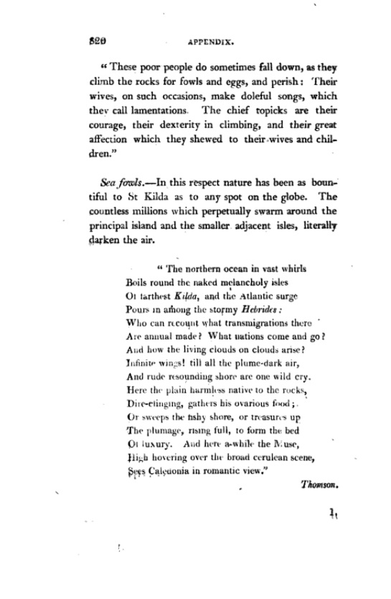

If Jane Eyre’s drawings are set in the Northern region of the British Isle such chiefly Scotland, the Hebrides or Northern Ireland—they introduce an element of Gothic romance which adds the element of stormy tragedy to the otherwise ‘polite’ social narrative of the novel. Her interest in such scenes, both in Chapter I and Chapter XIII serves as an acknowledgement of her own Irish provenance—being the daughter of an Ulsterman—and a claim upon ‘the spiritual eye’ (Chap. XIII) associated with turbulent scenes, both political and climatic, supposedly to be met with in Ireland and not in England.

THULE, the Greek and Roman name for the most northerly known land in the north Atlantic. The first to use the name was the Greek navigator Pytheas (about 300 B.C. probably). He calls it the most northerly of the British Isles and says that he reached it after six days’ sail from Britain: it was inhabited, but produced little; corn grew there sparingly and ripened ill; in summer the nights were long and bright.
This account of his travels is lost save for fragments, and the few surviving fragments do not determine where his Thule was, but Müllenhoff is probably right in thinking it was the Shetlands. The Faeroes, Iceland and Norway have also been suggested, but are for various reasons much less likely. After Pytheas, the name is used loosely for the farthest north. Thus Agricola’s fleet in A.D. 84 sailing up the east coast of Scotland is said to have espied but not to have reached Thule ("dispecta est Thule") but the phrase is merely literary.
The actual point meant may be the Orkneys or the Shetlands, or even some fragment of Scotland seen across the water. In some later writers (Procopius, &c.) Thule seems sometimes used to denote Scandinavia. The phrase "ultimate Thule" is commonly used to denote the farthest limit possible.
—Encyclopaedia Britannica, 1911 Edn.

