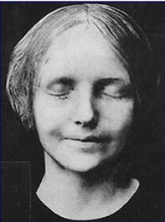 | L’inconnue de la Seine  Whose is the face we love to give  the kiss of life, the kiss of death?  L’Inconnue de la Seine.  And who is the girl behind the mask.  that kissable, missable little miss?  Why shame on you, Dorian Gray -  It’s Sybil Vane!  —Bruce Stewart | 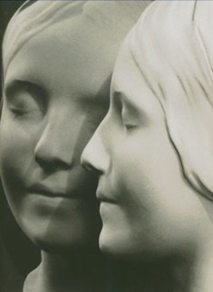

Dorian: “I love acting. It is so much more real than life.” [117]

[Sybil:] You taught me what reality is [126]

[A] third rate actress with a pretty face [128]

There is something ridiculous about the emotions of people whom one has ceased to love. [129]

Here was an ever-present sign of the ruin men brought upon their souls. [140]

Can they feel, I wonder, those white silent people we call the dead? [145]

It has all the terrible beauty of a Greek tragedy, a tragedy in which I took a great part, but by which I have not been wounded. [147]

That awful memory of woman! What a fearful thing it is! And what an utter intellectual stagnation it reveals! One should absorb the colour of life, but one should never remember its details. Details are always vulgar. [148]

The girl never really lived, and so she has never really died. […] The moment she touched actual life, she marred it, and it marred her, and so she passed away. Mourn for Ophelia […] Cordelia […] But don’t waste your tears over Sibyl Vane. She was less real than they are. [151]

Eternal youth, infinite passion, pleasures subtle and secret, wild joys and wilder sins—he was to have all these things. The portrait was to bear the burden of his shame: that was all. [153]

He would never again tempt by a prayer any terrible power. [154]

She acted badly because she had known the reality of love. When she knew its unreality, she died, as Juliet might have died. She passed again into the sphere of art. There is something of the martyr about her. [159]

To become the spectator of one’s own life […] is to escape the suffering of life. [160]

You became to me the visible incarnation of that unseen ideal whose memory haunts us artists like an exquisite dream. […] I was only happy when I was with you. [16]

It often seems to me that art conceals the artist far more completely than it ever reveals him. [167]

