The night before Larry was stretched,
The boys they all paid him a visit;
A bit in’ their sacks, too, they fetched
They sweated their duds till they riz it;
For Larry was always the lad,
When a friend was condemned to the squeezer,
To fence all the togs that he had,
just to help the poor boy to a sneezer,
And moisten his gob ’fore he died.

“I’m sorry now, Larry”, says I,
”To see you in this situation;
’Pon my conscience, my lad, I don’t lie,
I’d rather it was my own station.”
“Ochone! ’tis all over”, says he,
“For the neckcloth I am forced to put on,
And by this time to-morrow you’ll see
Your Larry will be dead as mutton;
Bekase why? - his courage was good!”

The boys they came crowding in fast;
They drew all their stools round about him,
Six glims round his trap-case were placed
He couldn’t be well waked without ’em.
I ax’d him was he fit to die,
Without having duly repented?
Says Larry, “That’s all in my eye,
And all by the gownsmen invented,
To make a fat bit for themselves.”

Then the cards being called for, they
played,
Till Larry found one of them cheated;
Quick he made a smart stroke at his head
The lad being easily heated.
“Oh! by the holy, you thief,
I’ll scuttle your nob with my daddle!
You cheat me bekase I’m in grief,
But soon I’ll demolish your noddle,
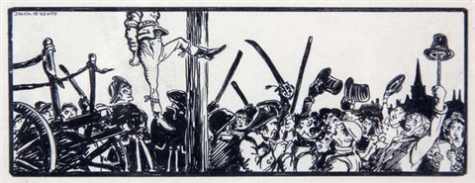
And leave you your claret to drink.”

Then in came the priest with his book;
He spoke him so smooth and so civil;
Larry tipp’d him a Kilmainham look,
And pitched his big wig to the divil.
Then stooping a little his head,
To get a sweet drop of the bottle,
And pitiful, sighing he said,
“Oh! the hemp will be soon round my
throttle,
And choke my poor windpipe to death!”

So moving these last words he spoke,
We all vented our tears in a shower;
For my part, I thought my heart broke,
To see him cut down like a flower!
on his travels we watched him next day,
Oh! the hangman I thought I could kill him!
Not one word did our poor Larry say,
Nor changed, till he came to “King William”:
Och! my dear, then his colour turned white.

When he came to the nubbling chit,
He was tucked up so neat and so pretty,
The rumbler jogged off from his feet,
And he died with his face to the city.
He kicked, too, but that was all pride,
For soon you might see ’twas all over;
And as soon as the noose was untied,
Then at evening we waked him in clover,
And sent him to take a ground sweat.
This celebrated Dublin ballad was written by a lawyer who must have had some experience of the brutal work of the 18th century courts and the prisons in Ireland and who obviously takes a sardonic view of the grisly business of public execution. It is full of ‘thieves’ jargon’ (or slang) which was presumably in use at that day. The absence of a final rhyme gives it a unsettled air which seems suit to the abruptness of Larry’s grim demise. The illustration is by Jack B. Yeats, (1871-1957), brother of the poet W. B. Yeats.

