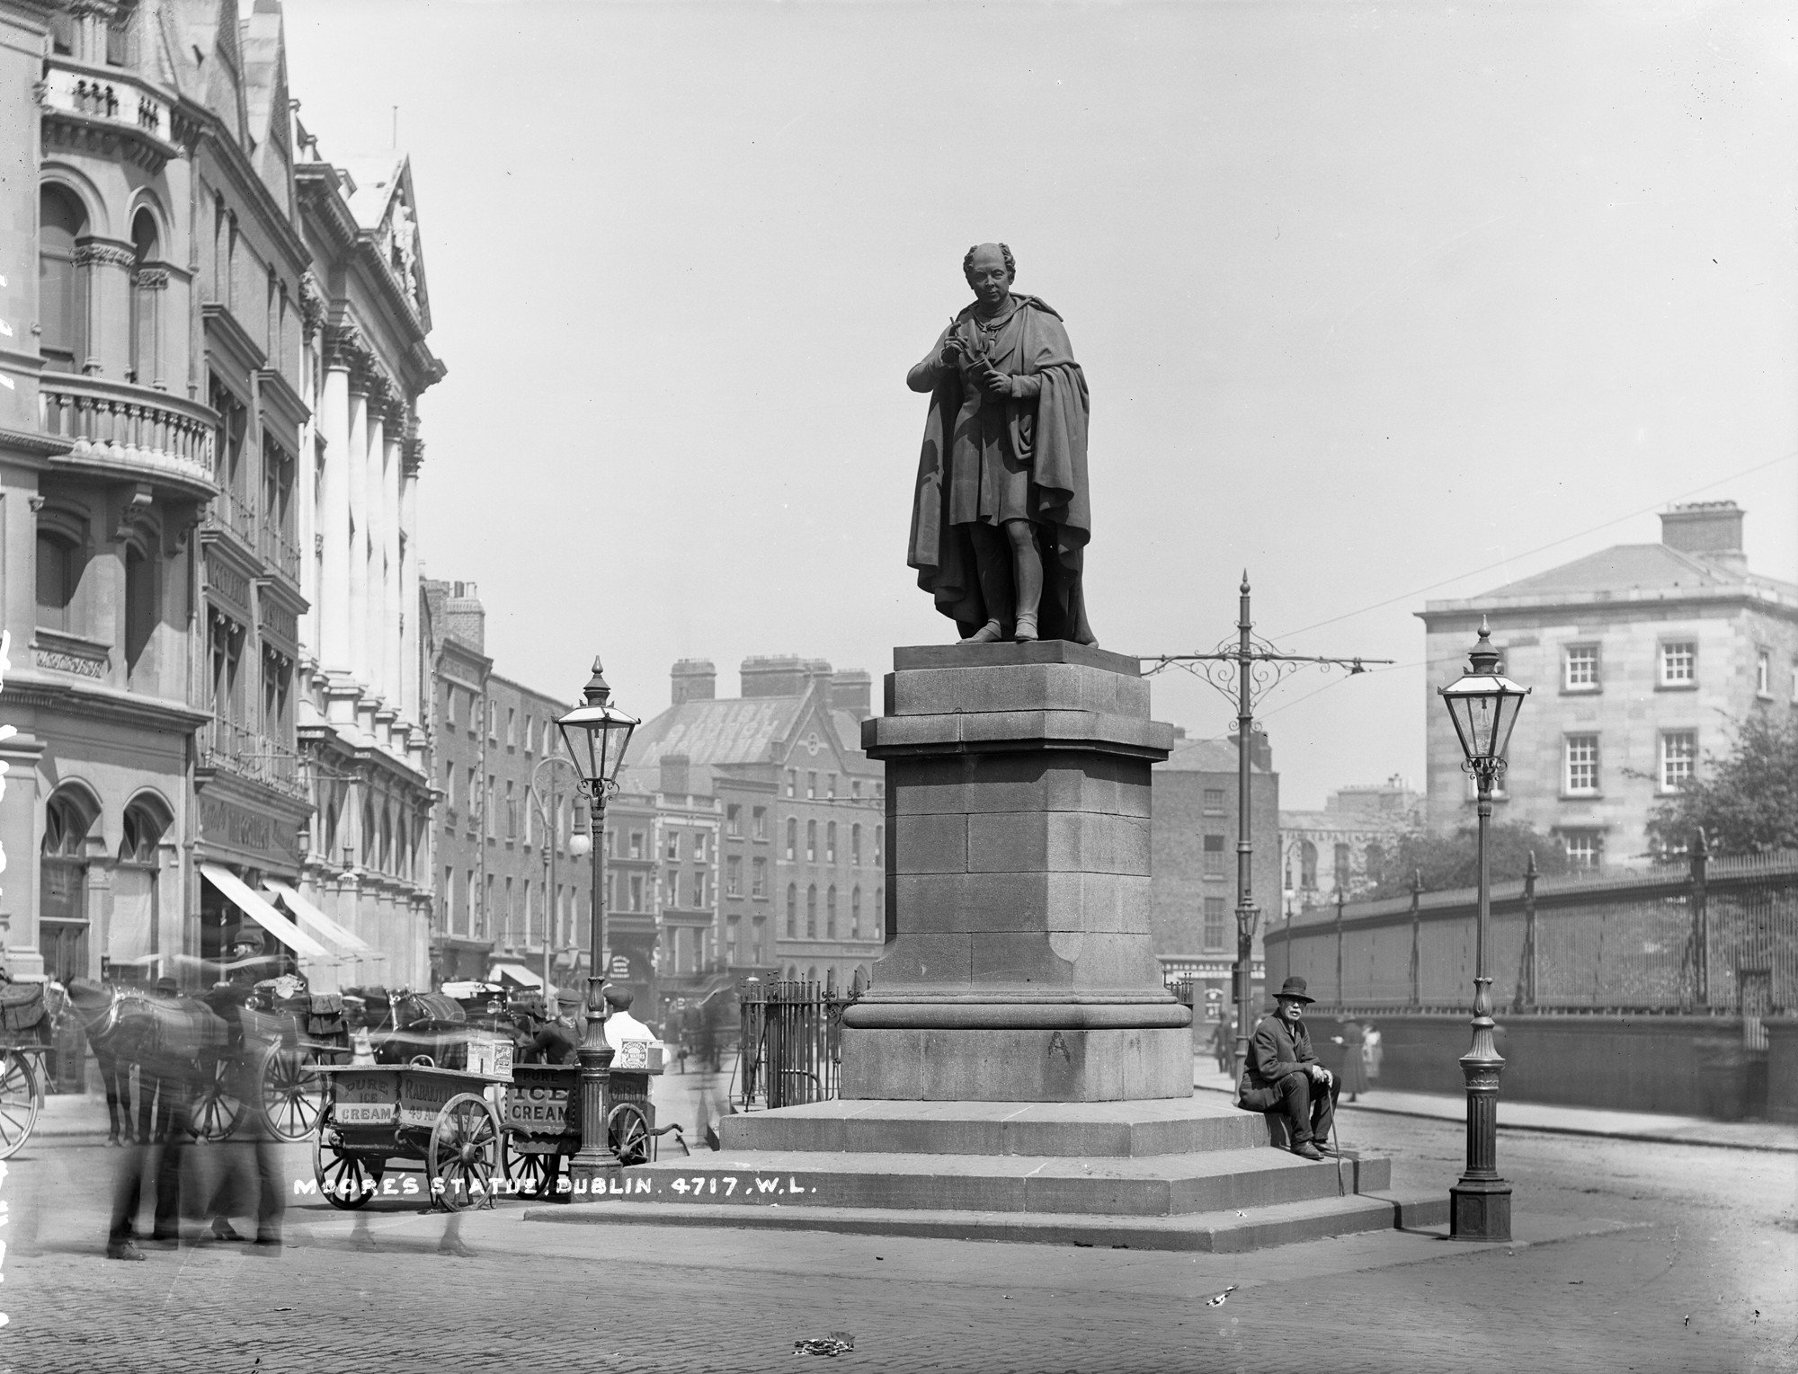

“The Meeting of the Waters”
There is not in the wide world a valley so sweet
As that vale in whose bosom the bright waters meet;
Oh! the last rays of feeling and life must depart,
Ere the bloom of that valley shall fade from my heart.
Yet it was not that nature had shed o’er the scene
Her purest of crystal and brightest of green;
’Twas not her soft magic of streamlet or hill,
Oh! no—it was something more exquisite still.
’Twas that friends, the beloved of my bosom, were near,
Who made every dear scene of enchantment more dear,
And who felt how the best charms of nature improve,
When we see them reflected from looks that we love.
Sweet vale of Avoca! how calm could I rest
In thy bosom of shade, with the friends I love best,
Where the storms that we feel in this cold world should cease,
And our hearts, like thy waters, be mingled in peace.
§
“Let Erin Remember the Days of Old”
Let Erin remember the days of old,
Ere her faithless sons betray’d her;
When Malachi wore the collar of gold,
Which he won from the proud invader,
When her kings , with standard of green unfurl’d.
Led the Red-branch Knights to danger; —
Ere the emerald gem of the western world
Was set in the crown of a stranger.
On Lough Neagh’s bank, as the fisherman strays
In the calm, cold eve’s declining,
He sees the Round Towers of other days
In the wave beneath him shining.
Thus shall memory often, in dreams sublime,
Catch a glimpse of the days that are over;
Thus, sighing, look through the waves of time
For the long-faded glories they cover.’

[…]
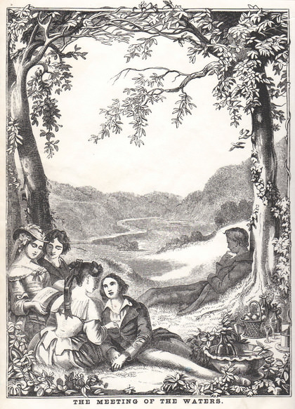
Moore’s “The Meeting of the Waters” was first published in 1808 and by the end of the century it had become one of the best known of his Irish Melodies, along with ‘The Harp that Once through Tara’s halls”, “The Minstrel Boy” and especially ‘The Last Rose of Summer’. These songs were performed in concerts, and in the polite parlours and drawing rooms where Moore thought they belonged. ‘The Meeting of the Waters’ no doubt owed much of its popularity to the traditional air “The Old Head of Dennis”, to which it was set by the Dublin composer John Stevenson. But the words too were responsible for the song’s great appeal. The song proposed that the pleasures of landscape were best experienced in company, and this preference for sociability over solitude was also a preference for the beautiful over the sublime, and allowed Moore’s readers to enjoy nature on easier terms than, say, Rousseau or Wordsworth seemed to offer. This turning away from the sublime was reinforced by the supposedly peaceful character of the confluence. At the place in County Wicklow that had come to be called the Meeting of the Waters, the rivers Avonmore and Avonbeg meet to become the Avoca in the “Sweet vale of Avoca”. A literary tourist described the river below the confluence as ‘rapid and impetuous in its progress’. But in Moore’s account, there is nothing torrential about these rivers, which behave as quietly as all rivers will one day behave, when, as the song puts it, ‘the storms that we feel in this cold world should cease.’
In Ireland in 1808, ten years after the start of the rebellion, five years after it was finally snuffed out with the execution of Moore’s friend Robert Emmet, this landscape meant much more than it would ever have done in England, where news from Ireland was allowed to fade from the memory as quickly as it arrived. There were a number of bloody engagements in Wicklow in the summer of 1798, as the United Irishmen pushed up from County Wexford towards Dublin. In Arklow in June, a few miles to the south-east of the confluence, a force of United Irishmen was defeated by the British. In September at Aughrim, a few miles to the west of the Meeting, General Joseph Holt led his United Irishmen to victory over the British. This history must have been present to Moore when, in a footnote to the first printing of the song, he wrote that ‘The Meeting of the Waters forms a part of that beautiful scenery which lies between Rathdrum and Arklow, in the county of Wicklow, and these lines were suggested by a visit to this romantic spot, in the summer of the year 1807.’ […] Of the thousands of references to the song and its title phrase that I have collected in the course of my research, only one, an account of Holt’s autobiography, mentions the song in the context of the 1798 rebellion. The general silence on that point may be vital to how the song came to be understood as the century got older.
[…]

