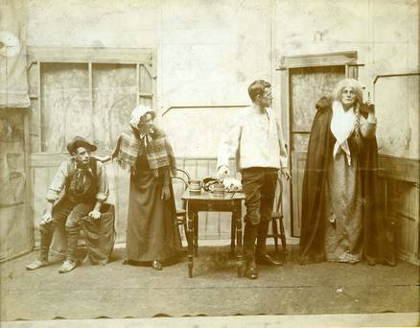

Kathleen Ni Houlihan, first performed at St. Teresa’s Abstinence
Association Hall, Clarendon St., Dublin, 2-4 April 1902.

[Michael Gillane is called from his impending marriage to Delia Cahel to fight for Ireland by an Old Woman of the Roads. The play is set in the West of Ireland during the United Irishmen’s Rebellion of 1789. Without any explicit reference to political matters, she persuades him to fight to regain her “stolen fields” – an allegory of territorial dispossession by the English. Every other sentence that she speaks is likewise allegorical and infused with nationalist meaning.]

‘BRIDGET: ‘It is a wonder that you are not worn out with so much wandering’.
OLD WOMAN: ‘Sometimes my feet are tired and my hands are quiet, but there is no quiet in my heart. When the people see me quiet, they think old age has come on me and that the stir has gone out of me. But when the trouble is on me I must be talking to my friends.’
BRIDGET: ‘What was it put you wondering?’
OLD WOMAN, ‘Too many strangers in the house.’
BRIDGET: ‘Indeed you look as if you’d had you’re share of trouble.’
OLD WOMAN, ‘I have had trouble indeed.
BRIDGET: ‘What was it put the trouble on you?
OLD WOMAN, ‘My land that was taken from me.’
PETER, ‘Was it much land they took from you?’
OLD WOMAN, ‘My four beautiful green fields. […]‘If any one would give me help he must give me himself, he must give me all [...] It is a hard service they take that help me. Many that are red-cheeked now will be pale-cheeked; many that have been free to walk the hills and the bogs and the rushes will be sent to walk hard streets in far countries; many that have gathered money will not stay to spend it; many a child will be born and there will be no father at its christening to give it a name. They that have red cheeks will have pale cheeks for my sake, and for all that, they will think they are well paid. [She goes out; her voice is head outside singing:] They shall be remembered forever / They shall be alive for ever, / They shall be speaking for ever, / The people shall hear them for ever.’
(Collected Plays, Macmillan 1960, p.86.)

